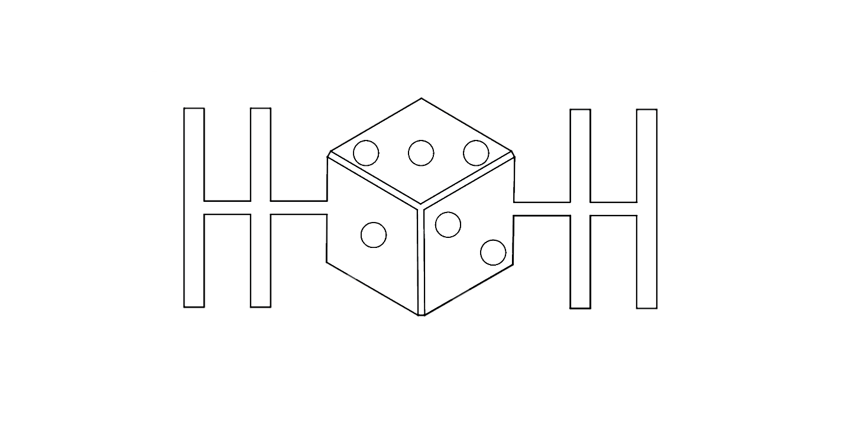

NASA HUNCH

EMAG ROLLER V56 MANUAL

TANNER LINDSAY

MATHIAS HOEHER

JACK BURCHER

FIRMWARE

Use FIRMWARE.ino for Arduino code