Plug-In Steering-Torque Feedback for Column Electric Power Steering with a Calibrated Assist Map
Minh Tan Tram^{1,*}, Thanh Huy Phung¹
¹Ho Chi Minh City University of Technology (HCMUT), Vietnam National University Ho Chi Minh City (VNU-HCM), 268 Ly Thuong Kiet Street, Ho Chi Minh City, Vietnam
*Corresponding author: Minh Tan Tram, e-mail: tmtan.sdh241@hcmut.edu.vn
Thanh Huy Phung, e-mail: huypt@hcmut.edu.vn

Abstract
In column-type electric power steering (C-EPS), a calibrated map converts the torsion-bar torque and the vehicle speed into the assist torque, and because the map has no target torque to follow, it compensates only part of the torque drop when tire–road adhesion falls. A stronger response of the map would restore more of that torque, but this makes the steering system less stable and amplifies sensor noise, so this study adds feedback on the error between the measured torque and a target torque derived from the speed and the lateral acceleration, which does not require an estimate of road friction. Two structures are examined, a PID controller that replaces the map and MapPID, in which a PID branch runs in parallel with the unchanged map. Each controller was tuned by selecting parameters on a Pareto front of tracking error and assist-torque noise under the same requirements, using a nonlinear model of the column, tires and vehicle body with noisy, quantized sensors, and then tested in steady cornering, a sudden friction change and continuous steering. In all three tests, MapPID removed the steady-state error left by the map and kept the tracking error several times below that of the map alone, and its tracking was close to that of the PID controller. Since MapPID keeps the existing map intact, it can be added to a calibrated system to correct the torque error that the map by itself cannot eliminate, provided the loop remains stable and the assist command stays within its limit.
Keywords: Electric power steering; Assist map; Torque feedback; PID control; Lateral acceleration; Road friction.

1. Introduction
Electric power steering (EPS) assists the driver with a motor governed by a microcontroller unit (MCU), which makes it possible to tune the steering feel in software [1]. The MCU can therefore respond to the driver's intention and deliver the assist that each driving situation requires. In the literature, the MCU stores an assist map that converts the sensed torsion-bar torque and the vehicle speed into an assist torque, followed by a lead–lag compensator that copes with rapid torque changes and reduces noise [1,2]. The map is calibrated on a dry road over a wide range of maneuvers, which gives the driver comfortable handling and sufficient torque to turn the wheel in each case.
However, when the vehicle runs in the rain or on a slippery road, the map is inappropriate because its fixed data correspond to dry-road conditions, so it supplies more assist than the road can support and may compromise safety [3,4]. The reason is that the map depends only on the measured torque and has no target torque to compare it with. In situations where tire–road adhesion falls and the road reaction drops [3,5,12], or friction inside the steering system shifts the torque balance [2], the map corrects only the part of the change that the slope of its curve allows. A steeper slope would leave a smaller error, but the higher loop gain amplifies sensor noise and shrinks the stability margin, that is, the room left before the loop becomes unstable [1,9], so the slope cannot be raised freely. In short, the problem is one of reducing the torque error under varying road conditions without disturbing the dry-road calibration that the map already carries.
Earlier studies tried to overcome this issue with three main approaches. The first adjusts the assist map or the motor current to the road. Some of these works select among several maps or assist characteristics according to the friction coefficient, the axle load or the road type [3,5], and others add a correction to the motor command based on estimated friction [4,6]. All of them rely on road information that must be identified beforehand and leave the slope limit of the map in place, and the compensation of [4] was capped by its authors and was not tied to a target torque, while that of [6] degraded the transient response. The second applies fuzzy control to deal with nonlinearity and noise [10,11]. However, Nguyen et al. [11] note that a change in adhesion may affect the robustness of the controller. The third adds or replaces a torque feedback loop. The proportional–integral–derivative (PID) loop of Zhao et al. [7] follows the torque requested by the map and not a target torque for the driver, and it does not consider variations in friction. Lee et al. [8,9] track a target torque, but with a linear tire model on a dry road [8] or mainly with the vehicle parked [9].
These studies leave a gap, since the methods that adjust the map need road information and keep its slope limit. The torque trackers in [8,9] drop the map and were restricted to simplified tires, a dry road, or a stationary vehicle. A design that preserves the existing map and compensator, includes target-torque feedback, and is tested with nonlinear tires under changing adhesion was therefore not found. To close this gap, the error between the measured torque and a target torque derived from the vehicle speed and the lateral acceleration is fed back [5,13], which makes a road estimate unnecessary, while the map and its compensator stay in place. The PID controller is a natural choice for this feedback, because its integral action removes the steady torque error without needing to know the road surface and it is the form adopted in torque-feedback studies [7–9]. Fuzzy [10,11] and model-based controllers were not chosen, since they require rules or a model of the road and the steering system, which the target-torque feedback is meant to avoid. On its own, however, the PID controller replaces the map and gives up the assist that the map already provides for dry roads. MapPID therefore adds a PID branch in parallel with the map and its compensator, so the map continues to supply that assist and the branch only has to correct what the map leaves, chiefly the steady error when adhesion varies, as long as the loop is stable and the motor does not saturate.
The contributions of this paper are as follows.
- MapPID, a plug-in structure that extends the assist map with a PID branch without modifying it, so the dry-road calibration stays valid, no friction estimate is needed, and only four PID parameters need tuning for each vehicle.
- A comparison of the map, the PID controller and MapPID on a coupled nonlinear model, with the parameters of each controller selected on a Pareto front of tracking error and assist-torque noise under the same requirements, which shows that MapPID keeps the tracking error several times below that of the map alone, while its difference from the PID controller is small and depends on the test.

2. System Modeling and Problem Formulation
The three controllers compared in this paper, the map, the PID controller and MapPID, all act on the torsion-bar torque, and this torque depends on the road through the tires and the vehicle body. A fair comparison therefore needs a plant in which a change of friction reaches the steering wheel, together with a target torque against which every controller is judged.
The plant consists of three coupled parts, namely the steering column with its assist motor, the front and rear tires, and the lateral and yaw motion of a single-track vehicle body, and Fig. 1 shows how the three interact. The column sets the lower-column angle $θ_{2}$, which steers the front wheels, and the tires return lateral forces to the body and the road-reaction torque $T_{r}$ to the column, while the body feeds its sideslip angle $β$ and yaw rate $γ$ back into the tire slip angles. Through this loop, a change in the tire–road friction coefficient $μ$ reaches the steering wheel. The external inputs are the steering-wheel angle $θ_{1}$ set by the driver, the assist torque $T_{a}$, the vehicle speed $v$ and the friction coefficient $μ$.
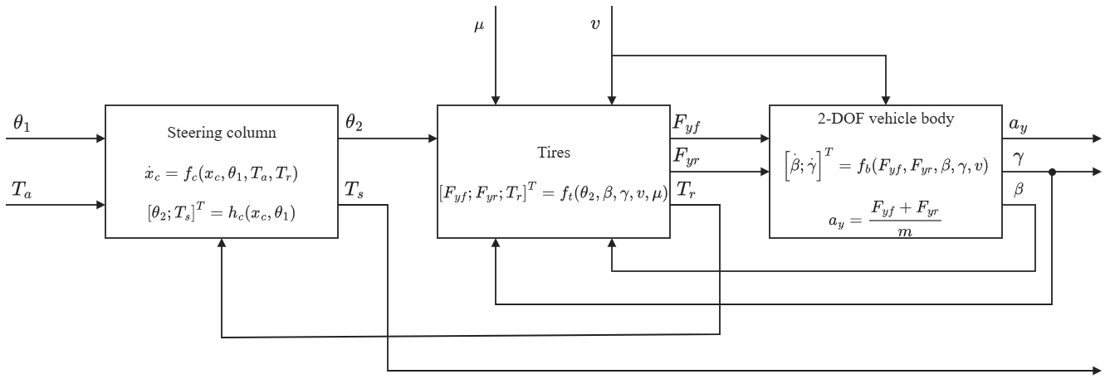
Fig. 1. Block diagram of the coupled C-EPS–vehicle plant: steering column, tires, and two-degree-of-freedom vehicle body.

2.1. Steering Column and Assist Motor
The steering wheel turns the upper column, which is joined to the lower column by a torsion bar of stiffness $K$, and the torque sensor measures the difference between $θ_{1}$ and $θ_{2}$ and computes the torque as in Eq. (2). The torsion bar transmits this torque to the lower column, where the motor adds the assist torque $T_{a}$ through a reduction gear, and $T_{a}$ follows the limited command $T_{a,lim}$ through the motor dynamics. The lower column then drives the pinion, which moves the rack and, through the steering arms, steers the front wheels, and the model lumps this chain into the steering ratio $n_{st}$ between the lower-column angle and the front-wheel angle, so the pinion radius $r_{p}$ does not appear separately. With $θ_{1}$ taken as the driver input, the lower column and the torsion bar obey [1]
$$\begin{aligned}J_{col}{\ddot{θ}}_{2}=T_{s}+T_{a}-T_{r}-C_{col}{\dot{θ}}_{2}-T_{f} tanh\left(c{\dot{θ}}_{2}\right)\#\left(1\right)\end{aligned}$$
$$\begin{aligned}T_{s}=K\left(θ_{1}-θ_{2}\right)\#\left(2\right)\end{aligned}$$
where $J_{col}$ and $C_{col}$ are the equivalent inertia and viscous damping of the lower column, with the motor and the gear referred to the column side, and $T_{f} tanh\left(c{\dot{θ}}_{2}\right)$ is a smooth form of Coulomb friction with amplitude $T_{f}$ and steepness parameter $c$. Both $T_{a}$ and $T_{r}$ act directly on the column. Figure 2 shows this arrangement.
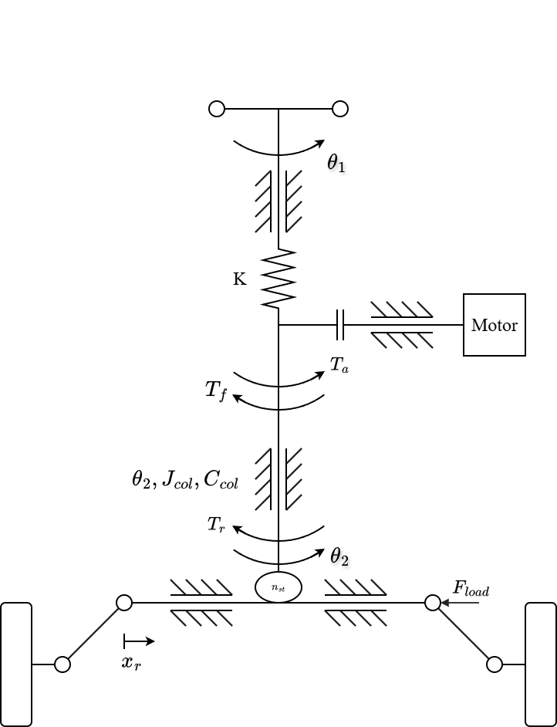
Fig. 2. Mechanical structure of the column-type EPS.
The angle is imposed, and not the driver torque, so that the torsion-bar torque can respond when the road reaction or the assist changes. A prescribed torque would fix the steady torsion-bar torque and hide the effect under study, so the angle input gives a controlled comparison of the steering-torque responses of the controllers. In exchange, the model leaves out the neuromuscular dynamics of the driver and the way a driver corrects the angle when the steering effort varies.

2.2. Tire Model and Road-Reaction Torque
The front-wheel angle is approximated by $δ_{f}=θ_{2}/n_{st}$, and Fig. 3 defines the tire quantities in the road plane. With small angles, and with a longitudinal speed that is treated as constant in the lateral equations, the slip angles of the front and rear axles are [13]
$$\begin{aligned}α_{f}=\frac{θ_{2}}{n_{st}}-β-\frac{l_{f}γ}{v}\#\left(3\right)\end{aligned}$$
$$\begin{aligned}α_{r}=-β+\frac{l_{r}γ}{v}\#\left(4\right)\end{aligned}$$
where $l_{f}$ and $l_{r}$ are the distances from the center of gravity to the two axles. Weight transfer is neglected in both directions, so each axle carries its static load:
$$\begin{aligned}F_{zf}=mg \frac{l_{r}}{l_{f}+l_{r}}\#\left(5\right)\end{aligned}$$
$$\begin{aligned}F_{zr}=mg \frac{l_{f}}{l_{f}+l_{r}}\#\left(6\right)\end{aligned}$$
where $m$ is the vehicle mass and $g$ the gravitational acceleration.
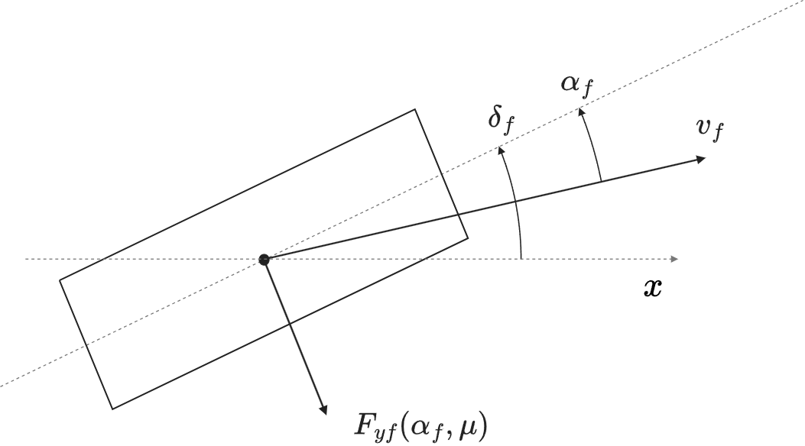 | Fig. 3. Top view of the front tire. The dashed line through the tire is the wheel plane and the horizontal dashed line is the vehicle longitudinal axis $x$. The front-wheel steering angle $δ_{f}$ is measured from $x$ to the wheel plane, the slip angle $α_{f}$ from the wheel plane to the velocity $v_{f}$ of the tire, and $F_{yf}\left(α_{f},μ\right)$ is the lateral force. Angles and geometry are schematic and not to scale.

Each axle is represented by one equivalent tire whose lateral force follows a reduced Magic Formula [12]. This form was chosen because it keeps the force saturation that a change of adhesion brings:
$$\begin{aligned}F_{yi}=D_{i} sin[C\tan^{-1}\left(B_{i}α_{i}-E \left(B_{i}α_{i}-\tan^{-1}\left(B_{i}α_{i}\right)\right)\right)], i∈\{f,r\}\#\left(7\right)\end{aligned}$$
$$\begin{aligned}D_{i}=μF_{zi}, B_{i}=\frac{C_{αi}}{C D_{i}}\#\left(8\right)\end{aligned}$$
where $i=f$ and $i=r$ denote the front and rear axles. The friction coefficient $μ$ is the same for both axles, $C_{αi}$ is the cornering stiffness of axle $i$, and $C$ and $E$ set the shape and curvature of the force curve. Since $D_{i}$ is tied to $μ$ and $B_{i}$ contains $D_{i}$ in its denominator, the initial slope stays at $C_{αi}$ while the peak force falls with $μ$, and on a slippery surface the tire therefore saturates at a smaller slip angle.
The front lateral force acts on the steering axis through an effective moment arm, which is the sum of a fixed caster offset and a pneumatic trail that shortens as the tire slides, a structure that [3] adopts for the tire offset and that the brush model of [12] supports. The trail relation of [3] is adapted as follows:
$$\begin{aligned}t_{p}= max\left(0, t_{0}-\frac{t_{0} C_{αf} | tanα_{f}|}{3μF_{zf}}\right)\#\left(9\right)\end{aligned}$$
$$\begin{aligned}e_{eff}=e_{c}+t_{p}, e_{c}=e_{p0}-t_{0}\#\left(10\right)\end{aligned}$$
where $e_{p0}$ is the moment arm at zero slip, $t_{0}$ the pneumatic trail at zero slip and $e_{c}$ the caster component. In the notation of [3], $t_{0}$ is the initial pneumatic offset and $e_{c}$ the mechanical offset, and $C_{αf}$ and $F_{zf}$ replace its tire stiffness and load, so no further tire parameter appears. Two choices in Eqs. (9) and (10) belong to this study and not to [3], namely the zero floor on $t_{p}$ and the values of $e_{p0}$ and $t_{0}$. The floor is needed because Eq. (9) without it reaches zero at $tanα_{sl}=3μF_{zf}/C_{αf}$, the slip angle at which a brush tire slides over its whole contact patch [12], and turns negative beyond that angle, where the brush model places the resultant force at the patch center. The brush-model trail starts from the same value at zero slip and also vanishes at this angle, and Eq. (9) follows it only approximately in between. With the parameters of Table 2, this angle is $7.8^{°}$ at $μ=0.8$ and $2.9^{°}$ at $μ=0.3$, slightly larger than the angles of maximum lateral force, $6.3^{°}$ and $2.4^{°}$, so the trail falls to zero shortly after the tire saturates, in line with real tires, whose aligning moment drops before the lateral force peaks [12]. The caster component stays fixed because it is a mechanical dimension that does not depend on slip or friction, so the arm shrinks to $e_{c}$ and the road-reaction torque keeps the sign of the lateral force at the force limit of the tire. Some tires reverse their aligning moment at large slip angles, a behavior that these equations do not describe, so the two bounds reproduce the aligning moment of a measured tire only in part.
The values of $e_{p0}$ and $t_{0}$ are estimated because no caster or trail measurement of a specific vehicle is available. In the brush model the trail at zero slip equals one third of the contact half-length $a$, and the empirical rule in [12] puts it at about one quarter of the patch length, which gives 17 to 35 mm for an assumed $a$ of 50 to 70 mm, and $t_{0}=25$ mm is taken near the middle of this range. A caster component of 23 mm is added, so that the total is $e_{p0}=48$ mm. These dimensions were fixed before the simulations and not adjusted to their results, and since they are not measured on a particular vehicle, they set the size of the torque drop caused by a loss of friction, but not its direction.
Referred to the column, the road reaction is
$$\begin{aligned}T_{r}=\frac{e_{eff}}{n_{st}} F_{yf}\#\left(11\right)\end{aligned}$$
Equations (8)–(11) therefore contain two paths by which adhesion reaches the column. A lower $μ$ reduces the lateral force that the front tire can develop and, at the same slip angle, shortens the pneumatic trail, and both changes lower $T_{r}$.

2.3. Single-Track Vehicle Body
The body follows the lateral-force and yaw-moment balances of a nonlinear single-track model [13]:
$$\begin{aligned}a_{y}=\frac{F_{yf}+F_{yr}}{m}\#\left(12\right)\end{aligned}$$
$$\begin{aligned}\dot{β}=\frac{a_{y}}{v}-γ\#\left(13\right)\end{aligned}$$
$$\begin{aligned}\dot{γ}=\frac{l_{f}F_{yf}-l_{r}F_{yr}}{I_{z}}\#\left(14\right)\end{aligned}$$
where $I_{z}$ is the yaw moment of inertia of the vehicle. The lateral acceleration of Eq. (12) is also the measured signal from which the target torque of Section 2.5 is computed.

2.4. Coupled Plant and Torque Balance
Equations (1)–(14) form the coupled plant of Fig. 1, with the four states $θ_{2}$, ${\dot{θ}}_{2}$, $β$ and $γ$. The motor, the compensator and the controller add their own states in the closed-loop simulations, but the plant states stay internal, because the controllers see only the measured torsion-bar torque, vehicle speed and lateral acceleration. When the column is at rest, the damping and friction terms vanish and Eq. (1) reduces to
$$\begin{aligned}T_{s}=T_{r}-T_{a}\#\left(15\right)\end{aligned}$$
In steady state the motor torque also equals the limited command $T_{a,lim}$, and this command is the controller command $T_{a,cmd}$ as long as the limit is not reached. Equations (7)–(15) thus show how the road enters the torque balance. A lower $μ$ lowers the tire-force capacity and the pneumatic trail, and $T_{r}$ falls with them, so if the assist decreases by less than $T_{r}$, Eq. (15) gives a smaller torsion-bar torque and the driver feels a wheel that is lighter than the road calls for.

2.5. Lateral-Acceleration-Based Torque Reference
The target steering torque is taken from the steering-effort data that Li and Xia [5] report as a function of vehicle speed and lateral acceleration. Table 1 reproduces the four acceleration levels of that study, which serve as the reference characteristic.
Table 1. Ideal steering-wheel torque reference (N·m), adopted from [5].
Lateral acceleration | 20 km/h | 40 km/h | 60 km/h | 80 km/h | 100 km/h
0.1 g | 1.0 | 1.7 | 2.1 | 2.3 | 2.6
0.2 g | 1.5 | 2.0 | 2.4 | 2.8 | 3.0
0.3 g | 1.6 | 2.3 | 2.8 | 3.1 | 3.3
0.4 g | 1.8 | 2.4 | 2.9 | 3.3 | 3.4

To turn these values into a reference that can run in real time, a zero-torque point was added at zero lateral acceleration, a monotone piecewise cubic Hermite interpolating polynomial (PCHIP) was applied first over lateral acceleration and then over speed, and the result was sampled on a finer table. Odd symmetry gives the torque for steering in the other direction, and inputs outside 20–100 km/h or 0–0.4 g are clipped to the nearest boundary:
$$\begin{aligned}T_{ref}\left(v,a_{y}\right)=sgn\left(a_{y}\right) \hat{T}\left(v,|a_{y}|\right)\#\left(16\right)\end{aligned}$$
$$\begin{aligned}\hat{T}\left(v,0\right)=0\#\left(17\right)\end{aligned}$$
where $\hat{T}$ is the characteristic obtained for positive lateral acceleration. The anchor at zero, the symmetry, the interpolation and the range limits are choices of this study, not of [5]. They keep the reference continuous through straight-ahead driving and avoid extrapolating values that were never published.
Because the reference uses only the measured speed and lateral acceleration, it needs no estimate of $μ$ or of the rack force. A loss of adhesion can still move the target, since lateral acceleration follows what the vehicle actually does, so the controller holds the steering effort that matches the motion the vehicle produces.

2.6. Torque-Tracking Objective
All controllers share one objective, which is to bring the torsion-bar torque to the target, and in terms of the plant variables the tracking error is
$$\begin{aligned}e_{T}=T_{s}-T_{ref}\left(v,a_{y}\right)\#\left(18\right)\end{aligned}$$
In the controllers, the measured signals $T_{s,m}$, $v_{m}$ and $a_{y,m}$ take the place of $T_{s}$, $v$ and $a_{y}$, the subscript $m$ marking the output of the corresponding sensor model. For a nonzero target, $sgn\left(T_{ref}\right) e_{T}<0$ means that the torque is below the target in the direction of the turn. Near a steering reversal this signed reading becomes ambiguous, so measures based on magnitude replace it.
The three controllers also work under one assist limit. The command $T_{a,cmd}$ that leaves the controller block passes through a limit that caps it at a speed-dependent value read at the measured speed, and the limited command $T_{a,lim}$ drives the motor:
$$\begin{aligned}|T_{a,lim}|≤T_{a,max}\left(v_{m}\right)\#\left(19\right)\end{aligned}$$
The limit acts on the command, while $T_{a}$ is the torque after the motor dynamics, and its value is the assist that the dry road demands in steady state, plus a margin. In steady state, Eq. (15) with $T_{s}$ at its target determines the assist needed to reach that target:
$$\begin{aligned}T_{a,req}\left(v,a_{y},μ\right)=T_{r}\left(v,a_{y},μ\right)-T_{ref}\left(v,a_{y}\right)\#\left(20\right)\end{aligned}$$
Since the road reaction is highest on dry road, where $μ=0.8$, the requirement is evaluated there, over the lateral accelerations that both the plant and Table 1 cover:
$$\begin{aligned}a_{y,lim}\left(v\right)= min\left(a_{y,max}\left(v,0.8\right), 0.4 g\right)\#\left(21\right)\end{aligned}$$
where $a_{y,max}\left(v,0.8\right)$ is the largest lateral acceleration that the dry-road plant can attain at speed $v$, bounded by tire friction and by the small-angle assumption, and $0.4 g$ is the upper edge of Table 1. At each $a_{y}$, the steady state of the plant fixes the front lateral force at $F_{yf}=m a_{y} l_{r}/\left(l_{f}+l_{r}\right)$, and Eqs. (7)–(11) then give $T_{r}$. The steady-state balance ignores the Coulomb friction of the column, which can add up to its amplitude $T_{f}$ when it opposes the assist, so the limit includes this known bound as a margin:
$$\begin{aligned}T_{a,max}\left(v\right)=\max_{0≤a_{y}≤a_{y,lim}\left(v\right)}T_{a,req}\left(v,a_{y},0.8\right)+T_{f}\#\left(22\right)\end{aligned}$$
The limit is computed at speeds from 20 to 100 km/h in steps of 5 km/h and interpolated linearly in between, so it is 5.7 N·m at 20 km/h, 9.8 N·m at 30 km/h and 8.5 N·m at 100 km/h. These values come from the plant equations and do not represent the capacity of a production motor, but all three controllers meet the same limit, motor model, sensors and stability conditions, so the comparison isolates how each structure keeps the torque on target as the road and the steering input change.

3. Control Strategy and Assist-Map Limitation

3.1. Conventional Assist-Map Control with Lead–Lag Compensation
The conventional controller, named Map, follows the architecture described in [1]. A two-dimensional map converts the measured torsion-bar torque and the vehicle speed into a base assist torque, and a lead–lag compensator placed after the map keeps the loop stable. Here $v$ is the vehicle speed of the plant and $v_{m}$ the speed measured by the sensor, which is the value that the controller receives, and the measured torque $T_{s,m}$ is written in the same way. The map is calibrated on a dry road, where $μ=0.8$, and at each calibration point the torque equilibrium of Eq. (15) fixes the assist, since the sensed torque is set equal to the target and the motor must supply the rest of the road reaction:
$$\begin{aligned}T_{s,cal}=T_{ref}\left(v,a_{y}\right)\#\left(23\right)\end{aligned}$$
$$\begin{aligned}T_{a,cal}=T_{r}\left(v,a_{y},0.8\right)-T_{ref}\left(v,a_{y}\right)\#\left(24\right)\end{aligned}$$
The calibration covers 17 speeds from 20 to 100 km/h, spaced 5 km/h apart, and at each speed the feasible lateral accelerations are scanned in steps of 0.005 g. Two constraints are then imposed on the raw table, namely a dead zone and a slope limit $K_{max}$. The dead zone sets the assist to zero while $|T_{s}|≤T_{s0}$, with $T_{s0}=0.3$ N·m, so that sensor noise does not make the motor chatter when the driver hardly touches the wheel. In addition, the slope limit $K_{max}$ caps how quickly the assist may grow with the torsion-bar torque, so every breakpoint satisfies ${\overline{M}}_{k}≤{\overline{M}}_{k-1}+K_{max}\left(|T_{s}|_{k}-|T_{s}|_{k-1}\right)$, and the table is also kept nondecreasing in torque. The map then reads
$$\begin{aligned}M\left(v,T_{s}\right)=sgn\left(T_{s}\right) \overline{M}\left(v,|T_{s}|\right)\#\left(25\right)\end{aligned}$$
where $\overline{M}\left(v,|T_{s}|\right)$ is the conditioned table for positive torque, stored for torques from 0 to 5 N·m and interpolated linearly in torque and in speed.
The output of the map goes through a lead–lag compensator [1] ahead of the assist limit, made of a lead stage with output $w$ followed by a lag stage:
$$\begin{aligned}τ_{1,out}\dot{w}+w=τ_{1,in}\frac{d}{dt}M\left(v_{m},T_{s,m}\right)+M\left(v_{m},T_{s,m}\right)\#\left(26\right)\end{aligned}$$
$$\begin{aligned}τ_{2,out}{\dot{u}}_{map}+u_{map}=τ_{2,in}\dot{w}+w\#\left(27\right)\end{aligned}$$
In Eqs. (26) and (27), $τ_{j,in}$ and $τ_{j,out}$ are the time constants, in seconds, multiplying the input and output derivatives of stage $j$, with $j=1$ for lead and $j=2$ for lag, while $u_{map}$ is the output of the compensator. The lead stage shapes the response to column oscillations with a period of about 0.16 s, and the lag stage smooths rapid torque changes before they reach the motor. In steady state the signals settle, so $w=M$ and $u_{map}=w$, and the static characteristic of the map is left untouched. Figure 4 shows the loop.
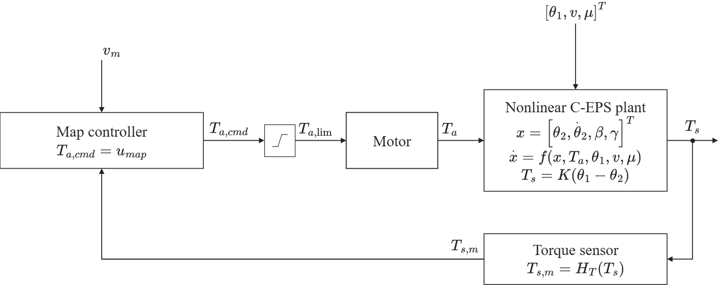
Fig. 4. Closed-loop signal flow of the assist-map controller. The measured vehicle speed is $v_{m}=H_{v}\left(v\right)$, with $H_{v}$ the speed-sensor model. The controller block contains the assist map $M$ of Eq. (25) followed by the lead–lag compensator of Eqs. (26)–(27), and its output $u_{map}$ is the command $T_{a,cmd}$. This command passes through the assist limit, which bounds it by $T_{a,max}\left(v_{m}\right)$, and the limited command $T_{a,lim}$ drives the motor.

3.2. Steady-State Limitation of Assist-Map Control
A map calibrated on a dry road is unlikely to stay exact on a slippery one, and a brief steady-state calculation reveals how large the error becomes. With the column at rest, the Coulomb friction term is zero and the compensator leaves the map output as it is, so at a given speed and lateral acceleration Map satisfies
$$\begin{aligned}T_{s}+M\left(v,T_{s}\right)=T_{r}\left(v,a_{y},μ\right)\#\left(28\right)\end{aligned}$$
Suppose that the road reaction shifts by $ΔT_{r}$ while speed and lateral acceleration are unchanged. Linearizing Eq. (28) gives
$$\begin{aligned}ΔT_{s}=\frac{ΔT_{r}}{1+s_{m}}\#\left(29\right)\end{aligned}$$
$$\begin{aligned}s_{m}=\frac{∂M\left(v,T_{s}\right)}{∂T_{s}}\#\left(30\right)\end{aligned}$$
where $s_{m}$ is the slope of the map at the operating point. The driver feels only $1/\left(1+s_{m}\right)$ of $ΔT_{r}$, and the map has compensated the remaining $s_{m}/\left(1+s_{m}\right)$. Because the target depends only on speed and lateral acceleration, the tracking error moves by the same amount as the sensed torque:
$$\begin{aligned}Δe_{T}=\frac{ΔT_{r}}{1+s_{m}}\#\left(31\right)\end{aligned}$$
When friction drops from its dry value, the tire force saturates earlier and the pneumatic trail shortens, so the road reaction decreases and $ΔT_{r}$ is negative. Since $s_{m}$ cannot exceed $K_{max}$, $|Δe_{T}|$ is never smaller than $|ΔT_{r}|/\left(1+K_{max}\right)$ and $Δe_{T}$ has the sign of $ΔT_{r}$, so the torque falls below its dry-road value and the assist is too high for the road. A larger $K_{max}$ would shrink the error, but a steeper slope also raises the loop gain, which amplifies sensor noise and makes the loop harder to keep stable. The slope limit also costs accuracy on the dry road, since wherever the calibration data ask for a slope above $K_{max}$, the table is flattened and supplies less assist than Eq. (24) requires.

3.3. PID Steering-Torque Feedback Control
The PID controller drops the map and works on the torque error alone. Its starting point is the textbook law of Åström and Hägglund [14], which computes the control signal from the error $e=y_{sp}-y$, the difference between the setpoint and the measured output:
$$\begin{aligned}u\left(t\right)=K_{p} e\left(t\right)+K_{i}∫_{0}^{t}e\left(τ\right) dτ+K_{d} \frac{de\left(t\right)}{dt}=K_{p}\left[e\left(t\right)+\frac{1}{T_{i}}∫_{0}^{t}e\left(τ\right) dτ+T_{d} \frac{de\left(t\right)}{dt}\right]\#\left(32\right)\end{aligned}$$
where $K_{p}$ is the proportional gain, and $T_{i}$ and $T_{d}$ are the integral and derivative times. The right-hand expression is the standard form of [14], known as the ISA or ideal algorithm, and the left-hand one is its parallel version, in which $K_{i}=K_{p}/T_{i}$ and $K_{d}=K_{p}T_{d}$ [14, Eqs. (3.9), (3.18)]. The former is adopted, because the rules of [14] for the derivative filter and the tracking time are written in $T_{i}$ and $T_{d}$ and because its complex zeros, which the series (interacting) structure lacks, are useful for processes with oscillatory poles such as this column [14, p. 73]. The proportional term reacts to the present error, the integral term removes the steady-state error, and the derivative term anticipates the trend of the error and adds damping [14, Sec. 3.3].
The law is seldom used as it stands, because modified versions perform much better [14, Sec. 3.4]. The controller of this paper therefore departs from it in three ways, all of them modifications described in [14].
First, the derivative acts on the measured torque $T_{s,m}$ and not on the error $e_{T}=T_{s,m}-T_{ref}\left(v_{m},a_{y,m}\right)$, which is Eq. (18) written with measured signals and has the sign opposite to the error $e$ of [14], because more assist lowers $T_{s}$. Since ${\dot{e}}_{T}={\dot{T}}_{s,m}-{\dot{T}}_{ref}$, this leaves out the derivative of the target. This is the setpoint weighting of [14], in which the derivative is applied to $c y_{sp}-y$ with a factor $c$ on the setpoint, and the usual choice $c=0$ avoids large transients in the control signal when the setpoint jumps [14, Eqs. (3.19)–(3.21)]. The proportional term keeps the full error because the loop has to follow the target, the integral term has to see the true error to avoid a steady-state error, and [14] calls this arrangement PI-D.
The case for $c=0$ is stronger in this loop than in [14], because the setpoint is the target torque, which is computed from the measured speed and lateral acceleration and not entered by an operator. The target moves quickly whenever a turn begins or ends, and it carries the noise and quantization steps of two more sensors, those of speed and lateral acceleration. A derivative taken of the error would convert both into spikes in the assist torque, and these would not add damping. The derivative term exists to suppress the oscillation of the column, which shows in $T_{s,m}$, while $T_{ref}$ varies with the steering input and the slower motion of the vehicle body. Leaving $T_{ref}$ out should not weaken the loop, because [14] notes that, for a setpoint independent of the loop, the factor on the setpoint alters only the behavior for setpoint changes and does not affect the rejection of load disturbances and measurement noise, and $T_{ref}$ depends on the loop only weakly, through the small twist of the torsion bar. A drop in friction reaches the column as such a load disturbance, through the road reaction. While the steering is held steady, $T_{ref}$ is nearly steady, so the derivative of $T_{s,m}$ provides almost the same damping as the derivative of the error. In the controller, $T_{s,m}$ goes straight into the derivative term, and only the proportional and integral terms receive $e_{T}$.
Second, the derivative uses a first-order state with time constant $τ_{f}=T_{d}/N$, so a measured-torque step $ΔT_{s,m}$ produces an initial change $NK_{p}ΔT_{s,m}$ in $u_{D}$ [14, Eq. (3.22)]. This finite response is needed because an ideal derivative would turn a jump in the noisy measurement into an impulse [14]. The ratio $N$ sets how much of this noise reaches the motor, and [14] gives 8 to 20 as typical values.
The three terms of the controller then read
$$\begin{aligned}u_{P}=K_{p} e_{T}\#\left(33\right)\end{aligned}$$
$$\begin{aligned}u_{I}=∫_{0}^{t}\left(K_{i} e_{T}+K_{aw} ΔT_{a}\right) dτ\#\left(34\right)\end{aligned}$$
$$\begin{aligned}u_{D}=K_{d} {\dot{T}}_{f}, τ_{f} {\dot{T}}_{f}+T_{f}=T_{s,m}\#\left(35\right)\end{aligned}$$
where $T_{f}$ is the measured torque after this lag, $K_{aw}$ is the anti-windup gain and $ΔT_{a}$ the anti-windup signal, both defined below. Their sum is the unconstrained command:
$$\begin{aligned}T_{a,cmd}=u_{P}+u_{I}+u_{D}\#\left(36\right)\end{aligned}$$
The four parameters to be tuned are $K_{p}$, $T_{i}$, $T_{d}$ and $N$, and $K_{i}$, $K_{d}$ and $τ_{f}$ are derived from them as above.
Third, the integrator is protected against windup, because the motor cannot follow the command beyond the assist limit of Eq. (19). The remedy is back-calculation [14, Sec. 3.5], which feeds the gap between the limited command $T_{a,lim}$ of Eq. (42) and the unlimited command $T_{a,cmd}$ back to the integrator through Eq. (34):
$$\begin{aligned}ΔT_{a}=T_{a,lim}-T_{a,cmd}\#\left(37\right)\end{aligned}$$
The feedback rate $K_{aw}$ is the reciprocal of a tracking time $T_{t}$, which [14, p. 85] recommends choosing larger than $T_{d}$ and smaller than $T_{i}$, with $T_{t}=\sqrt{T_{i}T_{d}}$ as a rule of thumb that meets this advice when $T_{d}<T_{i}$, a condition imposed in Section 4.3, so that
$$\begin{aligned}K_{aw}=\frac{1}{T_{t}}=\frac{1}{\sqrt{T_{i}T_{d}}}=\sqrt{\frac{K_{i}}{K_{d}}}\#\left(38\right)\end{aligned}$$
The same choice is used for PID and for MapPID. With it, the integrator is discharged whenever the command reaches the assist limit $T_{a,max}\left(v_{m}\right)$. Figure 5 shows the PID loop.
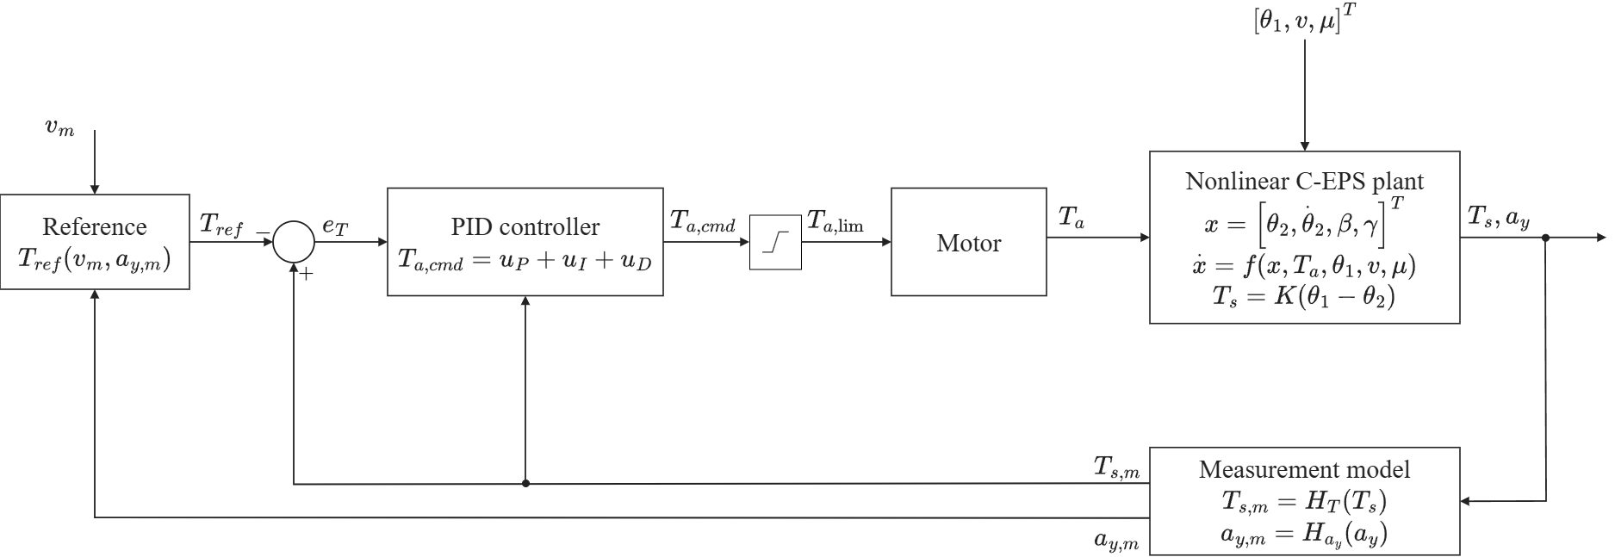
Fig. 5. Closed-loop signal flow of the PID steering-torque controller. The block contains the proportional, integral and derivative terms. Its command $T_{a,cmd}$ passes through the assist limit, and the limited command $T_{a,lim}$ drives the motor. The proportional and integral terms act on the error $e_{T}=T_{s,m}-T_{ref}$, while the derivative term acts on the measured torque $T_{s,m}$ only. The measured vehicle speed is $v_{m}=H_{v}\left(v\right)$.

3.4. Plug-In MapPID Control Structure
MapPID rests on a simple idea, which is to leave Map exactly as it is and let a PID branch work beside it. The assist map and the lead–lag compensator of Section 3.1 remain as calibrated, including $K_{max}$, $T_{s0}$ and the compensator time constants, and the PID branch of Section 3.3 is added in parallel (Fig. 6). Only the four branch parameters are tuned while the map is frozen, so the branch can be attached to an existing calibration without touching the map that holds the dry-road steering feel. The command before the assist limit is the sum of the two outputs:
$$\begin{aligned}T_{a,cmd}=u_{map}+u_{PID}\#\left(39\right)\end{aligned}$$
$$\begin{aligned}u_{PID}=u_{P}+u_{I}+u_{D}\#\left(40\right)\end{aligned}$$
where $u_{map}$ comes from Eqs. (26)–(27) and $u_{PID}$ from Eqs. (33)–(35).
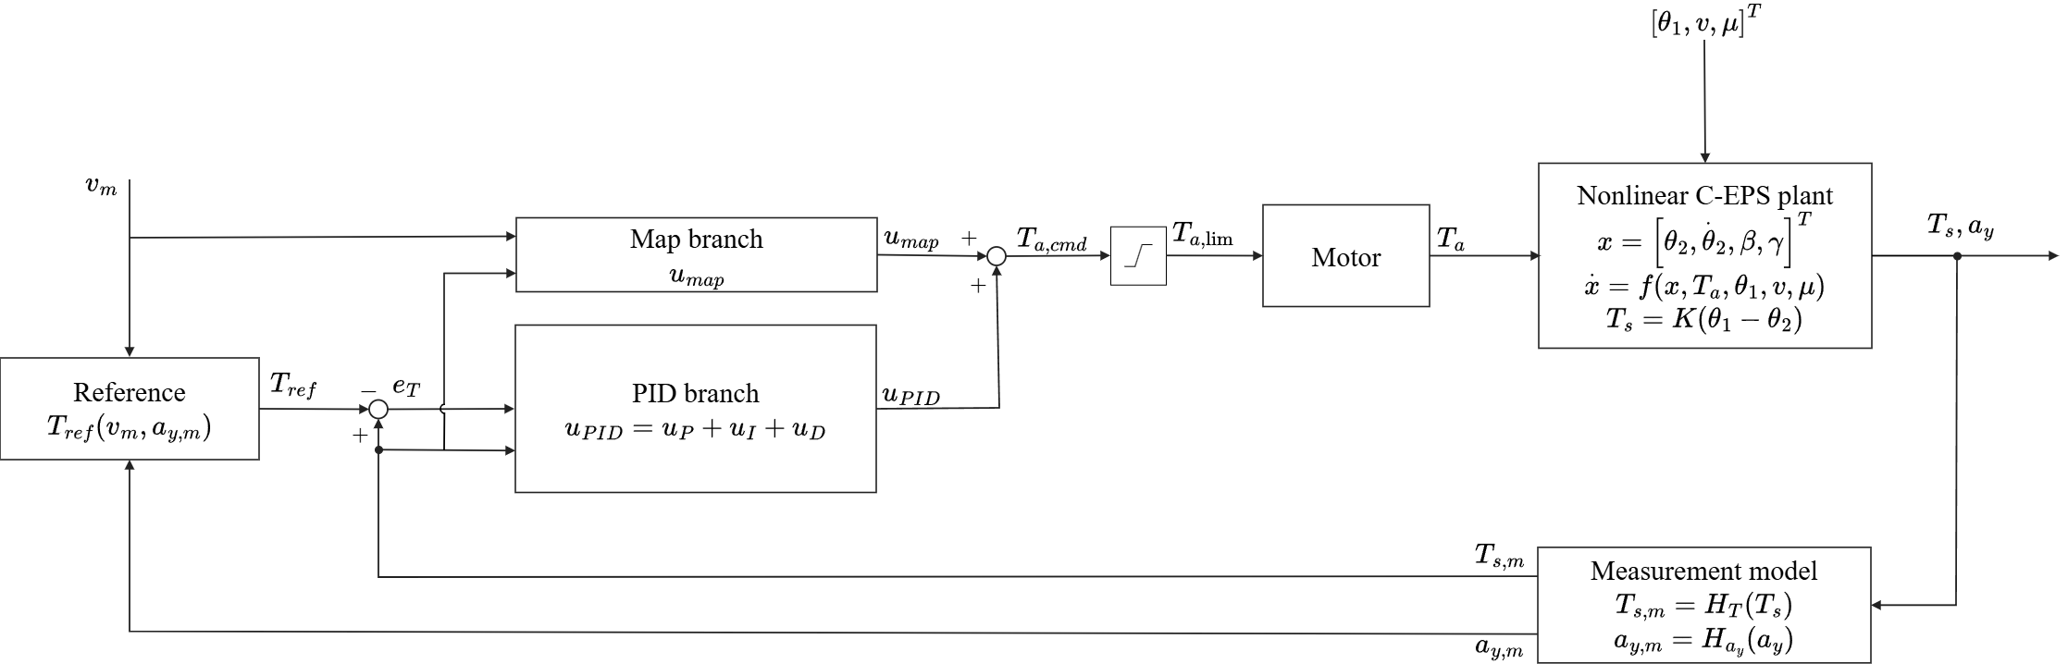
Fig. 6. Closed-loop signal flow of the plug-in MapPID controller. The command $T_{a,cmd}$ is the sum of the output $u_{map}$ of the assist map and lead–lag compensator of Fig. 4, which are kept unchanged, and the output $u_{PID}$ of the PID branch of Fig. 5, and the sum passes through one assist limit. The derivative term acts on $T_{s,m}$ as explained in Section 3.3. The measured vehicle speed is $v_{m}=H_{v}\left(v\right)$.
The steady state of the branch is derived from Eq. (28). With the branch present, the column equilibrium becomes $T_{s}+M\left(v,T_{s}\right)+u_{PID}=T_{r}\left(v,a_{y},μ\right)$. If the loop is stable and the motor is not saturated, the integrator can rest only at $e_{T}=0$, so $T_{s}=T_{ref}$ and the branch settles at
$$\begin{aligned}u_{PID,ss}=T_{r}\left(v,a_{y},μ\right)-T_{ref}\left(v,a_{y}\right)-M\left(v,T_{ref}\right)\#\left(41\right)\end{aligned}$$
Two properties follow from Eq. (41). The first is that the steady-state accuracy no longer depends on the map, since the integrator ends at $e_{T}=0$ whatever the slope or calibration of the map. The second is that the branch supplies only what the map leaves undone. Where the map reaches its dry-road calibration, Eq. (24) gives $M\left(v,T_{ref}\right)=T_{r}\left(v,a_{y},0.8\right)-T_{ref}$, so $u_{PID,ss}=T_{r}\left(v,a_{y},μ\right)-T_{r}\left(v,a_{y},0.8\right)$, which is zero on a dry road and, when friction falls, is negative with a magnitude equal to the drop in road reaction, so that the branch removes that much assist. Where the slope limit stops the map short of the calibrated assist, $u_{PID,ss}$ also absorbs that residual. The map thus remains responsible for the dry-road assist, and the branch deals with varying friction, tire saturation and the slope-limited calibration.
The map is not neutral for the dynamics of the branch. For small deviations around the operating point, the map multiplies the measured torque by its slope $s_{m}$ ahead of the compensator, and the PID branch runs beside it, so the forward path from the measured torque to the assist torque is the sum of the two contributions. The map supplies part of the assist during slow steering changes, which can reduce the proportional correction needed from the branch, but it also strengthens the reaction to column oscillations and can destabilize the loop. The branch's closed-loop response therefore depends on the map beneath it, so the branch is tuned for each vehicle on the loop as a whole, with the map and compensator frozen and the plant model matched to that vehicle. The assist limit is common to all three controllers and acts on the command $T_{a,cmd}$, which is $u_{map}$ in Map and follows Eq. (36) in PID and Eq. (39) in MapPID:
$$\begin{aligned}T_{a,lim}=clip\left(T_{a,cmd},-T_{a,max}\left(v_{m}\right),T_{a,max}\left(v_{m}\right)\right)\#\left(42\right)\end{aligned}$$
In application, the Map of this study stands for the assist map and compensator already installed on the vehicle. That pair is taken as given, the plant is adjusted to the vehicle, and the four PID parameters are searched on top of it, once for each vehicle. The reference has to reproduce the dry-road steady-state steering torque of the vehicle's own map, as Eq. (23) does for the map of this study, so that the added branch preserves the intended dry-road steering feel.

4. Controller Parameter Selection

4.1. Simulation Setup
The three controllers ran in MATLAB/Simulink against the nonlinear plant of Section 2, with a control period of 1 ms. Every command went through the assist limit of Eq. (42) before it reached the motor, which behaves as a first-order lag [1]:
$$\begin{aligned}τ_{m}{\dot{T}}_{a}+T_{a}=T_{a,lim}\#\left(43\right)\end{aligned}$$
where $τ_{m}=1.59155$ ms is the motor time constant. The nominal actuator had unit gain and no extra computational delay. At each step the integral term advanced by forward Euler, the derivative term came from the backward difference of the measured torque passed through the filter of Eq. (35), and the lead–lag compensator was discretized with the Tustin method.
Independent zero-mean white noise was added to the torsion-bar torque, the vehicle speed and the lateral acceleration, and the noisy values were then quantized. Each sensor held its output between samples, with the timing given in Table 2.
Table 2. Sensor settings in the simulations.
Quantity | Quantization step | Noise standard deviation | Update period
Torsion-bar torque $T_{s}$ | 0.01 N·m | 0.01 N·m | 1 ms
Vehicle speed $v$ | 1 km/h | 0.38 km/h | 10 ms
Lateral acceleration $a_{y}$ | 0.01 g | 0.01 g | 10 ms

The torque and acceleration noise levels were modeling choices, each set equal to one quantization step. The 10 ms interval of the two vehicle signals was an assumption, kept unchanged across the comparison.
The feedback paths used the measurements, but performance was scored on the true model quantities on a 1 ms grid. For that calculation, $T_{ref}$ was evaluated from uncorrupted speed and lateral acceleration. Sensor noise therefore affected the results only through the changes it caused in the steering effort and the applied assist torque.

4.2. Calibration Case and Performance Measures
Parameters were tuned on a 140 s calibration sequence called CALIB, which consists of nine speed blocks from 20 to 100 km/h in steps of 10 km/h. The steering-wheel angle came from a dry-road equilibrium table at nominal levels of lateral acceleration. The plant then produced its own lateral acceleration, and this value reached the torque reference of the controller through the sensor model. Table 3 lists the 68 evaluation windows.
Table 3. CALIB scoring intervals. Acceleration levels specify the prescribed angle, and speeds identify the start of each block.
Excitation | Nominal condition | Number of windows | Duration per window | Group
Staircase, held portion | 0.10 and 0.18 g at 20 km/h, then 0.10, 0.20 and 0.30 g at 30–100 km/h | 26 | 1 s | static
Staircase, entry portion | First 2 s of each level | 26 | 2 s | dyn
Continuous steering | Blocks from 40 km/h: period 2 s at 0.30 g, then period 1 s at 0.15 g | 14 | 2 s for period 2 s, 3 s for period 1 s | dyn
Friction change | 60 km/h, angle corresponding to 0.30 g, $μ=0.8→0.35→0.8$ | 2 | 2 s after each change | mu

Each staircase level opened with a 1 s ramp and a 2 s hold, with the final second of the hold assigned to the static group. That interval is the evaluation window, even when a slow candidate is still settling in it. From the 40 km/h block onwards, every staircase was followed by 1.25 cycles with a 2 s period and 3.5 cycles with a 1 s period. The first segment started at its peak, so that it joined the preceding hold without a jump. Speed rose by 10 km/h during these 6 s, except after the 100 km/h staircase. The scoring used one cycle of the 2 s input and the last three cycles of the 1 s input. Below 40 km/h, the larger angles that this input needs would load the column inertia more heavily, so the sinusoids were left out there. The two lower-speed blocks instead had a 3 s transition in which the steering-wheel angle went to zero.
The 60 km/h hold contained a further 10 s at the angle for 0.30 g, which served the friction test. In that interval, the friction coefficient dropped from 0.8 to 0.35 for 6 s and then returned to 0.8 for 4 s. The whole sequence began and ended with 2 s of straight-ahead driving.
The dyn group combines the staircase entries and the sinusoidal responses. For a group $g$, the samples of all its windows were pooled, and the root-mean-square (RMS) error was divided by the mean target magnitude:
$$\begin{aligned}R_{g}=100\frac{{RMS}_{g}\left(e_{T}\right)}{{mean}_{g}\left(|T_{ref}|\right)}\#\left(44\right)\end{aligned}$$
The tracking error $e_{T}$ follows Eq. (18), evaluated with the true plant signals as explained in Section 4.1. The overall measure weights the three groups equally, whatever their lengths:
$$\begin{aligned}R=\left[∏_{g∈\{static,dyn,mu}\right] max\left(R_{g},1\right)1/3\#\left(45\right)\end{aligned}$$
Both quantities are percentages, so the floor of 1 corresponds to 1%. Once the error of a group drops below 1%, a further reduction no longer changes $R$.
Assist-torque noise was judged from the applied torque $T_{a}$ after the motor dynamics. A first-order smoother with time constant $τ_{S}=31.8310$ ms removed the slow part of the signal through the recurrence
$$\begin{aligned}T_{a,LP}[k]=\left(1-α\right)T_{a,LP}[k-1]+αT_{a}[k], α=\frac{Δt}{τ_{S}+Δt}\#\left(46\right)\end{aligned}$$
where $Δt=0.001$ s and the filter state started at zero. $S$ is the RMS of the remaining residual over the whole sequence after the first 2 s:
$$\begin{aligned}S={RMS}_{2 s≤t_{k}≤140 s}\left(T_{a}[k]-T_{a,LP}[k]\right), t_{k}=kΔt\#\left(47\right)\end{aligned}$$
This residual contains the fluctuations caused by the sensors as well as the response to rapid steering. The 26 static windows, collected in the set $W$, also gave the largest relative mean error:
$$\begin{aligned}e_{rel}=100\max_{w∈W}\frac{|{mean}_{w}\left(e_{T}\right)|}{{mean}_{w}\left(|T_{ref}|\right)}\#\left(48\right)\end{aligned}$$
Each candidate was run with the five common noise seeds 99990–99994, and its scores are the arithmetic means of $R$ and $S$:
$$\begin{aligned}\overline{R}=\frac{1}{5}∑_{q=1}^{5}R_{q}, \overline{S}=\frac{1}{5}∑_{q=1}^{5}S_{q}\#\left(49\right)\end{aligned}$$
The accuracy check used the worst case over the same five realizations:
$$\begin{aligned}e_{rel,max}=\max_{q=1,…,5}e_{rel,q}\#\left(50\right)\end{aligned}$$
Two supplementary diagnostics were also kept, namely the total variation of $T_{a}$ per second and the fraction of time with reverse assist. The latter is the share of the samples recorded between 2 and 140 s that have $|T_{s}|≥0.5$ N·m and $T_{a}T_{s}<0$.

4.3. Design Constraints and Acceptance Criteria
PID and MapPID were restricted to $T_{d}<T_{i}$, which keeps the tracking time $\sqrt{T_{i}T_{d}}$ of the anti-windup between the two constants [14]. Another condition governed how much the filters could slow the response: for a sinusoidal input with a period of 0.5 s, the lag stage of Map and the derivative filter of PID had to pass at least $1/\sqrt{2}$ of the input amplitude once settled. MapPID had to meet both conditions, so the filter of its added branch was limited to $τ_{f}≤79.6$ ms.
Before nonlinear simulation, the candidates were screened on 68 linearized plants that cover 17 speeds from 20 to 100 km/h in steps of 5 km/h. At each speed the operating points were $a_{y}=0.001$ and 0.30 g at $μ=0.8$, and $a_{y}=0.001$ and 0.15 g at $μ=0.2$. Each loop included the motor response of Eq. (43) and a delay of 1 ms. This delay was an allowance for implementation in the linear analysis only, and the nominal nonlinear runs followed the setting of Section 4.1. MapPID was examined at map slopes of 0, 0.25, 0.50, 0.75 and 1 times $K_{max}$, where zero stands for the dead zone in which only the PID branch acts. The synthesis of Map used the four nonzero values and a stricter version of the same pre-screen.
At the common-seed selection stage, nonlinear acceptance was checked by repeating CALIB under two actuator perturbations. The first doubled the gain with no extra delay, and the second inserted a delay of 1 ms at unit gain. Both ran at seed 99990 and were compared with the nominal response. The three $R$ scores had to be finite and positive, and the ratios of perturbed to nominal $R$ had to satisfy
$$\begin{aligned}ρ_{gain}=\frac{R_{gain}}{R_{nom}}≤2, ρ_{delay}=\frac{R_{delay}}{R_{nom}}≤2\#\left(51\right)\end{aligned}$$
These tests assess only the simulated CALIB response in the stated cases. The accuracy requirement was $e_{rel,max}≤10\%$, applied to the static-window measure of Eq. (50).

4.4. Parameter Search and Final Selection
Table 4 gives the search bounds. Map had two outer variables, the slope limit $K_{max}$ and a minimum amplitude ratio $g_{min}$ for the settled response of its lag stage to a sinusoid with a period of 0.5 s. The lag stage was left out at $g_{min}=1$. For every pair of these two values, an inner grid minimized the initial jump of the command after a unit step in the measured torque at slope $K_{max}$, subject to the synthesis constraints. Ties were ranked by the linear pre-screen.
Table 4. Parameter bounds for the outer search. All coordinates were logarithmic.
Controller | Variable | Lower bound | Upper bound
Map | $K_{max}$ | 1 | 30
Map | $g_{min}$ | $1/\sqrt{2}$ | 1
PID and MapPID | $K_{p}$ | 0.01 | 30
PID and MapPID | $T_{i}$ (s) | 0.002 | 10
PID and MapPID | $T_{d}$ (s) | 0.020 | 0.796
PID and MapPID | $N$ | 8 | 20

The coarse grid for the first stage of Eq. (26) covered $τ_{1,in}$ from 2 to 200 ms and the ratio $τ_{1,in}/τ_{1,out}$ from 1.2 to 300. For the second stage of Eq. (27), $τ_{2,in}$ ranged from 8.33333 to 125 ms and $τ_{2,in}/τ_{2,out}$ from 0.1 to 0.9. The local refinement was allowed to widen these intervals, within $τ_{1,out}≥0.318310$ ms and $τ_{2,out}≤333.333$ ms.
MapPID kept the selected map and compensator fixed and varied only its four PID parameters. PID used the same bounds, and $K_{i}$, $K_{d}$ and $τ_{f}$ followed from the standard-form relations of Section 3. The interval for $N$ comes from [14], and the lower bound $T_{d}=20$ ms keeps $τ_{f}=T_{d}/N$ at or above one control period everywhere in the box. The other limits define the finite region considered in the comparison.
Each coordinate was mapped to $[0,1]$ before the coarse-to-fine search. The coarse grid had 13 levels on each Map axis (169 pairs) and four levels per variable for the PID structures (256 combinations each). The local noise seeds were 00000 for Map, 10000 for PID and 30000 for MapPID. For PID and MapPID, the refinement was centered on the design with the smallest $RS$ among those passing the structural, linear and local accuracy checks. The fine grid placed three values on each axis, with initial steps of $1/24$ for Map and $1/6$ for the PID structures. It moved with every improvement and halved its spacing whenever the best point stayed unchanged. The search ended after six refinement layers or when the step fell below 0.02.
The common-seed pool held all locally simulated designs that passed the linear screen, including those that missed the 10% accuracy threshold. A point is Pareto-optimal within a set if no other member lowers one of $R$ and $S$ without raising the other. In phase 1, the front found at the local seed was evaluated on the five common seeds of Section 4.2. For each controller, $σ_{R}$ and $σ_{S}$ were the median coefficients of variation over these front points, each coefficient being the standard deviation divided by the mean across the five realizations. Phase 2 admitted further points unless some phase-1 point $f$ satisfied both inequalities for the candidate $p$:
$$\begin{aligned}R_{0,f}\left(1+3σ_{R}\right)≤R_{0,p}, S_{0,f}\left(1+3σ_{S}\right)≤S_{0,p}\#\left(52\right)\end{aligned}$$
The subscript 0 marks the scores at the local seed, and the three-sigma margin allows for the scatter between noise seeds. All phase-1 points entered the evaluation set.
Two fronts were built from the common-seed results. The safe front left out the accuracy condition, and the full front also required $e_{rel,max}≤10\%$. The nondominated points were then stress-tested, and failing points were removed and the fronts recomputed until every remaining point had passed. The final selection took the full front, with safe as a fallback when full was empty. The balance criterion was
$$\begin{aligned}J=\overline{R} \overline{S}\#\left(53\right)\end{aligned}$$
Points within 3% of the smallest $J$ on the chosen front were treated as tied, and the final choice among them followed the ranking of the linear pre-screen. All three structures shared this rule, and the selected designs were fixed for the independent evaluation.

4.5. Calibration Results and Selected Parameters
Table 5 summarizes the candidate pool and the two final fronts. The accuracy column counts the passing points before stress rejection, so its entries need not lie on the full front.
Table 5. Search candidates and final Pareto fronts. All points on the reported fronts passed the nonlinear acceptance tests.
Controller | Locally simulated | Common-seed set | Accuracy passes in set | safe front | full front
Map | 149 | 80 | 17 | 58 | 0
PID | 184 | 134 | 99 | 44 | 31
MapPID | 225 | 187 | 142 | 33 | 22

For Map, all 17 points that met the 10% requirement failed the nonlinear acceptance check, so the full front stayed empty. The Map design therefore came from the safe front.
Fig. 7 plots both fronts of each controller. The full fronts of PID and MapPID also differed at comparable tracking targets. With $\overline{R}$ limited to 3%, the lowest $\overline{S}$ was 0.8713 N·m for PID and 0.7486 N·m for MapPID. At $\overline{R}≤6\%$, the values were 0.6685 and 0.6059 N·m. PID, however, offered quieter full designs at larger tracking errors, so the advantage of either controller depended on the part of the front considered.
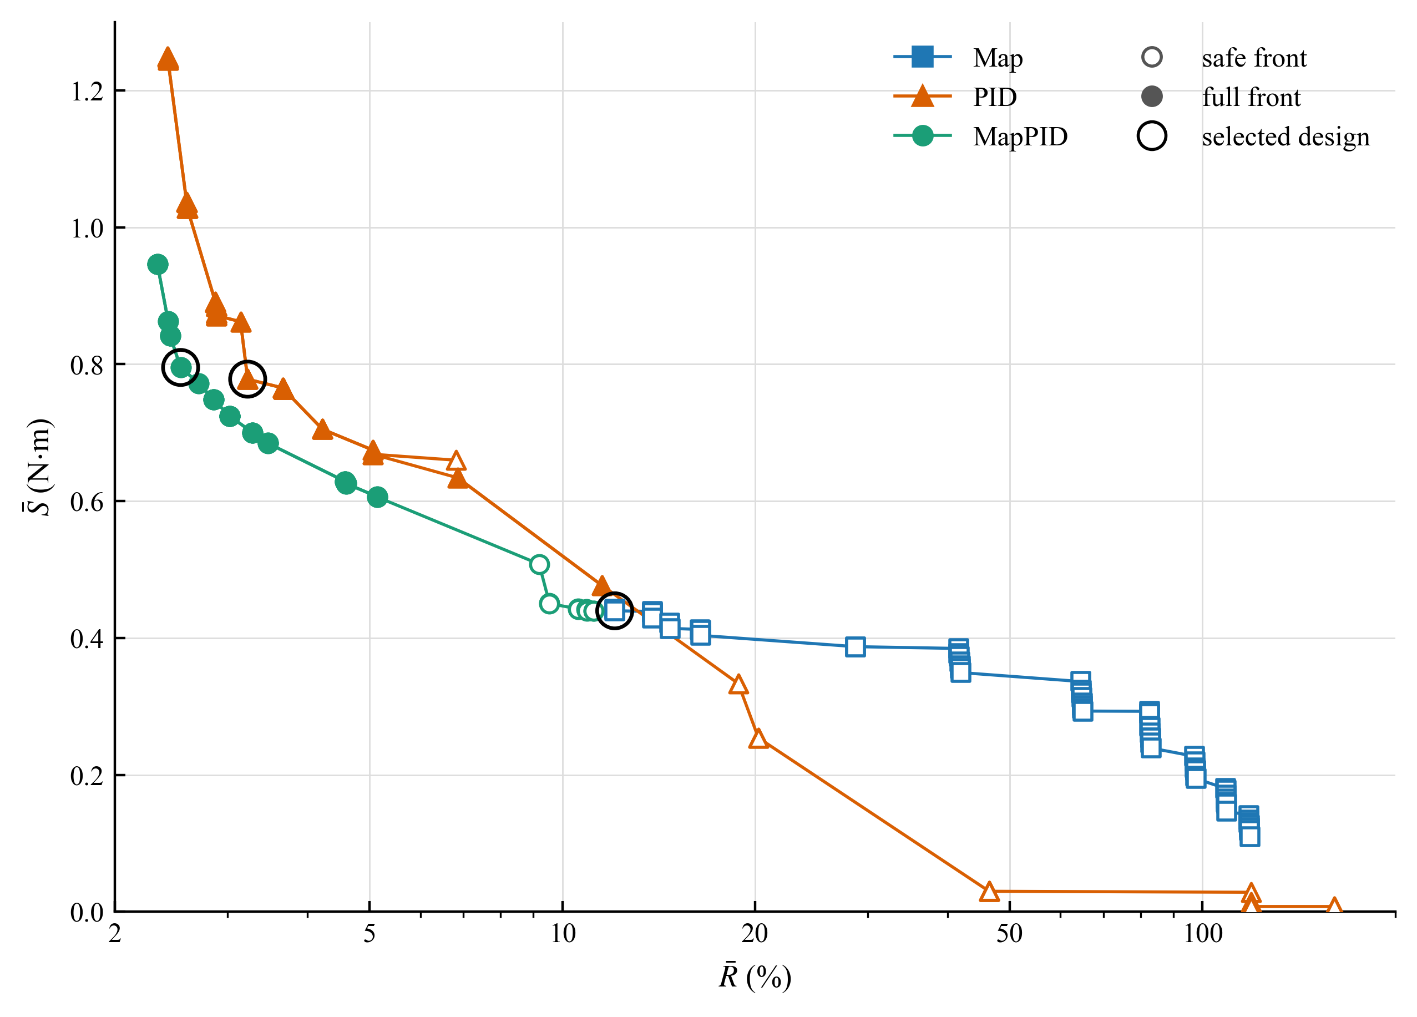
Fig. 7. Pareto fronts of Map, PID and MapPID on the common-seed evaluation set. Filled markers lie on the full front and open markers on the safe front only. Circles mark the designs selected with Eq. (53), and the horizontal axis is logarithmic.
Table 6 lists the settings chosen with Eq. (53) and its tie rule. The identical map columns show which parameters stayed frozen while the parallel branch was tuned, and $K_{aw}$ follows Eq. (38) for both PID structures.
Table 6. Selected controller parameters. A dash means not applicable.
Parameter | Map | PID | MapPID
$K_{max}$ | 6.77455 | - | 6.77455
$T_{s0}$ (N·m) | 0.300 | - | 0.300
$τ_{1,in}$ (ms) | 29.8499 | - | 29.8499
$τ_{1,out}$ (ms) | 1.48530 | - | 1.48530
$τ_{2,in}$ (ms) | 35.5523 | - | 35.5523
$τ_{2,out}$ (ms) | 93.5587 | - | 93.5587
$K_{p}$ | - | 2.90376 | 2.08008
$T_{i}$ (ms) | - | 34.1995 | 23.9826
$T_{d}$ (ms) | - | 23.3180 | 23.3180
$N$ | - | 19.2508 | 14.1841
$K_{i}$ ($s^{-1}$) | - | 84.9065 | 86.7330
$K_{d}$ (s) | - | 0.0677100 | 0.0485034
$τ_{f}$ (ms) | - | 1.21127 | 1.64395
$K_{aw}$ ($s^{-1}$) | - | 35.4115 | 42.2869

Both derivative times, about 23.3 ms, lie close to the lower search bound of 20 ms. The reported choice is therefore conditional on this range, and Table 7 gives the matching CALIB scores.
Table 7. Performance of the selected designs on CALIB. Means and maximum bias use five seeds, and the perturbation ratios use seed 99990.
Quantity | Map | PID | MapPID
$\overline{R}$ (%) | 12.0719 | 3.2241 | 2.5330
$\overline{S}$ (N·m) | 0.4397 | 0.7782 | 0.7953
$J$ (%·N·m) | 5.3085 | 2.5089 | 2.0145
$e_{rel,max}$ (%) | 26.2366 | 2.0861 | 1.8056
$ρ_{gain}$ | 1.931 | 0.698 | 0.810
$ρ_{delay}$ | 1.000 | 1.029 | 1.028
Front used for selection | safe | full | full

Compared with Map, MapPID cut $\overline{R}$ by about 79%, while the fast component of the applied assist torque grew. Map had the smallest $\overline{S}$, but its largest static-window error reached 26.2%. The added feedback brought this error below the 10% requirement without changing the calibrated map. Against PID, the selected MapPID point lowered $J$ by about 19.7% and raised $\overline{S}$ by 2.2%. The shared rule thus settled on a different balance of error and noise for each structure. These are calibration results for one simulated vehicle, and the fixed parameter sets form the basis of the tests in Section 5.

5. Evaluation Results

5.1. Evaluation Protocol
With the parameters of Table 6 held fixed, the controllers were tested on three 100 s sequences named STEADY, SLIP and WEAVE. All controllers ran with the same nonlinear vehicle model, assist limits, sensor settings and prescribed steering-wheel angle. Five noise seeds, 99995–99999, were common to all structures and separate from the CALIB seeds of Section 4. Reported statistics are arithmetic means and sample standard deviations across those runs, which represent noise realizations for one vehicle.
Table 8. Evaluation sequences. Acceleration levels specify the nominal dry-road condition used to generate the steering-wheel angle.
Sequence | Prescribed conditions | Scored windows
STEADY | Dry road, 25, 45, 65 and 85 km/h, nominal lateral acceleration from 0.15 to 0.38 g in magnitude | 11
SLIP | Speed decrease and increase in a turn, stepped adhesion reduction, and a 2 s water patch | 12
WEAVE | Steering near center, paired lane changes, successively shorter steering periods, and continuous steering at low adhesion | 8

Their timing and their combinations of speed, steering level and adhesion differ from those in CALIB. The nominal acceleration defines the angle input, while the plant determines the actual $a_{y}$ and hence $T_{ref}$. A friction drop can therefore change both the road reaction and the reference. Performance was evaluated from true model signals on the 1 ms grid, although each controller received noisy, quantized measurements.
Whole-sequence tracking was assessed after the initial 2 s by
$$\begin{aligned}E_{RMS}=\sqrt{\frac{1}{|I|}∑_{k∈I}e_{T}[k]^{2}}, I=\{k:2 s≤t_{k}≤100 s\}\#\left(54\right)\end{aligned}$$
where $e_{T}$ follows Eq. (18) and $|I|$ is the number of scored samples. Unlike the CALIB aggregate $R$ of Eq. (45), this measure is not normalized and is expressed in N·m. The assist-torque residual $S$ kept the smoother of Eq. (46) but was computed over the interval of Eq. (54). This residual contains both sensor-induced fluctuations and the response to rapid steering, so a lower value alone does not imply better tracking or subjective steering comfort.
For a window $w$ in which the target has a nonzero mean and keeps its direction, the signed relative bias was
$$\begin{aligned}ε_{w}=100 sgn\left({mean}_{w}T_{ref}\right)\frac{{mean}_{w}\left(e_{T}\right)}{{mean}_{w}\left(|T_{ref}|\right)}\#\left(55\right)\end{aligned}$$
A positive value means more torsion-bar torque than requested, and a negative value means lighter effort. Reversing inputs were assessed primarily by RMS error within their windows, since signed averaging can conceal deviations of opposite sign.

5.2. Steady Steering on a Dry Road
STEADY held the friction coefficient at $μ=0.8$ and applied eleven steering levels at the four speeds in Table 8. Each level comprised a 1 s entry ramp, a 4 s hold, a 1 s return and 1 s of straight-ahead driving. The last second of each hold formed its scoring window. The largest nominal accelerations were 0.35 g at 45 and 65 km/h and 0.38 g at 85 km/h.
Table 9 gives the whole-sequence results, and Figs. 8 and 9 show the torsion-bar torque of Map and MapPID against the target. The time plots in Figs. 8–13 leave out PID, because it overlaps MapPID at their scale. The whole-sequence $E_{RMS}$ of the two differs by 0.0002 N·m in STEADY and by at most 0.022 N·m in the other sequences, which is hard to resolve on axes that span 8 to 21 N·m. PID therefore enters through the tables, and its difference from MapPID is examined over the five seeds in Section 5.5.
Table 9. Whole-sequence $E_{RMS}$ and $S$ in STEADY over 2–100 s. Entries are the mean ± sample standard deviation across five noise seeds.
Controller | $E_{RMS}$ (N·m) | $S$ (N·m)
Map | 1.0585 ± 0.0007 | 0.1982 ± 0.0009
PID | 0.2496 ± 0.0039 | 0.5649 ± 0.0044
MapPID | 0.2498 ± 0.0049 | 0.5146 ± 0.0065

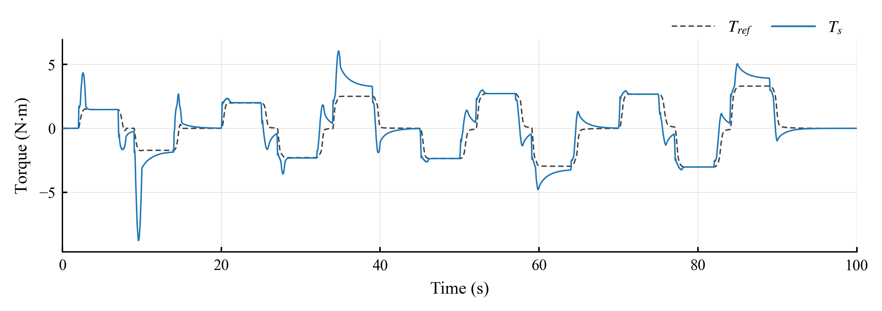
Fig. 8. Torsion-bar torque $T_{s}$ and target $T_{ref}$ of Map in STEADY.
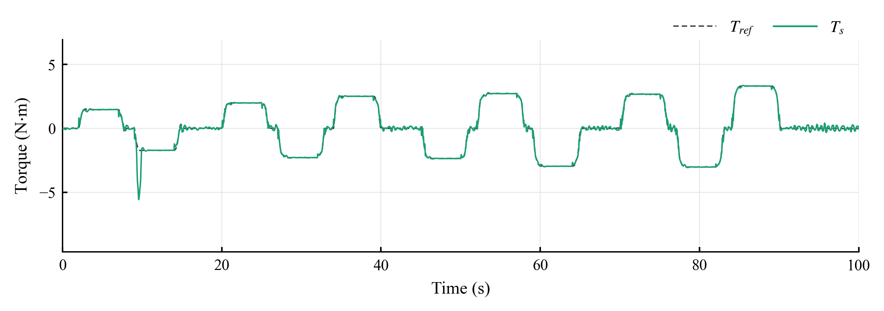
Fig. 9. Torsion-bar torque $T_{s}$ and target $T_{ref}$ of MapPID in STEADY.
In Fig. 8, Map reaches the target level only roughly. After each large step its torque overshoots and then decays slowly: at 45 km/h and +0.35 g it peaks at 6.1 N·m against a target of 2.5 N·m, and in the last second of the hold it is still 32.30% above the target (Table 10). The same offset appears at 65 and 85 km/h, where the final-second deviations are 10.78% and 19.26%, and a smaller one of 9.53% shows up at 25 km/h and 0.25 g. These offsets agree with the limited correction that a fixed map slope can provide, but settling time and column friction were not separated in this comparison. At five of the milder levels, the bias of Map was already below 0.06%, and its window RMS error was lower than that of either feedback structure. There the feedback had little offset to remove.
Table 10. Signed relative bias in the scoring windows at three high STEADY levels. Entries are mean ± sample standard deviation, in percent, across five noise seeds.
Condition | Map | PID | MapPID
45 km/h, +0.35 g | 32.3002 ± 0.0029 | −0.0185 ± 0.0610 | −0.0358 ± 0.0456
65 km/h, −0.35 g | 10.7759 ± 0.0185 | −0.0334 ± 0.1016 | −0.0441 ± 0.0843
85 km/h, +0.38 g | 19.2623 ± 0.0232 | −0.0264 ± 0.0571 | −0.0373 ± 0.0634

In Fig. 9, MapPID holds the target at every level. A short oscillation follows each step and dies out within the hold, so that the bias in the last second stays below 0.05% at the three strongest levels and under 0.43% in all eleven windows, for PID as well. This agrees with the integral action of both feedback structures, although a 1 s window at the end of a 4 s hold does not prove a true steady state.
The straight-ahead interval at the end of the sequence has a target close to zero. There the torque of Map remains flat, with a standard deviation of 0.015 N·m, while MapPID ripples with 0.17 N·m and PID with 0.14 N·m. This is consistent with the dead zone of the map keeping the assist off near zero torque, while the feedback branch reacts to the sensor noise in the measured torque. It also fits the larger assist-torque residual of MapPID in Table 9, 0.5146 against 0.1982 N·m for Map.
PID and MapPID reached almost the same whole-sequence $E_{RMS}$, about 0.25 N·m. This value is far above their holding errors, because the RMS also covers the entries and exits, where transient deviations remain. MapPID produced a lower residual than PID, with $S=0.5146$ compared with 0.5649 N·m. Map had the smallest $S$ and the largest overall tracking error.

5.3. Changes in Speed and Road Adhesion
SLIP began with a 13 s deceleration from 90 to 45 km/h, a 3 s hold and a 13 s acceleration back to 90 km/h, with $μ=0.8$. Throughout, the angle followed the dry-road equilibrium table for a nominal lateral acceleration of 0.20 g. The subsequent staircase kept 60 km/h and the angle for −0.30 g while $μ$ stepped from 0.8 through 0.5, 0.33 and 0.24 before returning to 0.8. Each lower coefficient was held for 5 s, and the last 2 s of each level were scored. The final water patch reduced the coefficient from 0.8 to 0.2 for 2 s at 80 km/h and the angle for +0.25 g. Because the angle stayed fixed in both tests, the lateral acceleration and the target torque depended on the force that the tires could still produce.
Table 11 gives the whole-sequence results, and Figs. 10 and 11 show the torque of Map and MapPID.
Table 11. Whole-sequence $E_{RMS}$ and $S$ in SLIP over 2–100 s. Entries are the mean ± sample standard deviation across five noise seeds.
Controller | $E_{RMS}$ (N·m) | $S$ (N·m)
Map | 0.6895 ± 0.0001 | 0.2028 ± 0.0009
PID | 0.2057 ± 0.0013 | 0.4900 ± 0.0057
MapPID | 0.1962 ± 0.0019 | 0.4820 ± 0.0069

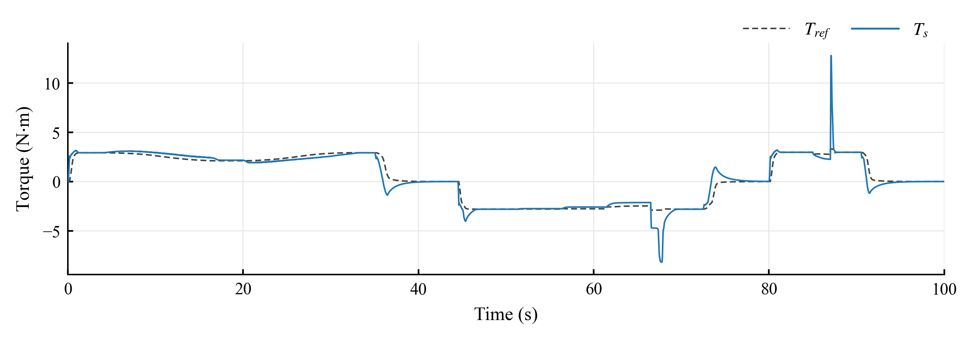
Fig. 10. Torsion-bar torque $T_{s}$ and target $T_{ref}$ of Map in SLIP. The friction coefficient is lowered between 51.5 and 66.5 s and between 85 and 87 s.
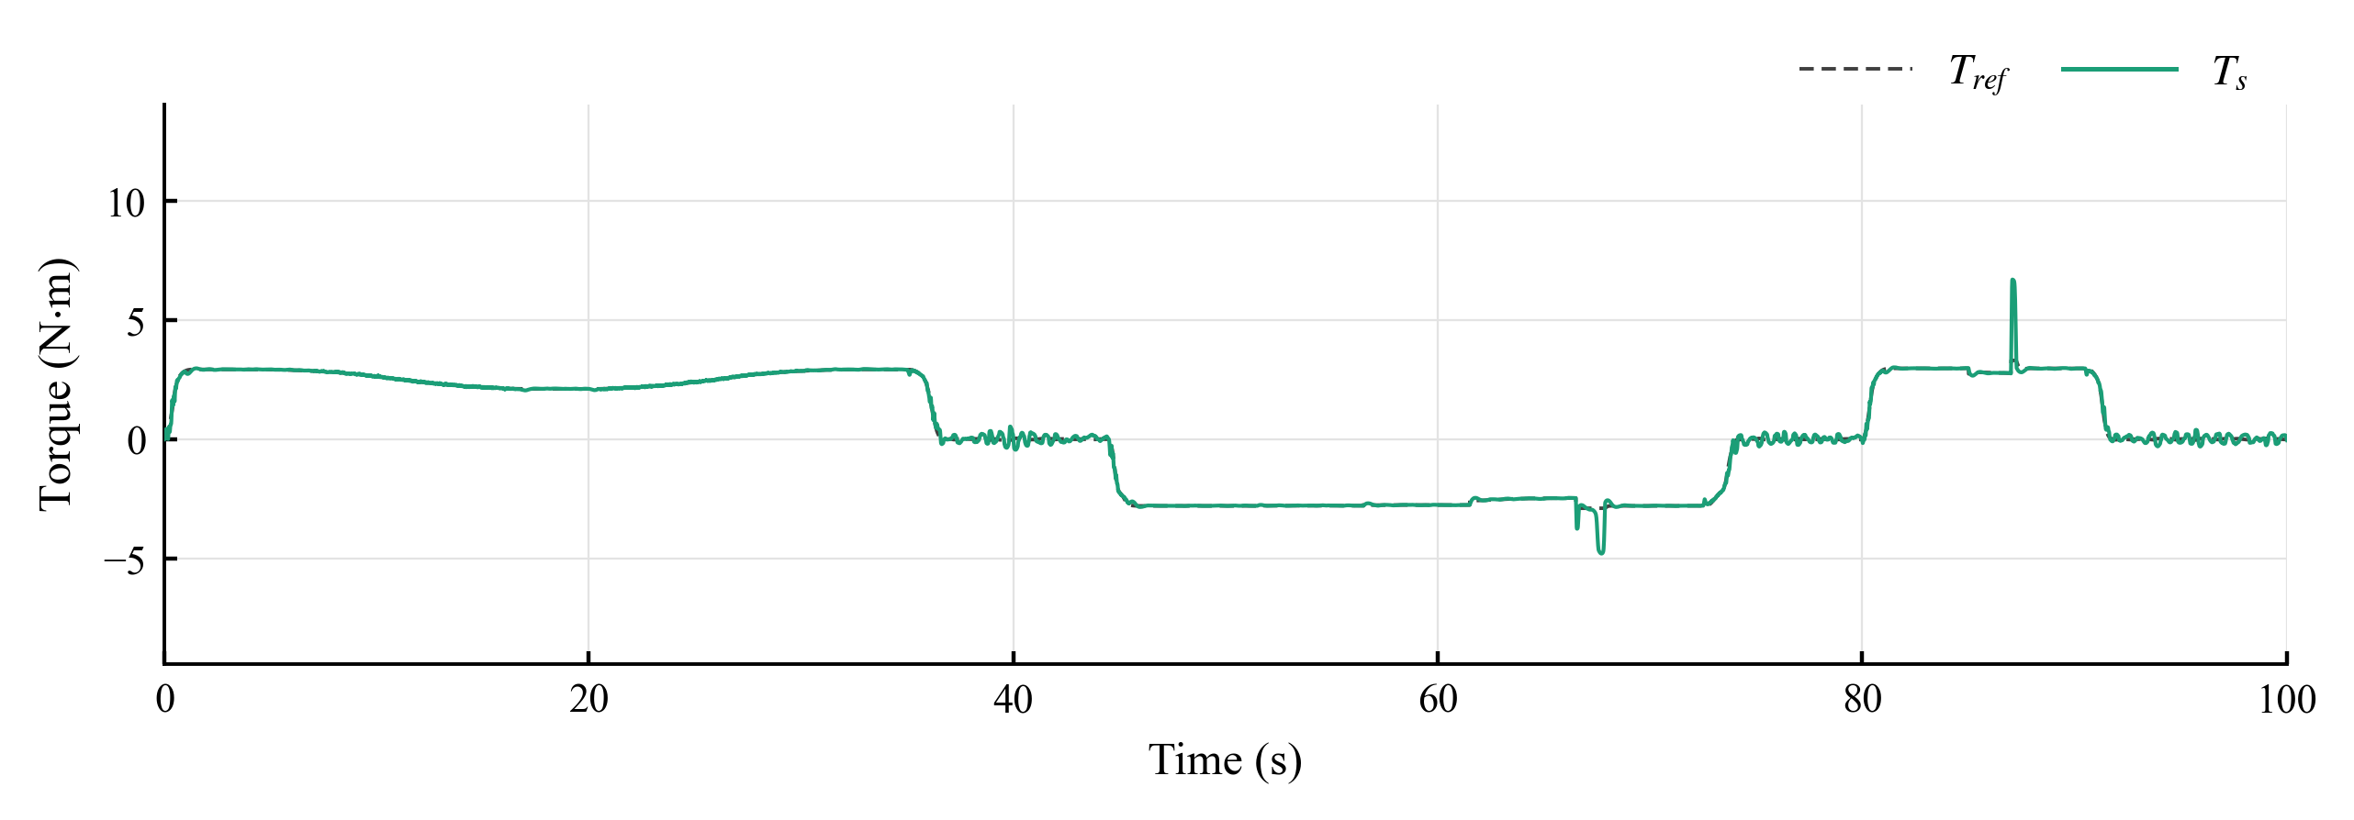
Fig. 11. Torsion-bar torque $T_{s}$ and target $T_{ref}$ of MapPID in SLIP.
During the speed ramps, the torque of Map drifts away from the target in Fig. 10, above it as the vehicle slows and below it as the vehicle accelerates. The window RMS errors were 0.2986 and 0.2503 N·m, with biases of +11.6% and −9.3%, so pooling the two windows would hide much of the deviation. The corresponding values for MapPID were 0.0140 and 0.0124 N·m, compared with 0.0205 and 0.0180 N·m for PID.
As the coefficient fell, the bias of Map grew from −1.52% at $μ=0.5$ to −6.42% at 0.33 and −13.94% at 0.24, so the effort became steadily lighter than the target. A torque below the target means that the assist exceeds what the slippery road calls for. In Fig. 10 the torque of Map is smaller in magnitude than the target during the last level, while MapPID in Fig. 11 overlaps it. PID and MapPID kept the bias within ±0.16% at all three levels.
Table 12. Signed relative bias in two SLIP windows. The first uses the final 2 s of the level at $μ=0.24$, and the second covers the 2 s water patch including the transient. Entries are mean ± sample standard deviation, in percent, across five noise seeds.
Condition | Map | PID | MapPID
Held angle, $μ=0.24$ | −13.9400 ± 0.0097 | 0.1251 ± 0.1255 | 0.1234 ± 0.1141
Water patch | −12.5616 ± 0.0188 | −0.8428 ± 0.0786 | −0.5141 ± 0.0655

The largest deviations in both figures occur when adhesion returns, at 66.5 and 87 s. At 87 s the torque of Map reaches 12.8 N·m against a target of 3.3 N·m, while that of MapPID rises to 6.7 N·m. The step at 66.5 s shows the same pattern, with extremes of −8.2 and −4.8 N·m. A plausible reading is that the road reaction rises abruptly while the assist, which had adapted to the slippery surface, lags behind. Inside the patch itself, the bias was −12.56% for Map, −0.84% for PID and −0.51% for MapPID (Table 12), and the RMS error fell from 0.3836 N·m for Map to 0.0875 N·m for PID and 0.0462 N·m for MapPID. This RMS value covers the adhesion transition and does not measure steady-state error.
Over the entire sequence, MapPID lowered $E_{RMS}$ from Map's 0.6895 to 0.1962 N·m without receiving an estimate of road friction. The difference from PID was small, about 4.6%, although it exceeded the seed-to-seed scatter. Their assist-torque residuals, 0.4820 N·m for MapPID and 0.4900 N·m for PID, differed by about as much as the noise realizations do.

5.4. Continuous Steering
WEAVE began with four cycles of near-center steering on the dry road at 95 km/h, with nominal 0.05 g and a 5 s period. Two identical single-cycle lane-change inputs followed at 80 km/h, nominal 0.20 g, and a period of 2.5 s. The first maneuver remained dry, while the second included a 0.4 s patch at $μ=0.2$ shortly after the steering peak. At 70 km/h, nominal 0.10 g was applied with successively shorter periods of 3.3333, 1.2500 and 0.6667 s. The sequence ended with eight cycles at 60 km/h, nominal 0.15 g, $μ=0.3$, and a period of 1.3333 s.
Table 13 gives the whole-sequence results, and Figs. 12 and 13 show the torque of Map and MapPID.
Table 13. Whole-sequence $E_{RMS}$ and $S$ in WEAVE over 2–100 s. Entries are the mean ± sample standard deviation across five noise seeds.
Controller | $E_{RMS}$ (N·m) | $S$ (N·m)
Map | 1.4510 ± 0.0001 | 0.2896 ± 0.0006
PID | 0.1998 ± 0.0044 | 0.8900 ± 0.0036
MapPID | 0.2217 ± 0.0064 | 0.7557 ± 0.0071

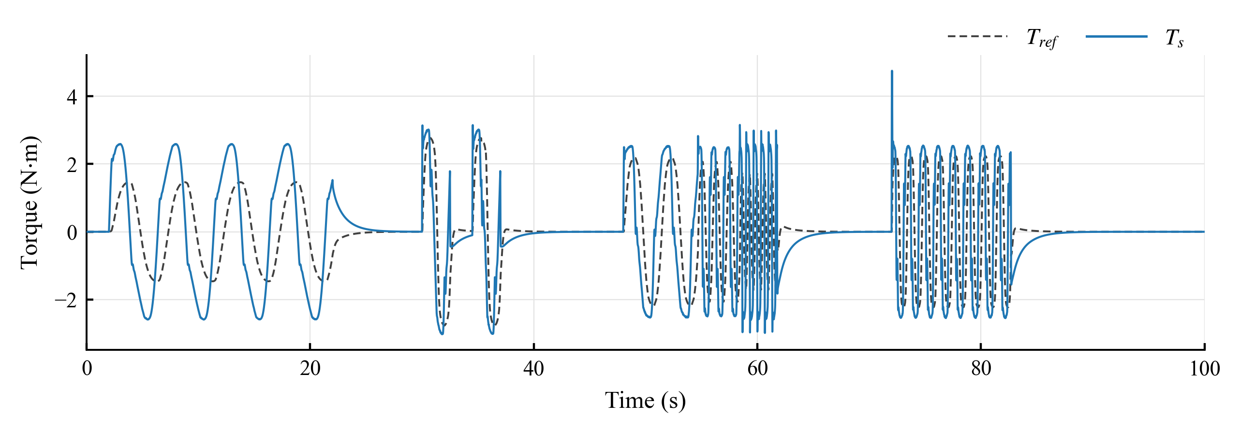
Fig. 12. Torsion-bar torque $T_{s}$ and target $T_{ref}$ of Map in WEAVE. Lane changes start at 30.0 and 34.5 s, the stepped periods at 48.0 s and $μ=0.3$ at 66.0 s.
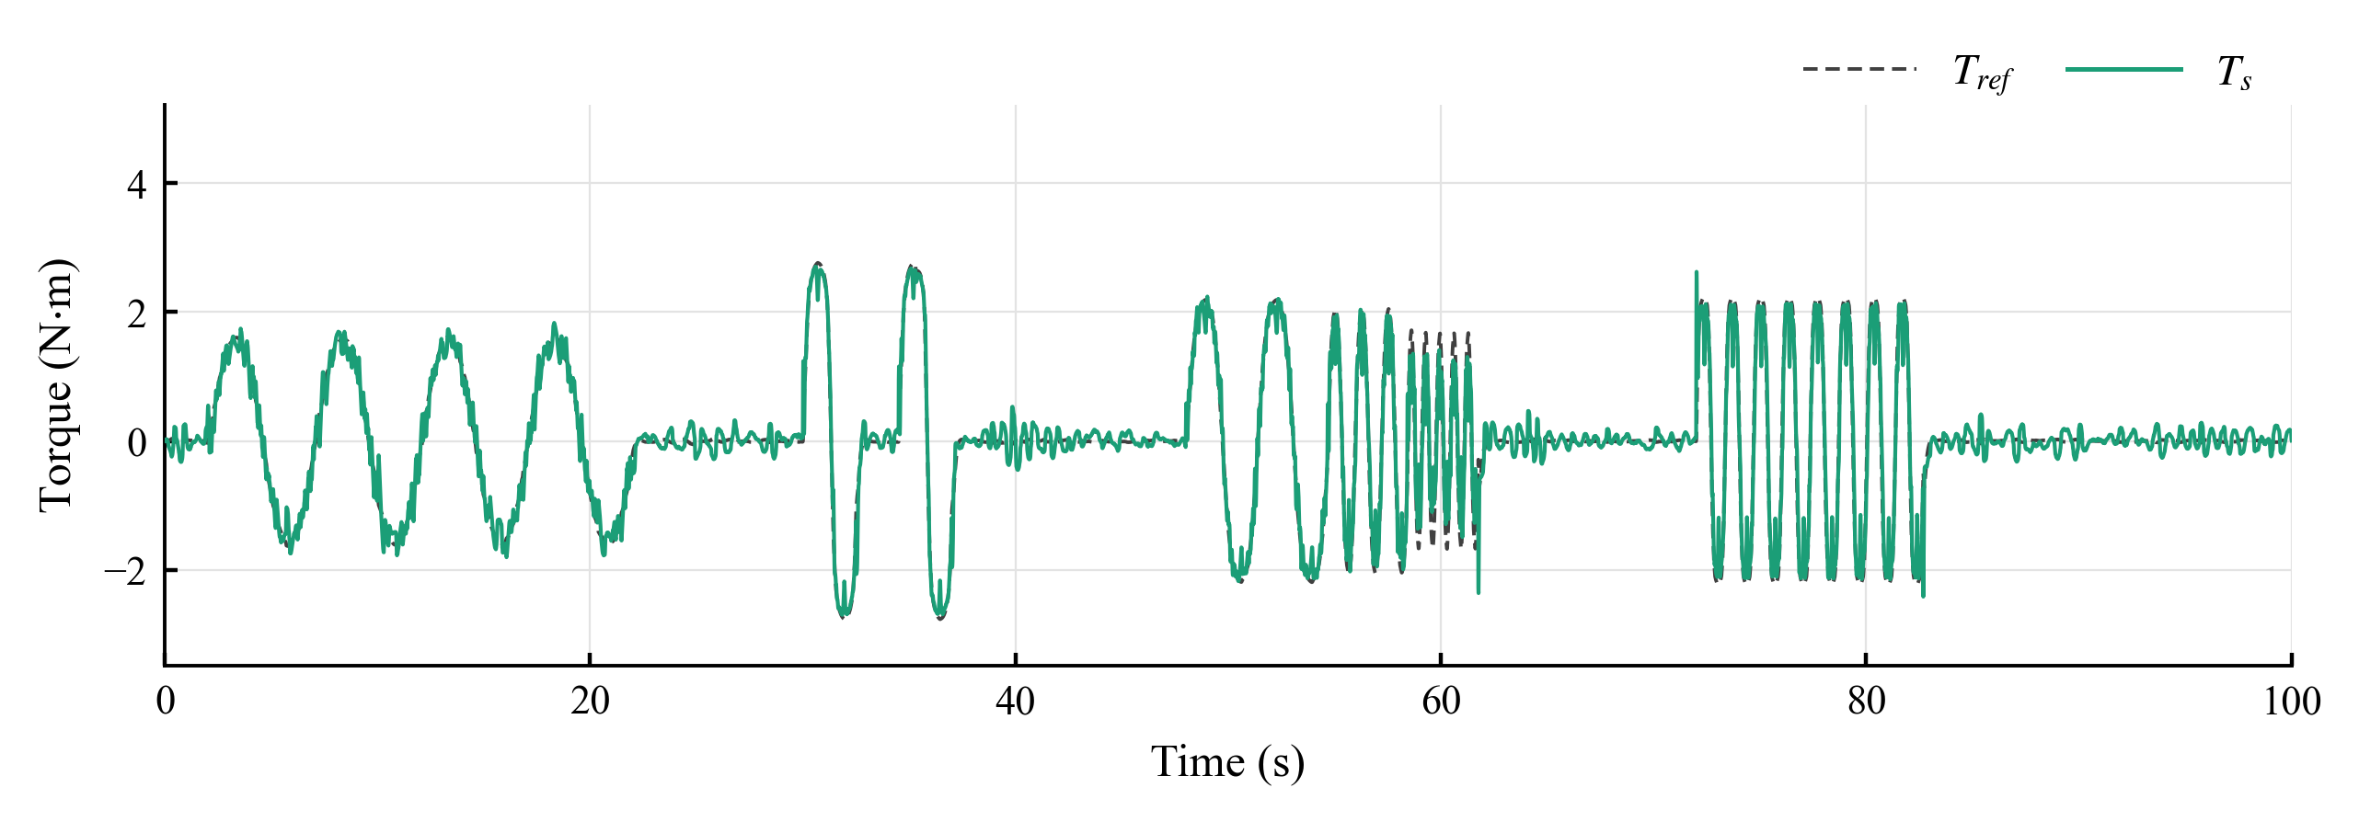
Fig. 13. Torsion-bar torque $T_{s}$ and target $T_{ref}$ of MapPID in WEAVE.
In Fig. 12, Map does not reproduce the shape of the target. Around the center, where the target amplitude is 1.6 N·m, its torque climbs to 2.6 N·m and moves in abrupt steps that come ahead of the target. The plots do not separate the cause, but a map with a dead zone and a high slope tends to change the assist in jumps. In Fig. 13, MapPID follows the target through the whole sequence, with small oscillations that grow when the steering period gets shorter.
Table 14. Window RMS tracking error in the 70 km/h continuous-steering segment. Values are mean ± sample standard deviation in N·m across five noise seeds.
Steering period (s) | Map | PID | MapPID
3.3333 | 1.7069 ± 0.0001 | 0.1690 ± 0.0094 | 0.1822 ± 0.0123
1.2500 | 2.3540 ± 0.0001 | 0.2761 ± 0.0121 | 0.3088 ± 0.0125
0.6667 | 2.6379 ± 0.0002 | 0.4622 ± 0.0071 | 0.5224 ± 0.0058

Shortening the period increased the error for all three controllers in Table 14. MapPID stayed well below Map but tracked less closely than PID, with a gap that grew from about 8% to 13%. PID also kept the smaller error in the near-center and low-adhesion stretches. These results show a limitation of the selected parallel design under rapid reversals. They do not identify a single cause, since the two feedback branches had different tuned parameters and their contributions were not separated.
The lane changes reversed this ranking. In the window of the second maneuver that contained the water patch, the RMS error was 0.0790 N·m for MapPID, 0.1060 N·m for PID and 2.2962 N·m for Map. The corresponding phase on the dry road gave 0.0644, 0.0889 and 2.0899 N·m in the same order. Map was thus far from the target even on the dry road. Its signed bias shifted from −76.59% in the dry reference window to −86.65% in the wet one, a difference of −10.06 percentage points. The complete wet-window offset therefore cannot be attributed to the water patch alone.
For the full WEAVE sequence, MapPID had 10.9% greater $E_{RMS}$ than PID but a 15.1% smaller assist-torque residual. Because $S$ also includes the response to steering reversals, this gap does not isolate sensor noise.

5.5. Overall Results and Limitations
With the map and compensator unchanged, MapPID reduced the whole-sequence RMS tracking error of Map by factors of 4.24 in STEADY, 3.51 in SLIP and 6.54 in WEAVE. The price was a larger assist-torque residual, which rose from 0.20–0.29 N·m for Map to 0.48–0.76 N·m for MapPID.
Compared with PID, MapPID tracked about equally well in STEADY, with a small gain in SLIP and a loss in WEAVE. Its $S$ was lower by 8.9% in STEADY and 15.1% in WEAVE, while the 1.6% difference in SLIP lay within the seed scatter (Fig. 14). This ordering differs from CALIB, where the selected MapPID point had a 2.2% higher residual. The balance therefore depends on the excitation and on the selected parameters, and the results do not establish a general ranking of the two structures in assist-torque noise.
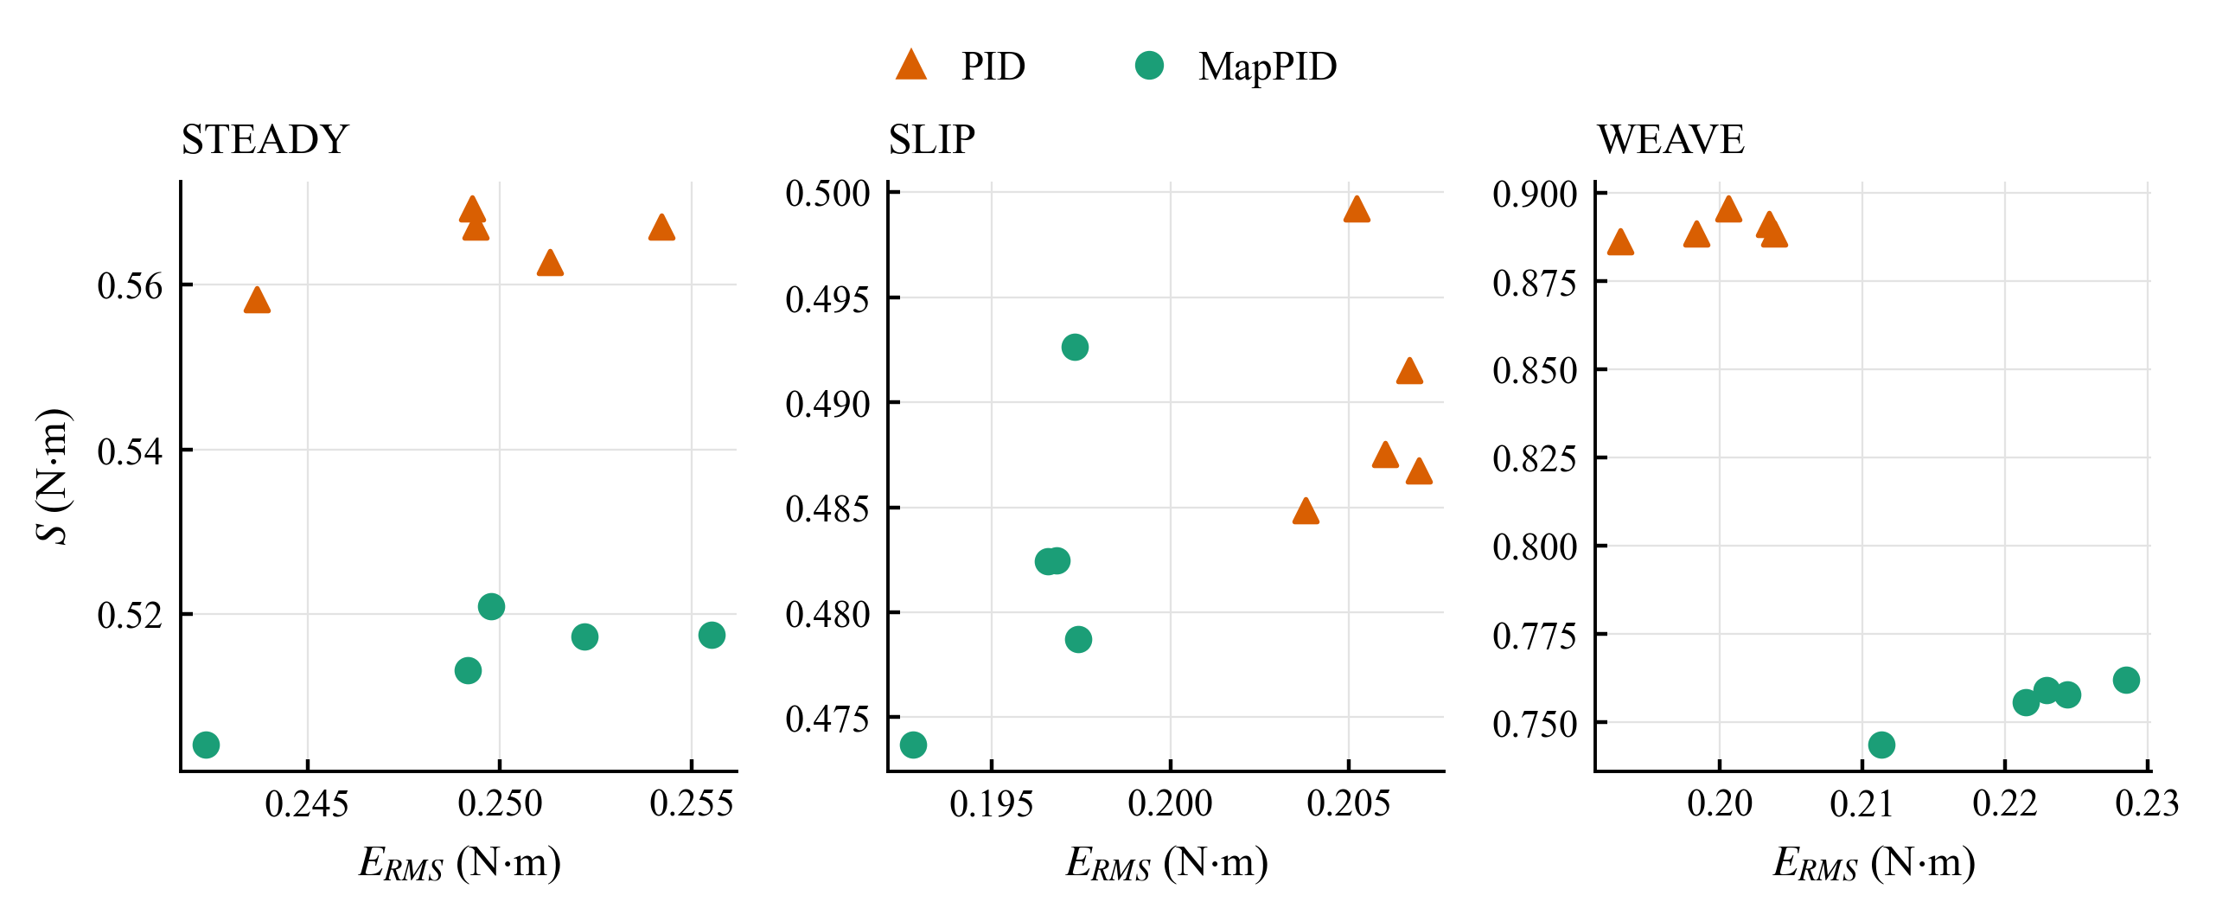
Fig. 14. Whole-sequence $E_{RMS}$ and $S$ of PID and MapPID for the five noise seeds in STEADY, SLIP and WEAVE.
The evaluation covers one simulated vehicle, with the steering-wheel angle prescribed independently of the effort felt by a driver. It excludes corrective human responses, and the five seeds characterize sensitivity to sensor noise in that model. The influence of vehicle parameters and agreement with measured data remain untested. A smaller torque error alone also does not demonstrate improved path following or safety. Within these limits, the added branch reduced the torque deviations of the fixed map, but it tracked less closely than PID during rapid steering, and hardware tests are still needed.

6. Conclusions
An assist map gives the intended steering effort only near the road and driving conditions it was built for. MapPID keeps that map and its lead–lag compensator unchanged and adds a PID branch in parallel, and the simulations of this study support the following conclusions.
- The branch corrects the torque error with respect to a target set by speed and lateral acceleration, so it needs no estimate of road friction. Only its four parameters are tuned for each vehicle.
- Map left a holding bias of up to +32.3% at the strongest dry-road levels and −13.9% at $μ=0.24$, while MapPID held it within 0.43%, as expected from integral action while the loop remains stable and the assist command stays below its limit.
- Over each complete test, MapPID lowered the RMS tracking error of Map by factors of 4.24, 3.51 and 6.54 in STEADY, SLIP and WEAVE, at the price of a larger fast component in the assist torque.
- Compared with PID, MapPID tracked about equally well in STEADY, with a small gain in SLIP and a 10.9% higher RMS error in WEAVE.
- Its assist-torque residual was 8.9% smaller in STEADY and 15.1% lower in WEAVE, with no clear difference in SLIP. This residual also contains the response to rapid steering, so it is not a direct measure of steering comfort.
- The evidence covers one simulated vehicle with a prescribed steering-wheel angle and five sensor-noise seeds. Tests with a driver in the loop, with parameter variations and on hardware are still needed.
- Further analysis should separate the contributions of the two branches during fast reversals, to explain why MapPID tracked less closely than PID there.

Acknowledgments
The authors acknowledge Ho Chi Minh City University of Technology (HCMUT), Vietnam National University Ho Chi Minh City (VNU-HCM) for supporting this research.

Conflict of Interest
The authors have no conflict of interest to declare.

Author contributions
Minh Tan Tram: modeling, simulation, data analysis, writing – original draft. Thanh Huy Phung: supervision, review and editing. All authors have approved the final article.

Declaration of Generative AI
During the preparation of this work, the authors used Claude (Anthropic) for language editing only. After using this tool, the authors reviewed and edited the content as needed and take full responsibility for the content of the published article.

References
[1]. D. Lee, K.-S. Kim, S. Kim (2018). Controller design of an electric power steering system. IEEE Transactions on Control Systems Technology, 26(2), 748-755. doi:10.1109/TCST.2017.2679062
[2]. X. Guan, Y.-N. Zhang, C.-G. Duan, W.-L. Yong, P.-P. Lu (2021). Study on decomposition and calculation method of EPS assist characteristic curve. Proceedings of the Institution of Mechanical Engineers, Part D: Journal of Automobile Engineering, 235, 2166-2175. doi:10.1177/0954407020987062
[3]. Y. Li, Z. Yang, D. Zhai, J. He, J. Fan (2023). Study on control strategy of electric power steering for commercial vehicle based on multi-map. World Electric Vehicle Journal, 14(2), 33. doi:10.3390/wevj14020033
[4]. L. Fan, B. Zhou, H. Zheng (2014). A new control strategy for electric power steering on low friction roads. SAE International Journal of Passenger Cars - Mechanical Systems, 7(3), 972-980. doi:10.4271/2014-01-0083
[5]. Q. Li, C. Xia (2012). Research of electric power steering system assistance characteristic based on the identification of the road. Proceedings of ICCIA 2012, 402-405. doi:10.2991/iccia.2012.97
[6]. Y. Li, J. Fan, J. He, Y. Nan, Q. Feng (2020). Novel electric power steering control strategies of commercial vehicles considering adhesion coefficient. Advances in Mechanical Engineering, 12(12), 1-11. doi:10.1177/1687814020983059
[7]. X. Zhao, X. Shi, J. Chen, X. Li (2011). Dynamic correction of the steering-characteristic curve and application to an EPS control system. International Journal of Automotive Technology, 12(2), 243-249. doi:10.1007/s12239-011-0029-5
[8]. D. Lee, K. Yi, S. Chang, B. Lee, B. Jang (2018). Robust steering-assist torque control of electric-power-assisted-steering systems for target steering wheel torque tracking. Mechatronics, 49, 157-167. doi:10.1016/j.mechatronics.2017.12.007
[9]. D. Lee, B. Jang, M. Han, K.-S. Kim (2021). A new controller design method for an electric power steering system based on a target steering torque feedback controller. Control Engineering Practice, 106, 104658. doi:10.1016/j.conengprac.2020.104658
[10]. D. Saifia, M. Chadli, H. R. Karimi, S. Labiod (2015). Fuzzy control for electric power steering system with assist motor current input constraints. Journal of the Franklin Institute, 352(2), 562-576. doi:10.1016/j.jfranklin.2014.05.007
[11]. H. Q. Nguyen, V. T. Vu, O. Sename (2025). Combining adaptive neural-fuzzy inference system with field-oriented control strategy for electric power steering system in cars. Advances in Mechanical Engineering, 17(9). doi:10.1177/16878132251369152
[12]. H.B. Pacejka. (2006). Tyre and vehicle dynamics (2nd ed.). Elsevier.
[13]. R. Rajamani. (2012). Vehicle dynamics and control (2nd ed.). Springer.
[14]. K. J. Åström and T. Hägglund. (1995). PID controllers: Theory, design, and tuning (2nd ed.). Instrument Society of America.

