Type the title of your paper
First Author¹, Second Author², Third Author^{1,2,*}
¹First affiliation, Address, City and Postcode, Country
²Second affiliation, Address, City and Postcode, Country
Article info  Type of article:  Original research paper  Corresponding author:  E-mail address:  Email@utt.edu.vn  Received: 00 December00  Accepted: 00 February 00  Published: 00 February 00 |  | Abstract: The abstract should be about 150 to 300 words in length and in lower case letters. The abstract should state concisely the whole research work including the necessary, purpose, methodology and main results obtained, not just the conclusions. It should contain no citation to other published work and uncommon abbreviations.  Keywords: Type your keywords here with 5 to 7 words, separated by semicolons
- Introduction
We believe a template should help you, not hinder you, in authoring your paper. It should follow you in how you want to write your paper, not force you to fill in bits and pieces of text. It should allow you to type any text, copy from previous versions, or load an already existing plain text to be formatted. You will therefore find no dialog boxes or fill-in screens. You will not need to remember shortcut keys, to use lists of styles, bother about alignment, indents, fonts and point sizes. Just a mouse-click at one of the menu options will give you the style that you want.
The objective of this template is to enable you in an easy way to style your article attractively in a style similar to that of JSTT. It should be emphasized, however, that the final appearance of your paper in print and in electronic media will very likely vary to some extent from the presentation achieved in this Word® document.
- Organisation of the template
A template (with its file name ending on .dot, rather than on .doc) in Word® is a “mold” that formats documents based on it. If you click ‘New’ on the ‘File’ menu, what you see and open are in fact templates. To use the Computer Physics Communications template you should first save it with the other templates, probably in a directory called ‘…\Microsoft Office\Templates’. If you cannot find it, go to the ‘Tools’ menu, choose ‘Options…’, click the ‘File locations’ tab and see which directory is specified for ‘User templates’. After saving the template in that directory, you can start using it via ‘New’ on the ‘File’ menu.
The template formats your text by using a Word® feature called ‘Styles’. Styles define the format (or appearance) of a paragraph of text as regards letter size, indentation, line spacing, etc. If you’re not familiar with using styles, do not worry; the template arranges everything for you in a user-friendly way.
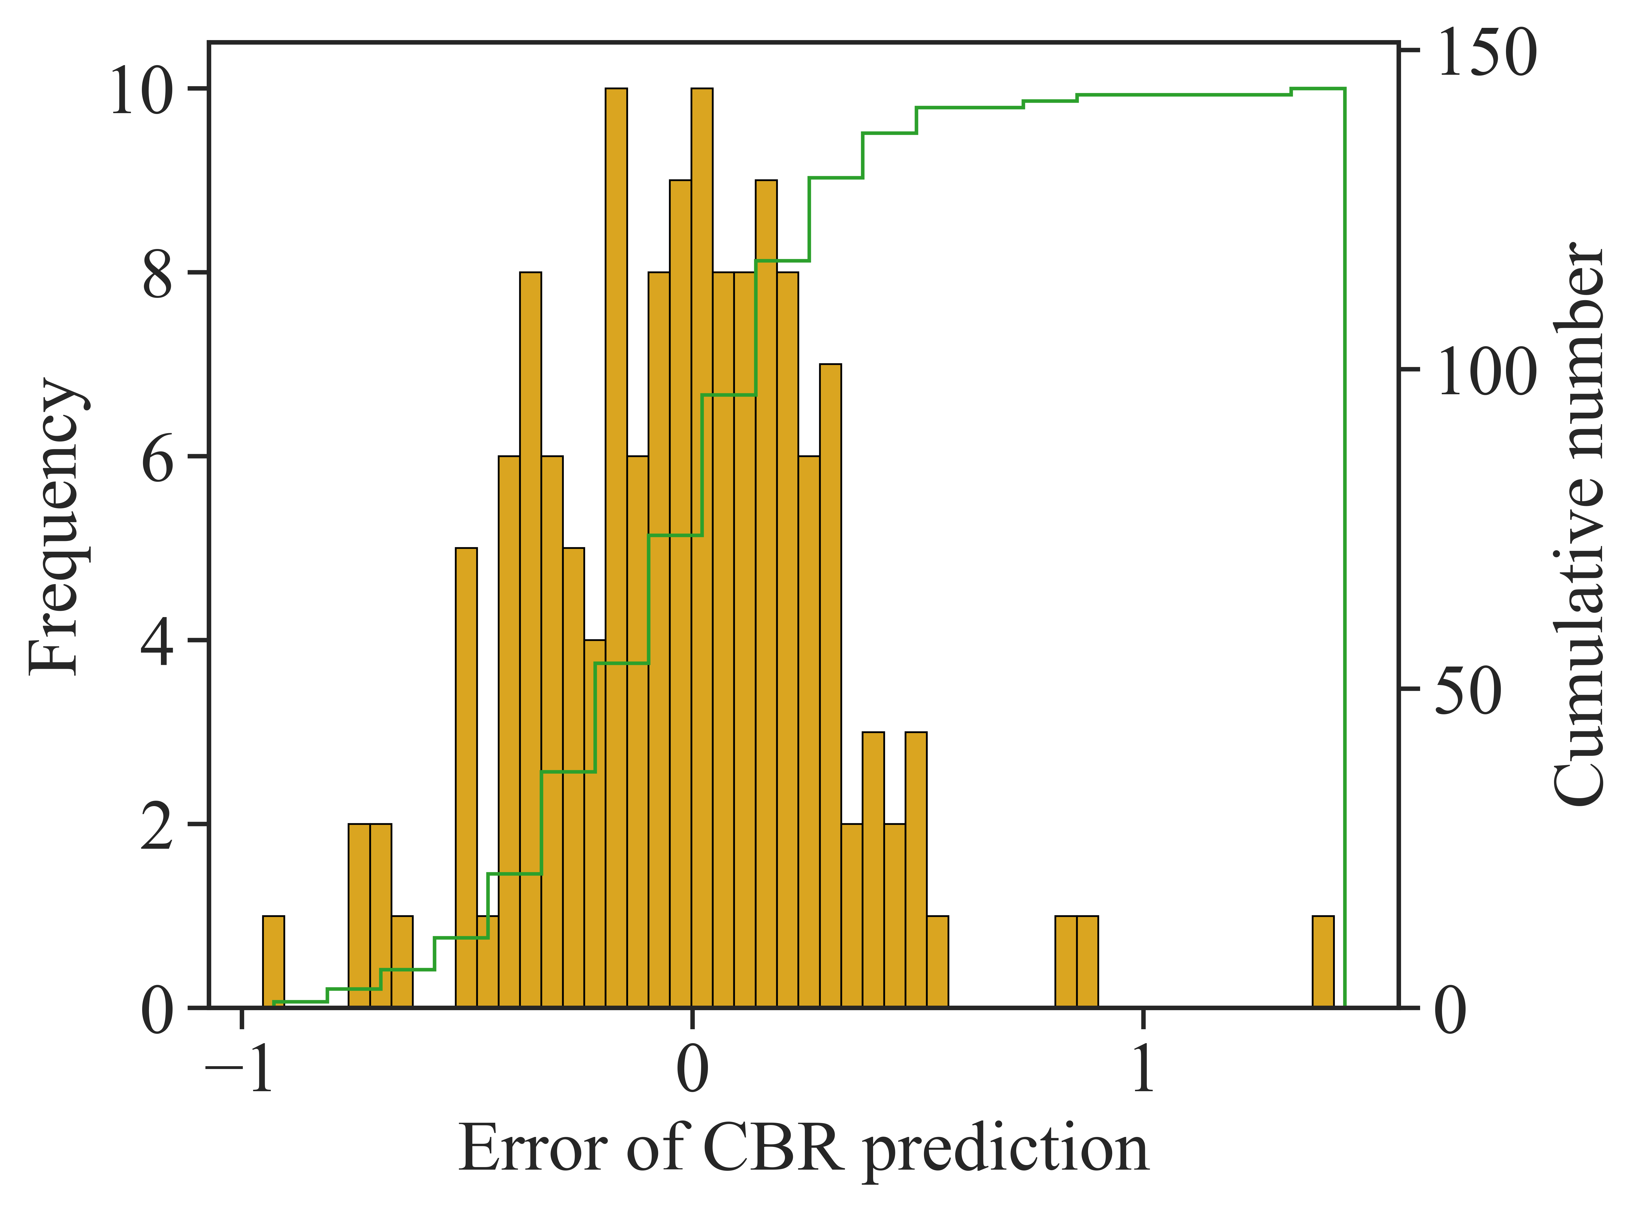
(a) | (b)
Fig 4. Error value between predicted and experimental CBR of stabilized expansive soils for (a) training part, (b) testing part.

  - The toolbar and its menus
At the top of the working area, you see a number of buttons that activate drop-down menus. You can select the required styles from these menus. Styles are applied to paragraphs, i.e. the text between two subsequent hard returns (¶). When you hit the Enter key, you finish a paragraph. The template chooses at that moment the most appropriate next style, e.g. after the style for authors’ names, you will automatically be in the affiliation style. After a section heading, the template will automatically switch to normal text.
Some menu options do more than just apply a style; they insert a special feature. You will recognise them because the menu entry starts with ‘Insert’.
    - Entering text
There are several ways in wich you can enter and format your text in this template. The first way is to simply type your text in a blank document based on this template. If you want to apply a different style, e.g. for a section heading, start typing the text first as a new paragraph and, while the cursor is somewhere within the paragraph, choose the required style from the drop-down menus. If you remove text to replace it with your own text, you should pay attention to the ‘section breaks’ in it. Switch to ‘Normal view’ on the ‘View’ menu to see the breaks. Word® uses those to separate the one-column and two-column parts, as well as to serve as page breaks. (You may find working in ‘Normal’ view more convenient anyway. Switching to ‘Page’ view will restore the two-column lay-out once you have finished.) The template is set up to have the text up to and including the Abstract in one-column lay-out with a text area 38 pica wide, and the rest of the article in two-column lay-out with two columns of 18 pica and a 2 pica gutter in between. On the ‘Document formatting’ menu you will find options to adjust the typing area to the paper size (A4 or Letter size paper) that you use. Using those options will remove the one- and two-column settings, so you will need to reinsert those, using the other menu options. In that case, or in case this lay-out becomes disrupted, insert a switch to double column from the ‘Document formatting’ menu after the article Abstract and at the end of your text, balance the columns using the option from the same menu. Insert a switch to one column before any page-wide tables
You may also attach the template to an already existing document. Choose from the ‘Tools’ menu the option ‘Templates and Add-Ins…’. Select the ‘Elsevier.dot’ template and make sure to tick the box ‘Automatically update document styles’ to make the styles available. You will in this case have to adjust the margins of the document, using one of the first two options from the ‘Document formatting’ menu.
Alternatively, you may insert the whole text or parts you previously prepared by using on the ‘Insert’ menu of Word® the option ‘File…’. In that case take care to retain the above mentioned section breaks. After the file is inserted you can style it by placing the cursor in each paragraph and clicking the required style on the drop-down menus.
- The first page
Naturally, your paper should start with a concise and informative title. Do not use abbreviations in it. Next, list all authors with their first names or initials and surnames (in that order). Indicate the author for correspondence using the third menu option. Present addresses can be inserted using a normal footnote (on the ‘Text’ menu). After having listed all authors’ names, you should list their respective affiliations. Link authors and affiliations using superscript lower case letters.
  - The Abstract
An Abstract is required for every paper; it should succinctly summarize the reason for the work, the main findings, and the conclusions of the study. The abstract should be no longer than 250 words. Do not include artwork, tables, elaborate equations or references to other parts of the paper or to the reference listing at the end. The reason is that the Abstract should be understandable in itself to be suitable for storage in textual information retrieval systems.
Supply some 5–6 keywords, separated with semicolons.
- The main text
You will usually want to divide your article into (numbered) sections and subsections (perhaps even subsubsections). Code section headings using the options in the ‘Text’ menu. Headings should reflect the relative importance of the sections. Note that text runs on after a 4th order heading. Use the heading style for the whole paragraph, but remove the bold coding except for the actual heading.
Ensure that all tables, figures and schemes are cited in the text in numerical order. It is strongly recommended that authors follow the recommendations of the IUPAC Manual of Symbols and Terminology for Physico-chemical Quantities and Units, edited by IM Mills, Blackwell, Oxford, 1988. Abbreviations should be used consistently throughout the text, and all nonstandard abbreviations should be defined on first usage.
  - Tables and figures
Graphics and tables may be pasted directly into the template and positioned as they should appear in the final manuscript. Figures (Fig 1), Schemes, and Tables should be numbered.
text should not run along the sides of any figure. If it does, right-click the figure, choose ‘Format Object (/Fig)’, choose the ‘Wrapping’ tab and select ‘Top & bottom’. Artwork is normally linked to, and moves with, a paragraph it is linked to. A small anchor symbol should indicate the paragraph to which it is linked. If you do not see the anchor, choose from the ‘Tools’ menu, ‘Options…’, and click the ‘View’ tab. Tick the ‘Object anchors’ tick box. You can move the figure inself by dragging but you can also drag the anchor.
You might find positioning your artwork within the text difficult. In that case you may choose to place all artwork at the end of the text and insert a marker in the text at the desired place. In any
Table 1. Statistical analysis of database
 | Count | Mean | Std | Min | Q25% | Q50% | Q75% | Max | Skw
Ash type | 207 | 1.986 | 0.815 | 1.000 | 1.000 | 2.000 | 3.000 | 3.000 | 0.027
Ash content (%) | 207 | 14.029 | 16.650 | 0.000 | 4.000 | 8.000 | 12.000 | 60.000 | 1.593
LL (%) | 207 | 39.383 | 10.533 | 17.000 | 32.200 | 39.000 | 46.750 | 64.000 | 0.215
PL (%) | 207 | 20.646 | 4.565 | 12.800 | 16.900 | 20.000 | 24.050 | 30.100 | 0.341
OMC (%) | 207 | 17.775 | 5.107 | 8.910 | 13.915 | 17.020 | 21.200 | 32.500 | 0.508
MDD (g/cm³) | 207 | 1.615 | 0.103 | 1.370 | 1.535 | 1.620 | 1.680 | 1.880 | 0.308
CBR (%) | 207 | 3.775 | 0.990 | 1.860 | 3.055 | 3.890 | 4.510 | 6.460 | -0.149
Skw=Skewness; Std=Standard deviation
case, please keep in mind that the placement of artwork may vary somewhat in relation to the page lay-out.
You can insert a caption below the figure or scheme. To keep the drawing and caption more easily together, select them both (hold down the <SHIFT> key and click both figure and caption) and choose, under the right mouse button, Grouping. Graphs may appear either on a fixed spot in the text or ‘floating’, normally a figure or scheme with a caption, which remains near to the paragraph it is linked to regardless of the text flowing around it. To choose between the two options, right-click the graph, choose ‘Format object’, choose the ‘Position’ tab and tick or clear the ‘Float over text’ tick-box. If grouped with a caption, a figure will always be floating.
Please remember that we will always also need high-resolution versions of your artwork for printing, submitted as separate files in standard format (i.e. TIFF or EPS), not included in the Word® text document. Before preparing your artwork, please take a look at our Web page:
http://www.elsevier.com/locate/authorartwork.
  - Lists
For tabular summations that do not deserve to be presented as a table, lists are often used. Lists may be either numbered or bulleted. Below you see examples of both.
- The first entry in this list
- The second entry
- The last entry
- A bulleted list item
- Another one
You can apply these styles using the ‘Text’ menu options. Note that you should first block the whole list. A sublisting is coded using the ‘Demote list item’ (go to a sublevel of numbering) and ‘Promote list item’ (go to a higher level of numbering) buttons.
  - Equations
Conventionally, in mathematical equations variables and anything that represents a value appear in italics. You may choose to number equations for easy referencing. In that case the number should appear at the right margin.
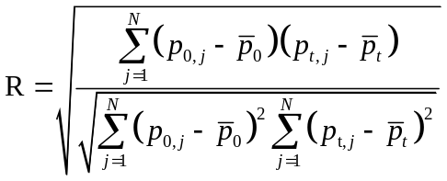 | (1)
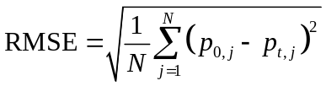 | (2)
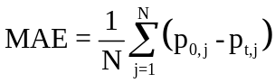 | (3)
- References
References in the text should be indicated by Arabic numerals in square brackets that run consecutively through the paper. Authors should ensure that all references are cited in the text and vice versa. The reference list should contain only literature references; other information (e.g. experimental details) should be placed either in the body of the text, or as a footnote. Each reference should contain only one literature citation. Authors are expected to check the original source reference for accuracy. Journal references should be formated in a required style such as journal articles [1], books [2], multi-author books [3], proceedings [4], personal communications [5], and standard [6] shown in References below.
Acknowledgments
Acknowledgments should be inserted at the end of the paper, before the references, not as footnote to the title. Use an unnumbered section heading for the Acknowledgments, similar to the References heading.
References
[1]. V. De Semir, C. RibasandG. Revuelta. (1998). Press releases of science journal articles and subsequent newspaper stories on the same topic. Jama, 280(3), 294-295.
[2]. I.A. Leonard. (2020). Books of the Brave. University of California Press. USA
[3]. H.J. Gilbert, G. Davies, B. HenrissatandB. Svensson. (1999). Recent advances in carbohydrate bioengineering. Royal Society of Chemistry: Vol. 246.
[4]. Q.-H. Nguyen, M. Hjiaj, X. NguyenandH. Nguyen. (2015). In Finite element analysis of a hybrid RCS beamcolumn connection. The 3rd international conference CIGOS, pp 11-32
[5]. I. GloverandP.M. Grant. (2010). Digital communications. Pearson Education.
[6]. AASHTO. (2018). Code T 267-86 (2018), Standard Method of Test for Determination of Organic Content in Soils by Loss of Ignition.

