Progress report: the controllers on a commercial tyre model (MathWorks VDB)
Tran Minh Tan, supervisor Dr. Phung Thanh Huy, HCMUT. Seed 99999, the same SSW cases (STEADY, SLIP, WEAVE) as in the paper.

1. Why
The paper evaluates Map, PID and MapPID on a simplified Plant written by us: a Magic Formula lateral force and a linear pneumatic trail, eq. (17). A reviewer may ask whether the conclusions depend on this home-made tyre. This work replaces only the Tires block with the tyre of the MathWorks Vehicle Dynamics Blockset (VDB) and re-runs the paper cases with the controllers unchanged (same parameters, same seed).

2. What was changed
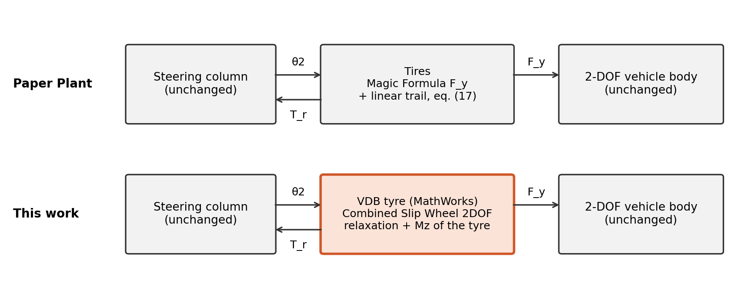
Figure 1. Only the Tires block is replaced; steering column, vehicle body, sensors, actuator and controllers are the paper versions.
The VDB tyre was added in three steps, and each step was checked against the paper Plant before the next one:
Step | What the VDB tyre adds | Open-loop deviation from Plant (STEADY / SLIP / WEAVE)
0. Same tyre as the Plant | VDB block configured with the Plant parameters (C, E, C_α, μ) | T_s 0.02 %, T_r 0.02 % (DRY)
1. Tyre lag | Real lateral relaxation length of the VDB tyre (force builds up over a rolling distance) | T_s 0.67 / 1.67 / 2.27 %
2. Aligning moment | T_r from the tyre moment M_z (Magic Formula trail) instead of eq. (17) | T_s 1.65 / 2.03 / 1.47 %

Open-loop deviation = RMS of the difference divided by the largest Plant value, with the same steering input and no assist. Acceptance level written before running step 2: T_s within 3 %.

3. Method for the aligning moment (step 2)
The VDB trail has the Magic Formula shape with three shape coefficients (B_t, C_t, E_t). They were chosen to follow the Plant trail as closely as possible, but only inside the range found for real tyres: Pacejka, Tyre and Vehicle Dynamics, Table 4.2 and Table A3.1 (measured 205/60R15), and the VDB library tyre. The trail at zero slip is fixed to the Plant value t_0 = 25 mm. Result: B_t = 11.78 (range 6-12), C_t = 1.083 (1.05-1.29), E_t = -3.03 (-4 to 0); largest trail difference 2.5 mm.
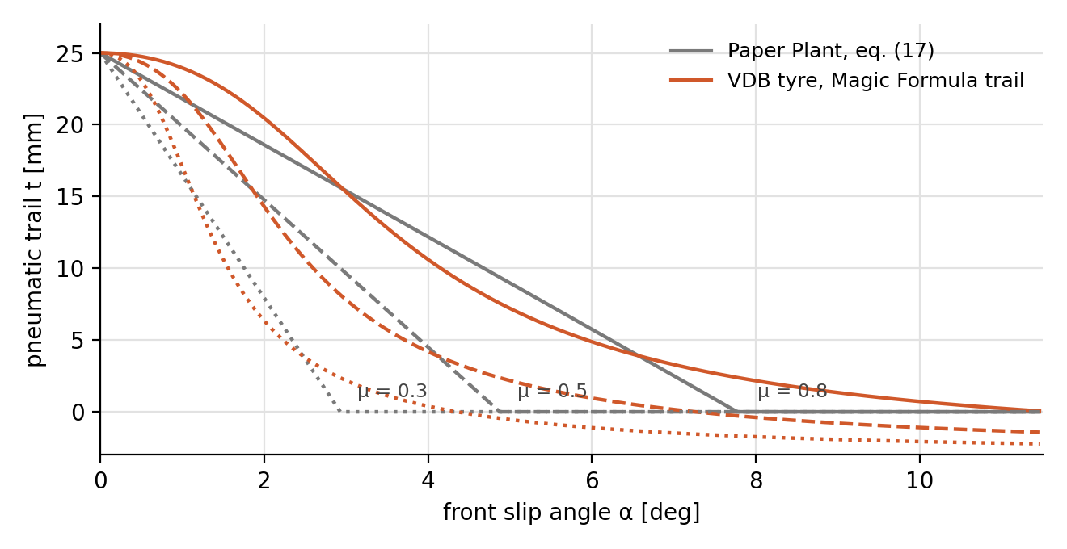
Figure 2. Pneumatic trail at three friction levels. The Plant trail is a straight line with a corner; a real tyre (Magic Formula) gives a smooth bell. The two cannot coincide with physical coefficients.

4. Closed-loop results on the paper cases
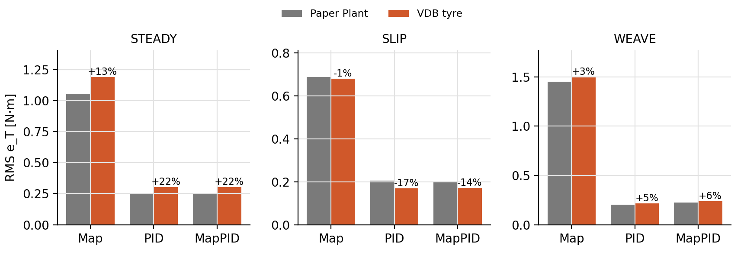
Figure 3. RMS torque tracking error e_T over each whole case, paper Plant versus VDB tyre (labels: change in %).
Controller | Case | RMS e_T Plant [N·m] | RMS e_T VDB [N·m] | Change [%] | S Plant / VDB [N·m]
Map | STEADY | 1.058 | 1.193 | +12.8 | 0.197 / 0.202
Map | SLIP | 0.690 | 0.680 | -1.3 | 0.202 / 0.197
Map | WEAVE | 1.451 | 1.501 | +3.4 | 0.289 / 0.294
PID | STEADY | 0.249 | 0.304 | +21.8 | 0.569 / 0.572
PID | SLIP | 0.205 | 0.170 | -17.3 | 0.499 / 0.499
PID | WEAVE | 0.203 | 0.214 | +5.4 | 0.891 / 0.897
MapPID | STEADY | 0.250 | 0.305 | +21.9 | 0.521 / 0.523
MapPID | SLIP | 0.197 | 0.171 | -13.5 | 0.493 / 0.491
MapPID | WEAVE | 0.224 | 0.237 | +5.8 | 0.758 / 0.771

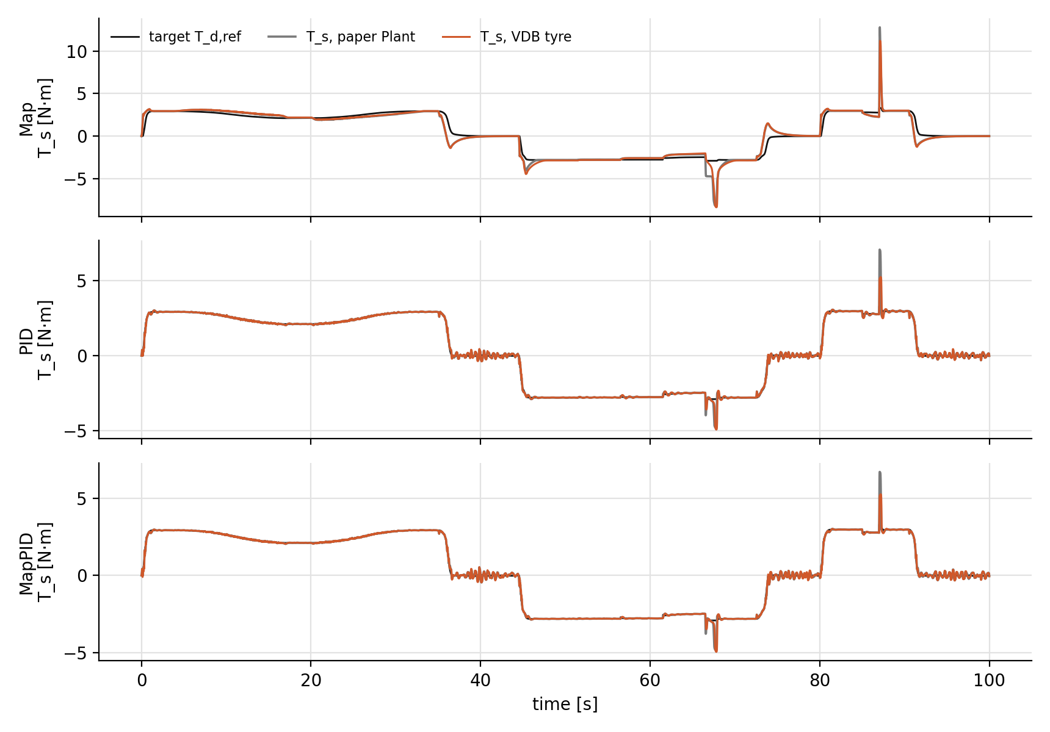
Figure 4. SLIP case (friction changes while cornering): steering torque T_s of each controller on both tyres.
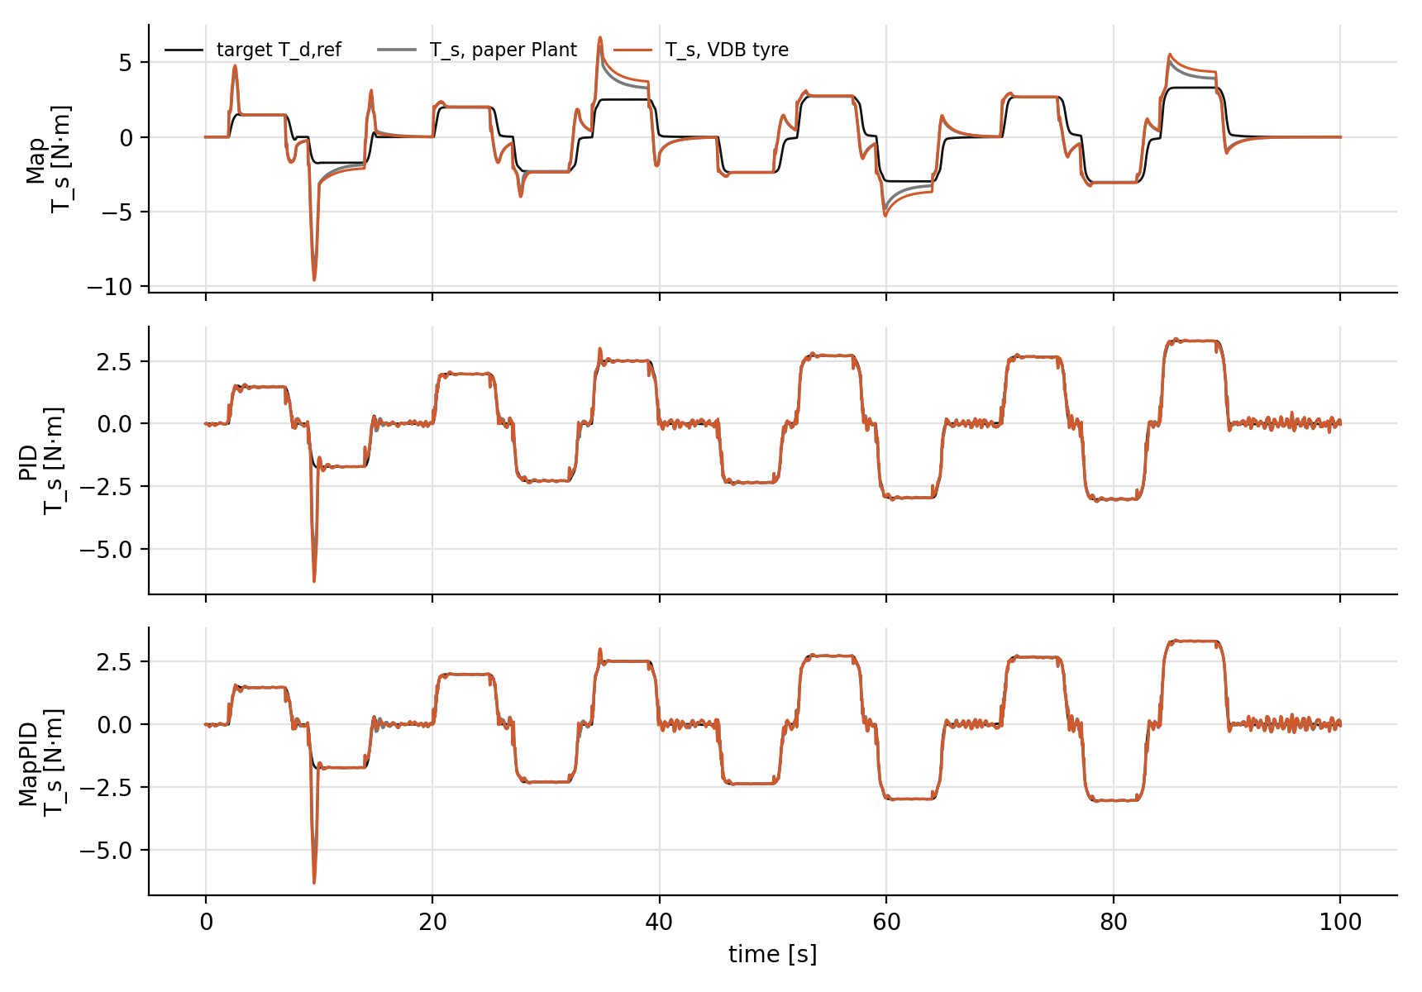
Figure 5. STEADY case: the largest differences appear in the high lateral-acceleration holds.

5. What the results say
- All three controllers stay stable and keep the same behaviour on the VDB tyre; no parameter was retuned.
- STEADY: RMS e_T changes between +12.8 % and +21.9 % across the three controllers.
- SLIP: RMS e_T changes between -17.3 % and -1.3 % across the three controllers.
- WEAVE: RMS e_T changes between +3.4 % and +5.8 % across the three controllers.
- In absolute terms the STEADY change is +0.135 N·m (Map), +0.054 N·m (PID), +0.055 N·m (MapPID). The percentage is larger for PID and MapPID only because their error on the paper Plant is already small. The comparison between controllers is unchanged: Map has the largest error in every case, and where PID and MapPID swap order (SLIP) they differ by less than 5 %, which the paper counts as a tie.
- The largest change is in STEADY at high lateral acceleration. It comes from the trail shape (Figure 2): with a real tyre the trail decays smoothly, so the road torque differs by a few percent and the fixed assist characteristic sees a slightly different load. This is a property of the tyre, not of a controller.
- Limits: one vehicle, one seed, simulation only; the vertical load on each tyre is still constant (no load transfer).

6. Next steps
- Replace the 2-DOF vehicle body by the VDB 3-DOF body (already built and checked: deviation below 0.03 % with the Plant tyre).
- Feed the vertical loads of the VDB body into the VDB tyre, so that load transfer in cornering changes the tyre force and trail.
- Run the three controllers on the full VDB vehicle with the same cases and seed, then write this part as the last section of thesis Chapter 5 (thesis = paper + VDB section).

