Lateral-Acceleration-Based Torque Tracking Control for Column Electric Power Steering under Varying Road Friction Conditions

Abstract
Conventional assist maps in column electric power steering (C-EPS) are calibrated for dry roads and do not directly regulate steering torque relative to a specified reference. When tire–road friction changes, the road-reaction torque changes, and the steering effort produced by the calibrated map departs from its intended value. This study examines whether torque-error feedback can be added to such a map without recalibrating it. Three structures are compared: a lead–lag-compensated assist map (Map), direct proportional–integral–derivative torque feedback (PID), and a plug-in combination (MapPID) in which the calibrated map and its compensator are kept unchanged and only a parallel PID branch is tuned. The desired torsion-bar torque is defined from measured vehicle speed and lateral acceleration, without online estimation of tire–road friction or rack force. A local steady-state analysis shows that a static assist map attenuates road-reaction variations only by a finite factor set by its slope, whereas an added integral branch removes the steady-state error for any map calibration while the actuator is unsaturated; the feedback branch then supplies only the residual that the map leaves. The controllers are assessed on a nonlinear C-EPS–vehicle model with tire-force saturation, slip-dependent pneumatic trail, motor dynamics, bounded assistance, and quantized sensor noise, under common feasibility constraints, Pareto-based calibration, and independent dry-cornering, speed-ramp, friction-change, edge, and weave scenarios.
Keywords: Electric power steering; Assist map; Torque tracking; Lateral acceleration; Road friction; PID control.

1. Introduction
Electric power steering (EPS) assists the driver with an electric motor instead of a hydraulic pump, which improves efficiency and makes the steering characteristic adjustable in software [1]. In column-type EPS (C-EPS), the motor acts on the steering column. The controller of a production vehicle usually reads the motor assistance from a static, nonlinear assist map indexed by the measured torsion-bar torque and the vehicle speed, followed by a stabilizing compensator, for example a lead–lag network, that stabilizes the column and limits noise amplification [1,2]. The map and compensator are calibrated on a dry road so that the torque felt by the driver follows a desired steering-effort characteristic.
A calibrated map has a structural limitation. It reacts only to the measured torque and has no comparison with a reference, so any change of the torque balance that it was not calibrated for is reduced only by the factor $1/\left(1+s_{m}\right)$ of the local map slope $s_{m}$ (Section 3.2), and the slope cannot be made large because it raises the loop gain that the compensator must stabilize and amplifies sensor noise [1,9]. One such change is a loss of tire–road friction: the front tire saturates earlier and its pneumatic trail shrinks, so the road-reaction torque falls [3,5,12], and a characteristic that ignores it provides too much assistance at low adhesion and impairs road feel [3,5]. Others are column Coulomb friction and the residual left where the slope limit keeps the map from its calibration points. Whether the deviation is perceptible is a quantitative question, since drivers discriminate steady torque differences of about 10–18% [18]; Section 5 evaluates it. Because the map and compensator are coupled and calibrated separately for each vehicle, redesigning them is costly [2,9]; a correction that leaves them in place is preferable.
Existing studies address the effect of the road in three ways. Road-adaptive strategies identify the road with neural networks [5], compensate the assist current with an estimated friction coefficient [4,6], or select among multiple maps by adhesion and axle load [3]; they need estimates that are not measured directly. Fuzzy [10] and neuro-fuzzy [11] controllers address other EPS nonlinearities. Zhao et al. [7] combined a characteristic curve with a PID loop on the motor torque, but the loop tracks the torque requested by the map and does not treat friction changes. Lee et al. [8,9] replaced the map by tracking a target steering torque, with an adaptive sliding-mode controller [8] or a lead–lag controller with a disturbance observer built on an estimated rack force [9]; their vehicle models and tests do not include friction transitions with nonlinear tire saturation, and the vehicle's own map is discarded. None of the reviewed studies adds torque feedback to an existing map and compensator that remain unchanged.
This study therefore adds a feedback branch to the existing block. A PID controller on the torque error is placed in parallel with the map and compensator, which are kept as the vehicle has them, and only its four parameters are searched, for each vehicle, on a plant model matched to that vehicle. The Map of this study, an assist map with lead–lag compensation, stands for the block of a production vehicle; the resulting structure is called MapPID. It is compared with the Map alone and with a PID controller that replaces the map (PID), to show what the branch adds to the map and what the map adds to direct feedback. All three share one torque reference defined from measured vehicle speed and lateral acceleration [5], which needs no friction estimate and, for the added branch, must reproduce the dry-road torque of the vehicle's own map. The comparison uses a nonlinear C-EPS–vehicle model with tire saturation, motor dynamics, and noisy sensors.
The main contributions of this study are as follows:
- A steady-state analysis showing that the assist map leaves a residual torque error set by its slope, which integral feedback removes for any map calibration while the actuator is unsaturated.
- A plug-in procedure that adds a PID branch to an existing assist map and compensator without changing them, with the four parameters searched per vehicle and an anti-windup rule adapted to the combined forward gain.
- A common simulation protocol with Pareto-based calibration and independent dry, speed-ramp, friction-change, edge, and weave scenarios, which quantifies torque tracking, high-frequency assist-torque content, and the deviation caused by friction loss against matched dry-road references.

2. System Modeling and Problem Formulation
The plant couples three subsystems: the steering column with the assist motor, the front and rear tires, and the lateral and yaw motion of a single-track vehicle body. Figure 1 shows how they are connected. The column delivers the lower-column angle $θ_{2}$ to the tires; the tires return the lateral forces to the vehicle body and the road-reaction torque $T_{r}$ to the column; the body returns the sideslip angle $β$ and the yaw rate $γ$ to the tire slip angles. This loop is the path through which a change of tire–road friction $μ$ changes the torque felt at the steering wheel. The external inputs are the driver steering-wheel angle $θ_{1}$, the assist torque $T_{a}$, the vehicle speed $v$, and $μ$. Sections 2.1–2.3 model each subsystem, Section 2.4 combines them, and Sections 2.5–2.6 define the torque reference and the tracking problem shared by all controllers.
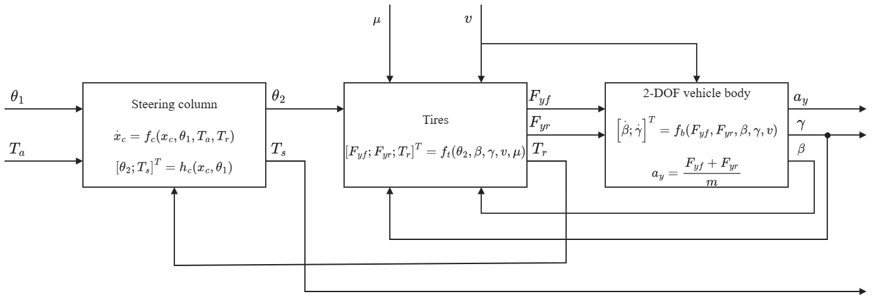
Fig. 1. Block diagram of the coupled C-EPS–vehicle plant: steering column, tires, and two-degree-of-freedom vehicle body.

2.1. Steering Column and Assist Motor
The mechanical structure of the column-type EPS is shown in Fig. 2. The upper column, driven by the steering wheel, is connected to the lower column through a torsion bar of stiffness $K$, which also serves as the torque sensor. The motor applies the assist torque $T_{a}$ to the lower column through a reduction gear, and the lower column drives the rack through the steering gear of ratio $n_{st}$. The steering-wheel angle $θ_{1}$ is prescribed as the driver input. The lower-column dynamics and the torsion-bar torque are modeled as [1]
$$\begin{aligned}J_{col}{\ddot{θ}}_{2}=T_{s}+T_{a}-T_{r}-C_{col}{\dot{θ}}_{2}-T_{f} tanh\left(c{\dot{θ}}_{2}\right)\#\left(1\right)\end{aligned}$$
$$\begin{aligned}T_{s}=K\left(θ_{1}-θ_{2}\right)\#\left(2\right)\end{aligned}$$
where $θ_{2}$ is the lower-column angle; $J_{col}$ and $C_{col}$ are the equivalent inertia and viscous damping of the lower column, including the motor and gear referred to the column; and $T_{f} tanh\left(c{\dot{θ}}_{2}\right)$ is a smooth approximation of Coulomb friction with amplitude $T_{f}$. Both $T_{a}$ and the road-reaction torque $T_{r}$ are referred to the column side of the mechanism.
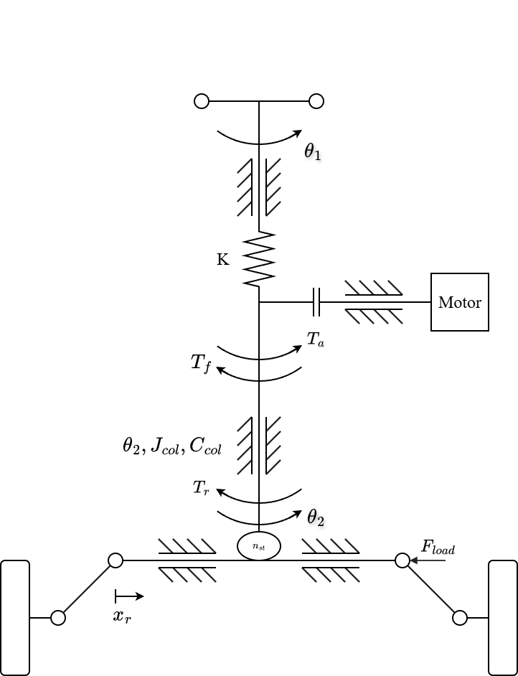
Fig. 2. Mechanical structure of the column-type EPS.
Prescribing $θ_{1}\left(t\right)$ allows $T_{s}$ to change when the road reaction or the motor assistance changes. If the driver torque were imposed instead, it would fix the sensed torque at steady state and hide the over-assist mechanism examined here. The prescribed-angle driver therefore supports a controlled comparison of steering-effort responses, but it does not represent the driver's neuromuscular response or the correction of steering angle in response to changing effort.

2.2. Tire Model and Road-Reaction Torque
Figure 3 defines the road-plane quantities of the front tire. The front-wheel angle is approximated by $δ_{f}=θ_{2}/n_{st}$. Under the small-angle and constant-longitudinal-speed assumptions, the front and rear slip angles are [13]
$$\begin{aligned}α_{f}=\frac{θ_{2}}{n_{st}}-β-\frac{l_{f}γ}{v}\#\left(3\right)\end{aligned}$$
$$\begin{aligned}α_{r}=-β+\frac{l_{r}γ}{v}\#\left(4\right)\end{aligned}$$
where $β$ is the vehicle sideslip angle, $γ$ is the yaw rate, and $l_{f}$ and $l_{r}$ are the distances from the center of gravity to the front and rear axles. Longitudinal and lateral load transfer are neglected, giving the static axle loads
$$\begin{aligned}F_{zf}=mg\frac{l_{r}}{l_{f}+l_{r}}\#\left(5\right)\end{aligned}$$
$$\begin{aligned}F_{zr}=mg\frac{l_{f}}{l_{f}+l_{r}}\#\left(6\right)\end{aligned}$$
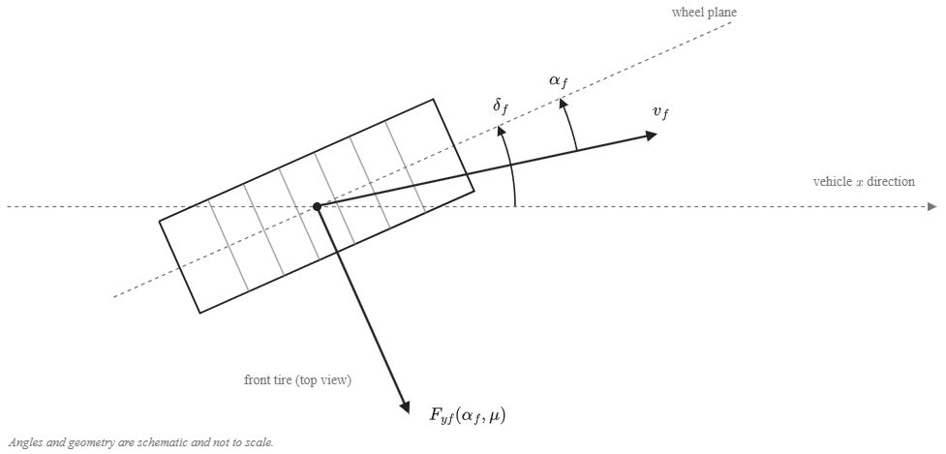
Fig. 3. Top-view geometry of the front-tire steering angle, slip angle, and lateral force.
Each axle is represented by one equivalent tire. To retain force saturation when road friction changes, the lateral forces are calculated with a simplified Pacejka Magic Formula [12]:
$$\begin{aligned}F_{yi}=D_{i} sin[C\tan^{-1}(B_{i}α_{i}-E(B_{i}α_{i}-\tan^{-1}\left(B_{i}α_{i}\right)))], i∈\{f,r\}\#\left(7\right)\end{aligned}$$
$$\begin{aligned}D_{i}=μF_{zi}, B_{i}=\frac{C_{αi}}{CD_{i}}\#\left(8\right)\end{aligned}$$
where $μ$ is the common tire–road friction coefficient, $C_{αi}$ is the axle cornering stiffness, and $C$ and $E$ are shape and curvature factors. This parameterization preserves the initial slope $C_{αi}$ while reducing the peak force $D_{i}$ as $μ$ decreases, so the tire saturates earlier on a lower-friction surface.
The front lateral force acts on the steering axis through an effective moment arm that contains a constant caster component and a slip-dependent pneumatic component. Adapting the pneumatic-trail relation used in [3], the model defines
$$\begin{aligned}t_{p}= max(0, t_{0}-\frac{t_{0}C_{αf}| tanα_{f}|}{3μF_{zf}})\#\left(9\right)\end{aligned}$$
$$\begin{aligned}e_{eff}=e_{c}+t_{p}, e_{c}=e_{p0}-t_{0}\#\left(10\right)\end{aligned}$$
where $e_{p0}$ is the effective moment arm at zero slip, $t_{0}$ is the zero-slip pneumatic trail, and $e_{c}$ is the constant caster component. The nonnegative bound on $t_{p}$ represents the loss of pneumatic trail as the modeled contact patch reaches full sliding; retaining $e_{c}$ prevents the total moment arm from being forced to zero. These bounds are modeling choices added to the source relation and do not reproduce the complete aligning-moment behavior of a measured tire. The road reaction referred to the steering column is
$$\begin{aligned}T_{r}=\frac{e_{eff}}{n_{st}}F_{yf}\#\left(11\right)\end{aligned}$$
Equations (8)–(11) contain the two effects of friction on the column: a lower $μ$ reduces the attainable $F_{yf}$ and, at the same slip angle, shortens the pneumatic trail $t_{p}$. Both reduce $T_{r}$.

2.3. Single-Track Vehicle Body
The lateral and yaw motion of the vehicle is governed by the nonlinear single-track balances [13]:
$$\begin{aligned}a_{y}=\frac{F_{yf}+F_{yr}}{m}\#\left(12\right)\end{aligned}$$
$$\begin{aligned}\dot{β}=\frac{a_{y}}{v}-γ\#\left(13\right)\end{aligned}$$
$$\begin{aligned}\dot{γ}=\frac{l_{f}F_{yf}-l_{r}F_{yr}}{I_{z}}\#\left(14\right)\end{aligned}$$
where $m$ and $I_{z}$ are the vehicle mass and yaw moment of inertia. The lateral acceleration $a_{y}$ of Eq. (12) is also the measured signal used by the torque reference in Section 2.5.

2.4. Coupled Plant and Over-Assist Mechanism
Combining Eqs. (1)–(14), the coupled steering-column and vehicle plant of Fig. 1 has four states, $θ_{2}$, ${\dot{θ}}_{2}$, $β$, and $γ$; the motor, compensator, and controller states are added separately in the closed-loop simulations. For a stationary steering column, Eq. (1) becomes
$$\begin{aligned}T_{s}=T_{r}-T_{a}\#\left(15\right)\end{aligned}$$
because the smoothed Coulomb-friction term vanishes at ${\dot{θ}}_{2}=0$. Equations (7)–(15) expose the mechanism of interest: decreasing $μ$ lowers the tire-force capacity and the pneumatic trail and therefore $T_{r}$. If the assistance does not decrease by the same amount, Eq. (15) predicts a reduction of the steering torque transmitted through the torsion bar, that is, over-assist.

2.5. Lateral-Acceleration-Based Torque Reference
The desired steering torque is obtained from the speed- and lateral-acceleration-dependent steering-effort data reported by Li and Xia [5]. The four lateral-acceleration levels published in that study are reproduced in Table 1 and are treated here as a reference characteristic rather than as a universal driver-preference model.
Table 1. Ideal steering-wheel torque reference (N·m), adopted from [5].
Lateral acceleration | 20 km/h | 40 km/h | 60 km/h | 80 km/h | 100 km/h
0.1 g | 1.0 | 1.7 | 2.1 | 2.3 | 2.6
0.2 g | 1.5 | 2.0 | 2.4 | 2.8 | 3.0
0.3 g | 1.6 | 2.3 | 2.8 | 3.1 | 3.3
0.4 g | 1.8 | 2.4 | 2.9 | 3.3 | 3.4

A zero-torque point is added at zero lateral acceleration. Monotone piecewise cubic Hermite interpolation is applied first along lateral acceleration and then along vehicle speed, after which the result is sampled on a finer table for implementation. Odd symmetry supplies the negative-turning branch, while inputs beyond 20–100 km/h or 0–0.4 g are clipped to the nearest boundary:
$$\begin{aligned}T_{ref}\left(v,a_{y}\right)=sgn\left(a_{y}\right)widehatT\left(v,|a_{y}|\right)\#\left(16\right)\end{aligned}$$
$$\begin{aligned}widehatT\left(v,0\right)=0\#\left(17\right)\end{aligned}$$
where $widehatT$ denotes the interpolated positive-acceleration characteristic. Adding the zero point, imposing odd symmetry, selecting PCHIP interpolation, and clipping outside the published grid are implementation choices of this study. They make the reference continuous through straight-ahead driving without extrapolating unreported steering-effort values.
The reference uses measured vehicle speed and lateral acceleration and does not require an estimate of $μ$ or rack force. Because $a_{y}$ is an input to the reference, a friction reduction can also change the target by changing the vehicle response. The controller therefore regulates effort relative to the motion actually produced by the vehicle instead of enforcing the same torque at a fixed steering-wheel angle on every surface.

2.6. Torque-Tracking Objective
The common control objective is to regulate the measured torsion-bar torque toward the reference:
$$\begin{aligned}e_{T}=T_{s}-T_{ref}\left(v,a_{y}\right)\#\left(18\right)\end{aligned}$$
For $T_{ref}ne0$, $sgn\left(T_{ref}\right)e_{T}<0$ denotes a torque magnitude below the target in the commanded turning direction. Reversal intervals are evaluated with magnitude-based measures because the signed interpretation becomes ambiguous near a zero crossing. All controllers act through the same bounded assist-torque channel:
$$\begin{aligned}|T_{a}|≤T_{a,max}\left(v\right)\#\left(19\right)\end{aligned}$$
where $T_{a,max}\left(v\right)$ is derived from the modeled dry-road assistance requirement and is specified with the actuator implementation. The comparison therefore asks how each controller reduces the torque-tracking error under varying friction while satisfying the same motor dynamics, assist limit, sensor conditions, and stability requirements.

3. Control Strategy and Assist-Map Limitation
This section presents the three control structures: conventional assist-map control with lead–lag compensation (Map), direct PID steering-torque feedback (PID), and the plug-in combination (MapPID), in which the Map design is retained unchanged and a PID branch is added in parallel. A steady-state sensitivity analysis quantifies the limitation of a static assist map when tire–road friction changes and shows why an added integral branch removes it independently of the map calibration.

3.1. Conventional Assist-Map Control with Lead–Lag Compensation
The conventional controller follows the standard automotive architecture in which basic motor assistance is scheduled through a static two-dimensional map from measured torsion-bar torque and vehicle speed, followed by dynamic stabilizing compensation [1]. Under nominal dry-road conditions ($μ=0.8$), the required assistance at each calibration breakpoint is determined from the static torque equilibrium of Eq. (15):
$$\begin{aligned}T_{s,cal}=T_{ref}\left(v,a_{y}\right)\#\left(20\right)\end{aligned}$$
$$\begin{aligned}T_{a,cal}=T_{r}\left(v,a_{y},0.8\right)-T_{ref}\left(v,a_{y}\right)\#\left(21\right)\end{aligned}$$
The nominal dry-road assist map is calibrated across 17 vehicle speeds from 20 to 100 km/h in increments of 5 km/h. At each speed, feasible lateral accelerations are evaluated in increments of 0.005 g. The raw assistance is bounded by a symmetric torque dead zone $T_{s0}=0.3$ N·m around straight-ahead driving to prevent motor chattering from sensor noise, and by a maximum local slope $K_{max}$. At each calibration breakpoint, the allowable assist increment is constrained by ${\overline{M}}_{k}≤{\overline{M}}_{k-1}+K_{max}\left(|T_{s}|_{k}-|T_{s}|_{k-1}\right)$, preserving nondecreasing assistance while preventing excessively steep transitions:
$$\begin{aligned}M\left(v,T_{s}\right)=sgn\left(T_{s}\right)\overline{M}\left(v,|T_{s}|\right)\#\left(22\right)\end{aligned}$$
where $\overline{M}\left(v,|T_{s}|\right)$ is the bounded monotonic assist characteristic for positive torque. The resulting characteristic is tabulated over measured steering torque from 0 to 5 N·m with linear interpolation across torque and vehicle speed.
To stabilize the closed loop around the steering-column resonance (about 6.2 Hz) while limiting high-frequency noise amplification from the high assist gain, the static map output is processed by a linear lead–lag compensator $C_{map}\left(s\right)$ [1]:
$$\begin{aligned}u_{map}\left(s\right)=C_{map}\left(s\right)M\left(v_{m},T_{s,m}\right)\#\left(23\right)\end{aligned}$$
$$\begin{aligned}C_{map}\left(s\right)=(\frac{\frac{s}{z}+1}{\frac{s}{p}+1})(\frac{\frac{s}{z_{1}}+1}{\frac{s}{p_{1}}+1})\#\left(24\right)\end{aligned}$$
where $z$ and $p$ are the zero and pole frequencies of the lead stage, and $z_{1}$ and $p_{1}$ are those of the lag stage. The lead stage provides phase advance around the column resonance, while the lag stage provides high-frequency gain roll-off. Both stages have unity steady-state gain ($C_{map}\left(0\right)=1$), so the calibrated static characteristic is preserved. The closed-loop signal flow of the assist-map controller is shown in Fig. 4.
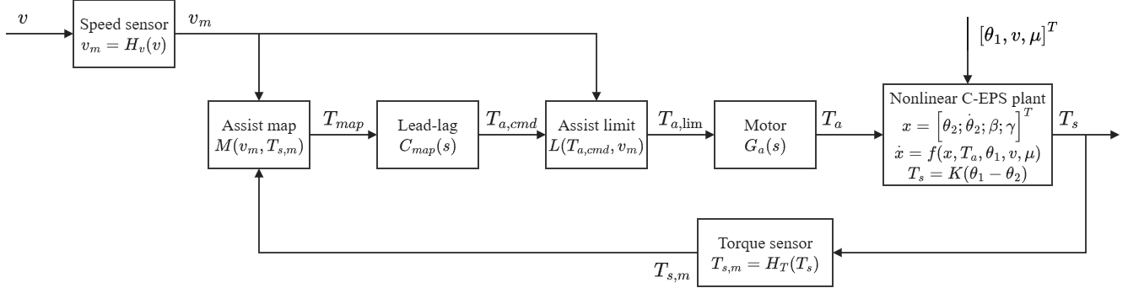
Fig. 4. Closed-loop signal flow of the assist-map controller.

3.2. Steady-State Limitation of Assist-Map Control
The limitation of the assist map under friction variation can be evaluated through a local steady-state sensitivity analysis. At a constant vehicle speed and fixed lateral acceleration, column equilibrium under assist-map control requires
$$\begin{aligned}T_{s}+M\left(v,T_{s}\right)=T_{r}\left(v,a_{y},μ\right)\#\left(25\right)\end{aligned}$$
where the Coulomb friction term vanishes at steady state (${\dot{θ}}_{2}=0$) and $C_{map}\left(0\right)=1$. Linearizing Eq. (25) with respect to a change in road-reaction torque $ΔT_{r}$ yields
$$\begin{aligned}ΔT_{s}=\frac{ΔT_{r}}{1+s_{m}}\#\left(26\right)\end{aligned}$$
$$\begin{aligned}s_{m}=\frac{∂M\left(v,T_{s}\right)}{∂T_{s}}\#\left(27\right)\end{aligned}$$
where $s_{m}$ denotes the local slope of the assist map at the operating point.
Equation (26) shows that the change in sensed torsion-bar torque is attenuated only by the factor $1/\left(1+s_{m}\right)$. Because the target torque $T_{ref}\left(v,a_{y}\right)$ is unchanged at fixed speed and lateral acceleration, the change in tracking error equals $ΔT_{s}$:
$$\begin{aligned}Δe_{T}=\frac{ΔT_{r}}{1+s_{m}}\#\left(28\right)\end{aligned}$$
When friction drops from the dry value ($μ=0.8$), the road reaction $T_{r}$ decreases because of tire-force saturation and pneumatic-trail reduction. Because $s_{m}$ is positive and finite ($s_{m}≤K_{max}$), $Δe_{T}$ is nonzero and has the same sign as $ΔT_{r}$: $T_{s}$ falls below the desired value, which is the over-assist condition. Increasing $K_{max}$ reduces $Δe_{T}$ but raises the loop gain and amplifies sensor noise, and no finite slope removes $Δe_{T}$. The same slope limit also prevents the map from reaching the calibration points of Eq. (21) where the required local slope exceeds $K_{max}$, so a residual error can remain even on a dry road. In contrast, any controller with integral action on $e_{T}$ enforces $e_{T}=0$ at steady state whenever the actuator is not saturated.

3.3. PID Steering-Torque Feedback Control
The PID controller regulates the torque-tracking error $e_{T}=T_{s,m}-T_{ref}\left(v_{m},a_{y,m}\right)$ directly. To avoid a derivative kick after rapid changes of the reference, the derivative action is placed on the measured torsion-bar torque $T_{s,m}$ rather than on the error, and it is filtered by a first-order lag:
$$\begin{aligned}u_{P}=K_{p}e_{T}\#\left(29\right)\end{aligned}$$
$$\begin{aligned}{\dot{u}}_{I}=K_{i}e_{T}+K_{aw}ΔT_{a}\#\left(30\right)\end{aligned}$$
$$\begin{aligned}u_{D}\left(s\right)=(\frac{K_{d}s}{T_{f}s+1})T_{s,m}\left(s\right)\#\left(31\right)\end{aligned}$$
where $K_{p}$, $K_{i}$, and $K_{d}$ are the proportional, integral, and derivative gains, $T_{f}$ is the derivative filter time constant, and $K_{aw}$ is the anti-windup tracking gain.
In Eq. (31), the derivative term has a positive sign because an increasing measured torque $T_{s}$ indicates insufficient assistance in the column convention of Eq. (1), which requires an increase of assist torque. The total unconstrained command is
$$\begin{aligned}T_{a,cmd}=u_{P}+u_{I}+u_{D}\#\left(32\right)\end{aligned}$$
Actuator saturation is handled by back-calculation anti-windup. The difference between the bounded motor command $T_{a,lim}$ and the raw command $T_{a,cmd}$ is fed back to the integrator in Eq. (30):
$$\begin{aligned}ΔT_{a}=T_{a,lim}-T_{a,cmd}\#\left(33\right)\end{aligned}$$
$$\begin{aligned}K_{aw}=\frac{K_{i}}{K_{p}}\#\left(34\right)\end{aligned}$$
This back-calculation discharges the integrator whenever the motor saturates at $T_{a,max}\left(v_{m}\right)$ and allows a fast recovery when the error reverses. Figure 5 shows the signal flow of the PID torque-feedback controller.
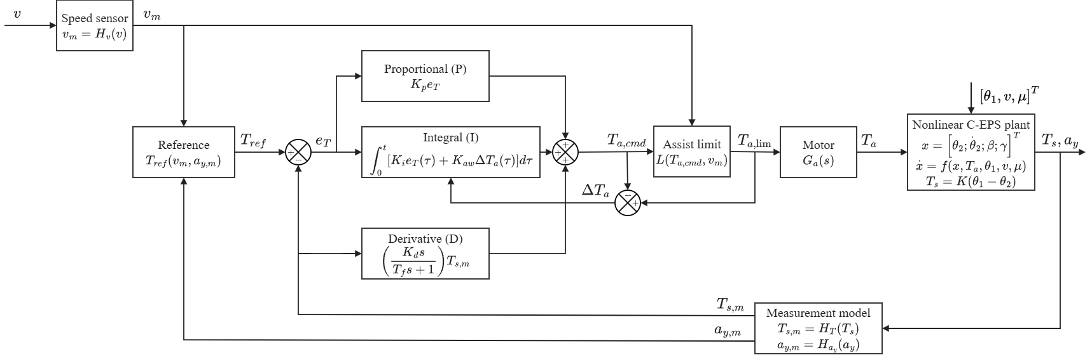
Fig. 5. Closed-loop signal flow of the PID steering-torque controller.

3.4. Plug-In Map-PID Control Structure
The MapPID structure keeps the assist map and lead–lag compensator of Section 3.1 exactly as calibrated for Map, including the slope limit $K_{max}$, the dead zone $T_{s0}$, and the compensator frequencies, and adds the PID branch of Section 3.3 in parallel (Fig. 6). Only the four branch parameters $K_{p}$, $K_{i}$, $K_{d}$, and $T_{f}$ are tuned, with the map block frozen. The branch is therefore a plug-in: it can be attached to an existing calibration without changing the map that encodes the dry-road steering characteristic. The assist command is
$$\begin{aligned}T_{a,cmd}=u_{map}+u_{PID}\#\left(35\right)\end{aligned}$$
$$\begin{aligned}u_{PID}=u_{P}+u_{I}+u_{D}\#\left(36\right)\end{aligned}$$
where $u_{map}$ is computed from Eq. (23) and $u_{PID}$ from Eqs. (29)–(31).
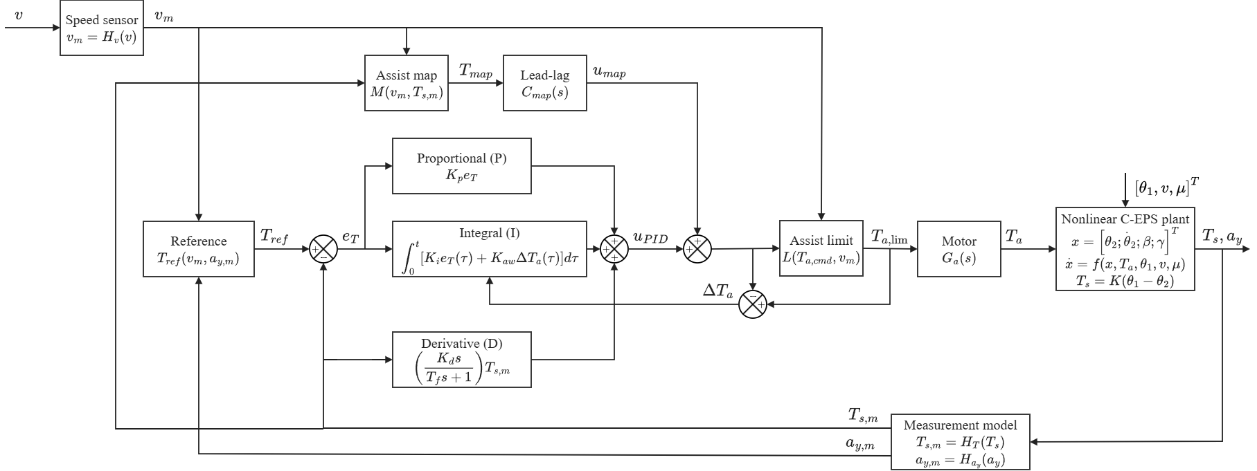
Fig. 6. Closed-loop signal flow of the plug-in MapPID controller.
The steady-state behavior of the plug-in branch follows from Eq. (25). With the branch attached, the column equilibrium becomes $T_{s}+M\left(v,T_{s}\right)+u_{PID}=T_{r}\left(v,a_{y},μ\right)$. While the closed loop is stable and the actuator is not saturated, the integrator stops changing only when $e_{T}=0$, so that $T_{s}=T_{ref}$ and the branch settles at
$$\begin{aligned}u_{PID,ss}=T_{r}\left(v,a_{y},μ\right)-T_{ref}\left(v,a_{y}\right)-M\left(v,T_{ref}\right)\#\left(37\right)\end{aligned}$$
Equation (37) states the two properties on which the plug-in structure relies. First, the steady-state accuracy does not depend on the map: any monotonic map, whatever its slope or calibration, leads to $e_{T}=0$. Second, the branch supplies only the residual that the map leaves. At a dry-road calibration point reached by the map, Eq. (21) gives $M\left(v,T_{ref}\right)=T_{r}\left(v,a_{y},0.8\right)-T_{ref}$, so $u_{PID,ss}=T_{r}\left(v,a_{y},μ\right)-T_{r}\left(v,a_{y},0.8\right)$, which is zero on the dry road and equal to the friction-induced change of road reaction otherwise. Where the slope limit prevents the map from reaching its calibration point, $u_{PID,ss}$ also contains that calibration residual.
The map is not neutral for the dynamics of the branch. Around an operating point, the forward path from measured torque to assist torque is $s_{m}C_{map}\left(s\right)+C_{PID}\left(s\right)$, where $C_{PID}\left(s\right)$ is the linearized PID transfer function. The map slope therefore adds to the low-frequency loop gain, which can reduce the proportional gain needed by the branch, but it also adds to the loop gain near the column resonance, so the stability margins of the branch depend on the map it is attached to. The branch is therefore tuned separately for each vehicle: the map and stabilizing compensator of that vehicle are frozen in the loop, the plant model is adjusted to match the vehicle, and the stability requirements are verified on the combined loop. Both branches share the common saturation limit:
$$\begin{aligned}T_{a,lim}=clip\left(T_{a,cmd},-T_{a,max}\left(v_{m}\right),T_{a,max}\left(v_{m}\right)\right)\#\left(38\right)\end{aligned}$$
Because both the map, with maximum slope $K_{max}$, and the proportional path $K_{p}$ contribute to the forward gain between sensed torque and assist torque, the effective forward gain is bounded by $K_{p}+K_{max}$. The back-calculation anti-windup gain is scaled accordingly:
$$\begin{aligned}K_{aw}=\frac{K_{i}}{K_{p}+K_{max}}\#\left(39\right)\end{aligned}$$
When $K_{max}=0$, Eq. (39) reduces to the PID rule of Eq. (34), and when $K_{p}$ is small, the map slope keeps the anti-windup gain finite. The map therefore remains responsible for the nominal dry-road assistance, while the plug-in branch corrects the deviations caused by friction changes, tire saturation, and the slope-limited calibration.
In application, the Map of this study stands for the block formed by the assist map and stabilizing compensator that a production vehicle already has. That block is taken as given, the plant model is adjusted to the vehicle, and the search for the four PID parameters is carried out on top of it, once for each vehicle. The reference must reproduce the dry-road steady-state steering torque of the vehicle's own map, as Eq. (20) does for the map of this study, so that the added branch preserves the intended dry-road steering feel.

4. Simulation Setup and Evaluation Methodology

4.1. Simulation Model and Implementation
The three controllers are evaluated using the nonlinear C-EPS–vehicle model described in Section 2. The adopted steering, vehicle, and tire parameters are summarized in Table 2. Steering-column parameters are based on [1], whereas the tire and vehicle model formulations follow [12,13]. The steering ratio and trail dimensions are prescribed modeling parameters. The magnitude of the friction-induced steering-torque reduction depends on the assumed zero-slip pneumatic trail. For a friction decrease from μ = 0.8 to 0.3 under the fixed-lateral-acceleration condition considered in the sensitivity analysis, varying $t_{0}$ from 17 to 35 mm changes the predicted reduction in sensed torque from approximately 6% to 13% without motor assistance. The nominal parameter value gives a reduction of about 9–10%. The model therefore captures the expected direction of the effect, while its magnitude remains dependent on the assumed steering geometry.
Table 2. Parameters of the nonlinear C-EPS–vehicle model.
Parameter | Symbol | Value | Unit
Torsion-bar stiffness | $K$ | 143.24 | N·m/rad
Lower-column inertia | $J_{col}$ | 0.11 | kg·m²
Column viscous damping | $C_{col}$ | 1.35 | N·m·s/rad
Coulomb friction amplitude | $T_{f}$ | 2 | N·m
Friction smoothing coefficient | $c$ | 100 | s/rad
Vehicle mass | $m$ | 1573 | kg
Yaw moment of inertia | $I_{z}$ | 2873 | kg·m²
Front axle distance | $l_{f}$ | 1.10 | m
Rear axle distance | $l_{r}$ | 1.58 | m
Front/rear cornering stiffness | $C_{αf}$, $C_{αr}$ | 160000 | N/rad
Magic Formula shape factor | $C$ | 1.3 | -
Magic Formula curvature factor | $E$ | −1 | -
Steering ratio | $n_{st}$ | 16 | -
Initial effective moment arm | $e_{p0}$ | 0.048 | m
Initial pneumatic trail | $t_{0}$ | 0.025 | m

The model is evaluated between 20 and 100 km/h and friction coefficients from 0.2 to 0.8. Below 20 km/h, the inverse-speed terms in the vehicle equations and the quasi-static tire assumptions become less reliable. The feasible lateral-acceleration range is limited by tire friction and by the small-angle assumptions. At 20 km/h, the adopted model permits approximately 0.2 g, whereas the upper limit approaches the friction-dependent tire-force limit at higher speeds. Therefore, calibration and test points are restricted to feasible operating conditions rather than the full rectangular range of the reference table. Equal tire–road friction is assumed on the left and right sides of the vehicle, and the steering-wheel angle is prescribed independently of the driver's response to steering torque.
The motor dynamics are approximated by a first-order transfer function [1]:
$$\begin{aligned}G_{m}\left(s\right)=\frac{ω_{m}}{s+ω_{m}}, ω_{m}=2π\left(100\right) rad/s\#\left(40\right)\end{aligned}$$
The common motor model includes a 1 ms computation delay and the speed-dependent assist limit defined in Eq. (19). The latter is calculated from the maximum required dry-road assistance:
$$\begin{aligned}T_{a,max}\left(v\right)=\max_{0≤a_{y}≤a_{y,lim}\left(v\right)} \left[T_{r}\left(v,a_{y},0.8\right)-T_{ref}\left(v,a_{y}\right)\right]+T_{f}\#\left(41\right)\end{aligned}$$
$$\begin{aligned}a_{y,lim}\left(v\right)= min\left(a_{y,max}\left(v,0.8\right), 0.4g\right)\#\left(42\right)\end{aligned}$$
where $a_{y,max}\left(v,0.8\right)$ denotes the maximum attainable lateral acceleration under the adopted dry-road model. This limit is derived from the simulation model and does not represent a validated capacity of a production EPS motor.
All controllers operate at a sampling period $T_{c}=1 ms$. The lead–lag compensator is discretized using the Tustin method, while the PI/PID integrator employs forward Euler integration with back-calculation anti-windup. The integral and filtered derivative states are updated as
$$\begin{aligned}u_{I}[k+1]=u_{I}[k]+\backslash T_{c}\left(K_{i}e_{T}[k]+K_{aw}\left(T_{a,lim}[k]-T_{a,cmd}[k]\right)\right)\#\left(43\right)\end{aligned}$$
$$\begin{aligned}d[k]=a_{d}d[k-1]+b_{d}\left(T_{s}[k]-T_{s}[k-1]\right)\#\left(44\right)\end{aligned}$$
$$\begin{aligned}a_{d}=\frac{τ_{d}}{τ_{d}+T_{c}}, b_{d}=\frac{K_{d}}{τ_{d}+T_{c}}\#\left(45\right)\end{aligned}$$
where $T_{a,lim}$ denotes the assist-torque command after application of the common motor-block saturation limit. The difference between the limited and unlimited commands provides the back-calculation signal used to prevent integrator windup. The PI controller uses d[k] = 0, whereas PID uses the derivative state in Eq. (44). The anti-windup gain is:
$$\begin{aligned}K_{aw}=\frac{K_{i}}{K_{p}}\#\left(46\right)\end{aligned}$$
Sensor noise, quantization, and update periods are modeled according to Table 3, with resolutions taken from the sensor data sheets [14–16]. The noise standard deviation equals one resolution step for each sensor, except for vehicle speed, for which 0.38 km/h is adopted [17]. The 10 ms vehicle-signal update period is an implementation assumption.
Table 3. Sensor and actuator settings.
Signal or component | Resolution or setting | Update period
Steering torque $T_{s}$ | 0.01 N·m | 1 ms
Steering-wheel angle $θ_{1}$ | 0.1° | 1 ms
Column angular velocity ${\dot{θ}}_{2}$ | 4°/s | 1 ms
Vehicle speed $v$ | 1 km/h | 10 ms
Yaw rate $γ$ | 0.1°/s | 10 ms
Lateral acceleration $a_{y}$ | 0.01 g | 10 ms
Controller sampling | 1 ms | 1 ms
Motor bandwidth | 100 Hz | Continuous-time model
Computation delay | 1 ms | -

The same five noise realizations (random-number seeds 99999 to 99995) are used for all controllers. The scoring results are reported as the mean and the sample standard deviation over the five realizations; the time histories in Figs. 8–10 show the realization with seed 99999. The motor current loop and electrical power constraints are not modeled. The initial 2 s of each simulation are excluded from performance evaluation.

4.2. Controller Calibration and Selection
The 117 s CALIB scenario contains steady cornering, sinusoidal steering, small lateral-acceleration corrections, and friction transitions. Steady-cornering tests are performed at 20, 60, and 100 km/h. The targets are 0.1, 0.15, and 0.18 g at 20 km/h, and 0.1, 0.2, and 0.3 g at 60 and 100 km/h. Each steady target is approached over 1 s and then held for 3 s, with the final second used for evaluation.
The calibration metric includes nine steady-cornering windows, three sinusoidal-steering windows at 0.5 Hz, three small-correction windows involving ±0.03 g target changes, and two friction-transition windows. At 60 km/h and a target of 0.3 g, road friction falls from 0.8 to 0.6 at 71 s and returns to 0.8 at 75 s. Two additional 0.4 g windows are retained for reporting but excluded from the calibration objective.
Torque-tracking accuracy and high-frequency assist-torque content are quantified by
$$\begin{aligned}R=\left(\frac{100}{4}\right) \sum_{q∈\{static,sine,small,mu\}}{}\backslash \left(\frac{RMS_{q}\left(e_{T}\right)}{mean_{q}\left(|T_{ref}|\right)}\right)\#\left(47\right)\end{aligned}$$
$$\begin{aligned}S=RMS\left(T_{a}-F_{5}\left(T_{a}\right)\right)\#\left(48\right)\end{aligned}$$
The metric R is the average normalized RMS tracking error across the four evaluation groups, expressed in percent. The metric S is computed as the RMS difference between the applied assist torque and its first-order low-pass-filtered counterpart, using a cutoff frequency of 5 Hz. It quantifies high-frequency assist-torque content, which may arise from both sensor-noise amplification and rapid control action. For steady-cornering windows, the signed relative error is calculated as:
$$\begin{aligned}e_{rel}=100\frac{sgn\left(T_{ref}\right) mean\left(e_{T}\right)}{mean\left(|T_{ref}|\right)}\#\left(49\right)\end{aligned}$$
RMS error is used for steering-reversal windows, where signed relative errors may be misleading.
Candidate controllers must satisfy two admissibility requirements. The maximum absolute steady-state relative error across the nine calibration windows must not exceed 5%. Additionally, each configuration must remain stable under a doubled motor gain and an extra 1 ms computation delay, with the corresponding R value no greater than twice its nominal value. These are specified perturbation tests rather than a general guarantee of robust stability.
The final configuration is selected by minimizing
$$\begin{aligned}J=R·S\#\left(50\right)\end{aligned}$$
among the admissible designs. To preserve the 0.2–2 Hz steering-response band, the lag stage of the assist-map compensator and the first-order derivative filters of PID are constrained to have a magnitude response no lower than −3 dB at 2 Hz. The PI controller has no corresponding filtering constraint.

4.3. Independent Evaluation Scenarios
After calibration, the controllers are tested on five independent scenarios. The conditions and principal evaluation measures are summarized in Table 4.
Table 4. Calibration and independent evaluation scenarios.
Scenario | Duration | Main operating conditions | Evaluation
CALIB | 117 s | 20, 60, 100 km/h; steady corners, 0.5 Hz steering and ±0.03 g corrections; μ = 0.8 → 0.6 → 0.8 | Controller selection
DRY | 129 s | Steady cornering at 20–100 km/h; μ = 0.8 | Maximum steady relative error
SLIP | 63 s | Low-friction patch, friction recovery and μ = 0.8 → 0.3 during cornering | Steady and transient torque errors
WEAVE | 61 s | Slalom and sinusoidal steering under dry and low-friction conditions | RMS error, noise, reverse assist
RAMP | 308.6 s | Vehicle-speed changes during steady cornering; μ = 0.8 | Signed relative error
EDGE | 87 s | High lateral acceleration of 0.35–0.4 g and sinusoidal steering | Tracking near operating limits

DRY evaluates tracking accuracy at operating speeds not fully represented by the calibration windows. SLIP tests the response to changing tire–road friction, whereas WEAVE examines continuous steering and steering-direction reversals. RAMP and EDGE provide additional diagnostic assessments rather than contributing to the calibration score.
Reverse-assist percentage is defined as the number of evaluated samples for which $T_{a}T_{s}$ is negative and $|T_{s}|$ is at least 0.5 N·m, divided by the total number of evaluated samples.
All three controllers are evaluated using identical steering inputs, speed profiles, friction conditions, and sensor-noise sequences. Their comparative results are presented in Section 5.

5. Results and Discussion

5.1. Calibration Performance and Tracking–Noise Trade-off
The CALIB parameter search evaluated 61 assist-map configurations, 453 PI configurations, and 824 PID configurations. Of the evaluated configurations, 56 assist-map, 149 PI, and 435 PID designs passed the steady-state accuracy gate. The stability-perturbation and filtering constraints were then applied to determine the admissible configurations used in the Pareto comparison. Fig. 7 shows the tracking metric R against the high-frequency assist-torque metric S for the evaluated designs and their admissible Pareto fronts.
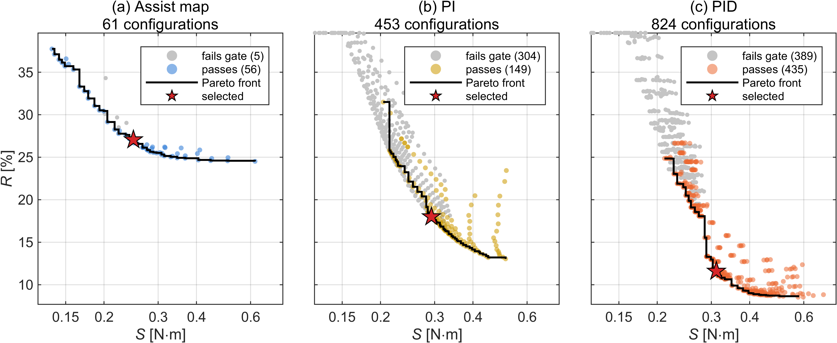
Fig. 7. Tracking–noise trade-off on CALIB: (a) assist map, (b) PI, (c) PID.
The evaluated assist-map and PID Pareto fronts share a high-frequency assist-torque range of approximately 0.21–0.62 N·m, allowing tracking errors to be compared at matched S values. At S = 0.25 N·m, the best admissible R values are 27.1% for the assist map and 20.5% for PID. At S = 0.30 N·m, these values are 25.5% and 13.0%, respectively. Thus, PID achieves lower tracking error at the two matched high-frequency assist-torque levels, while the assist map also provides admissible configurations at lower S values. Table 5 lists the selected designs. The tracking metric R decreases from 27.05% for the assist map to 18.00% for PI and 11.59% for PID. Over the same configurations, S increases from 0.249 to 0.293 and 0.312 N·m. All three designs satisfy the calibration accuracy gate and the specified gain- and delay-perturbation tests. The reported perturbation ratios describe changes in R and should not be interpreted as classical gain or phase margins.
Table 5. Calibration performance of the selected controllers.
Controller | R (%) | S (N·m) | J = R·S | Maximum steady error (%) | Gain ×2 ratio | Delay +1 ms ratio
Assist map | 27.05 | 0.249 | 6.74 | 3.17 | 0.78 | 1.00
PI | 18.00 | 0.293 | 5.27 | 3.78 | 0.58 | 1.02
PID | 11.59 | 0.312 | 3.61 | 2.33 | 0.40 | 1.01

The cost J is used solely to select a representative tracking–high-frequency-torque compromise within each controller family; it is not intended as a validated measure of steering feel.

5.2. Steering Torque Tracking under Dry-Road Conditions
The DRY scenario evaluates tracking performance under the calibration road condition across a wider set of steady-cornering operating points. Fig. 8 compares the steering torque response of the assist map, PI, and PID controllers.
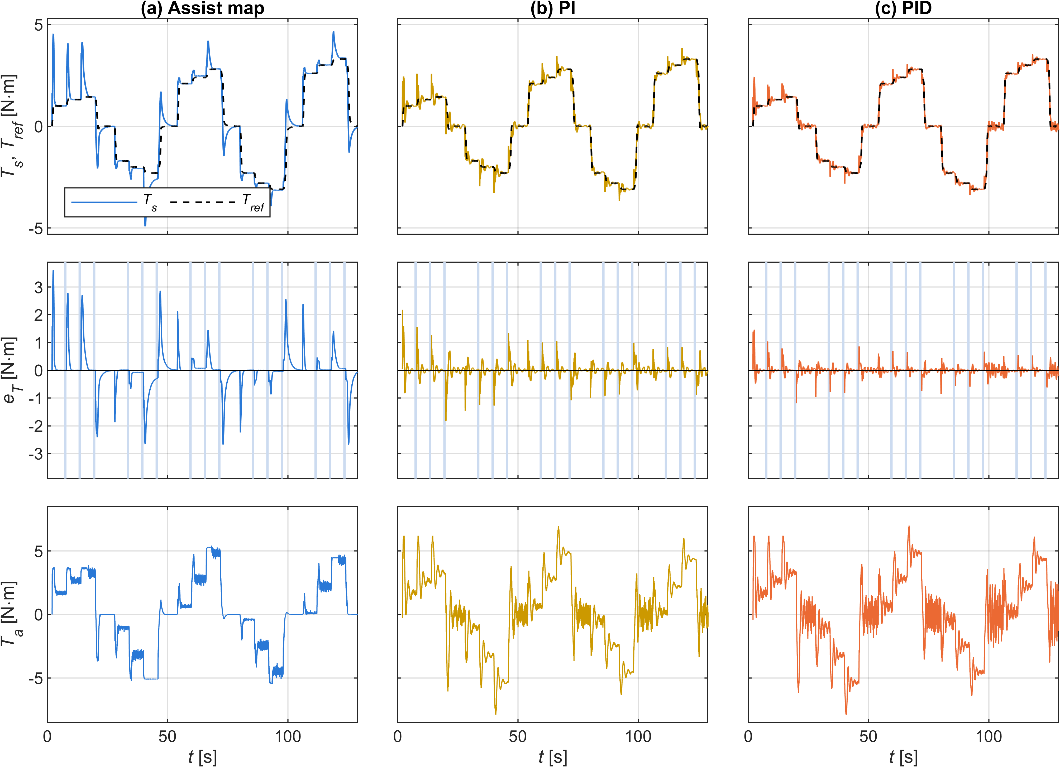
Fig. 8. DRY scenario: (a) assist map, (b) PI, (c) PID.
In the DRY scenario, the assist map reaches a maximum absolute steady-state error of 12.99% at 40 km/h and 0.3 g. At this point, measured steering torque exceeds the reference by approximately 0.30 N·m. In the 25–45 km/h and 0.25–0.3 g operating region, the unconstrained assist characteristic requires a local slope above the selected limit of 6. The slope-constrained map consequently provides less assistance than the ideal dry-road calibration characteristic, leaving the measured steering torque above its reference.
Across the DRY evaluation windows, the maximum absolute steady-state errors are 2.24% for PI and 1.77% for PID (standard deviations 0.41% and 0.39%). The difference between the two feedback controllers is within these standard deviations. The feedback controllers therefore maintain smaller worst-case errors across the evaluated operating points.

5.3. Torque Tracking under Varying Road Friction
The main objective of the proposed framework is assessed using the SLIP scenario. Fig. 9 compares the responses of the three controllers during low-friction disturbances and friction transitions.
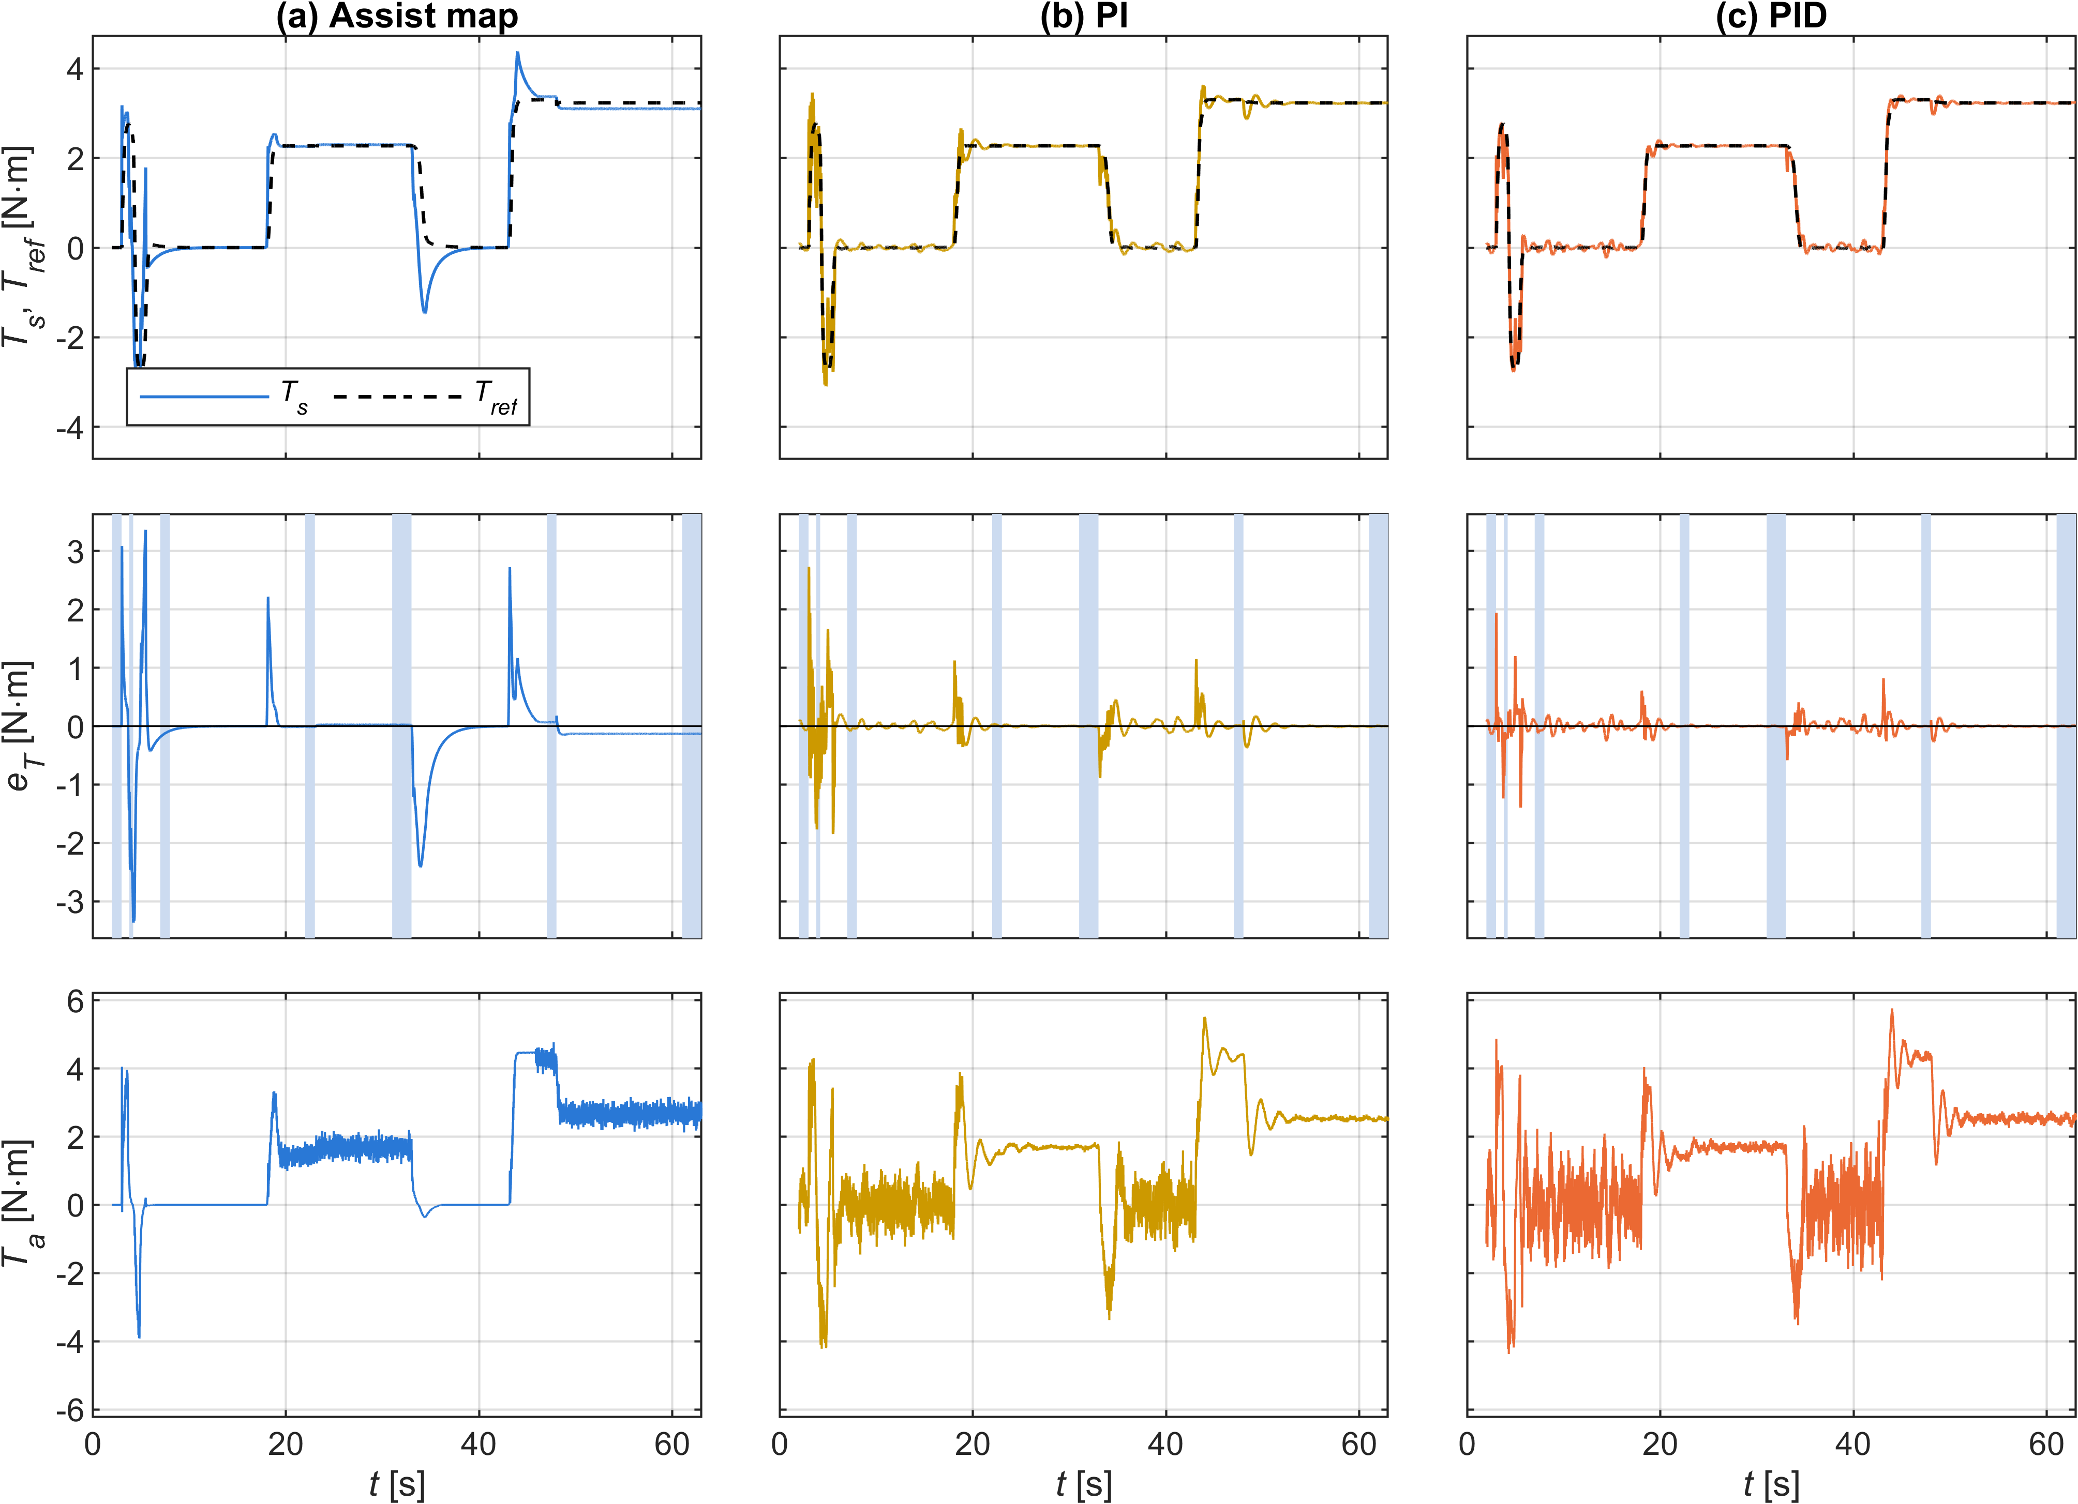
Fig. 9. SLIP scenario: (a) assist map, (b) PI, (c) PID.
In the SLIP scenario, road friction decreases from μ = 0.8 to 0.3 during a cornering maneuver at 100 km/h with a target lateral acceleration of 0.3 g. After the transition, the assist map retains a steady relative tracking error of −4.07%, compared with −0.08% for PI and −0.06% for PID (standard deviation 0.07% and 0.08%). The two feedback controllers are therefore both close to zero and cannot be distinguished from each other. The negative map error indicates that the measured steering torque is below the reference.
During the separate 0.4 s low-friction patch, the RMS tracking error is 2.30 N·m for the assist map, 0.85 N·m for PI, and 0.35 N·m for PID. In a friction-recovery event at 60 km/h and a target of 0.15 g, the corresponding steady relative errors are +1.01%, −0.15%, and −0.14%. Thus, the two integral-feedback controllers reduce the reported tracking errors for both friction reduction and recovery. These results apply to the simulated steering inputs and vehicle response; they do not isolate the map-slope effect from changes in lateral acceleration and reference torque during the transitions.

5.4. Dynamic Steering Performance and Practical Limitations
The remaining scenarios test continuous steering, changing vehicle speed, and operation at high lateral acceleration. Fig. 10 compares the tracking errors of the three controllers across DRY, RAMP, SLIP, WEAVE, and EDGE. Table 6 reports whole-case RMS tracking error, high-frequency assist-torque content, and reverse-assist percentage as mean ± standard deviation over the five noise realizations. Reverse assistance is defined here by the sign relationship between applied motor torque and measured steering torque. It does not, by itself, indicate closed-loop instability, actuator saturation, or a loss of steering control.
PID has the lowest whole-case RMS tracking error in all five scenarios. In WEAVE, for example, the RMS error decreases from 1.327 N·m for the assist map to 0.376 N·m for PI and 0.215 N·m for PID. The corresponding S values increase from 0.160 to 0.332 and 0.407 N·m. The tracking improvement is therefore accompanied by greater high-frequency assist-torque activity during continuous steering.
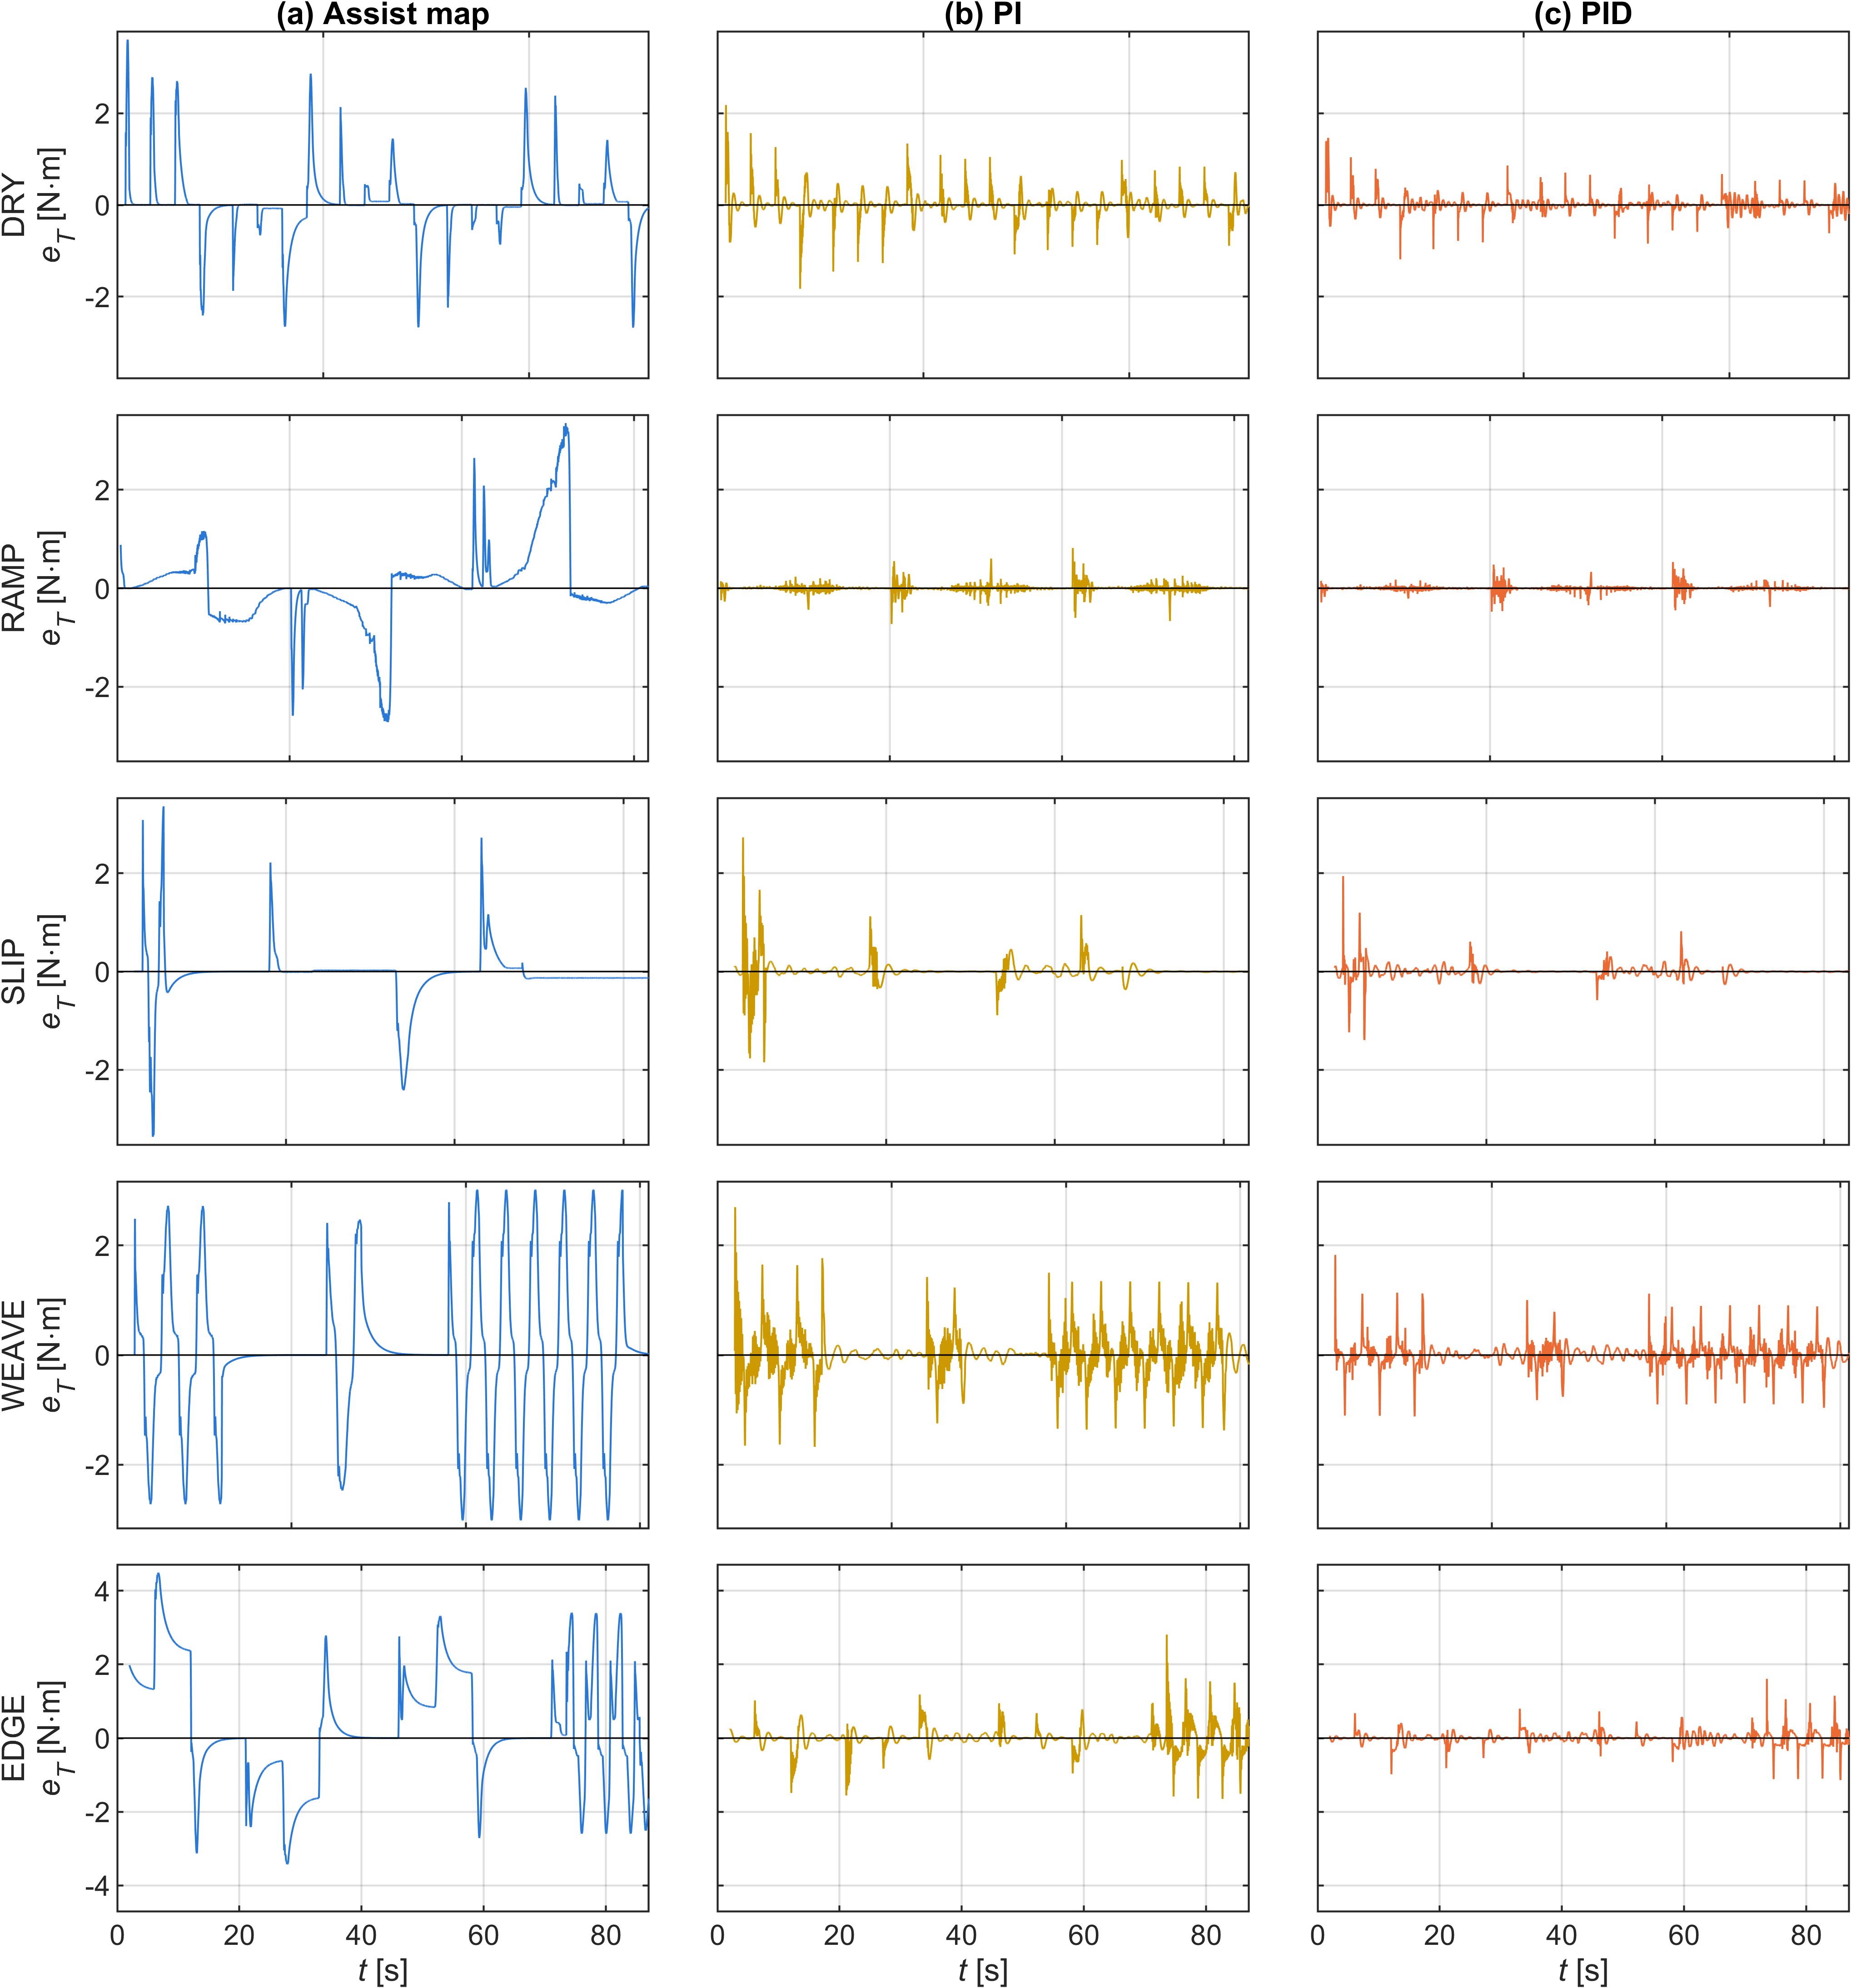
Fig. 10. Tracking error in the five scenarios: (a) assist map, (b) PI, (c) PID.
Table 6. Whole-case performance of the investigated controllers (mean ± standard deviation over five noise realizations).
Scenario | Controller | RMS tracking error (N·m) | S (N·m) | Reverse assist (%)
DRY | Assist map | 0.689 ± 0.000 | 0.149 ± 0.000 | 0.14 ± 0.02
DRY | PI | 0.244 ± 0.002 | 0.195 ± 0.002 | 6.04 ± 0.15
DRY | PID | 0.154 ± 0.001 | 0.255 ± 0.002 | 5.83 ± 0.14
SLIP | Assist map | 0.538 ± 0.000 | 0.163 ± 0.000 | 0.04 ± 0.01
SLIP | PI | 0.216 ± 0.002 | 0.236 ± 0.004 | 3.37 ± 0.09
SLIP | PID | 0.128 ± 0.004 | 0.304 ± 0.004 | 3.49 ± 0.07
WEAVE | Assist map | 1.327 ± 0.000 | 0.160 ± 0.000 | 0.05 ± 0.01
WEAVE | PI | 0.376 ± 0.004 | 0.332 ± 0.004 | 23.47 ± 0.05
WEAVE | PID | 0.215 ± 0.003 | 0.407 ± 0.003 | 25.50 ± 0.17
RAMP | Assist map | 0.835 ± 0.000 | 0.169 ± 0.001 | 0.00 ± 0.00
RAMP | PI | 0.070 ± 0.001 | 0.088 ± 0.001 | 5.89 ± 0.04
RAMP | PID | 0.046 ± 0.002 | 0.127 ± 0.001 | 5.84 ± 0.04
EDGE | Assist map | 1.534 ± 0.000 | 0.130 ± 0.000 | 0.02 ± 0.00
EDGE | PI | 0.300 ± 0.003 | 0.255 ± 0.004 | 6.97 ± 0.24
EDGE | PID | 0.163 ± 0.002 | 0.321 ± 0.003 | 6.67 ± 0.09

The whole-case RMS values in Table 6 describe the overall tracking performance of each scenario. To examine persistent errors at individual operating points, signed relative errors are evaluated separately over steady-state windows. These two measures are not directly interchangeable.
The RAMP case reveals a limitation of the assist map that is less apparent from the whole-case RMS values. During decreasing-speed cornering, its signed steady relative error reaches +15.2%, +31.4%, and +46.7% at the three evaluated lateral-acceleration levels. During increasing-speed cornering, the corresponding errors are −20.2%, −7.4%, and −5.8%. PI and PID remain within approximately 0.5% in these windows.
In EDGE, the largest assist-map steady relative errors occur at 40 km/h, reaching +56.7% at 0.35 g and +99.7% at 0.4 g. The corresponding PI errors are −0.4% and −0.5%, while the PID errors are −0.1% and −0.2%. At these high lateral accelerations, the reference torque increases only slightly while the road-reaction torque continues to rise. The resulting natural assistance characteristic requires a steep local slope. Limiting that slope to 6 prevents the assist map from delivering the calibrated torque, leaving the measured steering torque substantially above its reference. The EDGE results are treated as diagnostic tests near the limits of the adopted model. Their quantitative interpretation remains conditional on the validity of the small-angle assumptions at the evaluated operating points.
The additional RAMP and EDGE cases also indicate that the assist map is more sensitive to speed variation and high lateral acceleration, whereas the PI/PID controllers remain closer to the desired torque reference within the simulated operating range.

5.5. Discussion
The assist-map errors arise from two mechanisms. The first is the local slope limit. A road-reaction torque disturbance is attenuated by $1/\left(1+s_{m}\right)$, so a finite slope leaves a residual error. The same constraint prevents the map from reaching its unconstrained calibration characteristic where the required slope is high, as observed in DRY and EDGE.
The second mechanism is column Coulomb friction during continuous steering motion. In RAMP, the friction torque approaches ±2 N·m, with its sign determined by the direction of column motion. Its contribution to the steering-torque balance changes sign between decreasing- and increasing-speed maneuvers. The assist map only partially compensates for this disturbance, whereas integral feedback reduces the persistent torque error. These mechanisms explain why the map shows different error patterns in friction-transition, steady-cornering, and speed-ramp tests.
The reverse-assist results limit the interpretation of the tracking improvements. A possible cause is the delayed reversal of the integral contribution relative to the measured steering torque, but the individual events have not been analyzed to confirm this mechanism. The comparison is also affected by the 0.3 N·m dead zone in the assist map, which is absent from PI and PID. Reverse-assist percentage alone does not establish whether the driver would perceive the response as undesirable; that question requires driver-in-the-loop testing.
The comparison also reflects a difference in available feedback information: PI and PID use lateral acceleration to construct the torque reference, whereas the conventional assist map uses only measured steering torque and vehicle speed. The reported differences therefore characterize the complete controller architectures, not the isolated effect of PI or PID action.
Several limitations remain. The steering–vehicle model has not been validated against measurements from a physical vehicle, and the predicted road-reaction torque depends on the assumed pneumatic-trail parameters. The driver is represented by a prescribed steering angle, while motor current-loop dynamics and power constraints are omitted. The desired torque is taken from one published reference characteristic. Each controller was calibrated with a single noise realization, whereas the scoring cases are averaged over five realizations. In addition, the three controller searches used different numbers of parameter candidates, and the assist map includes a torque dead zone that is absent from PI and PID. These differences should be considered when interpreting the tracking and reverse-assist comparisons.

6. Conclusions
This study compared a conventional assist map with PI and PID steering-torque feedback for a column EPS system under changing tire–road friction. The torque reference was constructed from vehicle speed and lateral acceleration, without explicit friction estimation.
The analysis identified a steady-state limitation of the assist map: changes in road-reaction torque are attenuated according to the local map slope, which is constrained by stability and noise requirements. In the nonlinear simulations, a friction reduction from μ = 0.8 to 0.3 produced a steady relative tracking error of −4.07% for the assist map, compared with −0.08% for PI and −0.06% for PID. The PID controller also reduced the calibration tracking metric from 27.05% to 11.59%.
These improvements came with increased high-frequency assist-torque content and substantial reverse assistance during continuous steering. The results establish a tracking advantage for the investigated PI/PID configurations, but not an improvement in subjective steering feel. Further work should extend the parameter-sensitivity analysis beyond pneumatic trail, examine reverse-assist events in greater detail, and validate the controller responses experimentally.

Acknowledgments
The authors acknowledge Ho Chi Minh City University of Technology (HCMUT), Vietnam National University Ho Chi Minh City (VNU-HCM) for supporting this research.

Conflict of Interest
The authors have no conflict of interest to declare.

Author contributions
Tran Minh Tan: modeling, simulation, data analysis, writing – original draft. Phung Thanh Huy: supervision, review and editing. All authors have approved the final article.

Declaration of Generative AI
During the preparation of this work, the author(s) used Claude (Anthropic) in order to assist with simulation code, figure generation, data checking, and language editing. After using this tool, the author(s) reviewed and edited the content as needed and take full responsibility for the content of the published article.

References
[1]. D. Lee, K.-S. Kim, S. Kim (2018). Controller design of an electric power steering system. IEEE Transactions on Control Systems Technology, 26(2), 748-755. doi:10.1109/TCST.2017.2679062
[2]. X. Guan, Y.-N. Zhang, C.-G. Duan, W.-L. Yong, P.-P. Lu (2021). Study on decomposition and calculation method of EPS assist characteristic curve. Proceedings of the Institution of Mechanical Engineers, Part D: Journal of Automobile Engineering, 235, 2166-2175. doi:10.1177/0954407020987062
[3]. Y. Li, Z. Yang, D. Zhai, J. He, J. Fan (2023). Study on control strategy of electric power steering for commercial vehicle based on multi-map. World Electric Vehicle Journal, 14(2), 33. doi:10.3390/wevj14020033
[4]. L. Fan, B. Zhou, H. Zheng (2014). A new control strategy for electric power steering on low friction roads. SAE International Journal of Passenger Cars - Mechanical Systems, 7(3), 972-980. doi:10.4271/2014-01-0083
[5]. Q. Li, C. Xia (2012). Research of electric power steering system assistance characteristic based on the identification of the road. Proceedings of ICCIA 2012, 402-405. doi:10.2991/iccia.2012.97
[6]. Y. Li, J. Fan, J. He, Y. Nan, Q. Feng (2020). Novel electric power steering control strategies of commercial vehicles considering adhesion coefficient. Advances in Mechanical Engineering, 12(12), 1-11. doi:10.1177/1687814020983059
[7]. X. Zhao, X. Shi, J. Chen, X. Li (2011). Dynamic correction of the steering-characteristic curve and application to an EPS control system. International Journal of Automotive Technology, 12(2), 243-249. doi:10.1007/s12239-011-0029-5
[8]. D. Lee, K. Yi, S. Chang, B. Lee, B. Jang (2018). Robust steering-assist torque control of electric-power-assisted-steering systems for target steering wheel torque tracking. Mechatronics, 49, 157-167. doi:10.1016/j.mechatronics.2017.12.007
[9]. D. Lee, B. Jang, M. Han, K.-S. Kim (2021). A new controller design method for an electric power steering system based on a target steering torque feedback controller. Control Engineering Practice, 106, 104658. doi:10.1016/j.conengprac.2020.104658
[10]. D. Saifia, M. Chadli, H. R. Karimi, S. Labiod (2015). Fuzzy control for electric power steering system with assist motor current input constraints. Journal of the Franklin Institute, 352(2), 562-576. doi:10.1016/j.jfranklin.2014.05.007
[11]. H. Q. Nguyen, V. T. Vu, O. Sename (2025). Combining adaptive neural-fuzzy inference system with field-oriented control strategy for electric power steering system in cars. Advances in Mechanical Engineering, 17(9). doi:10.1177/16878132251369152
[12]. H.B. Pacejka. (2006). Tyre and vehicle dynamics (2nd ed.). Elsevier.
[13]. R. Rajamani. (2012). Vehicle dynamics and control (2nd ed.). Springer.
[14]. Valeo. Torque and/or angle sensors, product catalogue. https://www.valeo.com/en/catalogue/cda/torque-and-or-angle-sensors/
[15]. Bosch Motorsport. (2026). Steering wheel angle sensor LWS, data sheet. https://www.bosch-motorsport.com
[16]. Bosch Motorsport. (2020). Acceleration sensor MM5.10, data sheet. https://www.bosch-motorsport.com
[17]. H. Ragab, S. Givigi and A. Noureldin. (2024). Automotive speed estimation: Sensor types and error characteristics from OBD-II to ADAS. arXiv:2501.00242.
[18]. R. Deborne, S. Khouri Silva and A. Kemeny. (2014). Steering wheel torque rendering: Measure of driver discrimination capabilities. SAE Technical Paper 2014-01-0447. https://doi.org/10.4271/2014-01-0447

