Plug-In Steering-Torque Feedback for Column Electric Power Steering with a Calibrated Assist Map
Tram Minh Tan^{1,*}, Phung Thanh Huy¹
¹Ho Chi Minh City University of Technology (HCMUT), Vietnam National University Ho Chi Minh City (VNU-HCM), [address, city, postcode], Vietnam
Article info  Type of article:  Original research paper  Corresponding author: Tram Minh Tan  E-mail address:  [e-mail to be added]  Received: dd Month yyyy  Accepted: dd Month yyyy  Published: dd Month yyyy |  | Abstract: The steering feel of a column electric power steering (C-EPS) system is set by an assist map and a compensator calibrated for each vehicle on a dry road. Because the map has no target to compare with, a change of the road-reaction torque is attenuated only by the factor 1/(1+s), where s is the local map slope, which stability and noise keep small. This study adds torque feedback to a calibrated map without changing it. A PID branch acts on the error between the measured torque and a target defined from vehicle speed and lateral acceleration, without friction estimation, in parallel with the map and its compensator; only its four parameters are tuned for each vehicle. A steady-state analysis shows that it removes the torque error for any monotonic map while the actuator is unsaturated. The lead–lag-compensated map (Map), a PID controller that replaces the map (PID), and the plug-in combination (MapPID) are compared on a nonlinear C-EPS–vehicle model with tire saturation, motor dynamics, and sensor noise, with common gates and Pareto-based parameter selection. In independent cornering, friction-change, and weaving scenarios, the RMS torque error of Map is 3.3 to 8.1 times that of the feedback controllers, reaching 32 % of the reference in held turns and 87 % in lane changes. MapPID tracks like PID in cornering and within 7 % and 36 % of it in friction change and weaving, while its high-frequency assist torque is 30 to 38 % lower. The results come from one simulated vehicle.  Keywords: Electric power steering; Assist map; Torque feedback; PID control; Lateral acceleration; Road friction
Abbreviations: C-EPS, column-type electric power steering; EPS, electric power steering; PID, proportional–integral–derivative; RMS, root mean square; CALIB, calibration scenario; STEADY, held-turn scenario; SLIP, friction-change scenario; WEAVE, continuous-steering scenario. Units: lateral acceleration in g (1 g = 9.81 m/s²); speed in km/h (1 km/h = 0.278 m/s).
- Introduction
Electric power steering (EPS) assists the driver with an electric motor instead of a hydraulic pump, which saves energy and lets the steering characteristic be set in software [1]. In column-type EPS (C-EPS) the motor acts on the steering column. In a production vehicle the motor assistance is usually read from a static, nonlinear assist map indexed by the measured torsion-bar torque and the vehicle speed, followed by a stabilizing compensator, for example a lead–lag network, that stabilizes the column and limits noise amplification [1,2]. The map and the compensator are coupled and are calibrated together for each vehicle on a dry road, so that the torque felt by the driver follows a desired steering-effort characteristic; redesigning them is costly [2,9].
A calibrated map has a structural limitation: it reacts only to the measured torque and has no reference to compare with. Whatever changes the torque balance of the column after calibration is reduced only by the factor $1/\left(1+s_{m}\right)$ of the local map slope $s_{m}$ (Section 3.2), and the slope cannot be made large because it raises the loop gain that the compensator must stabilize and amplifies sensor noise [1,9]. Several disturbances act in this way. A loss of tire–road friction saturates the front tire earlier and shortens its pneumatic trail, so the road-reaction torque falls, and a characteristic that ignores this gives too much assistance at low adhesion and impairs road feel [3,5,12]. Coulomb friction of the column adds a torque whose sign follows the direction of column motion. The slope limit also keeps the map from its own calibration points where a steep slope would be needed, which leaves a residual error even on a dry road. Whether such an error is perceptible is a quantitative question, since drivers discriminate steady torque differences of about 10–18% [17]; Section 5 evaluates it.
Existing studies address the effect of the road in three ways. Road-adaptive strategies identify the road with neural networks [5], compensate the assist current with an estimated friction coefficient [4,6], or select among several maps by adhesion and axle load [3]; they depend on estimates that are not measured directly. Fuzzy [10] and neuro-fuzzy [11] controllers address other EPS nonlinearities. Zhao et al. [7] combined a characteristic curve with a PID loop on the motor torque, but the loop tracks the torque requested by the map and does not treat friction changes. Lee et al. [8,9] replaced the map by tracking a target steering torque, with an adaptive sliding-mode controller [8] or a lead–lag controller with a disturbance observer built on an estimated rack force [9]; their tests do not include friction transitions with nonlinear tire saturation, and the vehicle's own map is discarded. None of the reviewed studies adds torque feedback to an assist map and compensator that remain unchanged.
This study adds that feedback as a branch. A PID controller on the torque error is placed in parallel with the map and compensator, which stay as the vehicle has them, and only its four parameters are tuned for each vehicle. The Map of this study, an assist map with lead–lag compensation, stands for the block of a production vehicle, and the resulting structure is called MapPID. It is compared with the Map alone and with a PID controller that replaces the map (PID), to show what the branch adds to the map and what the map adds to direct feedback. All three share one torque target defined from measured vehicle speed and lateral acceleration [5,13], which needs no friction estimate and, for the added branch, must reproduce the dry-road torque of the vehicle's own map. The comparison uses a nonlinear C-EPS–vehicle model with tire saturation, motor dynamics, and noisy sensors.
The main contributions of this study are as follows:
- A steady-state analysis showing that the assist map leaves a residual torque error set by its slope, which integral feedback removes for any map calibration while the actuator is unsaturated.
- A plug-in procedure that adds a PID branch to an existing assist map and compensator without changing them, with four parameters tuned for each vehicle and an anti-windup rule adapted to the combined forward gain.
- A common simulation protocol, with Pareto-based calibration and independent scenarios, that quantifies torque tracking and high-frequency assist-torque content of the three structures against the same target.
- System Modeling and Problem Formulation
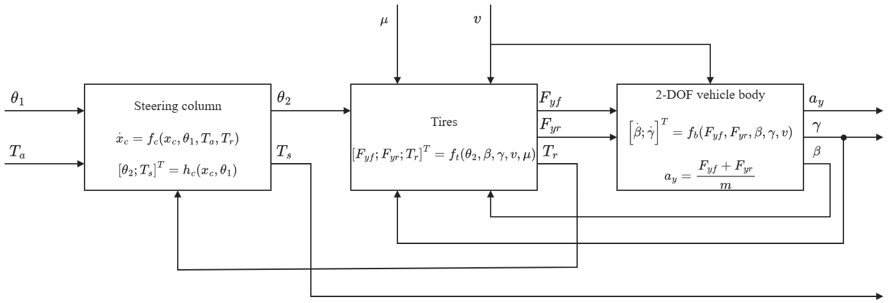
The plant couples three subsystems: the steering column with the assist motor, the front and rear tires, and the lateral and yaw motion of a single-track vehicle body. Figure 1 shows how they are connected. The column delivers the lower-column angle $θ_{2}$ to the tires; the tires return the lateral forces to the vehicle body and the road-reaction torque $T_{r}$ to the column; the body returns the sideslip angle $β$ and the yaw rate $γ$ to the tire slip angles. This loop is the path through which a change of tire–road friction $μ$ changes the torque felt at the steering wheel. The external inputs are the driver steering-wheel angle $θ_{1}$, the assist torque $T_{a}$, the vehicle speed $v$, and $μ$. Sections 2.1–2.3 model each subsystem, Section 2.4 combines them, and Sections 2.5–2.6 define the torque reference and the tracking problem shared by all controllers.
Fig. 1. Block diagram of the coupled C-EPS–vehicle plant: steering column, tires, and two-degree-of-freedom vehicle body.
  - Steering Column and Assist Motor
The mechanical structure of the column-type EPS is shown in Fig. 2. The upper column, driven by the steering wheel, is connected to the lower column through a torsion bar of stiffness $K$, which also serves as the torque sensor. The motor applies the assist torque $T_{a}$ to the lower column through a reduction gear, and the lower column drives the rack through the steering gear of ratio $n_{st}$. The steering-wheel angle $θ_{1}$ is prescribed as the driver input. The lower-column dynamics and the torsion-bar torque are modeled as [1]
$$\begin{aligned}J_{col}{\ddot{θ}}_{2}=T_{s}+T_{a}-T_{r}-C_{col}{\dot{θ}}_{2}-T_{f} tanh\left(c{\dot{θ}}_{2}\right)\#\left(1\right)\end{aligned}$$
$$\begin{aligned}T_{s}=K\left(θ_{1}-θ_{2}\right)\#\left(2\right)\end{aligned}$$
where $θ_{2}$ is the lower-column angle; $J_{col}$ and $C_{col}$ are the equivalent inertia and viscous damping of the lower column, including the motor and gear referred to the column; and $T_{f} tanh\left(c{\dot{θ}}_{2}\right)$ is a smooth approximation of Coulomb friction with amplitude $T_{f}$. Both $T_{a}$ and the road-reaction torque $T_{r}$ are referred to the column side of the mechanism.
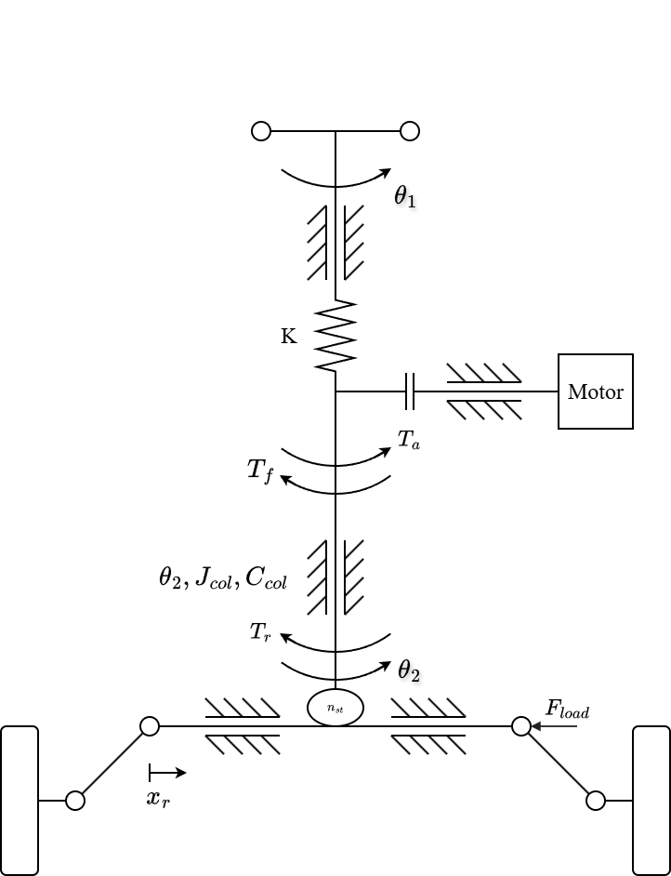
Fig. 2. Mechanical structure of the column-type EPS.
Prescribing $θ_{1}\left(t\right)$ allows $T_{s}$ to change when the road reaction or the motor assistance changes. If the driver torque were imposed instead, it would fix the sensed torque at steady state and hide the effect of the road reaction examined here. The prescribed-angle driver therefore supports a controlled comparison of steering-effort responses, but it does not represent the driver's neuromuscular response or the correction of steering angle in response to changing effort.
  - Tire Model and Road-Reaction Torque
Figure 3 defines the road-plane quantities of the front tire. The front-wheel angle is approximated by $δ_{f}=θ_{2}/n_{st}$. Under the small-angle and constant-longitudinal-speed assumptions, the front and rear slip angles are [13]
$$\begin{aligned}α_{f}=\frac{θ_{2}}{n_{st}}-β-\frac{l_{f}γ}{v}\#\left(3\right)\end{aligned}$$
$$\begin{aligned}α_{r}=-β+\frac{l_{r}γ}{v}\#\left(4\right)\end{aligned}$$
where $β$ is the vehicle sideslip angle, $γ$ is the yaw rate, and $l_{f}$ and $l_{r}$ are the distances from the center of gravity to the front and rear axles. Longitudinal and lateral load transfer are neglected, giving the static axle loads
$$\begin{aligned}F_{zf}=mg\frac{l_{r}}{l_{f}+l_{r}}\#\left(5\right)\end{aligned}$$
$$\begin{aligned}F_{zr}=mg\frac{l_{f}}{l_{f}+l_{r}}\#\left(6\right)\end{aligned}$$
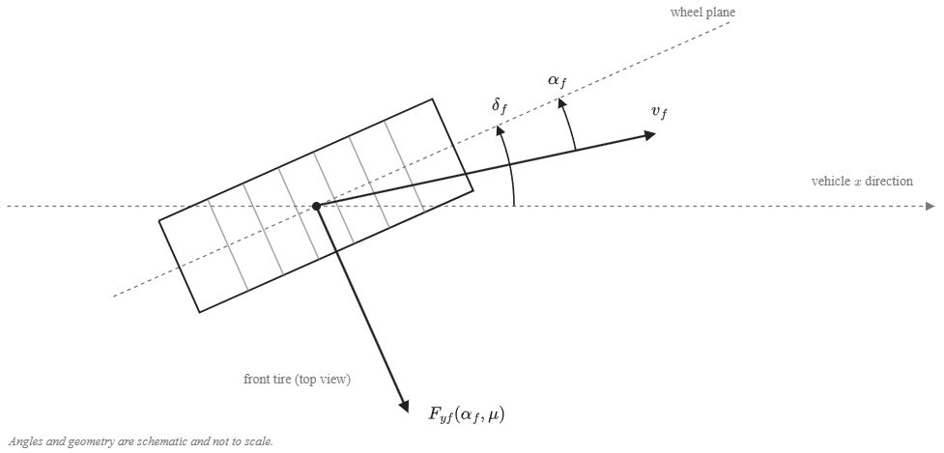
Fig. 3. Top-view geometry of the front-tire steering angle, slip angle, and lateral force.
Each axle is represented by one equivalent tire. To retain force saturation when road friction changes, the lateral forces are calculated with a simplified Pacejka Magic Formula [12]:
$$\begin{aligned}F_{yi}=D_{i} sin\left[C\tan^{-1}\left(B_{i}α_{i}-E\left(B_{i}α_{i}-\tan^{-1}\left(B_{i}α_{i}\right)\right)\right)\right] \\ i∈\{f,r\}\#\left(7\right)\end{aligned}$$
$$\begin{aligned}D_{i}=μF_{zi}, B_{i}=\frac{C_{αi}}{CD_{i}}\#\left(8\right)\end{aligned}$$
where $μ$ is the common tire–road friction coefficient, $C_{αi}$ is the axle cornering stiffness, and $C$ and $E$ are shape and curvature factors. This parameterization preserves the initial slope $C_{αi}$ while reducing the peak force $D_{i}$ as $μ$ decreases, so the tire saturates earlier on a lower-friction surface.
The front lateral force acts on the steering axis through an effective moment arm that contains a constant caster component and a slip-dependent pneumatic component. Adapting the pneumatic-trail relation used in [3], the model defines
$$\begin{aligned}t_{p}= max\left(0, t_{0}-\frac{t_{0}C_{αf}| tanα_{f}|}{3μF_{zf}}\right)\#\left(9\right)\end{aligned}$$
$$\begin{aligned}e_{eff}=e_{c}+t_{p}, e_{c}=e_{p0}-t_{0}\#\left(10\right)\end{aligned}$$
where $e_{p0}$ is the effective moment arm at zero slip, $t_{0}$ is the zero-slip pneumatic trail, and $e_{c}$ is the constant caster component. The nonnegative bound on $t_{p}$ represents the loss of pneumatic trail as the modeled contact patch reaches full sliding; retaining $e_{c}$ prevents the total moment arm from being forced to zero. These bounds are modeling choices added to the source relation and do not reproduce the complete aligning-moment behavior of a measured tire. The road reaction referred to the steering column is
$$\begin{aligned}T_{r}=\frac{e_{eff}}{n_{st}}F_{yf}\#\left(11\right)\end{aligned}$$
Equations (8)–(11) contain the two effects of friction on the column: a lower $μ$ reduces the attainable $F_{yf}$ and, at the same slip angle, shortens the pneumatic trail $t_{p}$. Both reduce $T_{r}$.
  - Single-Track Vehicle Body
The lateral and yaw motion of the vehicle is governed by the nonlinear single-track balances [13]:
$$\begin{aligned}a_{y}=\frac{F_{yf}+F_{yr}}{m}\#\left(12\right)\end{aligned}$$
$$\begin{aligned}\dot{β}=\frac{a_{y}}{v}-γ\#\left(13\right)\end{aligned}$$
$$\begin{aligned}\dot{γ}=\frac{l_{f}F_{yf}-l_{r}F_{yr}}{I_{z}}\#\left(14\right)\end{aligned}$$
where $m$ and $I_{z}$ are the vehicle mass and yaw moment of inertia. The lateral acceleration $a_{y}$ of Eq. (12) is also the measured signal used by the torque reference in Section 2.5.
  - Coupled Plant and Torque Balance
Combining Eqs. (1)–(14), the coupled steering-column and vehicle plant of Fig. 1 has four states, $θ_{2}$, ${\dot{θ}}_{2}$, $β$, and $γ$; the motor, compensator, and controller states are added separately in the closed-loop simulations. The states are internal to the plant: none of the controllers measures $β$ or $γ$, and all of them use only the measured torsion-bar torque $T_{s}$, the vehicle speed $v$, and the lateral acceleration $a_{y}$. For a stationary steering column, Eq. (1) becomes
$$\begin{aligned}T_{s}=T_{r}-T_{a}\#\left(15\right)\end{aligned}$$
because the smoothed Coulomb-friction term vanishes at ${\dot{θ}}_{2}=0$. Equations (7)–(15) expose how the road enters the torque balance: decreasing $μ$ lowers the tire-force capacity and the pneumatic trail and therefore $T_{r}$. If the assistance does not decrease by the same amount, Eq. (15) predicts a reduction of the steering torque transmitted through the torsion bar, that is, too much assistance for the road.
  - Lateral-Acceleration-Based Torque Reference
The desired steering torque is obtained from the speed- and lateral-acceleration-dependent steering-effort data reported by Li and Xia [5]. The four lateral-acceleration levels published in that study are reproduced in Table 1 and are treated here as a reference characteristic rather than as a universal driver-preference model.
Table 1. Ideal steering-wheel torque reference (N·m), adopted from [5].
Lateral acceleration | 20 km/h | 40 km/h | 60 km/h | 80 km/h | 100 km/h
0.1 g | 1.0 | 1.7 | 2.1 | 2.3 | 2.6
0.2 g | 1.5 | 2.0 | 2.4 | 2.8 | 3.0
0.3 g | 1.6 | 2.3 | 2.8 | 3.1 | 3.3
0.4 g | 1.8 | 2.4 | 2.9 | 3.3 | 3.4

A zero-torque point is added at zero lateral acceleration. Monotone piecewise cubic Hermite interpolation is applied first along lateral acceleration and then along vehicle speed, after which the result is sampled on a finer table for implementation. Odd symmetry supplies the negative-turning branch, while inputs beyond 20–100 km/h or 0–0.4 g are clipped to the nearest boundary:
$$\begin{aligned}T_{ref}\left(v,a_{y}\right)=sgn\left(a_{y}\right)\hat{T}\left(v,|a_{y}|\right)\#\left(16\right)\end{aligned}$$
$$\begin{aligned}\hat{T}\left(v,0\right)=0\#\left(17\right)\end{aligned}$$
where $\hat{T}$ denotes the interpolated positive-acceleration characteristic. Adding the zero point, imposing odd symmetry, selecting PCHIP interpolation, and clipping outside the published grid are implementation choices of this study. They make the reference continuous through straight-ahead driving without extrapolating unreported steering-effort values.
The reference uses measured vehicle speed and lateral acceleration and does not require an estimate of $μ$ or rack force. Because $a_{y}$ is an input to the reference, a friction reduction can also change the target by changing the vehicle response. The controller therefore regulates effort relative to the motion actually produced by the vehicle instead of enforcing the same torque at a fixed steering-wheel angle on every surface.
  - Torque-Tracking Objective
The common control objective is to regulate the measured torsion-bar torque toward the reference:
$$\begin{aligned}e_{T}=T_{s}-T_{ref}\left(v,a_{y}\right)\#\left(18\right)\end{aligned}$$
For $T_{ref}≠0$, $sgn\left(T_{ref}\right)e_{T}<0$ denotes a torque magnitude below the target in the commanded turning direction. Reversal intervals are evaluated with magnitude-based measures because the signed interpretation becomes ambiguous near a zero crossing. All controllers act through the same bounded assist-torque channel:
$$\begin{aligned}|T_{a}|≤T_{a,max}\left(v\right)\#\left(19\right)\end{aligned}$$
where $T_{a,max}\left(v\right)$ is derived from the modeled dry-road assistance requirement and is specified with the actuator implementation. The comparison therefore asks how each controller reduces the torque-tracking error under changing road and driving conditions while satisfying the same motor dynamics, assist limit, sensor conditions, and stability requirements.
- Control Strategy and Assist-Map Limitation
This section presents the three control structures: the assist map with lead–lag compensation (Map), direct PID torque feedback (PID), and the plug-in combination (MapPID), in which the Map design is kept unchanged and a PID branch is added in parallel. A steady-state sensitivity analysis quantifies what a static assist map cannot do when the road-reaction torque changes, and shows why an added integral branch removes the error independently of the map calibration.
  - Conventional Assist-Map Control with Lead–Lag Compensation
The conventional controller follows the standard automotive architecture in which basic motor assistance is scheduled through a static two-dimensional map from measured torsion-bar torque and vehicle speed, followed by stabilizing compensation [1]. Under nominal dry-road conditions ($μ=0.8$), the required assistance at each calibration breakpoint is determined from the static torque equilibrium of Eq. (15):
$$\begin{aligned}T_{s,cal}=T_{ref}\left(v,a_{y}\right)\#\left(20\right)\end{aligned}$$
$$\begin{aligned}T_{a,cal}=T_{r}\left(v,a_{y},0.8\right)-T_{ref}\left(v,a_{y}\right)\#\left(21\right)\end{aligned}$$
The nominal dry-road assist map is calibrated across 17 vehicle speeds from 20 to 100 km/h in increments of 5 km/h. At each speed, feasible lateral accelerations are evaluated in increments of 0.005 g. The raw assistance is bounded by a symmetric torque dead zone $T_{s0}=0.3$ N·m around straight-ahead driving to prevent motor chattering from sensor noise, and by a maximum local slope $K_{max}$. At each calibration breakpoint, the allowable assist increment is constrained by ${\overline{M}}_{k}≤{\overline{M}}_{k-1}+K_{max}\left(|T_{s}|_{k}-|T_{s}|_{k-1}\right)$, preserving nondecreasing assistance while preventing excessively steep transitions:
$$\begin{aligned}M\left(v,T_{s}\right)=sgn\left(T_{s}\right)\overline{M}\left(v,|T_{s}|\right)\#\left(22\right)\end{aligned}$$
where $\overline{M}\left(v,|T_{s}|\right)$ is the bounded monotonic assist characteristic for positive torque. The resulting characteristic is tabulated over measured steering torque from 0 to 5 N·m with linear interpolation across torque and vehicle speed.
To stabilize the closed loop around the steering-column resonance (about 6.2 Hz) while limiting high-frequency noise amplification from the high assist gain, the static map output is processed by a linear lead–lag compensator $C_{map}\left(s\right)$ [1]:
$$\begin{aligned}u_{map}\left(s\right)=C_{map}\left(s\right)M\left(v_{m},T_{s,m}\right)\#\left(23\right)\end{aligned}$$
$$\begin{aligned}C_{map}\left(s\right)=\left(\frac{\frac{s}{z}+1}{\frac{s}{p}+1}\right)\left(\frac{\frac{s}{z_{1}}+1}{\frac{s}{p_{1}}+1}\right)\#\left(24\right)\end{aligned}$$
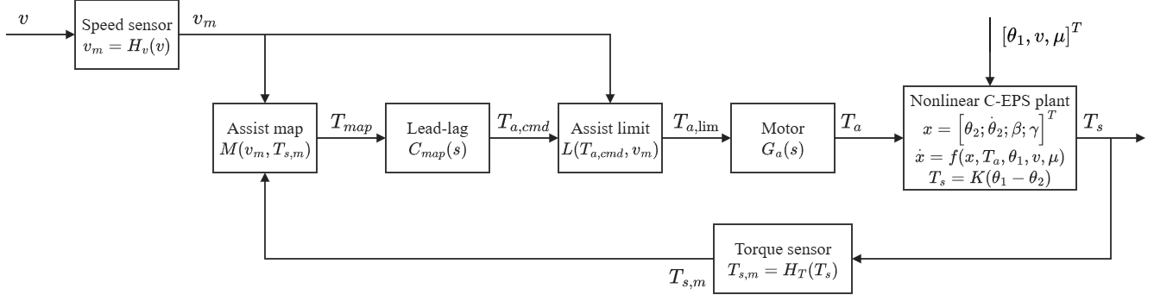
where $z$ and $p$ are the zero and pole frequencies of the lead stage, and $z_{1}$ and $p_{1}$ are those of the lag stage. The lead stage provides phase advance around the column resonance, while the lag stage provides high-frequency gain roll-off. Both stages have unity steady-state gain ($C_{map}\left(0\right)=1$), so the calibrated static characteristic is preserved. The closed-loop signal flow of the assist-map controller is shown in Fig. 4.
Fig. 4. Closed-loop signal flow of the assist-map controller.
  - Steady-State Limitation of Assist-Map Control
The limitation of the assist map under friction variation can be evaluated through a local steady-state sensitivity analysis. At a constant vehicle speed and fixed lateral acceleration, column equilibrium under assist-map control requires
$$\begin{aligned}T_{s}+M\left(v,T_{s}\right)=T_{r}\left(v,a_{y},μ\right)\#\left(25\right)\end{aligned}$$
where the Coulomb friction term vanishes at steady state (${\dot{θ}}_{2}=0$) and $C_{map}\left(0\right)=1$. Linearizing Eq. (25) with respect to a change in road-reaction torque $ΔT_{r}$ yields
$$\begin{aligned}ΔT_{s}=\frac{ΔT_{r}}{1+s_{m}}\#\left(26\right)\end{aligned}$$
$$\begin{aligned}s_{m}=\frac{∂M\left(v,T_{s}\right)}{∂T_{s}}\#\left(27\right)\end{aligned}$$
where $s_{m}$ denotes the local slope of the assist map at the operating point.
Equation (26) shows that the change in sensed torsion-bar torque is attenuated only by the factor $1/\left(1+s_{m}\right)$. Because the target torque $T_{ref}\left(v,a_{y}\right)$ is unchanged at fixed speed and lateral acceleration, the change in tracking error equals $ΔT_{s}$:
$$\begin{aligned}Δe_{T}=\frac{ΔT_{r}}{1+s_{m}}\#\left(28\right)\end{aligned}$$
When friction drops from the dry value ($μ=0.8$), the road reaction $T_{r}$ decreases because of tire-force saturation and pneumatic-trail reduction. Because $s_{m}$ is positive and finite ($s_{m}≤K_{max}$), $Δe_{T}$ is nonzero and has the same sign as $ΔT_{r}$: $T_{s}$ falls below the desired value, so the assistance is too high for the road. Increasing $K_{max}$ reduces $Δe_{T}$ but raises the loop gain and amplifies sensor noise, and no finite slope removes $Δe_{T}$. The same slope limit also prevents the map from reaching the calibration points of Eq. (21) where the required local slope exceeds $K_{max}$, so a residual error can remain even on a dry road. In contrast, any controller with integral action on $e_{T}$ enforces $e_{T}=0$ at steady state whenever the actuator is not saturated.
  - PID Steering-Torque Feedback Control
The PID controller regulates the torque-tracking error $e_{T}=T_{s,m}-T_{ref}\left(v_{m},a_{y,m}\right)$ directly. To avoid a derivative kick after rapid changes of the reference, the derivative action is placed on the measured torsion-bar torque $T_{s,m}$ rather than on the error, and it is filtered by a first-order lag:
$$\begin{aligned}u_{P}=K_{p}e_{T}\#\left(29\right)\end{aligned}$$
$$\begin{aligned}{\dot{u}}_{I}=K_{i}e_{T}+K_{aw}ΔT_{a}\#\left(30\right)\end{aligned}$$
$$\begin{aligned}u_{D}\left(s\right)=\left(\frac{K_{d}s}{τ_{f}s+1}\right)T_{s,m}\left(s\right)\#\left(31\right)\end{aligned}$$
where $K_{p}$, $K_{i}$, and $K_{d}$ are the proportional, integral, and derivative gains, $τ_{f}$ is the derivative filter time constant, and $K_{aw}$ is the anti-windup tracking gain.
In Eq. (31), the derivative term has a positive sign because an increasing measured torque $T_{s}$ indicates insufficient assistance in the column convention of Eq. (1), which requires an increase of assist torque. The total unconstrained command is
$$\begin{aligned}T_{a,cmd}=u_{P}+u_{I}+u_{D}\#\left(32\right)\end{aligned}$$
Actuator saturation is handled by back-calculation anti-windup. The difference between the bounded motor command $T_{a,lim}$ and the raw command $T_{a,cmd}$ is fed back to the integrator in Eq. (30):
$$\begin{aligned}ΔT_{a}=T_{a,lim}-T_{a,cmd}\#\left(33\right)\end{aligned}$$
$$\begin{aligned}K_{aw}=\frac{K_{i}}{K_{p}}\#\left(34\right)\end{aligned}$$
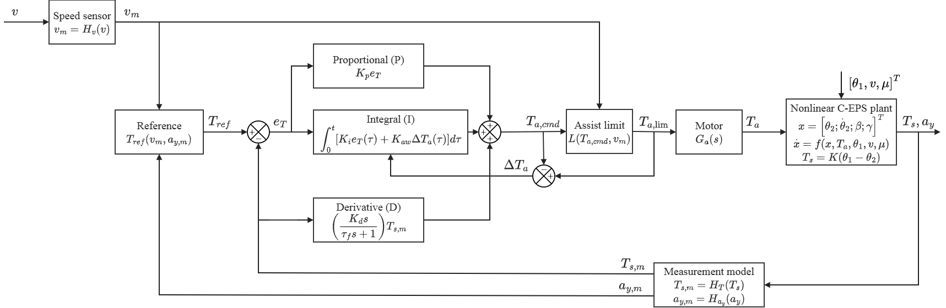
This back-calculation discharges the integrator whenever the motor saturates at $T_{a,max}\left(v_{m}\right)$ and allows a fast recovery when the error reverses. Figure 5 shows the signal flow of the PID torque-feedback controller.
Fig. 5. Closed-loop signal flow of the PID steering-torque controller.
  - Plug-In MapPID Control Structure
The MapPID structure keeps the assist map and lead–lag compensator of Section 3.1 exactly as calibrated for Map, including the slope limit $K_{max}$, the dead zone $T_{s0}$, and the compensator frequencies, and adds the PID branch of Section 3.3 in parallel (Fig. 6). Only the four branch parameters $K_{p}$, $K_{i}$, $K_{d}$, and $τ_{f}$ are tuned, with the map block frozen. The branch is therefore a plug-in: it can be attached to an existing calibration without changing the map that encodes the dry-road steering characteristic. The assist command is
$$\begin{aligned}T_{a,cmd}=u_{map}+u_{PID}\#\left(35\right)\end{aligned}$$
$$\begin{aligned}u_{PID}=u_{P}+u_{I}+u_{D}\#\left(36\right)\end{aligned}$$
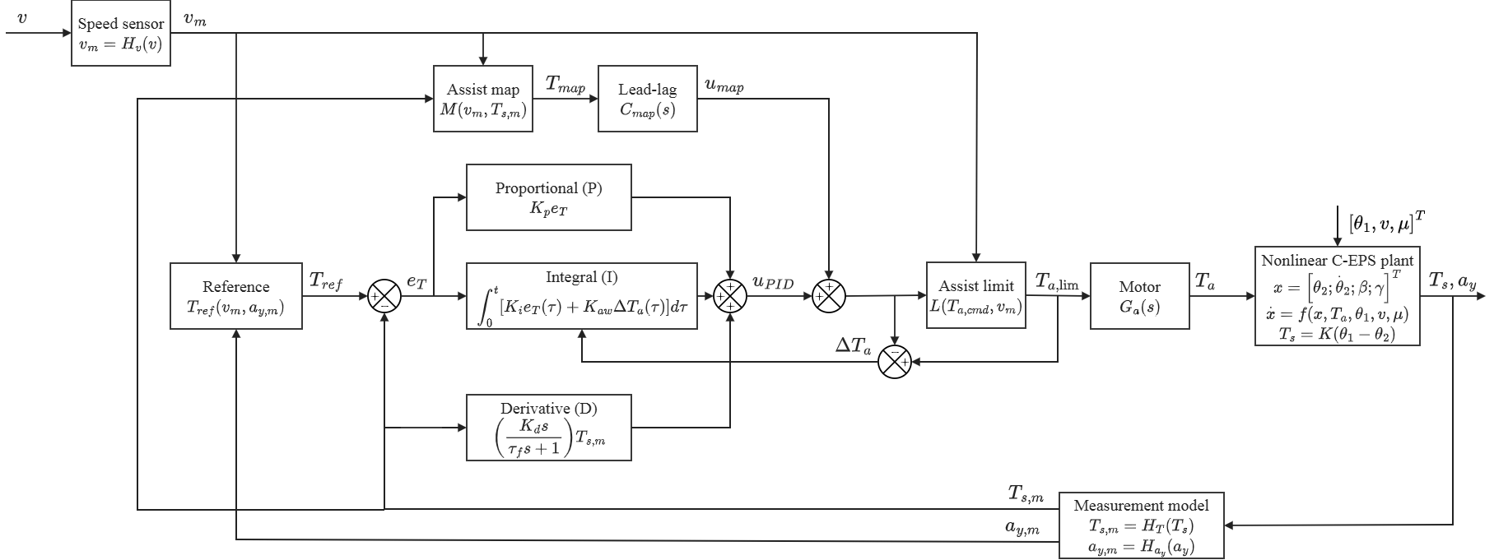
where $u_{map}$ is computed from Eq. (23) and $u_{PID}$ from Eqs. (29)–(31).
Fig. 6. Closed-loop signal flow of the plug-in MapPID controller.
The steady-state behavior of the plug-in branch follows from Eq. (25). With the branch attached, the column equilibrium becomes $T_{s}+M\left(v,T_{s}\right)+u_{PID}=T_{r}\left(v,a_{y},μ\right)$. While the closed loop is stable and the actuator is not saturated, the integrator stops changing only when $e_{T}=0$, so that $T_{s}=T_{ref}$ and the branch settles at
$$\begin{aligned}u_{PID,ss}=T_{r}\left(v,a_{y},μ\right)-T_{ref}\left(v,a_{y}\right)-M\left(v,T_{ref}\right)\#\left(37\right)\end{aligned}$$
Equation (37) states the two properties on which the plug-in structure relies. First, the steady-state accuracy does not depend on the map: any monotonic map, whatever its slope or calibration, leads to $e_{T}=0$. Second, the branch supplies only the residual that the map leaves. At a dry-road calibration point reached by the map, Eq. (21) gives $M\left(v,T_{ref}\right)=T_{r}\left(v,a_{y},0.8\right)-T_{ref}$, so $u_{PID,ss}=T_{r}\left(v,a_{y},μ\right)-T_{r}\left(v,a_{y},0.8\right)$, which is zero on the dry road and equal to the friction-induced change of road reaction otherwise. Where the slope limit prevents the map from reaching its calibration point, $u_{PID,ss}$ also contains that calibration residual.
The map is not neutral for the dynamics of the branch. Around an operating point, the forward path from measured torque to assist torque is $s_{m}C_{map}\left(s\right)+C_{PID}\left(s\right)$, where $C_{PID}\left(s\right)$ is the linearized PID transfer function. The map slope therefore adds to the low-frequency loop gain, which can reduce the proportional gain needed by the branch, but it also adds to the loop gain near the column resonance, so the stability margins of the branch depend on the map it is attached to. The branch is therefore tuned separately for each vehicle: the map and stabilizing compensator of that vehicle are frozen in the loop, the plant model is adjusted to match the vehicle, and the stability requirements are verified on the combined loop. Both branches share the common saturation limit:
$$\begin{aligned}T_{a,lim}=clip\left(T_{a,cmd},-T_{a,max}\left(v_{m}\right),T_{a,max}\left(v_{m}\right)\right)\#\left(38\right)\end{aligned}$$
Because both the map, with maximum slope $K_{max}$, and the proportional path $K_{p}$ contribute to the forward gain between sensed torque and assist torque, the effective forward gain is bounded by $K_{p}+K_{max}$. The back-calculation anti-windup gain is scaled accordingly:
$$\begin{aligned}K_{aw}=\frac{K_{i}}{K_{p}+K_{max}}\#\left(39\right)\end{aligned}$$
When $K_{max}=0$, Eq. (39) reduces to the PID rule of Eq. (34), and when $K_{p}$ is small, the map slope keeps the anti-windup gain finite. The map therefore remains responsible for the nominal dry-road assistance, while the plug-in branch corrects the deviations caused by friction changes, tire saturation, and the slope-limited calibration.
In application, the Map of this study stands for the block formed by the assist map and stabilizing compensator that a production vehicle already has. That block is taken as given, the plant model is adjusted to the vehicle, and the search for the four PID parameters is carried out on top of it, once for each vehicle. The reference must reproduce the dry-road steady-state steering torque of the vehicle's own map, as Eq. (20) does for the map of this study, so that the added branch preserves the intended dry-road steering feel.
- Controller Parameter Selection
This section describes how the parameters of the three controllers are chosen on one calibration scenario, with the same model, metrics, gates, and search procedure for all of them. Section 4.1 gives the simulation model and its implementation, Sections 4.2 and 4.3 define the calibration scenario, the metrics, and the admissibility gates, Section 4.4 describes the search, and Section 4.5 presents the resulting designs. The scenarios used to evaluate the selected designs in Section 5 are independent of the one used here.
  - Simulation Model and Implementation
The controllers are simulated on the nonlinear C-EPS–vehicle model of Section 2. The parameters are listed in Table 2. The steering-column parameters are based on [1], and the tire and vehicle formulations follow [12,13]. The steering ratio and the trail dimensions are prescribed modeling parameters, and the size of the torque change caused by a loss of friction depends on the assumed zero-slip pneumatic trail $t_{0}$. The model is used between 20 and 100 km/h and for friction coefficients from 0.2 to 0.8. Below 20 km/h the inverse-speed terms of the vehicle equations and the quasi-static tire assumptions become unreliable. The feasible lateral acceleration is limited by tire friction and by the small-angle assumption: at 20 km/h the model reaches about 0.2 g, and at higher speeds the limit approaches the friction-dependent tire-force limit, so that operating points are restricted to the feasible region instead of the full rectangle of Table 1. The same friction is assumed on both sides of the vehicle, and the steering-wheel angle is prescribed independently of the driver's response to the steering torque.
The motor is approximated by a first-order transfer function [1]:
$$\begin{aligned}G_{m}\left(s\right)=\frac{ω_{m}}{s+ω_{m}}, ω_{m}=2π\left(100\right) rad/s\#\left(40\right)\end{aligned}$$
The common motor block also includes a 1 ms computation delay and the speed-dependent assist limit of Eq. (19). The limit is the largest dry-road assistance that is needed to reach the reference, plus a margin equal to the Coulomb friction amplitude:
$$\begin{aligned}T_{a,max}\left(v\right)=\max_{a_{y}}\left(T_{r}\left(v,a_{y},0.8\right)-T_{ref}\left(v,a_{y}\right)\right)+T_{f} \\ 0≤a_{y}≤a_{y,lim}\left(v\right)\#\left(41\right)\end{aligned}$$
$$\begin{aligned}a_{y,lim}\left(v\right)= min\left(a_{y,max}\left(v,0.8\right), 0.4g\right)\#\left(42\right)\end{aligned}$$
where $a_{y,max}\left(v,0.8\right)$ is the largest lateral acceleration that the dry-road model can reach at speed $v$. The limit is derived from the simulation model and does not represent a validated capacity of a production EPS motor. It is applied by the same actuator block to all three controllers, so that no controller carries its own copy of it.
Table 2. Parameters of the nonlinear C-EPS–vehicle model.
Parameter | Symbol | Value | Unit
Torsion-bar stiffness | $K$ | 143.24 | N·m/rad
Lower-column inertia | $J_{col}$ | 0.11 | kg·m²
Column viscous damping | $C_{col}$ | 1.35 | N·m·s/rad
Coulomb friction amplitude | $T_{f}$ | 2 | N·m
Friction smoothing coefficient | $c$ | 100 | s/rad
Vehicle mass | $m$ | 1573 | kg
Yaw moment of inertia | $I_{z}$ | 2873 | kg·m²
Front axle distance | $l_{f}$ | 1.10 | m
Rear axle distance | $l_{r}$ | 1.58 | m
Front/rear cornering stiffness | $C_{αf}$, $C_{αr}$ | 160000 | N/rad
Magic Formula shape factor | $C$ | 1.3 | -
Magic Formula curvature factor | $E$ | −1 | -
Steering ratio | $n_{st}$ | 16 | -
Initial effective moment arm | $e_{p0}$ | 0.048 | m
Initial pneumatic trail | $t_{0}$ | 0.025 | m

All controllers run at a sampling period $T_{c}=1 ms$. The lead–lag compensator of Eq. (24) is discretized with the Tustin method, and the PID integrator uses forward Euler integration with back-calculation anti-windup. The integral and filtered derivative states are updated as
$$\begin{aligned}u_{I}[k+1]=u_{I}[k]+T_{c}K_{i}e_{T}[k] \\ +T_{c}K_{aw}\left(T_{a,lim}[k]-T_{a,cmd}[k]\right)\#\left(43\right)\end{aligned}$$
$$\begin{aligned}d[k]=a_{d} d[k-1]+b_{d}\left(T_{s}[k]-T_{s}[k-1]\right)\#\left(44\right)\end{aligned}$$
$$\begin{aligned}a_{d}=\frac{τ_{f}}{τ_{f}+T_{c}}, b_{d}=\frac{K_{d}}{τ_{f}+T_{c}}\#\left(45\right)\end{aligned}$$
where $T_{a,lim}$ is the command after the common saturation limit, and the anti-windup gain $K_{aw}$ is given by Eq. (34) for PID and by Eq. (39) for MapPID. The difference between the limited and unlimited commands is the back-calculation signal that prevents integrator windup.
The controllers use three measured signals: the torsion-bar torque $T_{s}$, the vehicle speed $v$, and the lateral acceleration $a_{y}$. Their noise, quantization, and update periods are given in Table 3, with the resolutions taken from the sensor data sheets [14,15]. The noise standard deviation equals one resolution step for each sensor, except for the vehicle speed, for which 0.38 km/h is adopted [16]. The 10 ms update period of the vehicle signals is an implementation assumption.
Table 3. Sensor and actuator settings.
Signal or component | Resolution or setting | Update period
Steering torque $T_{s}$ | 0.01 N·m | 1 ms
Vehicle speed $v$ | 1 km/h | 10 ms
Lateral acceleration $a_{y}$ | 0.01 g | 10 ms
Controller sampling | 1 ms | 1 ms
Motor bandwidth | 100 Hz | Continuous-time model
Computation delay | 1 ms | -

The motor current loop and the electrical power constraints are not modeled. The first 2 s of every simulation are excluded from the metrics. Because the torque sensor resolves 0.01 N·m and a quantization step of 0.01 g in $a_{y}$ moves the reference by about 0.03–0.05 N·m, torque errors are rounded to 0.01 N·m in this paper, and an error or a difference between controllers below this level is described as indistinguishable from zero instead of being quoted as a number.
  - Calibration Scenario and Performance Metrics
The parameters are chosen on one 140 s scenario, CALIB, in which the vehicle speed rises from 20 to 100 km/h in nine blocks of 10 km/h on a dry road ($μ=0.8$). The steering-wheel angle is prescribed open loop from the steady-state angle table, so the lateral acceleration is a label of the commanded angle and is not visible to the controllers. Table 4 lists the four groups of evaluation windows. In every block a staircase of held turns is followed, from 40 km/h upward, by sinusoidal steering through zero, which exposes the dead zone around straight-ahead driving and the change of sign of the assistance. Sinusoidal steering is omitted below 40 km/h, where the open-loop driver would need 80–144° of steering-wheel angle and the column inertia dominates the sensed torque for every controller. The scenario contains 68 windows in total.

Table 4. Evaluation windows of the calibration scenario CALIB.
Group | Count | Condition | Group of R
Held turn | 26 | Last 1 s of each held level of 0.1, 0.2, and 0.3 g (0.10 and 0.18 g at 20 km/h, where the model reaches only about 0.2 g), 3 s per level, at 20–100 km/h | static
Transition | 26 | 1 s ramp and 1 s of settling before each held level | dyn
Sinusoidal steering | 14 | Through zero at 0.5 Hz (1.25 cycles, 0.3 g amplitude) and at 1 Hz (3.5 cycles, 0.15 g amplitude), at 40–100 km/h | dyn
Friction change | 2 | 60 km/h, 0.3 g: $μ$ falls from 0.8 to 0.35 and returns to 0.8 after 6 s | mu

Tracking accuracy and high-frequency assist-torque content are quantified by
$$\begin{aligned}R_{g}=100\frac{{RMS}_{g}\left(e_{T}\right)}{{mean}_{g}\left(|T_{ref}|\right)}, R={\left(R_{static}R_{dyn}R_{μ}\right)}^{1/3}\#\left(46\right)\end{aligned}$$
$$\begin{aligned}S=RMS\left(T_{a}-F_{5}\left(T_{a}\right)\right)\#\left(47\right)\end{aligned}$$
where $g$ is one of the three groups of Table 4 and $F_{5}\left(·\right)$ is a first-order low-pass filter with a cutoff of 5 Hz. Each $R_{g}$ is bounded below by 1 %, which is two to three times the torque-sensor step, so that errors below the sensor resolution are not rewarded. The geometric mean keeps the large dyn group from dominating the small static group. The metric $S$ is the RMS difference between the applied assist torque and its low-pass-filtered counterpart. It measures the assist-torque content that the steering command, whose band is below about 2 Hz [11], cannot explain, which arises mainly from sensor-noise amplification and fast control action. For the held-turn windows the signed relative error is
$$\begin{aligned}e_{rel}=100\frac{sgn\left(T_{ref}\right) mean\left(e_{T}\right)}{mean\left(|T_{ref}|\right)}\#\left(48\right)\end{aligned}$$
The RMS error is used for the other windows, where a signed relative error may be misleading.
  - Admissibility Gates
A design is admissible only if it passes three gates. The first is static accuracy: $max|e_{rel}|$ over the 26 held-turn windows must not exceed 10 %, the lowest just-noticeable difference of steering-wheel torque reported for drivers [17]. The second is stability, checked by simulation: CALIB is repeated with the motor gain doubled and, separately, with an extra 1 ms delay between the controller and the motor, and in both cases $R$ must be finite and no more than twice its nominal value. These are specified perturbation tests, not a general guarantee of robust stability; a delay of one control period stands for unmodeled computation and current-loop lag. The third is the steering band: to preserve the 0.2–2 Hz band of the driver [11], the lag stage of the assist-map compensator and the first-order derivative filter of PID must keep a magnitude response of at least −3 dB at 2 Hz. In addition, a linear screening step discards designs whose phase margin is below 30° or whose gain margin is below 2 on the linearized plant models of 17 speeds, which avoids simulating designs that are certain to be unstable.
  - Search Procedure
The design variables are searched on a logarithmic scale inside boxes set from physical meaning and not from earlier results (Table 5). The assist map has two variables: the slope limit $K_{max}$ and the lowest gain $g_{min}$ of the lag stage over 0.2–2 Hz; for each pair the lead and lag frequencies of Eq. (24) are synthesized by a fixed design rule on the linearized plants. PID has four variables ($K_{p}$, $K_{i}$, $K_{d}$, $τ_{f}$). In MapPID the map block is fixed to the Map design and only the four PID variables are searched with the same box as PID, so that any difference from Map is due to the feedback branch alone.
Table 5. Design variables and search boxes.
Controller | Variable | Box | Scale
Map | $K_{max}$ | 1–30 | log
Map | $g_{min}$ | 0.707–1 | log
PID, MapPID | $K_{p}$ | 0.001–30 | log
PID, MapPID | $K_{i}$ | 0.1–2000 s⁻¹ | log
PID, MapPID | $K_{d}$ | 0 or 0.0001–2 s | log
PID, MapPID | $τ_{f}$ | 1–79.6 ms | log

The upper bound of $τ_{f}$, 79.6 ms, is the time constant for which a first-order filter has a gain of −3 dB at 2 Hz, and the lower bound is the control period. Each controller is searched on a coarse grid over its box, followed by finer grids of three values per variable around the best feasible point, with the step halved until the best point stops changing. Every candidate is simulated on CALIB with a noise realization that is local to its controller, and only candidates that pass the linear screening are kept; they number 149 for Map, 168 for PID, and 211 for MapPID. Because $S$ depends on the noise sequence, a front computed on a single noise realization can reorder its neighbours. The candidates on the front of the local realization, together with those within the noise band of that front, are therefore simulated again on five noise realizations that are common to the three controllers (seeds 99990 to 99994), and $R$ and $S$ are averaged over them. The accuracy gate uses the largest $e_{rel}$ over the five realizations, and the stability test is run on the realization 99990.
Two fronts in the $\left(R,S\right)$ plane are formed for each controller from the averaged values: the stability-only front, made of the candidates that pass the stability test, and the all-gates front, made of those that also pass the accuracy gate. The selected design is the one with the smallest product
$$\begin{aligned}J=R·S\#\left(49\right)\end{aligned}$$
on the all-gates front. The product trades a percentage of tracking accuracy against the same percentage of assist-torque noise and does not depend on the units of $R$ and $S$. Designs whose $J$ is within 3 % of the minimum are regarded as equal and the one with the largest linear phase margin is taken. If the all-gates front of a controller is empty, the selection is made on its stability-only front and the failed gate is reported.
  - Pareto Fronts and Selected Designs
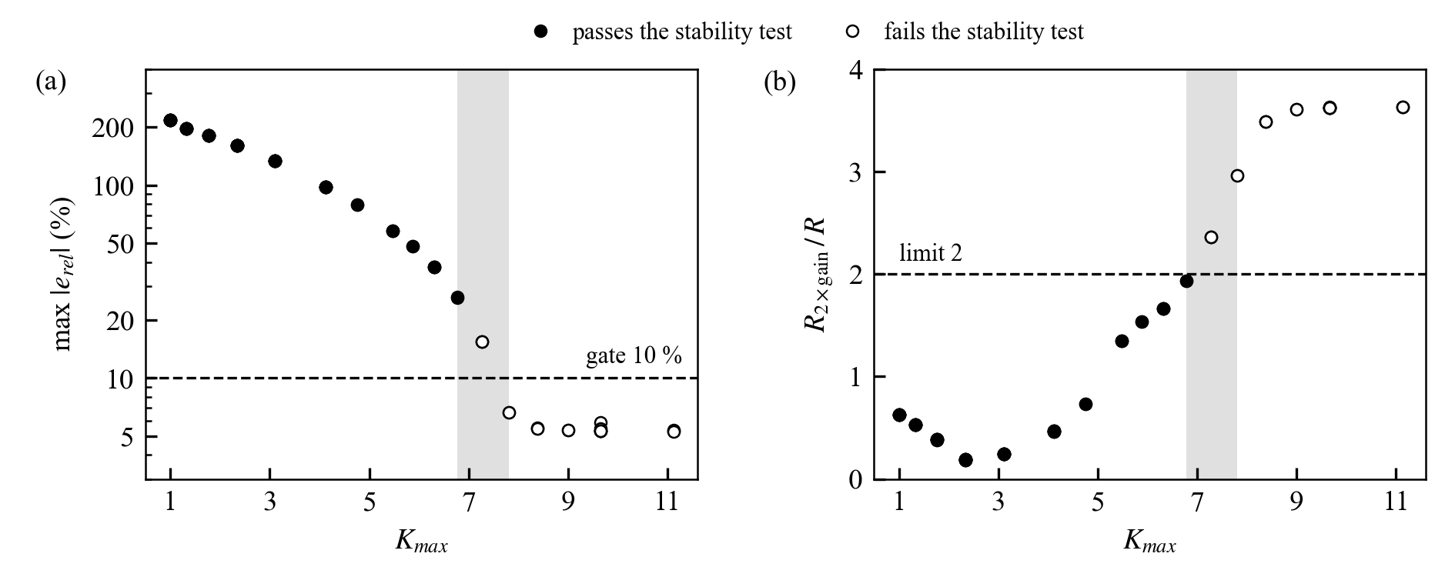
Table 6 counts the candidates that remain after each step. The assist map shows a conflict between the two gates, which Fig. 7 resolves by plotting the candidates against the slope limit. Slopes up to $K_{max}=6.77$ are stable, but the largest steady error is at least 26 %, because the slope is too small to reproduce the calibrated assistance. The smallest slope that passes the accuracy gate is $K_{max}=7.81$, with a largest steady error of 6.7 %, but there $R$ rises 3.0 times when the motor gain is doubled. At $K_{max}=7.27$ both gates fail. No Map design passes both gates, so its all-gates front is empty. Because of this, the Map design is selected on the stability-only front and is reported with its steady error of 26.2 %; it is the stable design with the lowest steady error that the grid contains. The conflict follows from the local analysis of Section 3.2: a larger slope $s_{m}$ reduces the error but also raises the loop gain that the compensator must stabilize.
Fig. 7. Candidates of the assist map against the slope limit: (a) largest steady relative error, (b) ratio of $R$ with doubled motor gain to nominal $R$. Open circles fail the stability test; the shaded band lies between the largest stable and the smallest accurate slope.

Table 6. Candidates after each step of the selection (five common noise realizations).
Controller | Candidates | Re-simulated | Pass $e_{rel}$ gate | Stability-only front | All-gates front
Map | 149 | 80 | 17 | 58 | 0
PID | 168 | 105 | 60 | 35 | 22
MapPID | 211 | 118 | 117 | 48 | 48

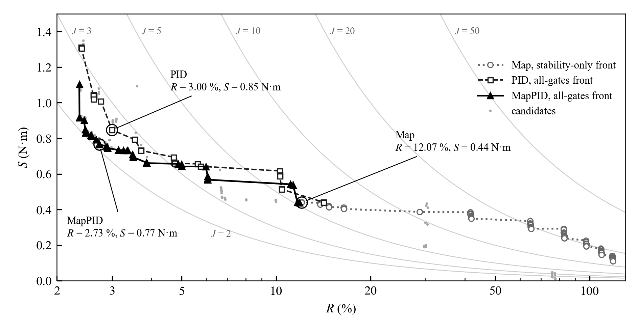
Fig. 8 shows the fronts of the three controllers. The MapPID front lies below the PID front over most of the range. For $R$ up to 2.5 % the smallest $S$ is 0.83 N·m for MapPID and 1.31 N·m for PID, 36 % lower; at 3 % it is 0.75 and 0.85 N·m, at 4 % 0.66 and 0.73 N·m, at 10 % 0.57 and 0.64 N·m, and at 14 % 0.44 and 0.51 N·m, a reduction of 10–15 %. At $R$ of about 6 % and at 20 % the two fronts are equal within the 5 % tolerance. The stability-only front of Map begins at $R=12$ %, four to five times the value of the other two controllers, and its steady error exceeds the 10 % gate at every point. Map therefore offers lower $S$ only at a much larger tracking error.
Fig. 8. Fronts of Map (stability-only), PID, and MapPID (all gates) with curves of constant $J=R·S$. The selected designs are ringed.
The selected designs are listed in Table 7. All three satisfy the stability test with a margin: doubling the motor gain raises $R$ by a factor of 1.93 for Map and lowers it for PID and MapPID, and the extra delay changes $R$ by 2.3 % at most. The MapPID design keeps the Map block of the Map design unchanged and adds a PID branch whose proportional and integral gains are smaller than those of PID alone, since the map already supplies a part of the loop gain. Its $J$ is 18 % below PID and 61 % below Map. The values are the means over the five common realizations; their standard deviations are below 0.1 % for $R$ and below 0.01 N·m for $S$.

Table 7. Selected designs (means over five common noise realizations).
Controller | Parameters | R (%) | S (N·m) | J | Largest steady error (%) | Phase margin (°)
Map | $K_{max}$ = 6.77, $g_{min}$ = 0.707; lead $z$ = 33.5, $p$ = 673 rad/s; lag $z_{1}$ = 28.1, $p_{1}$ = 10.7 rad/s | 12.07 | 0.44 | 5.31 | 26.2 | 45.5
PID | $K_{p}$ = 3.50, $K_{i}$ = 111, $K_{d}$ = 0.108, $τ_{f}$ = 1.20 ms | 3.00 | 0.85 | 2.54 | 2.5 | 50.5
MapPID | Map as above; $K_{p}$ = 1.48, $K_{i}$ = 73.7, $K_{d}$ = 0.0470, $τ_{f}$ = 2.07 ms | 2.73 | 0.77 | 2.09 | 2.0 | 39.5

- Evaluation on Independent Scenarios
The three designs of Table 7 are evaluated without further tuning on three scenarios that were not used for the selection. Section 5.1 describes the scenarios and the measures, Section 5.2 compares the overall tracking and the assist-torque noise, Section 5.3 the steady errors in held turns and under changing speed and friction, and Section 5.4 the response to continuous steering. Section 5.5 discusses the results.
  - Scenarios and Metrics
Each scenario lasts 100 s and asks one question (Table 8). The speeds, lateral-acceleration levels, friction values, and steering frequencies lie outside the grid of CALIB, and the steering-wheel angle is again prescribed open loop. The three controllers see the same three noise realizations (seeds 99987 to 99989), which have not been used in Section 4. The whole-case measures are the RMS of $e_{T}$ and the high-frequency content $S$ of Eq. (47) over the full scenario, both in N·m, and their product, which plays the role of $J$ for one scenario. In each evaluation window the signed error of Eq. (48) is reported in percent of $T_{ref}$. All values are means over the three realizations; their standard deviations are below 0.01 N·m for both the RMS error and $S$, so the differences discussed below are not caused by the noise sequence. Two values that differ by less than 5 % are treated as equal.

Table 8. Evaluation scenarios (100 s each).
Scenario | Scenes and conditions | Count | Question
STEADY | Held turns on a dry road at 25, 45, 65, and 85 km/h; levels of 0.15 and 0.25 g at every speed and 0.35–0.38 g from 45 km/h; 4 s per level | 11 | Steady error from light cornering up to the tire limit
SLIP | Speed ramp 90 → 45 → 90 km/h in a 0.2 g turn; friction staircase μ = 0.8 → 0.5 → 0.33 → 0.24 → 0.8 at 60 km/h, 0.3 g; puddle of μ = 0.2 for 2 s at 80 km/h, 0.25 g | 12 | Steering effort when speed or friction changes during a turn
WEAVE | Weaving about the center (0.05 g, 0.2 Hz, 95 km/h); two double lane changes (0.2 g, 0.4 Hz, 80 km/h), the second across a puddle of μ = 0.2; sinusoidal steering at 0.3, 0.8, and 1.5 Hz (0.1 g, 70 km/h); slalom on μ = 0.3 (0.15 g, 0.75 Hz, 60 km/h) | 8 | Tracking and assist-torque noise in continuous steering

  - Overall Tracking and Assist-Torque Noise
Table 9 lists the whole-case measures. The ranking is the same in the three scenarios. Map has the lowest $S$, but its RMS error is 3.3 to 8.1 times that of the feedback controllers. PID has the lowest RMS error and the highest $S$. MapPID tracks almost as well as PID, with an RMS error that is equal to that of PID in STEADY and 7 % and 36 % higher in SLIP and WEAVE, while its $S$ is 35 %, 30 %, and 38 % lower. Its product of RMS error and $S$ is therefore the lowest in every scenario, 32 %, 24 %, and 16 % below PID.
Table 9. Whole-case measures (means over three noise realizations).
Scenario | Controller | RMS of $e_{T}$ (N·m) | S (N·m) | Product (N²·m²)
STEADY | Map | 1.06 | 0.20 | 0.210
STEADY | PID | 0.25 | 0.68 | 0.168
STEADY | MapPID | 0.26 | 0.44 | 0.114
SLIP | Map | 0.69 | 0.20 | 0.140
SLIP | PID | 0.19 | 0.60 | 0.116
SLIP | MapPID | 0.21 | 0.42 | 0.088
WEAVE | Map | 1.45 | 0.29 | 0.420
WEAVE | PID | 0.18 | 1.04 | 0.185
WEAVE | MapPID | 0.24 | 0.64 | 0.155

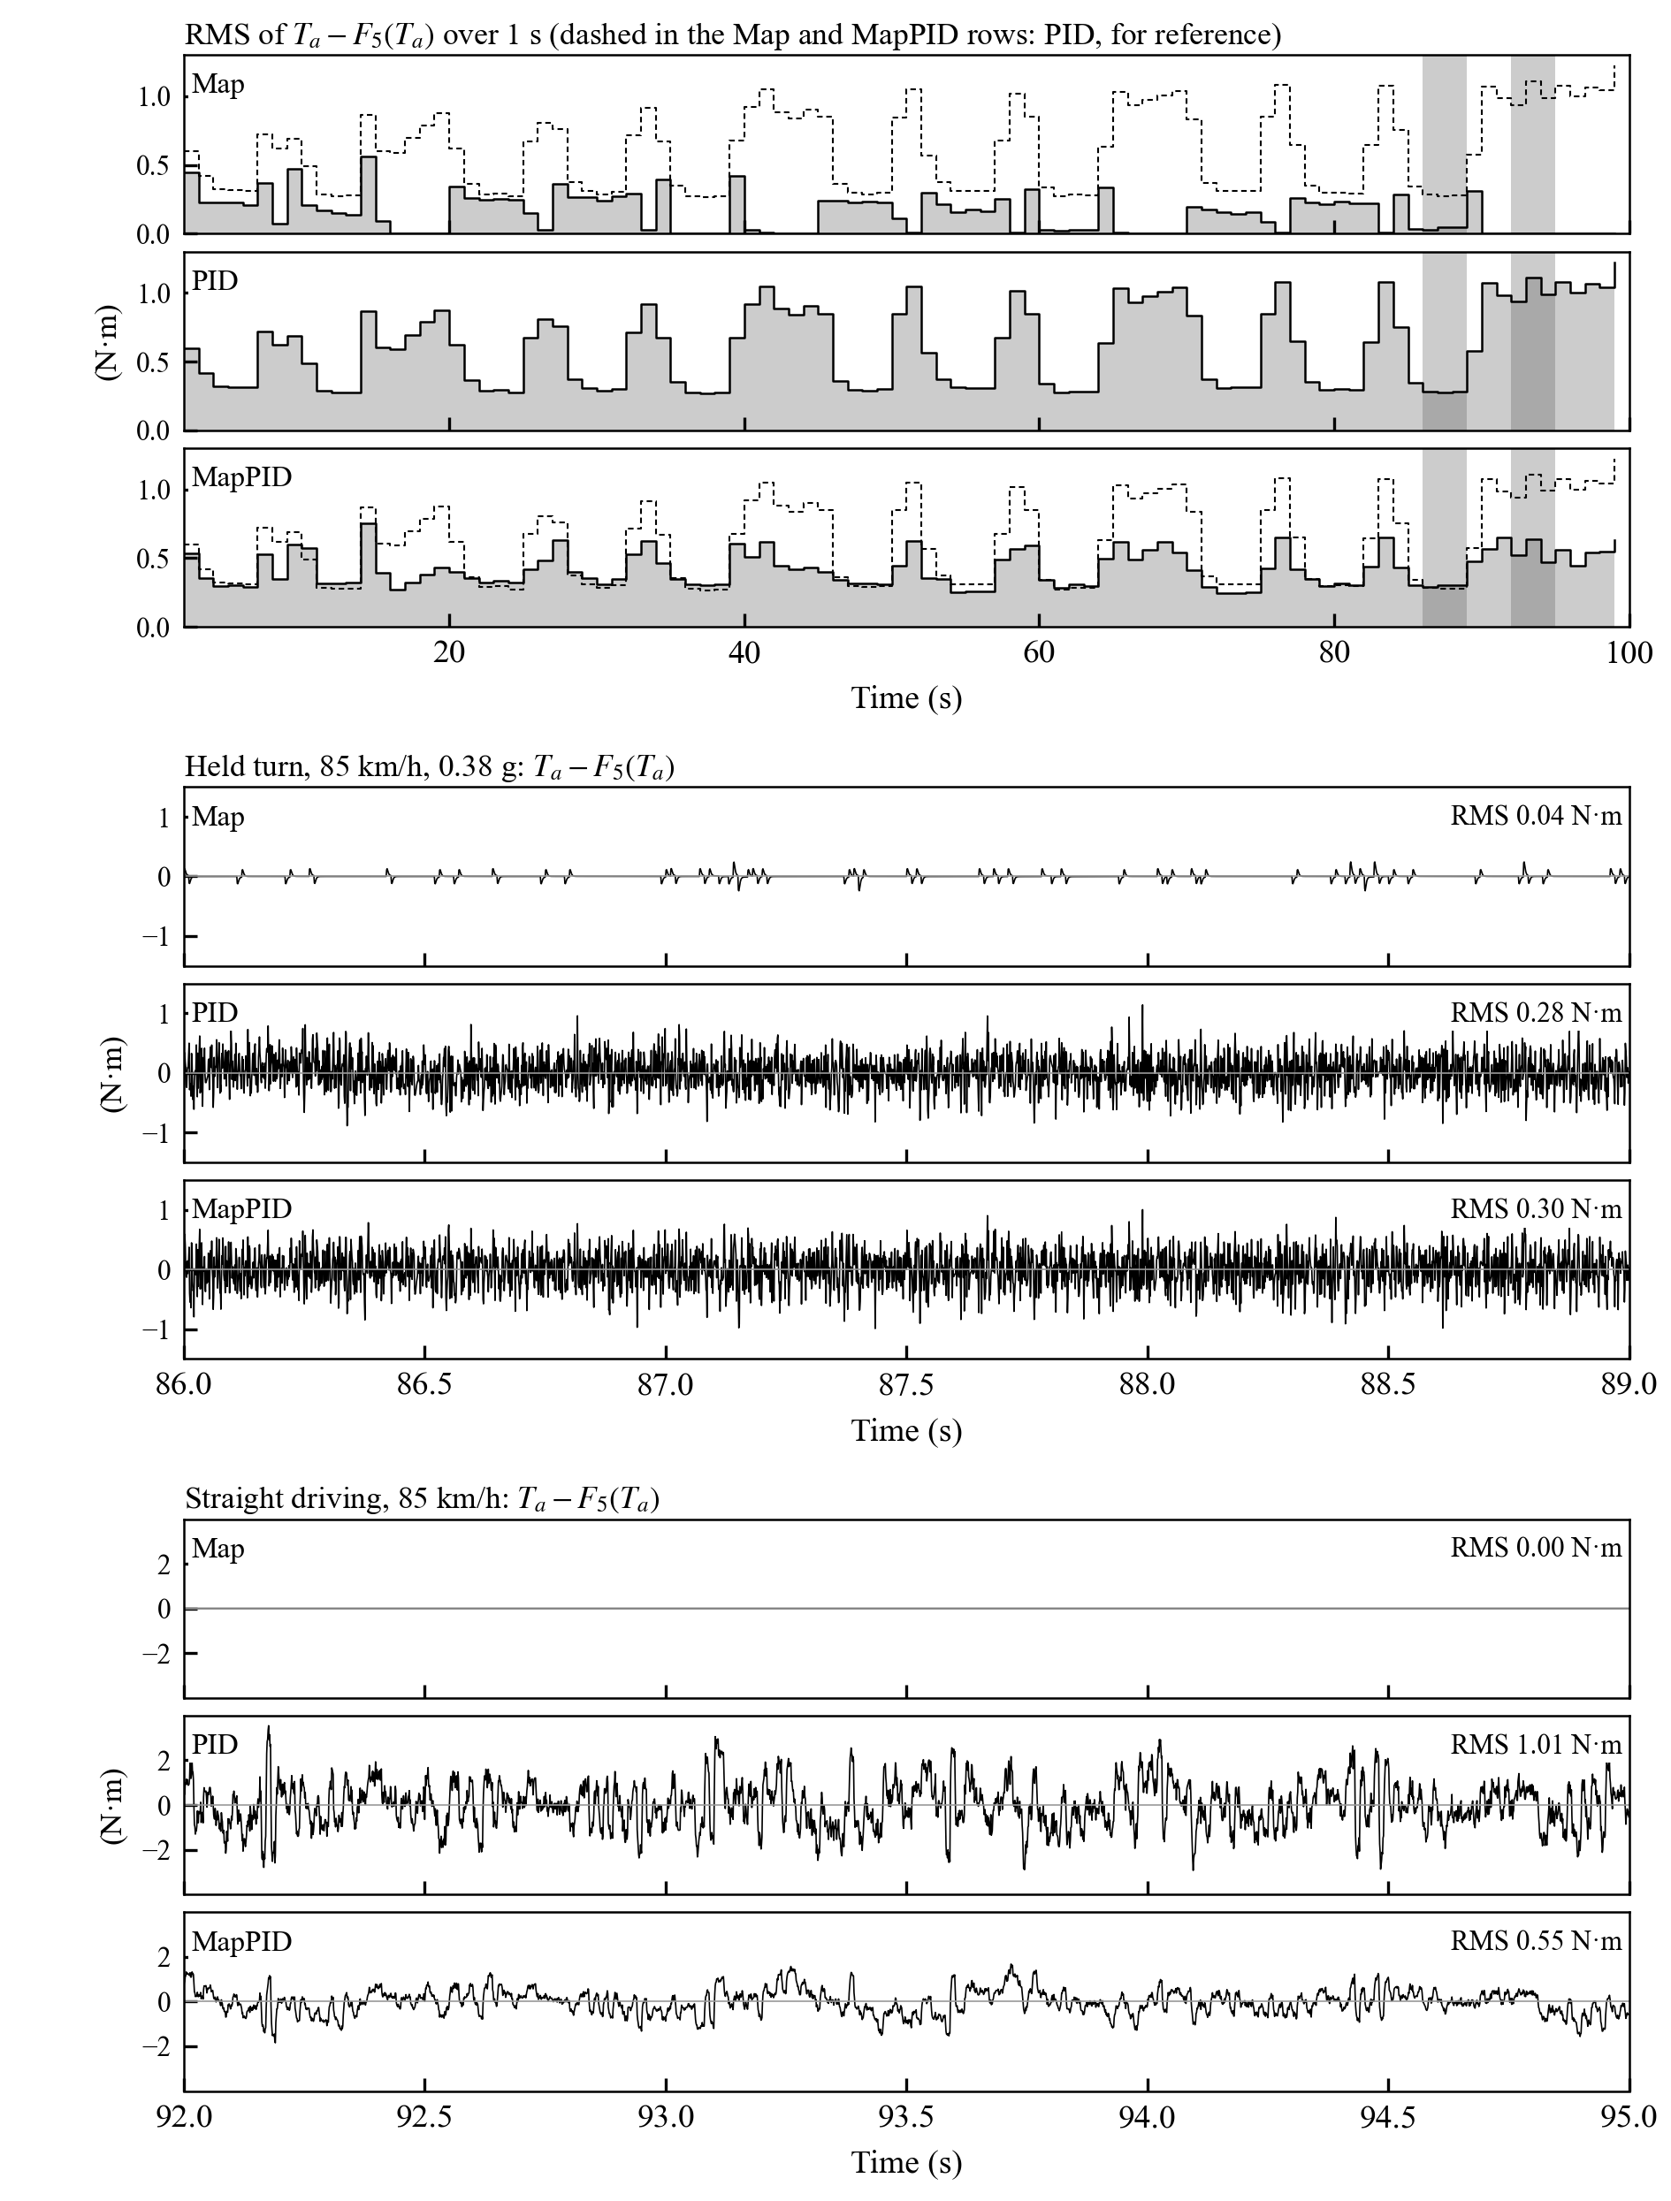
A single value of $S$ for a whole scenario does not show where the noise arises. Fig. 9 therefore follows the high-frequency part of the assist torque, $T_{a}-F_{5}\left(T_{a}\right)$, along STEADY with 1 ms resolution for one realization. The first three rows give its RMS over consecutive 1 s intervals, one row per controller on one common scale. The next three rows show the signal itself in a held turn of 0.38 g (86–89 s) and the last three rows in straight driving (92–95 s), each group on its own common scale; both intervals are shaded in the first three rows. During the held turns the three controllers produce similar noise: over the last 3 s of the holds the RMS is 0.18 N·m for Map, 0.29 N·m for PID, and 0.30 N·m for MapPID. The difference appears near straight-ahead driving and in the transitions between turns. In the final 10 s of straight driving the RMS is 1.04 N·m for PID and 0.56 N·m for MapPID, while Map produces no assistance because the measured torque stays inside its dead zone; in the transitions and the short straight segments between turns it is 0.76 and 0.48 N·m. In straight driving (last three rows), the assist torque of PID swings by about ±2 N·m within tens of milliseconds, against about ±1 N·m for MapPID, and this ripple reaches the steering wheel through the column.
Fig. 9. High-frequency assist torque $T_{a}-F_{5}\left(T_{a}\right)$ in STEADY (seed 99987, 1 ms): first three rows, RMS over 1 s intervals, with the PID values dashed in the Map and MapPID rows for reference; next three rows, the signal in a held turn (86–89 s); last three rows, the signal in straight driving (92–95 s). One row per controller, one scale in each group; the two shaded intervals in the first three rows are the intervals of the other six.
The noise follows from the gain that each structure applies to the measured torque above the steering band. For the PID branch this gain approaches $K_{p}+K_{d}/τ_{f}$, which is 94 for PID and 24 for the branch of MapPID. The map supplies part of the loop gain of MapPID, so its branch needs smaller proportional and derivative gains and a longer filter time constant, and near zero torque the map adds nothing because of its dead zone. In a held turn the map slope adds its own gain, which is why the two controllers are close there.
  - Held Turns and Changes of Speed and Friction
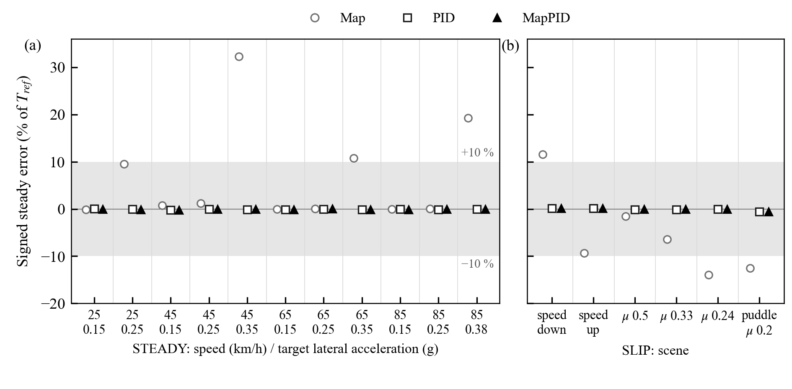
Fig. 10 shows the signed steady error in every hold window of STEADY and in the windows of SLIP after the speed or the friction has changed. The mean error of the two feedback controllers stays within 0.02 N·m of the reference in every window, below 0.7 % of $T_{ref}$, which is indistinguishable from zero at the sensor resolution. The error of Map depends on the operating point. In STEADY it is below 1.3 % at 0.15 and 0.25 g except at 25 km/h and 0.25 g (+9.5 %), and it grows to +32 % at 45 km/h and 0.35 g, +11 % at 65 km/h and 0.35 g, and +19 % at 85 km/h and 0.38 g. A positive error means that the steering is heavier than intended; these are the operating points where the calibrated assistance would need a slope above $K_{max}$, as in Fig. 7.
Fig. 10. Signed steady error in the windows of (a) STEADY and (b) SLIP (means over three noise realizations). The band marks ±10 %.
In SLIP the error of Map changes sign with the direction of the speed ramp, +11.6 % while the speed falls and −9.3 % while it rises, because the column Coulomb friction acts against the direction of column motion. On the friction staircase the error of Map is −1.5, −6.4, and −13.9 % at μ = 0.5, 0.33, and 0.24, and −12.6 % in the puddle; the negative sign means that the steering becomes lighter than intended as the road reaction falls, which is the effect predicted by Eq. (28). Relative to the same scene on μ = 0.8, the friction alone accounts for −1.8, −6.7, and −14.2 %. When the friction returns to 0.8 while the front tire is still sliding, all controllers show a transient error; over the recovery windows its mean is +29 % and +19 % for Map, +3.8 % and +6.0 % for PID, and +3.1 % and +5.0 % for MapPID.
  - Continuous Steering
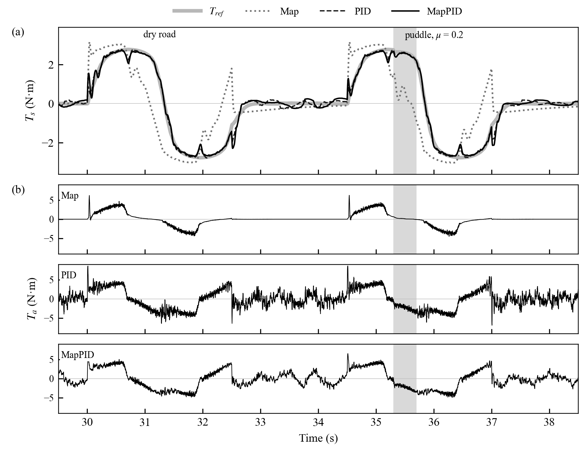
Fig. 11 shows the double lane changes of WEAVE. Map lags the reference: its sensed torque overshoots at the start of each steering motion and then falls behind, so the mean error over the window after the peak is −77 % on the dry road and −87 % in the puddle. The puddle itself adds about −10 % to this error; the remainder is the dynamic error of the map that is present on the dry road as well. PID and MapPID follow the reference with errors of about −2 % and −2.5 % in both cycles. Panels (b) show that the assist torque of PID carries visibly more high-frequency content than that of MapPID throughout the maneuver, also between the two lane changes, where the steering is close to straight ahead. In the sinusoidal steering windows the RMS error grows with frequency for all controllers, from 0.14 to 0.35 N·m for PID and from 0.18 to 0.60 N·m for MapPID between 0.3 and 1.5 Hz, against 1.7–2.6 N·m for Map; at 1.5 Hz PID therefore tracks better, at the price of the higher noise seen in Table 9.
Fig. 11. Double lane changes in WEAVE (seed 99987), dry road and puddle ($μ$ = 0.2, shaded): (a) sensed torque and reference; (b) assist torque of each controller, on one scale.
  - Discussion
The errors of Map come from three sources, and the scenarios separate them. The first is the slope limit: where the calibrated assistance would need a slope above $K_{max}$, the map cannot reach it, which produces the errors of up to +32 % in STEADY. The same limit attenuates a change of road reaction only by $1/\left(1+s_{m}\right)$, which gives the errors of −6 to −14 % on low friction. The second is column Coulomb friction, which reverses the error when the direction of column motion reverses, as in the speed ramp. The third is the dynamic error during fast steering, which dominates the lane change. Integral feedback removes the first two, and the feedback branch also reduces the third.
The comparison between PID and MapPID shows what the map contributes to direct feedback. Both remove the steady errors, so the static accuracy no longer separates them. The map, however, carries part of the loop gain, which lets the branch use smaller gains and a longer derivative filter; the assist torque of MapPID is therefore 30–38 % quieter, with the largest difference near straight-ahead driving, at the cost of a somewhat larger tracking error in fast steering. For a vehicle that already has a calibrated map, the plug-in branch thus obtains the accuracy of torque feedback while keeping the assist torque closer to that of the map.
The results are limited by the model and the test conditions. One vehicle model and one assist map were used; the procedure is the same for the map of another vehicle, but it was not repeated here. The steering–vehicle model has not been validated against measurements, the road-reaction torque depends on the assumed pneumatic trail, and the driver is represented by a prescribed steering angle, so the driver's correction of the angle in response to the changed effort is not included. The motor current loop and power limits are omitted, and the reference is one published characteristic. The measure $S$ describes the high-frequency content of the assist torque, which relates to the roughness felt at the steering wheel, but whether drivers prefer the MapPID response requires tests with drivers.
- Conclusions
This study added torque feedback to a calibrated assist map as a parallel PID branch that leaves the map and its compensator unchanged, and compared the Map, a PID controller that replaces the map (PID), and the plug-in combination (MapPID) in simulation.
The assist map has a structural accuracy limit. Its slope cannot be made both stable and accurate: on the grid of this study, slopes up to $K_{max}=6.77$ are stable but leave a steady error of at least 26 %, and slopes from 7.81 are accurate but lose the stability margin when the motor gain is doubled. In the independent scenarios the RMS error of Map was 3.3 to 8.1 times that of the feedback controllers. The largest deviations came from the slope limit (up to +32 % in held turns), column Coulomb friction (about ±10 % in speed ramps), and fast steering (−77 % and −87 % in lane changes), while the loss of friction alone accounted for −2 to −14 % of the reference.
Integral feedback removed the steady errors: PID and MapPID stayed within 0.02 N·m of the reference in every held-turn and friction window. MapPID tracked as well as PID in steady cornering and 7 % and 36 % worse in friction change and weaving, while its assist-torque noise was 30 to 38 % lower and the product of RMS error and noise was 16 to 32 % below that of PID in every scenario. In held turns the two feedback controllers had the same noise; the difference lies in straight driving and in transitions.
For a vehicle that already has a calibrated map, the PID branch therefore gives the accuracy of torque feedback while keeping the assist torque closer to that of the map, at the cost of tuning four parameters for each vehicle. The results come from one vehicle model that has not been validated against measurements, with a prescribed steering angle instead of a driver. The next steps are to repeat the tuning on the map of another vehicle and to test the perceived steering feel with drivers.
Acknowledgments
The authors acknowledge Ho Chi Minh City University of Technology (HCMUT), Vietnam National University Ho Chi Minh City (VNU-HCM) for supporting this research.
Conflict of Interest
The authors have no conflict of interest to declare.
Author contributions
Tram Minh Tan: modeling, simulation, data analysis, writing – original draft. Phung Thanh Huy: supervision, review and editing. All authors have approved the final article.
Declaration of Generative AI
During the preparation of this work, the authors used Claude (Anthropic) for language editing only. After using this tool, the authors reviewed and edited the content as needed and take full responsibility for the content of the published article.
References
[1]. D. Lee, K.-S. Kim, S. Kim (2018). Controller design of an electric power steering system. IEEE Transactions on Control Systems Technology, 26(2), 748-755. doi:10.1109/TCST.2017.2679062
[2]. X. Guan, Y.-N. Zhang, C.-G. Duan, W.-L. Yong, P.-P. Lu (2021). Study on decomposition and calculation method of EPS assist characteristic curve. Proceedings of the Institution of Mechanical Engineers, Part D: Journal of Automobile Engineering, 235, 2166-2175. doi:10.1177/0954407020987062
[3]. Y. Li, Z. Yang, D. Zhai, J. He, J. Fan (2023). Study on control strategy of electric power steering for commercial vehicle based on multi-map. World Electric Vehicle Journal, 14(2), 33. doi:10.3390/wevj14020033
[4]. L. Fan, B. Zhou, H. Zheng (2014). A new control strategy for electric power steering on low friction roads. SAE International Journal of Passenger Cars - Mechanical Systems, 7(3), 972-980. doi:10.4271/2014-01-0083
[5]. Q. Li, C. Xia (2012). Research of electric power steering system assistance characteristic based on the identification of the road. Proceedings of ICCIA 2012, 402-405. doi:10.2991/iccia.2012.97
[6]. Y. Li, J. Fan, J. He, Y. Nan, Q. Feng (2020). Novel electric power steering control strategies of commercial vehicles considering adhesion coefficient. Advances in Mechanical Engineering, 12(12), 1-11. doi:10.1177/1687814020983059
[7]. X. Zhao, X. Shi, J. Chen, X. Li (2011). Dynamic correction of the steering-characteristic curve and application to an EPS control system. International Journal of Automotive Technology, 12(2), 243-249. doi:10.1007/s12239-011-0029-5
[8]. D. Lee, K. Yi, S. Chang, B. Lee, B. Jang (2018). Robust steering-assist torque control of electric-power-assisted-steering systems for target steering wheel torque tracking. Mechatronics, 49, 157-167. doi:10.1016/j.mechatronics.2017.12.007
[9]. D. Lee, B. Jang, M. Han, K.-S. Kim (2021). A new controller design method for an electric power steering system based on a target steering torque feedback controller. Control Engineering Practice, 106, 104658. doi:10.1016/j.conengprac.2020.104658
[10]. D. Saifia, M. Chadli, H. R. Karimi, S. Labiod (2015). Fuzzy control for electric power steering system with assist motor current input constraints. Journal of the Franklin Institute, 352(2), 562-576. doi:10.1016/j.jfranklin.2014.05.007
[11]. H. Q. Nguyen, V. T. Vu, O. Sename (2025). Combining adaptive neural-fuzzy inference system with field-oriented control strategy for electric power steering system in cars. Advances in Mechanical Engineering, 17(9). doi:10.1177/16878132251369152
[12]. H.B. Pacejka. (2006). Tyre and vehicle dynamics (2nd ed.). Elsevier.
[13]. R. Rajamani. (2012). Vehicle dynamics and control (2nd ed.). Springer.
[14]. Valeo. Torque and/or angle sensors, product catalogue. https://www.valeo.com/en/catalogue/cda/torque-and-or-angle-sensors/
[15]. Bosch Motorsport. (2020). Acceleration sensor MM5.10, data sheet. https://www.bosch-motorsport.com
[16]. H. Ragab, S. Givigi and A. Noureldin. (2024). Automotive speed estimation: Sensor types and error characteristics from OBD-II to ADAS. arXiv:2501.00242.
[17]. R. Deborne, S. Khouri Silva and A. Kemeny. (2014). Steering wheel torque rendering: Measure of driver discrimination capabilities. SAE Technical Paper 2014-01-0447. https://doi.org/10.4271/2014-01-0447

