Common parameter-selection method for the C-EPS controllers: method and first comparison
Trần Minh Tân — progress report to TS. Phùng Thanh Huy — 2026-10-17

1. Summary
- All controllers are now tuned with ONE common procedure: a global search (surrogateopt, then patternsearch) on the calibration case CALIB at one seed, the 20 best distinct admissible designs re-scored on five other seeds, and the design with the smallest MEAN J = R × S chosen. The old grid sweeps with one seed are kept as references.
- Results are given for the three controllers tuned with this method: Map (assist map with lead-lag), PID and MapPID (map branch + PID branch), scored on the five test cases DRY, RAMP, SLIP, WEAVE, EDGE at five scoring seeds (99995-99999), as mean ± standard deviation over the seeds.
- MapPID vs PID (same tuning effort): RMS e_T +15, +36, +46, +41, +26 %, S -20, -21, -21, -20, -22 % (DRY, RAMP, SLIP, WEAVE, EDGE).
- MapPID vs Map: RMS e_T -77, -92, -68, -81, -89 %, S +123, +41, +144, +163, +145 %.

2. Old method (used in the paper draft)
Each controller was tuned on CALIB (117 s: steady cornering 0.1–0.3 g at 20/60/100 km/h, sine steering, small corrections and a friction step) with ONE noise seed of its own range. R is the tracking error (mean of four group errors in % of T_d,ref), S the RMS of the assist torque above 5 Hz (noise), J = R × S. Gates: steady-state error e_rel ≤ 5 % on 9 windows, stability with margin by simulation (gain × 2 and +1 ms delay), steering-band constraint (filter gain ≥ 0.707 at 2 Hz). The admissible point with the smallest J was chosen.
- Map: lead-lag designed off line on 68 linear plants (smallest high-frequency gain with PM ≥ 45°), only the slope limit K simulated (61 configurations).
- PID: grid on Kp, Ki, Kd, Tf (824 configurations).
- MapPID: first simultaneous optimisation of 9 parameters (930 evaluations) at one seed, checked on one more seed.
Weak points: different tuning effort and method per controller (so a better result can come from the method, not the structure), narrow boxes (MapPID stuck at the lower bound of its lead), and one-seed selection (the ranking of points closer than about 3 % is noise).

3. New common method
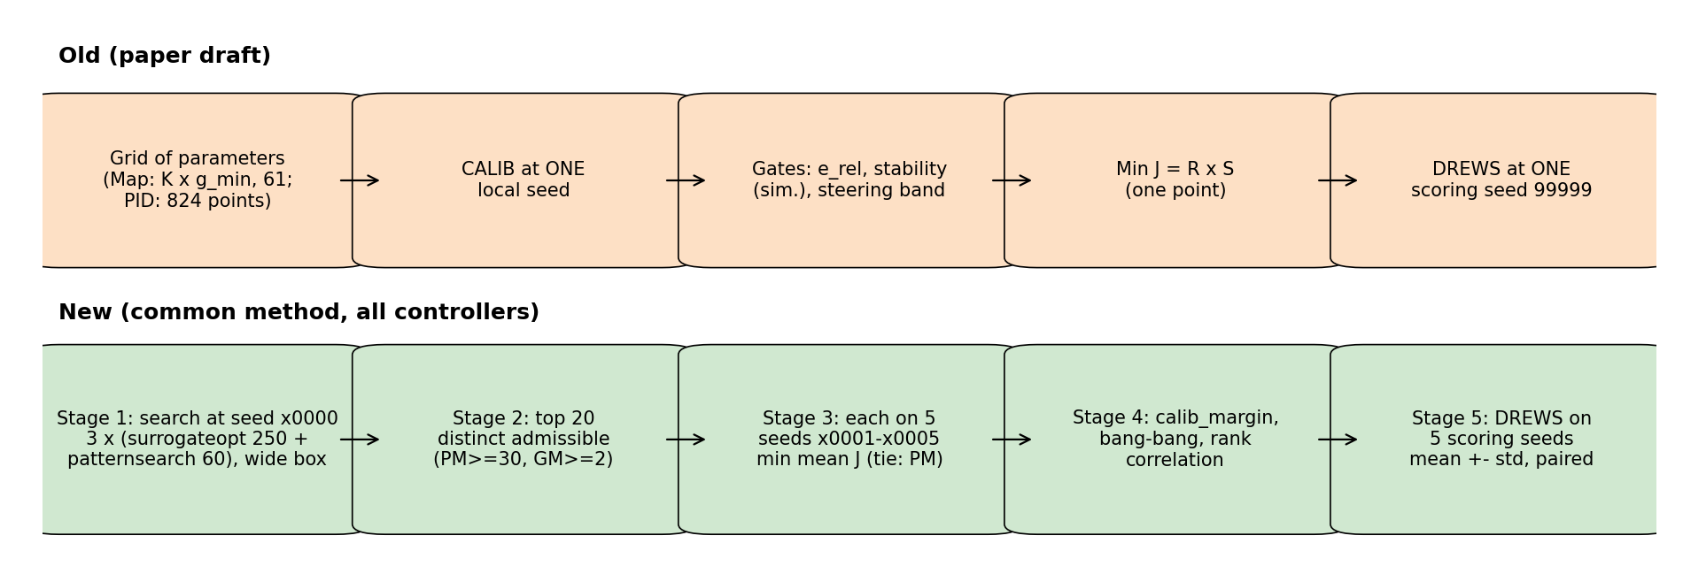
Figure 1. Old and new parameter-selection procedures.
Item | Old | New
Parameters searched | grid (Map: K only, lead-lag off line) | all parameters at once, surrogateopt ×3 + patternsearch ×3 (≈ 930 evaluations)
Box | narrow, hand set | wide, log scale; lead p/z ≥ 1 and lag p1/z1 ≤ 1 (stages can switch off); K 0.1–16; Kp 1e-3–30; Ki 0.1–2000; Kd 0 or 1e-4–2; Tf 1–79.6 ms
Linear requirement | Map PM ≥ 45° (design), others report | PM ≥ 30°, GM ≥ 2 on 68 plants (also during the search for Map and MapPID)
Seeds for the choice | 1 | search at x0000; choice on 5 seeds x0001–x0005 (x0000 not in the mean)
Choice | min J at one seed | min mean J over 5 seeds among the 20 best; tie (difference < std) → larger PM; e_rel ≤ 5 % at every seed
Checks | calib_margin | calib_margin, bang-bang, rank correlation search seed vs mean, convergence of 3 chains
Test cases | 1 scoring seed | 5 scoring seeds, mean ± std, paired differences
Table 1. Differences between the two methods.
Lesson learned while applying it: the linear requirement must already be imposed during the search. For the assist map the best J lies at PM ≈ 15°; a search with PM > 0 and a filter PM ≥ 30° afterwards left only 7 admissible designs of 583. Re-run with PM ≥ 30° in the search, Map reached J = 5.63 instead of 6.29.

4. Chosen designs
Controller | Parameters (rad/s, N·m, s) | CALIB J (5 seeds) | R [%] / S [N·m] | PM [deg] | GM
Map | K 6.06, lead z 38.7 p 385.2, lag z1 46.2 p1 11.7 | 5.630 ± 0.005 | 27.23 / 0.207 | 30.1 | 7.36
PID | Kp 1.36, Ki 52.1, Kd 0.046, Tf 2.9 ms | 3.486 ± 0.021 | 10.34 / 0.337 | 52.8 | 7.19
MapPID | K 3.73, lead z 405 p 428, lag z1 30.8 p1 18.6, Kp 0.007, Ki 49.4, Kd 0.046, Tf 4.2 ms | 3.054 ± 0.043 | 9.75 / 0.313 | 34.2 | 5.24
Table 2. Chosen designs: mean ± std over the 5 choice seeds; PM and GM over 68 linear plants.
Observations: in MapPID the lead is practically switched off (p/z = 1.06, corner at 405 rad/s), the lag stays, and Kp ≈ 0 (the map branch supplies the proportional action). Within the top 20 of MapPID the J differences (0.03–0.05) are smaller than the seed-to-seed spread; the rank correlation between the search seed and the 5-seed mean is only 0.43 (PID: 0.94), which is why the choice must use several seeds.
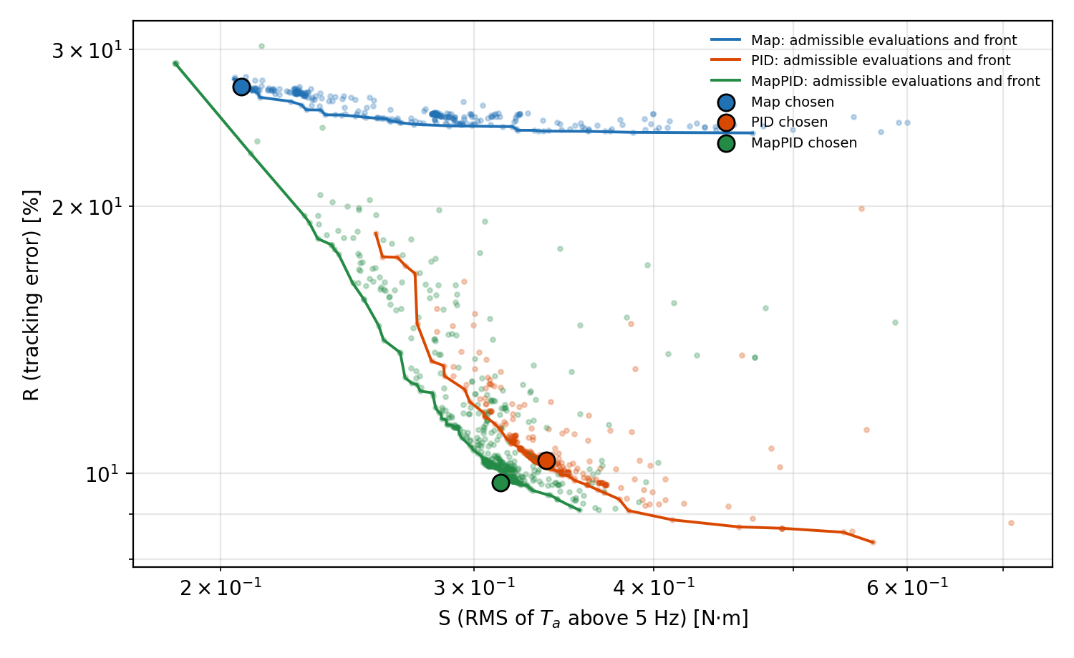
Figure 2. CALIB tracking–noise plane: admissible evaluations of the -Opt searches with their fronts, and the chosen designs (circles: mean over the 5 choice seeds). Map, PID and MapPID were searched at different seeds (0, 10000, 30000).

5. Results on the test cases (5 scoring seeds)
Controller | DRY | RAMP | SLIP | WEAVE | EDGE
Map | 0.687 ± 0.000 | 0.828 ± 0.000 | 0.539 ± 0.000 | 1.329 ± 0.000 | 1.518 ± 0.000
PID | 0.136 ± 0.002 | 0.046 ± 0.002 | 0.119 ± 0.007 | 0.182 ± 0.003 | 0.134 ± 0.005
MapPID | 0.157 ± 0.009 | 0.062 ± 0.006 | 0.174 ± 0.005 | 0.258 ± 0.015 | 0.169 ± 0.011
Table: RMS tracking error e_T [N·m], mean ± std over seeds 99995–99999.
Controller | DRY | RAMP | SLIP | WEAVE | EDGE
Map | 0.097 ± 0.000 | 0.079 ± 0.000 | 0.104 ± 0.000 | 0.127 ± 0.000 | 0.107 ± 0.000
PID | 0.270 ± 0.003 | 0.140 ± 0.002 | 0.321 ± 0.007 | 0.418 ± 0.005 | 0.334 ± 0.004
MapPID | 0.217 ± 0.010 | 0.111 ± 0.005 | 0.253 ± 0.009 | 0.333 ± 0.016 | 0.262 ± 0.011
Table: noise S [N·m], mean ± std over seeds 99995–99999.
Controller | DRY | RAMP | SLIP | WEAVE | EDGE
Map | 30.2 ± 0.1 | 44.9 ± 0.0 | 37.5 ± 0.2 | 18.5 ± 0.1 | 8.6 ± 0.1
PID | 72.3 ± 0.1 | 67.0 ± 0.1 | 77.3 ± 0.3 | 85.4 ± 0.5 | 77.1 ± 0.3
MapPID | 49.2 ± 0.0 | 53.2 ± 0.1 | 50.2 ± 0.2 | 47.3 ± 0.1 | 48.4 ± 0.1
Table: total variation of T_a [N·m/s], mean ± std over seeds 99995–99999.
Controller | DRY | RAMP | EDGE
Map | 11.50 ± 0.01 | 45.96 ± 0.03 | 98.29 ± 0.02
PID | 1.54 ± 0.34 | 0.28 ± 0.01 | 0.38 ± 0.21
MapPID | 1.50 ± 0.24 | 0.17 ± 0.02 | 0.28 ± 0.20
Table: largest steady-state error |e_rel| [%], mean ± std over seeds 99995–99999 (steady windows of DRY, RAMP, EDGE).
Controller | DRY | RAMP | SLIP | WEAVE | EDGE
Map | 0.0 ± 0.0 | 0.0 ± 0.0 | 0.0 ± 0.0 | 0.0 ± 0.0 | 0.0 ± 0.0
PID | 6.2 ± 0.3 | 5.8 ± 0.0 | 3.6 ± 0.1 | 26.2 ± 0.1 | 6.5 ± 0.1
MapPID | 6.4 ± 0.3 | 6.0 ± 0.0 | 3.9 ± 0.1 | 26.7 ± 0.5 | 7.1 ± 0.4
Table: reverse assist [% of time], mean ± std over seeds 99995–99999.
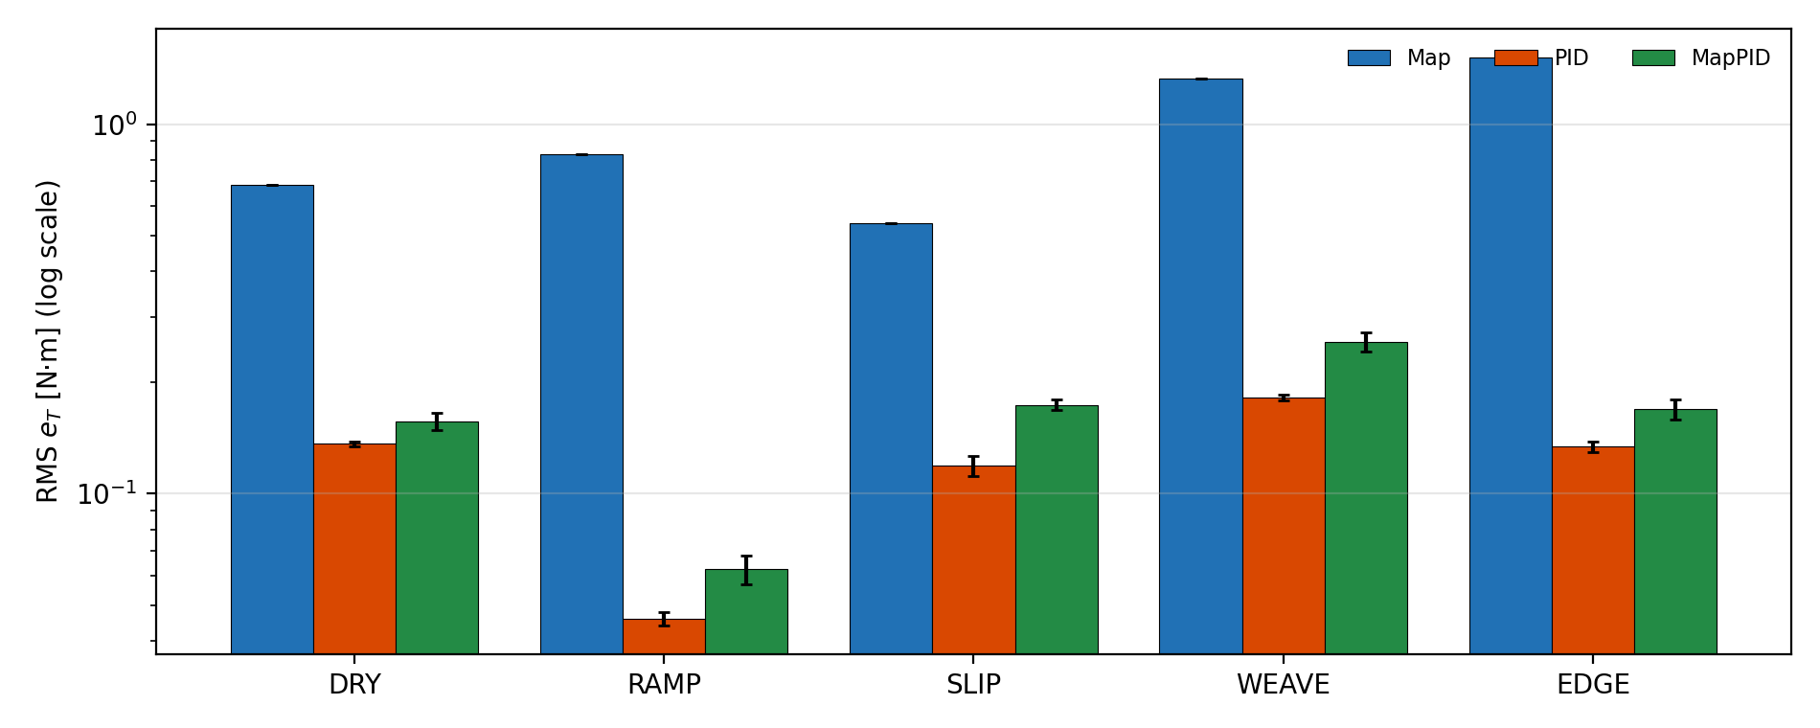
Figure 3. RMS e_T per case (mean ± std over 5 seeds, log scale).
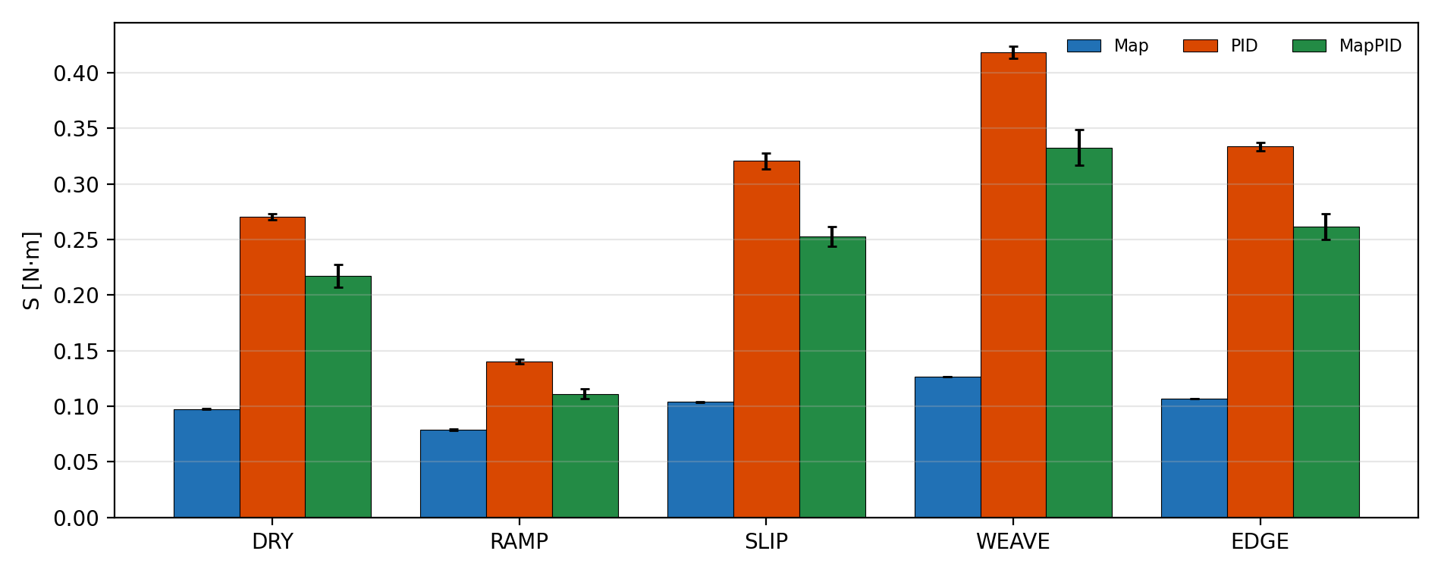
Figure 4. Noise S per case (mean ± std over 5 seeds).
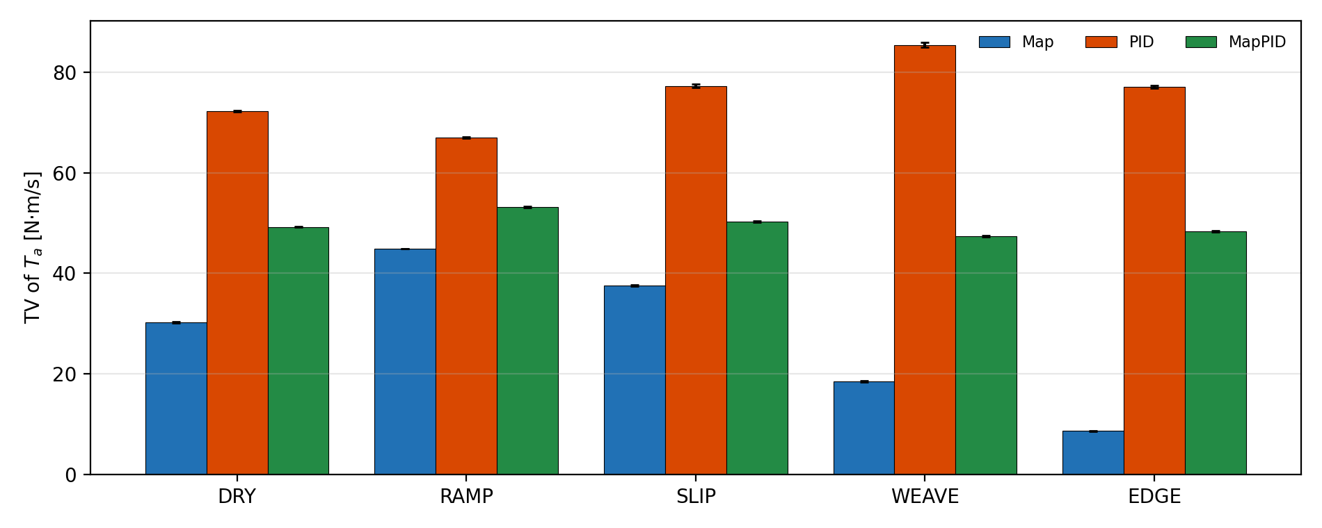
Figure 5. Total variation of the assist torque per case.
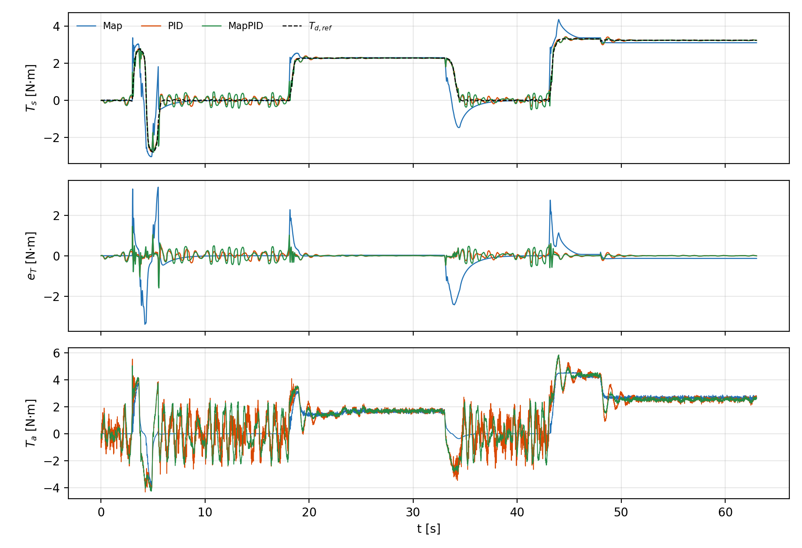
Figure 6. SLIP case (friction changes while cornering), seed 99999: T_s with T_d,ref, error e_T and assist T_a of the three controllers.

6. Paired comparisons
The assist map is almost insensitive to the sensor noise: its standard deviation over seeds is below 0.001 N·m and shows as 0.000.
Relative difference 100 (A − B)/B per seed, mean ± std over the 5 seeds, and the number of seeds where A is lower (better).
Pair (A vs B) | DRY | RAMP | SLIP | WEAVE | EDGE
MapPID vs PID | +15 ± 6 (0/5) | +36 ± 16 (0/5) | +46 ± 5 (0/5) | +41 ± 7 (0/5) | +26 ± 5 (0/5)
MapPID vs Map | -77 ± 1 (5/5) | -92 ± 1 (5/5) | -68 ± 1 (5/5) | -81 ± 1 (5/5) | -89 ± 1 (5/5)
PID vs Map | -80 ± 0 (5/5) | -94 ± 0 (5/5) | -78 ± 1 (5/5) | -86 ± 0 (5/5) | -91 ± 0 (5/5)
Table: paired difference of RMS e_T [%].
Pair (A vs B) | DRY | RAMP | SLIP | WEAVE | EDGE
MapPID vs PID | -20 ± 3 (5/5) | -21 ± 4 (5/5) | -21 ± 1 (5/5) | -20 ± 4 (5/5) | -22 ± 3 (5/5)
MapPID vs Map | +123 ± 10 (0/5) | +41 ± 7 (0/5) | +144 ± 8 (0/5) | +163 ± 12 (0/5) | +145 ± 11 (0/5)
PID vs Map | +178 ± 2 (0/5) | +78 ± 2 (0/5) | +209 ± 7 (0/5) | +231 ± 5 (0/5) | +213 ± 4 (0/5)
Table: paired difference of S [%].

7. Discussion
- Same method, different structure: MapPID vs PID isolates the effect of the map branch on top of a PID tuned with the same effort.
- In MapPID the optimiser removed the lead (p/z close to 1) and set Kp close to 0: the map branch takes over the proportional action and the PID branch keeps the integral and derivative parts; the lag on the map branch remains. CALIB cannot distinguish designs with different Kp (their group errors and S are equal), while the speed ramp, friction changes and weaving of RAMP, SLIP and WEAVE do; this is a limitation of J = R × S on CALIB.
- The assist map alone keeps the lowest noise and almost no reverse assist but large steady-state errors (no integral action), whatever the tuning.

8. Limitations and next steps
- One search seed per controller and five choice seeds; the -Opt searches are local optima (convergence checked by 3 chains).
- The rule was changed after seeing results (common method, PM ≥ 30° during the search); this must be stated in the paper.
- Possible next step (needs a decision): add a dynamic test (speed ramp) or the total variation to the selection criterion, so that CALIB sees the effect of Kp.

