Plug-In Steering-Torque Feedback for Column Electric Power Steering with a Calibrated Assist Map
Minh Tan Tram^{1,*}, Thanh Huy Phung¹
¹Ho Chi Minh City University of Technology (HCMUT), Vietnam National University Ho Chi Minh City (VNU-HCM), 268 Ly Thuong Kiet Street, Ho Chi Minh City, Vietnam
*Corresponding author: Minh Tan Tram, e-mail: tmtan.sdh241@hcmut.edu.vn
Thanh Huy Phung, e-mail: huypt@hcmut.edu.vn

Abstract
In many electric power steering (EPS) systems in the literature, the assist torque comes from an assist map and a compensator, both calibrated for each vehicle on a dry road. Because the map responds only to the measured torsion-bar torque and vehicle speed, it has no reference to track, so when the road reaction torque changes (loss of grip, column friction, rapid steering) it reduces the torque error only by a factor set by its local slope, which cannot be raised because a steeper map lowers stability and amplifies noise. This study adds torque feedback to the map.
Map, an assist map with a lead–lag compensator, represents the existing controller, whereas PID replaces the map with a PID controller acting on the error between the measured torque and a target torque set by vehicle speed and lateral acceleration, without a friction estimate. MapPID retains Map and adds a parallel PID branch on the same error, with only four parameters tuned for each vehicle; analysis shows that this branch removes the steady error unless the motor saturates.
Closed-loop simulations use a nonlinear steering–vehicle model with tire saturation, motor dynamics, and noisy, quantized sensors, with parameters chosen on a Pareto front and tested on independent cases. Map shows large errors near its slope limit and in rapid steering, whereas PID and MapPID remove the steady error; at low torque MapPID gives a smoother assist than PID because the map carries part of the loop gain, but it tracks worse during rapid steering.
Keywords: Electric power steering; Assist map; Torque feedback; PID control; Lateral acceleration; Road friction.

1. Introduction
Electric power steering (EPS) replaces the hydraulic pump with an electric motor, which saves energy and allows the steering feel to be tuned in software [1]. In the column-assist type (C-EPS) the motor acts directly on the steering column. A good steering feel is an important requirement, since the driver should find the wheel heavy or light as the situation demands and should sense the road condition through the wheel; if the assist is excessive on a slippery road, the driver may over-steer, which compromises safety [3,4].
In the C-EPS systems described in the literature, the assist torque comes from an assist map that gives the required torque as a function of the torsion-bar torque and the vehicle speed, followed by a compensator, for example a lead–lag filter, that keeps the loop stable and limits noise amplification [1,2]. The map and the compensator are calibrated for each vehicle on a dry road, and repeating this work is costly [2,9]. The difficulty is that the map receives only the measured torque and has no target torque to compare with, so that when the road reaction torque changes it reduces the error only partly, by a factor set by its slope. The slope cannot be raised freely, because a steeper map lowers stability and amplifies sensor noise [1,9]. Three causes change the reaction torque: loss of tire grip reduces the reaction, so that the assist becomes excessive and the wheel loses road feel [3,5,12]; column friction opposes the direction of motion; and the limited slope prevents the map from reaching the points at which it was calibrated. Whether the resulting error matters depends on the situation, since drivers can distinguish a steady torque difference only above about 10–18 % [17], and this study therefore measures the error explicitly.
Earlier studies have addressed this problem in three directions. The first adjusts the map or the motor current according to the road. Li et al. [3] used several maps selected by the friction coefficient and the front-axle load, with the resisting torque estimated by a neural network; in simulation at light load (4 t) and a friction coefficient of 0.2 the yaw rate fell from 5.64 to 4.72 deg/s relative to a conventional EPS, but at full load (5.33 t) and a friction coefficient of 0.8 the result was almost unchanged (5.160 and 5.163 deg/s). Fan et al. [4] added a fuzzy-logic current compensation based on an estimated friction coefficient, using a nonlinear tire model and a physical test to check the model; their simulation shows a higher steering effort on slippery roads, but the increase is set by the authors (at most 25 %) and does not follow a target torque. Li and Xia [5] selected the characteristic curve according to a road type identified by a neural network, and Li et al. [6] proposed two strategies based on the friction coefficient; both improve road feel on slippery roads in simulation, although the current-compensation strategy degrades the transient response [6]. All of these studies require the friction coefficient or the axle load to be known or estimated, although neither can be measured directly, and they are judged by vehicle-level indices rather than by the error from a target torque, with the improvement appearing only on slippery roads.
The second direction uses fuzzy and neuro-fuzzy control. Saifia et al. [10] kept the system stable when the motor current is limited, and Nguyen et al. [11] combined an adaptive neuro-fuzzy system with field-oriented control in simulation; both address the nonlinearity and noise of the EPS rather than this torque error, and [11] notes that changes in road adhesion may affect the robustness of the controller.
The third direction adds or replaces a torque feedback loop. Zhao et al. [7] combined a characteristic curve with a PID loop on the motor torque and corrected the dynamics of the curve; on real vehicles the vibration of the assist torque at the start of steering and on return decreased from 4.97 % and 4.32 % to 1.43 % and 1.87 %, but this loop follows only the torque requested by the map, not a target torque for the driver, and it does not consider changes in friction. Lee et al. [8] removed the map and used adaptive sliding-mode control to track a target steering torque, but the rack force was computed from a linear tire model and all tests were on a dry road (friction coefficient 0.85). Lee et al. [9] separated the generation of steering feel from the torque tracker (a lead–lag filter with a disturbance observer), but the tracking was evaluated mainly with the vehicle parked, and while driving their model treats the road reaction as proportional to the column angle, without tire saturation or a change of friction.
Two points follow from these results. First, adjusting the map to the road requires an estimate of the friction coefficient and improves behavior only on slippery roads, while the map itself is unchanged, so the limit set by its slope remains. Second, the torque-feedback methods were tested with a linear tire model, on a dry road or with the vehicle parked, and they discard the map already calibrated for the vehicle; none of the studies above keeps the existing map and compensator, adds torque feedback on top of them, and evaluates the result with a nonlinear tire model while the friction changes.
This study takes a different direction: keep the map and add feedback. A PID controller acting on the torque error is placed in parallel with the existing map and compensator, and only the PID parameters are tuned for each vehicle; we call this structure MapPID. The target torque is computed from vehicle speed and lateral acceleration [5,13], so no friction estimate is needed. Three controllers are compared: Map (the map with its compensator, representing the controller already on the vehicle), PID (a PID controller replacing the map), and MapPID, all simulated with a nonlinear vehicle model that includes tire saturation, motor dynamics, and noisy sensors and tuned by the same parameter-selection procedure.
The main contributions are as follows:
- An analysis of the steady-state error of the assist map, showing that integral feedback removes this error while the motor is not saturated.
- A way to add a PID branch to an existing map and compensator without changing them, with four parameters tuned for each vehicle and an anti-windup mechanism consistent with the overall gain.
- A common comparison procedure, with parameters chosen on a Pareto front and tested on independent cases, that measures torque tracking and assist-torque noise for the three controllers.

2. System Modeling and Problem Formulation
The plant couples three subsystems: the steering column with the assist motor, the front and rear tires, and the lateral and yaw motion of a single-track vehicle body. Figure 1 shows how they are connected. The column delivers the lower-column angle $θ_{2}$ to the tires; the tires return the lateral forces to the vehicle body and the road-reaction torque $T_{r}$ to the column; the body returns the sideslip angle $β$ and the yaw rate $γ$ to the tire slip angles. This loop is the path through which a change of tire–road friction $μ$ changes the torque felt at the steering wheel. The external inputs are the driver steering-wheel angle $θ_{1}$, the assist torque $T_{a}$, the vehicle speed $v$, and $μ$. Sections 2.1–2.3 model each subsystem, Section 2.4 combines them, and Sections 2.5–2.6 define the torque reference and the tracking problem shared by all controllers.
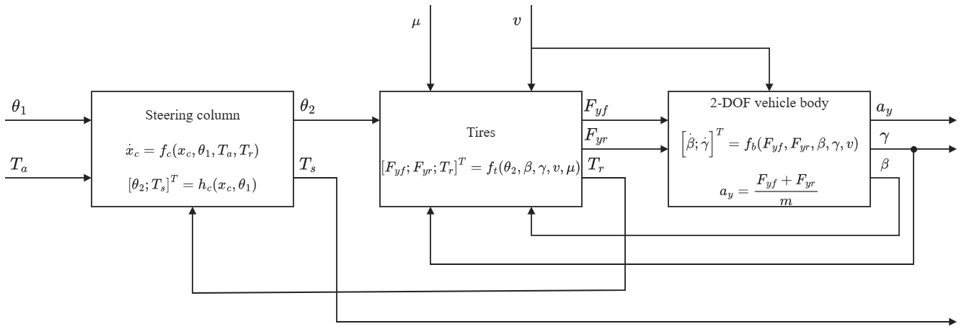
Fig. 1. Block diagram of the coupled C-EPS–vehicle plant: steering column, tires, and two-degree-of-freedom vehicle body.

2.1. Steering Column and Assist Motor
The mechanical structure of the column-type EPS is shown in Fig. 2. The upper column, driven by the steering wheel, is connected to the lower column through a torsion bar of stiffness $K$, which also serves as the torque sensor. The motor applies the assist torque $T_{a}$ to the lower column through a reduction gear, and the lower column drives the rack through the steering gear of ratio $n_{st}$. The steering-wheel angle $θ_{1}$ is prescribed as the driver input, and the lower-column dynamics and the torsion-bar torque are modeled as [1]
$$\begin{aligned}J_{col}{\ddot{θ}}_{2}=T_{s}+T_{a}-T_{r}-C_{col}{\dot{θ}}_{2}-T_{f} tanh\left(c{\dot{θ}}_{2}\right)\#\left(1\right)\end{aligned}$$
$$\begin{aligned}T_{s}=K\left(θ_{1}-θ_{2}\right)\#\left(2\right)\end{aligned}$$
where $θ_{2}$ is the lower-column angle; $J_{col}$ and $C_{col}$ are the equivalent inertia and viscous damping of the lower column, including the motor and gear referred to the column; and $T_{f} tanh\left(c{\dot{θ}}_{2}\right)$ is a smooth approximation of Coulomb friction with amplitude $T_{f}$; both $T_{a}$ and the road-reaction torque $T_{r}$ are referred to the column side of the mechanism.
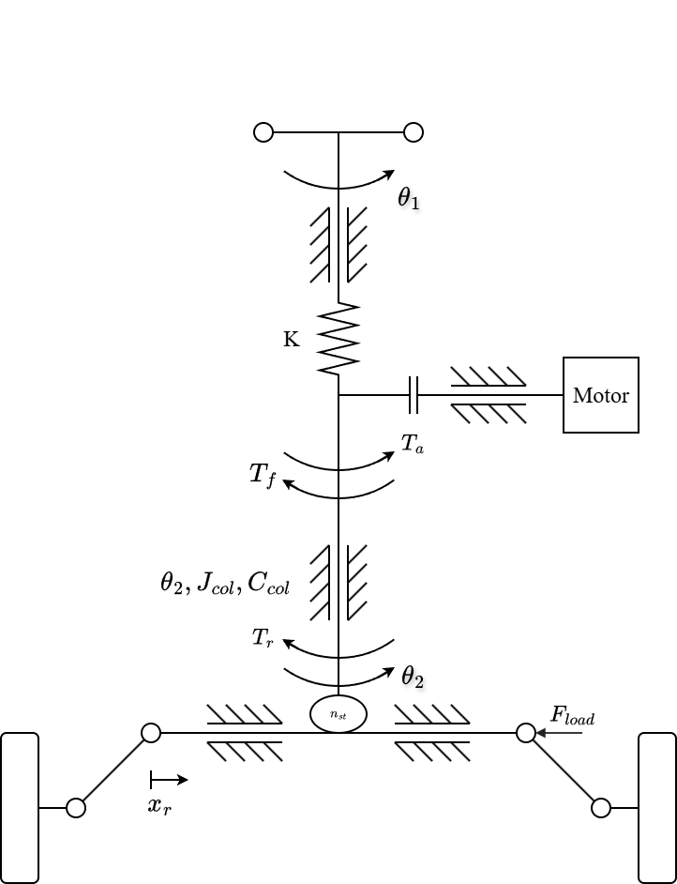
Fig. 2. Mechanical structure of the column-type EPS.
Prescribing $θ_{1}\left(t\right)$ allows $T_{s}$ to change when the road reaction or the motor assistance changes, whereas imposing the driver torque instead would fix the sensed torque at steady state and hide the effect of the road reaction examined here; the prescribed-angle driver therefore supports a controlled comparison of steering-effort responses, but it does not represent the driver's neuromuscular response or the correction of steering angle in response to changing effort.

2.2. Tire Model and Road-Reaction Torque
Figure 3 defines the road-plane quantities of the front tire, with the front-wheel angle approximated by $δ_{f}=θ_{2}/n_{st}$. Under the small-angle and constant-longitudinal-speed assumptions, the front and rear slip angles are [13]
$$\begin{aligned}α_{f}=\frac{θ_{2}}{n_{st}}-β-\frac{l_{f}γ}{v}\#\left(3\right)\end{aligned}$$
$$\begin{aligned}α_{r}=-β+\frac{l_{r}γ}{v}\#\left(4\right)\end{aligned}$$
where $β$ is the vehicle sideslip angle, $γ$ is the yaw rate, and $l_{f}$ and $l_{r}$ are the distances from the center of gravity to the front and rear axles. Longitudinal and lateral load transfer are neglected, giving the static axle loads
$$\begin{aligned}F_{zf}=mg\frac{l_{r}}{l_{f}+l_{r}}\#\left(5\right)\end{aligned}$$
$$\begin{aligned}F_{zr}=mg\frac{l_{f}}{l_{f}+l_{r}}\#\left(6\right)\end{aligned}$$
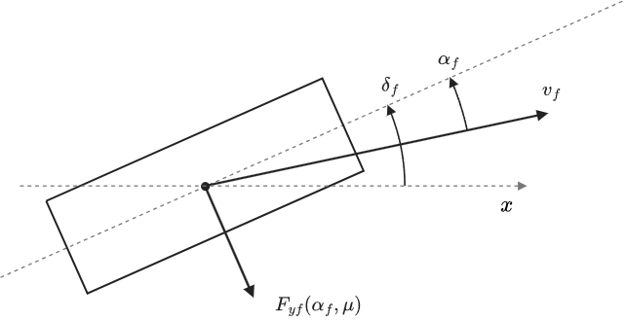
Fig. 3. Top view of the front tire. The dashed line through the tire is the wheel plane and the horizontal dashed line is the vehicle longitudinal axis x. The front-wheel steering angle $δ_{f}$ is measured from x to the wheel plane, the slip angle $α_{f}$ from the wheel plane to the velocity $v_{f}$ of the tire, and $F_{yf}\left(α_{f},μ\right)$ is the lateral force. Angles and geometry are schematic and not to scale.
Each axle is represented by one equivalent tire, and to retain force saturation when road friction changes, the lateral forces are calculated with a simplified Pacejka Magic Formula [12]:
$$\begin{aligned}F_{yi}=D_{i} sin\left[C\tan^{-1}\left(B_{i}α_{i}-E\left(B_{i}α_{i}-\tan^{-1}\left(B_{i}α_{i}\right)\right)\right)\right], i∈\{f,r\}\#\left(7\right)\end{aligned}$$
$$\begin{aligned}D_{i}=μF_{zi}, B_{i}=\frac{C_{αi}}{CD_{i}}\#\left(8\right)\end{aligned}$$
where $μ$ is the common tire–road friction coefficient, $C_{αi}$ is the axle cornering stiffness, and $C$ and $E$ are shape and curvature factors. This parameterization preserves the initial slope $C_{αi}$ while reducing the peak force $D_{i}$ as $μ$ decreases, so the tire saturates earlier on a lower-friction surface.
The front lateral force acts on the steering axis through an effective moment arm that contains a constant caster component and a slip-dependent pneumatic component. Adapting the pneumatic-trail relation used in [3], the model defines
$$\begin{aligned}t_{p}= max\left(0, t_{0}-\frac{t_{0}C_{αf}| tanα_{f}|}{3μF_{zf}}\right)\#\left(9\right)\end{aligned}$$
$$\begin{aligned}e_{eff}=e_{c}+t_{p}, e_{c}=e_{p0}-t_{0}\#\left(10\right)\end{aligned}$$
where $e_{p0}$ is the effective moment arm at zero slip, $t_{0}$ is the zero-slip pneumatic trail, and $e_{c}$ is the constant caster component. The nonnegative bound on $t_{p}$ represents the loss of pneumatic trail as the modeled contact patch reaches full sliding; retaining $e_{c}$ prevents the total moment arm from being forced to zero. These bounds are modeling choices added to the source relation and do not reproduce the complete aligning-moment behavior of a measured tire. The road reaction referred to the steering column is
$$\begin{aligned}T_{r}=\frac{e_{eff}}{n_{st}}F_{yf}\#\left(11\right)\end{aligned}$$
Equations (8)–(11) contain the two effects of friction on the column: a lower $μ$ reduces the attainable $F_{yf}$ and, at the same slip angle, shortens the pneumatic trail $t_{p}$, and both reduce $T_{r}$.

2.3. Single-Track Vehicle Body
The lateral and yaw motion of the vehicle is governed by the nonlinear single-track balances [13]:
$$\begin{aligned}a_{y}=\frac{F_{yf}+F_{yr}}{m}\#\left(12\right)\end{aligned}$$
$$\begin{aligned}\dot{β}=\frac{a_{y}}{v}-γ\#\left(13\right)\end{aligned}$$
$$\begin{aligned}\dot{γ}=\frac{l_{f}F_{yf}-l_{r}F_{yr}}{I_{z}}\#\left(14\right)\end{aligned}$$
where $m$ and $I_{z}$ are the vehicle mass and yaw moment of inertia. The lateral acceleration $a_{y}$ of Eq. (12) is also the measured signal used by the torque reference in Section 2.5.

2.4. Coupled Plant and Torque Balance
Combining Eqs. (1)–(14), the coupled steering-column and vehicle plant of Fig. 1 has four states, $θ_{2}$, ${\dot{θ}}_{2}$, $β$, and $γ$; the motor, compensator, and controller states are added separately in the closed-loop simulations. The states are internal to the plant: none of the controllers measures $β$ or $γ$, and all of them use only the measured torsion-bar torque $T_{s}$, the vehicle speed $v$, and the lateral acceleration $a_{y}$. For a stationary steering column, Eq. (1) becomes
$$\begin{aligned}T_{s}=T_{r}-T_{a}\#\left(15\right)\end{aligned}$$
because the smoothed Coulomb-friction term vanishes at ${\dot{θ}}_{2}=0$. Equations (7)–(15) expose how the road enters the torque balance: decreasing $μ$ lowers the tire-force capacity and the pneumatic trail and therefore $T_{r}$. If the assistance does not decrease by the same amount, Eq. (15) predicts a reduction of the steering torque transmitted through the torsion bar, that is, too much assistance for the road.

2.5. Lateral-Acceleration-Based Torque Reference
The desired steering torque is obtained from the speed- and lateral-acceleration-dependent steering-effort data reported by Li and Xia [5]. The four lateral-acceleration levels published in that study are reproduced in Table 1 and are treated here as a reference characteristic rather than as a universal driver-preference model.
Table 1. Ideal steering-wheel torque reference (N·m), adopted from [5].
Lateral acceleration | 20 km/h | 40 km/h | 60 km/h | 80 km/h | 100 km/h
0.1 g | 1.0 | 1.7 | 2.1 | 2.3 | 2.6
0.2 g | 1.5 | 2.0 | 2.4 | 2.8 | 3.0
0.3 g | 1.6 | 2.3 | 2.8 | 3.1 | 3.3
0.4 g | 1.8 | 2.4 | 2.9 | 3.3 | 3.4

A zero-torque point is added at zero lateral acceleration, and monotone piecewise cubic Hermite interpolation is applied first along lateral acceleration and then along vehicle speed, after which the result is sampled on a finer table for implementation; odd symmetry supplies the negative-turning branch, while inputs beyond 20–100 km/h or 0–0.4 g are clipped to the nearest boundary:
$$\begin{aligned}T_{ref}\left(v,a_{y}\right)=sgn\left(a_{y}\right)\hat{T}\left(v,|a_{y}|\right)\#\left(16\right)\end{aligned}$$
$$\begin{aligned}\hat{T}\left(v,0\right)=0\#\left(17\right)\end{aligned}$$
where $\hat{T}$ denotes the interpolated positive-acceleration characteristic. Adding the zero point, imposing odd symmetry, selecting PCHIP interpolation, and clipping outside the published grid are implementation choices of this study, which make the reference continuous through straight-ahead driving without extrapolating unreported steering-effort values.
The reference uses measured vehicle speed and lateral acceleration and does not require an estimate of $μ$ or rack force; because $a_{y}$ is an input to the reference, a friction reduction can also change the target by changing the vehicle response, and the controller therefore regulates effort relative to the motion actually produced by the vehicle instead of enforcing the same torque at a fixed steering-wheel angle on every surface.

2.6. Torque-Tracking Objective
The common control objective is to regulate the measured torsion-bar torque toward the reference:
$$\begin{aligned}e_{T}=T_{s}-T_{ref}\left(v,a_{y}\right)\#\left(18\right)\end{aligned}$$
For $T_{ref}≠0$, $sgn\left(T_{ref}\right)e_{T}<0$ denotes a torque magnitude below the target in the commanded turning direction, and reversal intervals are evaluated with magnitude-based measures because the signed interpretation becomes ambiguous near a zero crossing. All controllers act through the same bounded assist-torque channel:
$$\begin{aligned}|T_{a}|≤T_{a,max}\left(v\right)\#\left(19\right)\end{aligned}$$
where $T_{a,max}\left(v\right)$ is derived from the modeled dry-road assistance requirement and is specified with the actuator implementation. The comparison therefore asks how each controller reduces the torque-tracking error under changing road and driving conditions while satisfying the same motor dynamics, assist limit, sensor conditions, and stability requirements.

