Friction-Independent Torque Tracking for Column Electric Power Steering: Closing the Over-Assist Gap of Assist Maps with a Lateral-Acceleration Reference
[Authors] Tran Minh Tan, Phung Thanh Huy. [Affiliation] Ho Chi Minh City University of Technology (HCMUT), VNU-HCM. DRAFT of the Abstract and Sections 1-3; items in square brackets are open and must be filled or checked before submission.
Abstract
The assist map of an electric power steering (EPS) system is tuned on dry asphalt and sees only the driver torque and the vehicle speed. When the tire-road friction coefficient drops while the car is cornering, the self-aligning torque falls, the map keeps assisting as before, and the steering wheel becomes lighter than the driver expects: over-assist. Existing remedies estimate the road or the axle load and switch between maps. We ask whether such an estimate is needed at all. We define the desired steering torque as a function of the measured speed and lateral acceleration, which already carry the friction information, and we treat over-assist as the tracking error of the measured column torque with respect to this reference. A first-order analysis shows that an assist map can attenuate the friction-induced error only by the factor 1/(1+s) of its local slope s, which stability and noise limit, whereas a feedback controller with integral action removes the error in steady state. We compare a map with a lead(-lag) compensator against PI and PID torque feedback on a four-state nonlinear column-bicycle model with a Magic-Formula tire, with quantized and noisy sensors and a bounded, lagged motor. The comparison follows a protocol fixed before the runs: pass/fail gates (stability margin, reverse assist, bang-bang, steady accuracy) and a Pareto comparison of tracking error against command noise on a calibration case, then scoring on three single-feature test cases and one report-only extreme case. [Result sentence 1: tracking error of the map and of the PID after a friction drop, in percent of the reference.] [Result sentence 2: price paid in command noise.] The study is simulation only.
Keywords: electric power steering, over-assist, road friction, torque tracking, assist map, PID control

Introduction
Electric power steering (EPS) has replaced hydraulic power steering in most passenger cars because it saves fuel, is compact and its steering feel is easy to tune [1]. In a column-type EPS (C-EPS) a motor on the steering column adds an assist torque $T_{a}$ to the driver torque, and a torque sensor on the column measures the torque $T_{s}$ that the driver feels. The core of the controller is the assist map, a nonlinear one-to-one function from the measured torque and the vehicle speed to the assist torque [1]. Its shape defines the steering feel, and a stabilizing compensator is always needed because the high gain and the nonlinearity of the map can make the loop vibrate or diverge [1].
An assist map is calibrated on a dry road. The torque that the road returns to the steering wheel, the self-aligning torque, depends on the tire-road friction coefficient: when the coefficient drops, the lateral force of the front tire saturates earlier and at a lower level and the pneumatic trail shrinks, so the returned torque falls. The map does not know this and keeps assisting by the dry-road rule, so the wheel becomes lighter than the driver expects at the same speed and lateral acceleration. This is over-assist. It removes the road feel exactly when the grip margin is small, which is why it is considered to damage driving safety [2].
The remedies in the literature make the map aware of the road. Li et al. [2] design several maps for different front-axle loads and adhesion coefficients and control the assist with the map of the current load and adhesion, using a back-propagation (BP) neural network to determine the steering resistance torque. Li and Xia [3] identify the road with a neural network and select the assist curve of the identified road. Both ideas need an estimate of a quantity that is not measured and that the map then uses in an open-loop way. Other work replaces the map by intelligent controllers: a neural-fuzzy controller with field-oriented motor control is tested against disturbance torque in [5], and a fuzzy controller with current constraints is designed in [6]; none of these works defines over-assist as a tracking error with respect to a reference that depends only on measured signals [to be verified against a systematic literature search before submission].
In this paper we take a different route. The driver does not feel the friction coefficient; the driver feels the torque at the wheel, and an experienced driver expects a torque that goes with the speed and the lateral acceleration of the car [3], [4]. Both quantities are measured on every car. If the desired torque is defined as $T_{d,ref}$(v, $a_{y}$), a lighter wheel on a slippery road is no longer an error by itself, because the lateral acceleration is also lower; only the part of the lightness that is not explained by the lateral acceleration is over-assist. Over-assist becomes the tracking error $e_{T}$ = $T_{s}$ - $T_{d,ref}$ and can be attacked by feedback of the measured torque, without any estimate of the friction coefficient.
The contributions are:
C1. A formulation of over-assist as a torque-tracking problem with a reference built only from measured signals and with an assist limit derived from the model, and a first-order analysis (Section 3.4) of why an assist map cannot remove the friction-induced error while an integral controller can.
C2. A comparison protocol fixed before the runs: pass/fail gates, a Pareto comparison of tracking against command noise on one calibration case, and a set of single-feature test cases (dry-road accuracy, friction change while cornering, continuous steering, and an extreme region above 0.3 g) that every controller meets with identical inputs and identical noise.
C3. A quantitative comparison of an assist map with a lead(-lag) compensator and of PI and PID torque feedback, with a mechanism for each difference found [results of Section 6 to be summarized here once the final runs are done].
The study is limited to simulation; the plant is not validated against vehicle data, the driver is modeled by a steering-angle source and the motor current loop is not modeled. Section 2 presents the plant, Section 3 the problem, the reference and the assist limit. [Sections 4-7: controllers, evaluation protocol, results, discussion and conclusion.]

Plant model

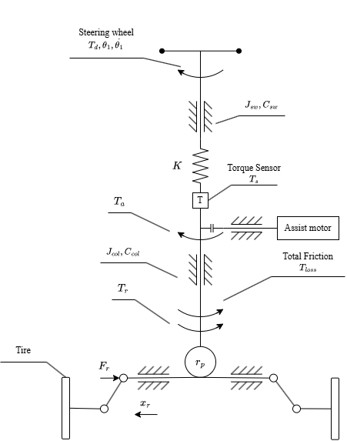
System and model structure
Figure 1 shows the C-EPS. The driver acts on the steering wheel, which is connected through an elastic torsion bar to the lower column. The torque sensor measures the twist of the bar. The assist motor acts on the lower column through a reduction gear, and a rack-and-pinion turns the column rotation into the motion of the tie rods and the steered wheels. In the opposite direction, the lateral force of the front tires creates a torque about the kingpin axis that is returned to the column as the road reaction torque $T_{r}$.

The model has three clusters (Figure 2): the steering column, the tire (an algebraic block without own state) and the vehicle body (single-track model with two degrees of freedom). Two feedback paths close the model. The column angle sets the steered angle, hence the front lateral force, which returns as $T_{r}$; and the lateral forces drive the sideslip angle and the yaw rate, which return to the tire block through the slip angles. Without both paths the model would lose the mechanism of over-assist.
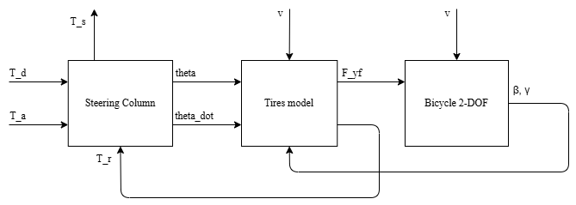
Figure 2: Block diagram of the plant: steering column, tires and bicycle model
The driver is modeled by the steering-wheel angle $θ_{1}$(t), a known input. If the driver torque $T_{d}$ were given instead, the steady-state torque balance would force $T_{s}$ = $T_{d}$ whatever the assist, and the assist torque could not change the quantity to be controlled. The angle model corresponds to a driver who holds the angle regardless of the torque and does not react to the steering feel; it measures the cause of over-assist (the torque deviates from the desired value) but not the reaction of a human driver to it [1], [2]. The model inputs are the assist torque $T_{a}$ (control), the steering angle $θ_{1}$ and the speed v (exogenous, measured) and the friction coefficient $μ$ (exogenous, not measured).

Steering column
The column is modeled as two inertias joined by a linear torsion bar [1]. With the steering angle $θ_{1}$ given, the lower column obeys
$$J_{col}{\ddot{θ}}_{2}=K(θ_{1}-θ_{2})+T_{a}-T_{r}-C_{col}{\dot{θ}}_{2}-T_{f} tanh(c {\dot{θ}}_{2})$$ | (1)
and the torque measured by the sensor is the torque transmitted by the bar:
$$T_{s}=K(θ_{1}-θ_{2})$$ | (2)
$J_{col}$ is the inertia of the lower column, motor and rack reduced to the column, $C_{col}$ the viscous damping, K the torsion stiffness, and $T_{f}$ the amplitude of the Coulomb friction of the gears; the sign function of the Coulomb friction is smoothed by tanh(c*theta2_dot) so that the equation is continuous at zero speed. The driver torque follows from the upper inertia and is not needed in the simulation. In steady state, with theta2_dot = 0, the torque balance reads
$$T_{s}=T_{r}-T_{a}$$ | (3)
so the assist torque reduces the sensed torque directly, and a drop of $T_{r}$ at constant $T_{a}$ lowers $T_{s}$: over-assist. With the parameters of Table 1 the lower column alone has a natural frequency of 5.7 Hz and a damping ratio of 0.17; the road reaction acts as a spring in parallel with the torsion bar (Eq. (14)) and the coupled resonance is about 6 Hz, which limits the bandwidth of any torque feedback.

Tire and road reaction torque
The two wheels of an axle are lumped into one. With the small-angle assumption, the steered angle is $δ_{f}$ = $θ_{2}$/$n_{st}$, where $n_{st}$ is the overall steering ratio, and the tire slip angles are
$$α_{f}=δ_{f}-β-\frac{l_{f}γ}{v}, α_{r}=-β+\frac{l_{r}γ}{v}$$ | (4)
where beta is the sideslip angle, gamma the yaw rate, and $l_{f}$, $l_{r}$ the distances from the center of gravity to the front and rear axle. The static axle loads are $F_{zf}$ = m g $l_{r}$/($l_{f}$ + $l_{r}$) and $F_{zr}$ = m g $l_{f}$/($l_{f}$ + $l_{r}$). The lateral force of each axle follows the Magic Formula of Pacejka [7]:
$$F_{y}=D sin(C arctan(Bα-E(Bα- arctan(Bα)))), D=μF_{z}, B=\frac{C_{α}}{C D}$$ | (5)
The peak D is proportional to the friction coefficient and B is chosen so that the initial slope B C D equals the cornering stiffness $C_{α}$, which does not depend on $μ$. At small slip angles the force is therefore almost independent of $μ$, and when $μ$ drops the tire saturates earlier and lower. The geometry is shown in Figure 3. The kingpin axis meets the ground at the point Q, ahead of the center C of the contact patch by the caster trail; the front lateral force acts at the point P, behind C; the lever arm is the sum of the caster trail $e_{c}$, a fixed geometric length, and the pneumatic trail, which shrinks as the slip angle grows and vanishes when the patch slides completely [7]:
$$e_{p}=e_{c}+ max(0, t_{0}-sgn(α_{f}) t_{0}\frac{C_{αf} tanα_{f}}{3μF_{zf}}), e_{c}=e_{p0}-t_{0}$$ | (6)
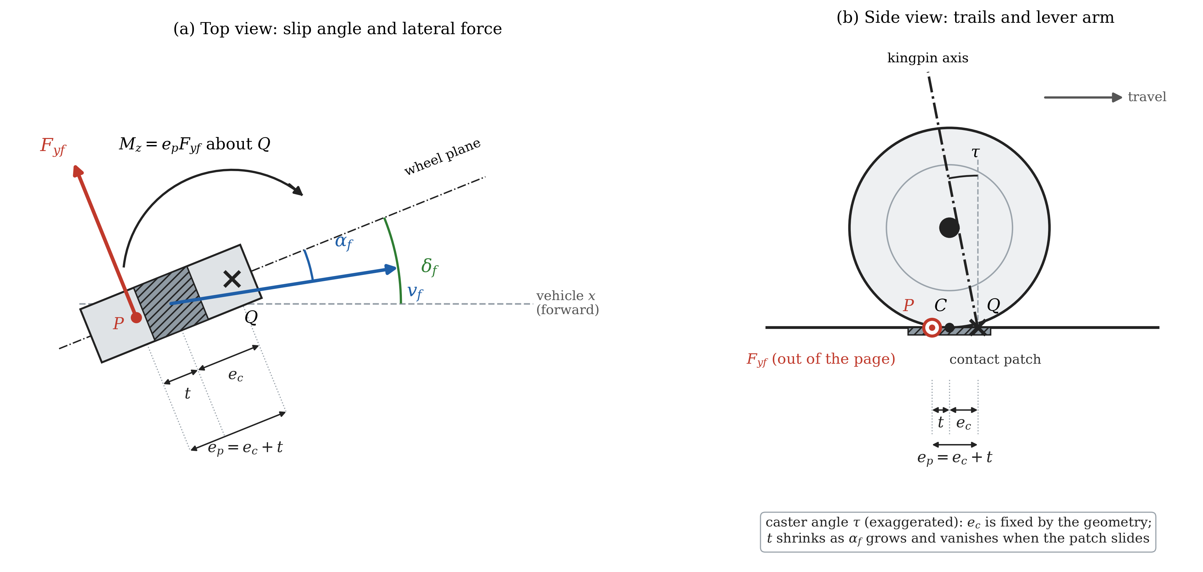
Figure 3: Forces on the front wheel. (a) Top view: steered angle delta_f, velocity direction, slip angle alpha_f, lateral force F_yf applied at P and its moment about the kingpin point Q. (b) Side view: contact patch, caster trail e_c, pneumatic trail t and total lever arm e_p = e_c + t (not to scale)
Conservation of power through the lossless steering linkage gives the reaction torque at the column
$$T_{r}=\frac{e_{p}}{n_{st}}F_{yf}$$ | (7)
When $μ$ drops, $T_{r}$ falls for two cumulative reasons: $F_{yf}$ saturates earlier and lower (Eq. (5)) and the pneumatic trail shrinks faster (Eq. (6)). This is the physical mechanism of over-assist in the model.

Vehicle body
With the speed v treated as slowly varying, the single-track model gives
$$a_{y}=\frac{F_{yf}+F_{yr}}{m}, \dot{β}=\frac{a_{y}}{v}-γ, \dot{γ}=\frac{l_{f}F_{yf}-l_{r}F_{yr}}{I_{z}}$$ | (8)
Since each lateral force is bounded by its peak D, the lateral acceleration satisfies $a_{y}$ ≤ $μg$ in every state.

State-space form
The model has four states, x = [$θ_{2}$, ${\dot{θ}}_{2}$, beta, gamma]^T, and is affine in the control:
$$\dot{x}=f(x,θ_{1},v,μ)+g T_{a}, g={\left[\begin{matrix}0 & 1/J_{col} & 0 & 0\end{matrix}\right]}^{T}$$ | (9)
where f collects Eqs. (1)-(8). The outputs are the sensed torque $T_{s}$, the lateral acceleration $a_{y}$, the column speed ${\dot{θ}}_{2}$ and the yaw rate gamma; all are measured on a car except beta. The parameters are in Table 1. The column parameters were identified on a passenger car in [1]; the vehicle and the tire (mass, inertia, cornering stiffness) come from the same sedan data set of [8], and C, E from the illustrative values of [7]. Three values are our choice: $n_{st}$ = 16 (the ratios measured on three cars in [4] are 16.5, 19 and 24.7), $e_{p0}$ = 0.048 m, and the split $t_{0}$ = 0.025 m, $e_{c}$ = 0.023 m, taken as the middle of the 17-35 mm range that the brush model of [7] gives for the pneumatic trail before any simulation was run.
Table 1: Plant parameters
Symbol | Value | Unit | Meaning | Source
K | 143.24 | N.m/rad | Torsion-bar stiffness | [1]
$J_{sw}$, $C_{sw}$ | 0.044, 0.25 | kg.m2, N.m.s/rad | Steering-wheel inertia and damping | [1]
$J_{col}$, $C_{col}$ | 0.11, 1.35 | kg.m2, N.m.s/rad | Lower-column inertia and damping | [1]
$T_{f}$, c | 2, 100 | N.m, s/rad | Coulomb friction amplitude, tanh smoothing | [1], chosen
m, $I_{z}$ | 1573, 2873 | kg, kg.m2 | Vehicle mass and yaw inertia | [8]
$l_{f}$, $l_{r}$ | 1.1, 1.58 | m | Center of gravity to front, rear axle | [8]
$C_{αf}$, $C_{αr}$ | 160000 | N/rad | Cornering stiffness per axle | [8]
C, E | 1.3, -1 | - | Magic Formula shape and curvature | [7]
$$n_{st}$$ | 16 | - | Overall steering ratio | chosen
$e_{p0}$, $t_{0}$ | 0.048, 0.025 | m | Total lever arm and pneumatic trail at zero slip | chosen

Sensors and motor
The controller sees measured signals only. Each measurement is the true value plus white noise, quantized at the sensor resolution and held at the update period of the signal (Table 2); the standard deviation of the noise is one resolution step, except for the speed (0.38 km/h, from [11]). The torque, steering-angle and column-speed signals are read directly by the EPS controller every 1 ms; the speed, yaw rate and lateral acceleration come from the stability controller over the CAN bus, with an assumed update period of 10 ms [to be sourced]. The controller runs at 1 ms. The motor is a first-order lag $G_{m}$(s) = $ω_{m}$/(s + $ω_{m}$) with a bandwidth of 100 Hz [1]; its current loop and its power limit are not modeled, and the assist torque is bounded only by $T_{a,max}$(v) of Section 3.5.
Table 2: Sensor model
Signal | Resolution | Update period | Source
$$T_{s}$$ | 0.01 N.m | 1 ms | torque sensor datasheet [11]
$$θ_{1}$$ | 0.1 deg | 1 ms | torque/angle sensor datasheet [11]
$${\dot{θ}}_{2}$$ | 4 deg/s | 1 ms | steering-angle sensor datasheet [11]
v | 1 km/h (noise 0.38 km/h) | 10 ms | [11]
gamma | 0.1 deg/s | 10 ms | [11]
$$a_{y}$$ | 0.01 g | 10 ms | [11]

Validity and limitations
The model is used for speeds of 20-100 km/h and friction coefficients of 0.2-0.8. Below 20 km/h the terms divided by v and the static-tire assumption break down. The small-angle assumption limits the lateral acceleration to the smaller of $μg$ and the value at which the steered angle or the sideslip reaches 10 degrees; at 20 km/h this is about 0.2 g for every friction coefficient, at 25 km/h 0.31 g on dry road, and from 45 km/h upward $μg$. Open-loop simulations with $T_{a}$ = 0 show that load transfer changes every indicator by less than 1 % and that tire lag mainly slows the body response at low speed, while the torque at the wheel is almost unaffected. The size of over-assist depends on the unmeasured split of the lever arm: for a friction drop from 0.8 to 0.3 with the wheel held at 0.2 g and no assist, the sensed torque falls by about 9-10 % with the chosen $t_{0}$, between 6 % and 13 % over the whole 17-35 mm range and between 1-3 % and 18 % at the two physical bounds $t_{0}$ = 0 and $t_{0}$ = $e_{p0}$. The size of over-assist in this paper is therefore reliable only as an order of magnitude; its direction (a lighter wheel when $μ$ drops) does not depend on $t_{0}$. Further limitations: constant speed in the body equations, one friction value for both sides of the car, no roll, no motor dynamics beyond the lag, and a driver that does not react to the torque. The model has not been compared with measurements of a vehicle [to be stated as a limitation in the discussion].

Problem formulation

Control objective and available signals
The controlled variable is the sensed torque $T_{s}$, the torque that the driver feels, and the control is the assist torque $T_{a}$. By Eq. (3), $T_{a}$ lowers $T_{s}$ in steady state; the column angle shifts and changes $T_{r}$ a little, so the drop of $T_{s}$ is not exactly the rise of $T_{a}$, but the sign of the action is fixed. Because $μ$ is not measured, any change of $T_{r}$ caused by the road shows up only in $T_{s}$; a controller that must remove it needs feedback of $T_{s}$. Two classes of controllers are considered, and they differ only in the signals they read (Figure 4). The assist map (with a compensator) reads $T_{s}$ and v. The torque-feedback controllers (PI, PID) read $T_{s}$, v and $a_{y}$, and compute the reference internally.
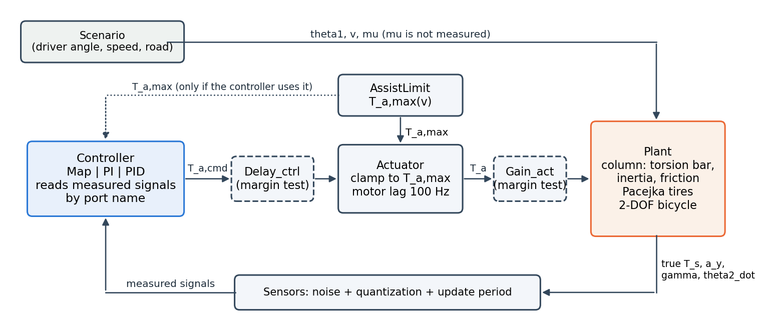
Figure 4: Closed loop: scenario, plant, sensors, controller, assist limit and motor; true and measured signals

Reference torque
The reference $T_{d,ref}$(v, $a_{y}$) is the torque that an average driver prefers at the speed v and the lateral acceleration $a_{y}$. We use the ideal steering-wheel torque of [3] (Table 4 there), given at five speeds from 20 to 100 km/h and four levels of lateral acceleration from 0.1 g to 0.4 g (Table 3). [4] measured the ideal torque on three cars of 1.5, 1.7 and 1.9 t and found that it is almost independent of the vehicle for similar size and mass; the car of [3] (about 1.53 t) is within 3 % of the mass of the model car, so the table is used without correction. The torque grows with the lateral acceleration, because a sharper turn should feel heavier, and with the speed, because the wheel should be heavier at high speed.
Table 3: Ideal steering-wheel torque $T_{d,ref}$ [N.m] from [3]
$a_{y}$ [g] | 20 km/h | 40 km/h | 60 km/h | 80 km/h | 100 km/h
0.1 | 1.0 | 1.7 | 2.1 | 2.3 | 2.6
0.2 | 1.5 | 2.0 | 2.4 | 2.8 | 3.0
0.3 | 1.6 | 2.3 | 2.8 | 3.1 | 3.3
0.4 | 1.8 | 2.4 | 2.9 | 3.3 | 3.4

Three completions make the table a usable reference. The point $a_{y}$ = 0 with zero torque is added, because a car driving straight returns no road torque. The table is interpolated by monotone piecewise cubic Hermite polynomials (PCHIP) in $a_{y}$ and then in v, so the reference is smooth and passes through every value of the table. The table is extended to negative $a_{y}$ by symmetry. Outside the table the boundary value is held (speed outside 20-100 km/h, |$a_{y}$| above 0.4 g):
$$T_{d,ref}(v,a_{y})=sgn(a_{y}) \hat{T}(v,|a_{y}|), \hat{T}(v,0)=0$$ | (10)
The reference depends only on measured signals and is continuous when the direction of the turn changes. The essential choice is that it depends on $a_{y}$ and not on $μ$: on a slippery road the car reaches a lower lateral acceleration, and a lighter wheel at that acceleration is information for the driver, not an error. Over-assist is only the part of the lightness that the lateral acceleration does not explain.

Tracking error and definition of over-assist
$$e_{T}=T_{s}-T_{d,ref}(v,a_{y}), e_{rel}=100 sgn(T_{d,ref})\frac{mean(e_{T})}{mean(|T_{d,ref}|)}$$ | (11)
where the means are taken over a window. The control goal is $e_{T}$ = 0 at every speed and lateral acceleration, a tracking problem and not the regulation of a constant. Over-assist occurs when sgn($a_{y}$)*$e_{T}$ < 0, that is, |$T_{s}$| < |$T_{d,ref}$|: the wheel is lighter than desired at the same speed and lateral acceleration. The opposite sign is a lack of assist. Accordingly, $e_{rel}$ < 0 is over-assist and $e_{rel}$ > 0 a heavier wheel than desired. The relative error is not used when the mean reference in the window is close to zero (windows with a steering reversal), where the denominator makes it meaningless; the RMS of $e_{T}$ is used there.

Why a map cannot remove the friction-induced error
Let the map be $T_{a}$ = M(v, $T_{s}$) and consider a steady state. By Eq. (3), $T_{s}$ solves
$$T_{s}+M(v,T_{s})=T_{r}(v,a_{y},μ)$$ | (12)
The left side does not contain $μ$. Calibration on dry road makes $T_{s}$ equal to $T_{d,ref}$(v, $a_{y}$) at $μ$ = 0.8. For the same v and $a_{y}$, a lower friction coefficient reduces the right side by $ΔT_{r}$ < 0 (Section 2.3), and to first order the sensed torque changes by
$$ΔT_{s}=\frac{ΔT_{r}}{1+s}, s=\frac{∂M}{∂T_{s}}$$ | (13)
Because $T_{d,ref}$(v, $a_{y}$) does not change at the same $a_{y}$, $ΔT_{s}$ is the steady over-assist. A map therefore attenuates the error by 1/(1+s), and it can do so only by raising its slope s. A higher slope raises the loop gain at the column resonance of about 6 Hz and the gain from sensor noise to the assist torque, so the slope is limited by stability and by command noise (Section 4). In contrast, a controller with integral action on $e_{T}$ can be at rest only when $e_{T}$ = 0 (provided $T_{a}$ is inside its limit). Because the assist needed, $T_{a,req}$ = $T_{r}$ - $T_{d,ref}$, falls when $T_{r}$ falls, the limit of Section 3.5 is not exceeded. Its steady over-assist is therefore zero by construction, whatever $μ$ is; the price is paid in the dynamic behavior and in the noise gain of the added terms. [Eq. (13) is derived in the smoothed-friction model, where the dry friction acts only while the column moves; the size of the effect in simulation is reported in Section 6.]

Assist limit
The assist torque is bounded for every controller by $T_{a,max}$(v). In steady state, Eq. (3) gives the assist needed to reach the reference, $T_{a,req}$ = $T_{r}$(v, $a_{y}$, $μ$) - $T_{d,ref}$(v, $a_{y}$). $T_{r}$ is largest on dry road, so the largest need is evaluated at $μ$ = 0.8 over the lateral accelerations that both the model and the reference allow, $a_{y,lim}$(v) = min($a_{y,max}$(v, 0.8), 0.4 g):
$$T_{a,max}(v)=\max_{0≤a_{y}≤a_{y,lim}(v)}[T_{r}(v,a_{y},0.8)-T_{d,ref}(v,a_{y})]+F, F=T_{f}$$ | (14)
The margin F covers the dry friction of the column, an uncertainty with a known bound: following Slotine and Li [9] (Sec. 7.1.3), the magnitude of the control must exceed the nominal need by the bound of the model error. The margin of the control law itself is not added, because it belongs to the controller and not to the motor. Table 4 gives sample values; the limit is interpolated linearly in v and applied in the motor block, not in the controllers. The motor capacity is not modeled (no data), so the limit is a model-based estimate and its size is reliable only as an order of magnitude; what matters for the comparison is that all controllers share the same limit.
Table 4: Assist limit $T_{a,max}$(v) on dry road
v [km/h] | $a_{y,lim}$ [g] | $T_{r}$ [N.m] | $T_{d,ref}$ [N.m] | $T_{a,req}$ [N.m] | $T_{a,max}$ [N.m]
20 | 0.201 | 5.24 | 1.50 | 3.74 | 5.74
30 | 0.400 | 9.92 | 2.11 | 7.80 | 9.80
60 | 0.400 | 9.92 | 2.90 | 7.02 | 9.02
100 | 0.400 | 9.92 | 3.40 | 6.52 | 8.52

Problem statement
Given the plant (9) with sensors of Table 2 and the motor of Section 2.6, find a controller $T_{a}$ = u(measured signals) with |$T_{a}$| ≤ $T_{a,max}$(v) such that $e_{T}$ of Eq. (11) is small for every friction coefficient in 0.2-0.8 and every speed in 20-100 km/h while the loop satisfies the following requirements, which are made precise as gates in Section 5: (i) the closed loop is stable with a margin, (ii) the assist does not push against the driver's hand (reverse assist), (iii) the command does not switch between the two limits because of sensor noise (bang-bang), and (iv) the steady error on a dry road is small. The tracking error and the noise of the command pull in opposite directions, so the result of a design is a point in the plane (tracking error, command noise), and controllers are compared by their whole front and not by one tuned point.
References (draft list, numbered in order of first citation; check every entry before submission)
[1] D. Lee, K.-S. Kim, S. Kim, "Controller design of an electric power steering system," IEEE Trans. Control Syst. Technol., 2018.
[2] Y. Li, Z. Yang, D. Zhai, J. He, J. Fan, "Study on control strategy of electric power steering for commercial vehicle based on multi-map," World Electr. Veh. J., vol. 14, 33, 2023.
[3] Q. Li, C. Xia, "Research of electric power steering system assistance characteristic based on the identification of the road," Jiangsu University [venue and year to add].
[4] X. A. Ren, Z. X. Deng, "Research on ideal steering wheel effort characteristics of driver," China Mechanical Engineering, vol. 25, no. 16, pp. 2261-2265, 2014.
[5] H. Q. Nguyen, V. T. Vu, O. Sename, "Combining adaptive neural-fuzzy inference system with field-oriented control strategy for electric power steering system in cars," Advances in Mechanical Engineering, vol. 17, no. 9, 2025.
[6] D. Saifia, M. Chadli, H. R. Karimi, S. Labiod, "Fuzzy control for electric power steering system with assist motor current input constraints," J. Franklin Inst., 2014/2015 [check year and volume].
[7] H. B. Pacejka, Tyre and Vehicle Dynamics, 2nd ed., Elsevier, 2006.
[8] R. Rajamani, Vehicle Dynamics and Control, 2nd ed., Springer, 2012.
[9] J.-J. E. Slotine, W. Li, Applied Nonlinear Control, Prentice Hall, 1991.
[10] [Reserved: X. Guan et al., decomposition and calculation method of the EPS assist characteristic curve, Proc. IMechE Part D, 2021; cite in Section 1 if used.]
[11] Sensor data: Valeo torque/angle sensor catalogue; Bosch Motorsport steering-wheel angle sensor LWS and acceleration sensor MM5.10 datasheets; H. Ragab, S. Givigi, A. Noureldin, arXiv:2501.00242 (speed sensor error) [separate entries to write].

