Individual Practical Assignment

Question (10% of total marks)

Design and develop an Android loan calculator application (No restriction on choice of development tool used) that fulfils the following:
- Allows birth year of user to be entered and saved when the user uses the app for the first time.
- Allows user to select which types of loan to calculate:
- Personal loan (Maximum loan tenure is 10 years or up to 60 years of age, whichever is earlier)
- Housing loan (Maximum loan tenure is 35 years or up to 70 years of age, whichever is earlier)
- Provides fields to enter loan amount, interest rate (e.g. per annum), number of repayments (in months, up to 120 months i.e. 10 years), and loan start date
- Calculates and displays the amount to repay each month (monthly instalment)
- Calculates and displays the last payment date
- Calculates and displays the total amount that would have been repaid by the end of the loan period
- Allows user the option to display amortisation schedule for personal and housing loans
- Allows user the option to display the amount of interest that needs to be paid at a specified month

For calculating the monthly instalment of personal loan, please use the following formula:
$Monthly instalment=\frac{P(1 + R×N)}{N}$
where P = Principal (loan amount)
R = Rate of interest
N = Number of instalments
(e.g. for monthly repayment, R will be interest rate per annum in percentage divide by 12 and then 100)
Equation 1: Formula for calculating monthly instalment of personal loan.

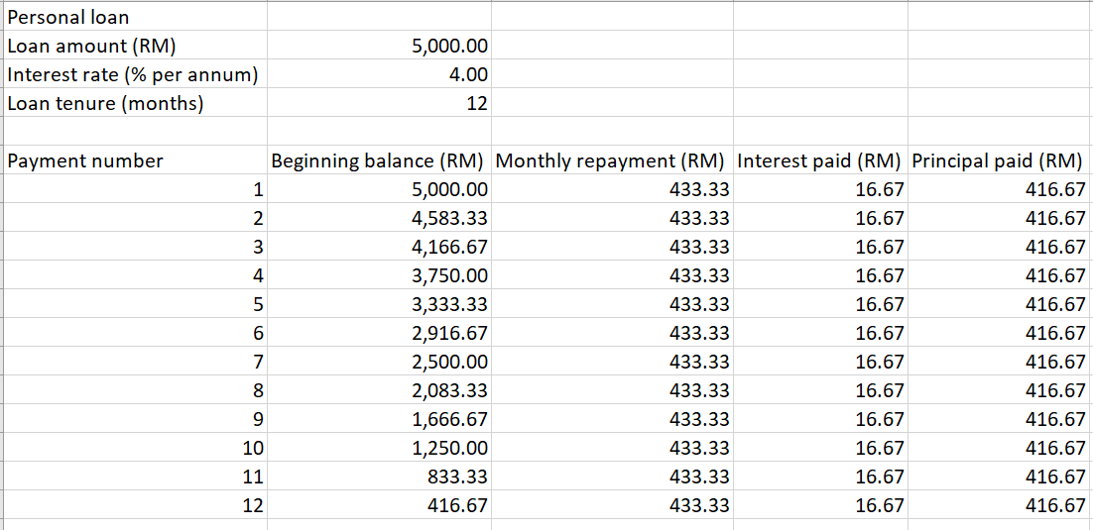
Figure 1: An example of amortisation schedule for personal loan based on loan amount of RM5,000, interest rate at 4% and loan period of 1 year.

For calculating the monthly instalment of housing loan, please use the following formula:
$Monthly instalment=\frac{P×R×{(1+R)}^{N}}{{(1+R)}^{N}-1}$
where P = Principal (loan amount)
R = Rate of interest
N = Number of instalments
(e.g. for monthly repayment, R will be interest rate per annum in percentage divide by 12 and then 100)
Equation 2: Formula for calculating monthly instalment of housing loan.

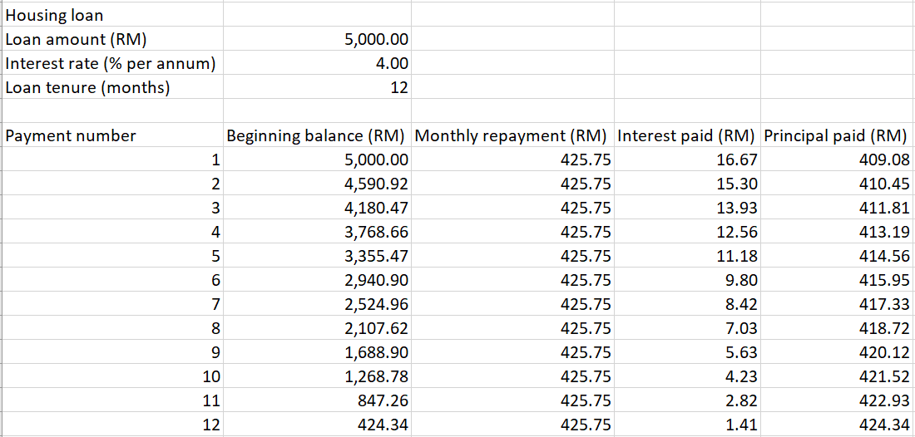
Figure 2: An example of amortisation schedule for housing loan based on loan amount of RM5,000, interest rate at 4% and loan period of 1 year.

There is no restriction on the choice of development tool and programming language to use for developing the mobile app. However, you are required to produce a simple report (softcopy) that shows screen captures of your loan calculator mobile app along with its source code. The screen captures should show a flow of how your application is intended to be used, and you can try to show more than one scenario. If you have added any extra features to make the app better, please remember to also highlight them in the report. You will be asked to demonstrate your mobile app during your practical class. So please make an effort to work on this individual assignment yourself.

Marking criterias:
- Correctness of output (25%)
- Design of the UI (25%)
- User Friendliness (30%)
- Neat Program Documentation (10%)
- Report Format (10%)
[The correctness of the app is mainly based on the requirements stated earlier. Optional and any extra features introduced will be assessed under “Design”, and “User Friendliness”.]

Submission Detail
Due Date: 7 August 2024 (Wednesday)
Rules:
- Submitted report must use the cover page as provided
- The deadline for submission is 5 PM on the submission date
- After 5 PM it is strictly regarded as LATE SUBMISSION
- The following penalty will be imposed for Late Submission
  - 20% will be deducted from the allocated marks for this assignment if NOT EXCEED 72 hours
  - Marks will not be given to those who submit after 72 hours
- Submit softcopy via Google Form, of which the link will be provided on WBLE days before the submission deadline
[Please submit your individual practical assignment in a zipped file. It should contain:
1. your report in PDF format.
2. source files, having excluded those listed in .gitignore (e.g. generated using GitHub for Android projects), as placed in its original directory structure.
The above files should be placed in a parent folder named like this:
<Practical Group>-<Name>-<Student ID>.zip (e.g. P1-Lau_Ding_Kin-1903405)
And the zipped file should be similarly named, e.g. P1-Lau_Ding_Kin-1903405.zip]

UNIVERSITI TUNKU ABDUL RAHMAN
Faculty of Information and Communication Technology



UCCD3223 Mobile Applications Development
(June 2024 Trimester)

Individual Practical Assignment

Name
Student ID
Course
Practical Group
Lecturer

Marking scheme | Marks | Remarks
Correctness of output | × 2.5
Design of UI | × 2.5
User Friendliness | × 3
Neat Program Documentation
Report Format
TOTAL

