[Include a title for your proposal]
Table of contents
- Introduction
- may include background

- Problem Statement / Motivation / Market Gap Analysis
- can be research on what others have done in the market
- hopefully can introduce innovations or improvements

- Proposed idea / solution / contribution
- includes scope (to narrow down what will be delivered by the next milestone, as part 2 of the assignment, but your mobile application needs to be a working one)

- Initial design of solution
- overall system design of solution (can be a simple diagram to show how everything fits together with some explanation without getting into too much details)

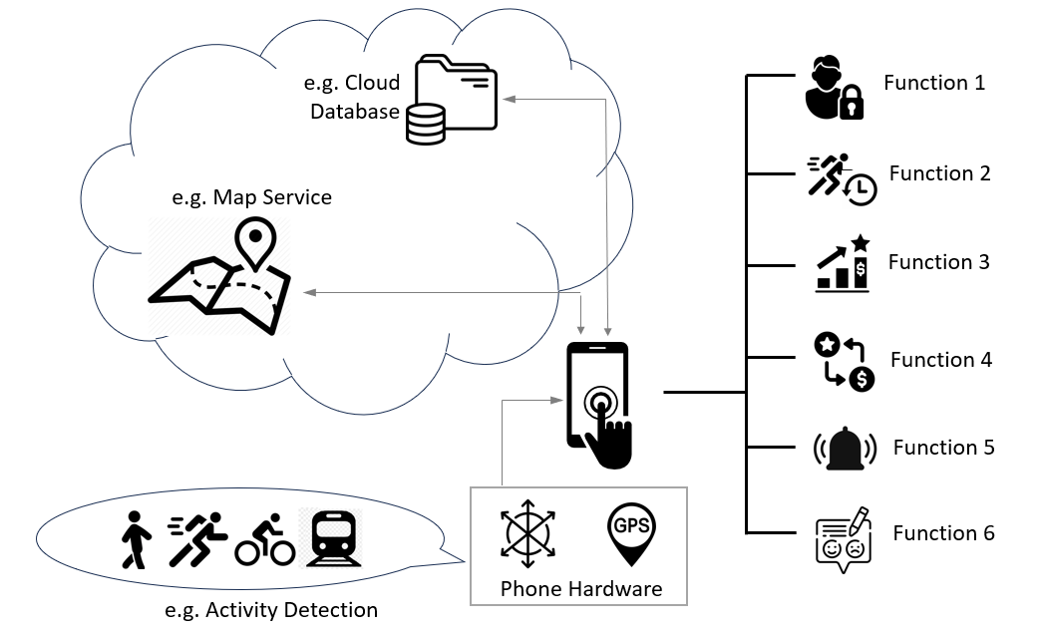
An example of a simple system block diagram.

- mock-up UI design of mobile application (can be screenshots of emulator or wireframes designed using graphics tool, focusing on a theme for your mobile application, whether your application employ a certain way to help user navigate around etc and try to impress considering that this is a proposal)
[Keep the proposal under 10 pages]

