Khmer Word Embeddings and Neural Language Modeling using Temples Corpus
Natural Language Processing
Mini Project 3 - Word Embeddings
Program: Master of Data Science
Institute: Institute of Technology of Cambodia
Student Name: ____________________
Date: 2026-06-15

Executive Summary
This project builds Khmer word embeddings and neural language models using a temple-related Khmer corpus. The workflow includes cleaning, Khmer tokenization, vocabulary construction, skip-gram training with negative sampling, PCA visualization, n-gram baseline modeling, fixed skip-gram neural language modeling, and scratch embedding comparison.
The fixed skip-gram neural language model achieved the best test perplexity. This shows that pretrained contextual embeddings helped next-word prediction on the small Khmer temple corpus.

Project Requirement Alignment
Requirement | Expected Setting | Implementation | Status
Khmer corpus | Use temples.txt | data/temples.txt or temples.txt | Completed
Khmer tokenization | Use Khmer tokenizer | khmernltk / khmer-nltk plus fallback | Completed
MIN_FREQ | Remove frequency < 10 | MIN_FREQ = 10 | Completed
Noisy token removal | Ignore spaces/noise | Punctuation, numbers, empty and non-Khmer tokens removed | Completed
Skip-gram | Build model/classifier | Skip-gram with negative sampling | Completed
Embedding dimension | 50 | EMBEDDING_DIM = 50 | Completed
Context window | +/-4 | WINDOW_SIZE = 4 | Completed
Negative sampling | k = 2 | NEGATIVE_SAMPLES = 2 | Completed
PCA | 2 components | 2D skip-gram and scratch embedding visualization | Completed
Neural LM | Predict next word | Previous 5 words to next word | Completed
Hidden layer | h = 512 | HIDDEN_SIZE = 512 | Completed
Scratch embeddings | Learn from scratch | Scratch LM implemented and compared | Completed
Comparison | Compare embeddings/models | Model comparison table and discussion | Completed
Report summary | Max 4-page summary | Notebook and generated report include summary | Completed

Dataset Description
The project uses temples.txt, a Khmer temple Wikipedia-style corpus focused on Angkor and temple-related content.
Metric | Value
Total useful tokens | 9,075
Vocabulary size after MIN_FREQ=10 | 175
Corpus domain | Khmer temple text
Corpus limitation | Small and domain-specific

Text Preprocessing and Data Quality
Khmer tokenization is important because Khmer does not mark word boundaries as clearly as English. The notebook tries Khmer tokenizer packages and keeps a fallback tokenizer for reproducibility.
- Removed references, repeated spaces, punctuation-only tokens, number-only tokens, and noisy non-Khmer tokens.
- Kept MIN_FREQ = 10 to satisfy the project instruction.
- Mapped rare words to <UNK>, which increases the unknown-word rate but follows the required threshold.

Exploratory Data Analysis
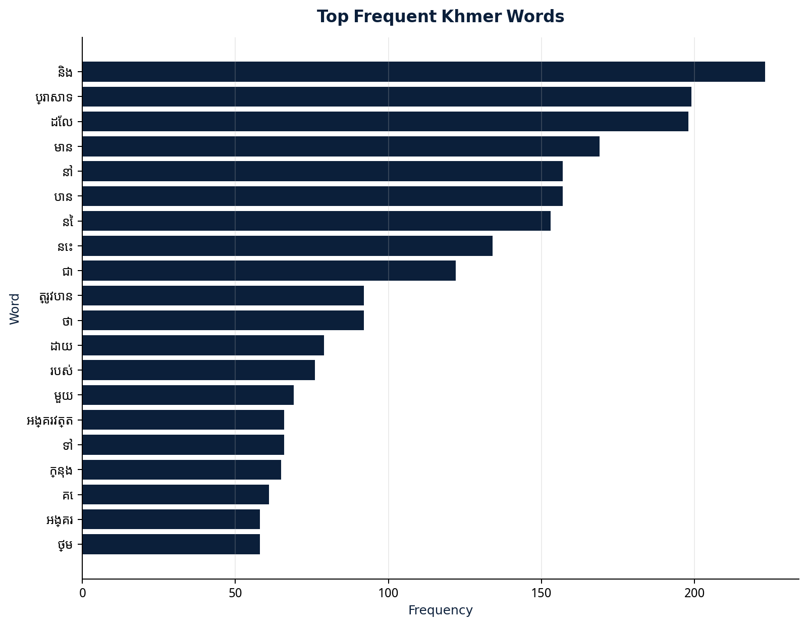
Figure 1. Top frequent Khmer words after cleaning.
The frequent-word chart confirms that the vocabulary contains meaningful Khmer words rather than punctuation.
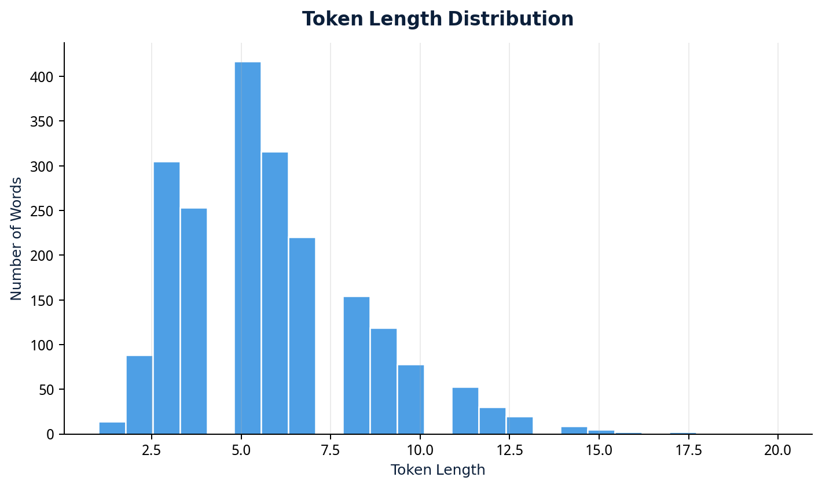
Figure 2. Token length distribution.
The length distribution helps detect tokenization problems and unusually long tokens.
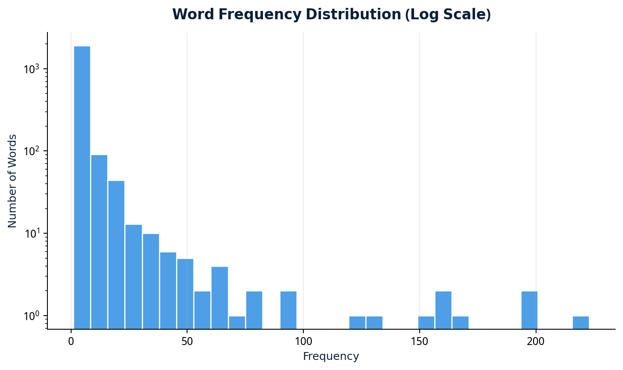
Figure 3. Word frequency distribution using log scale.
The distribution is highly skewed: many words are rare while a few occur very frequently.
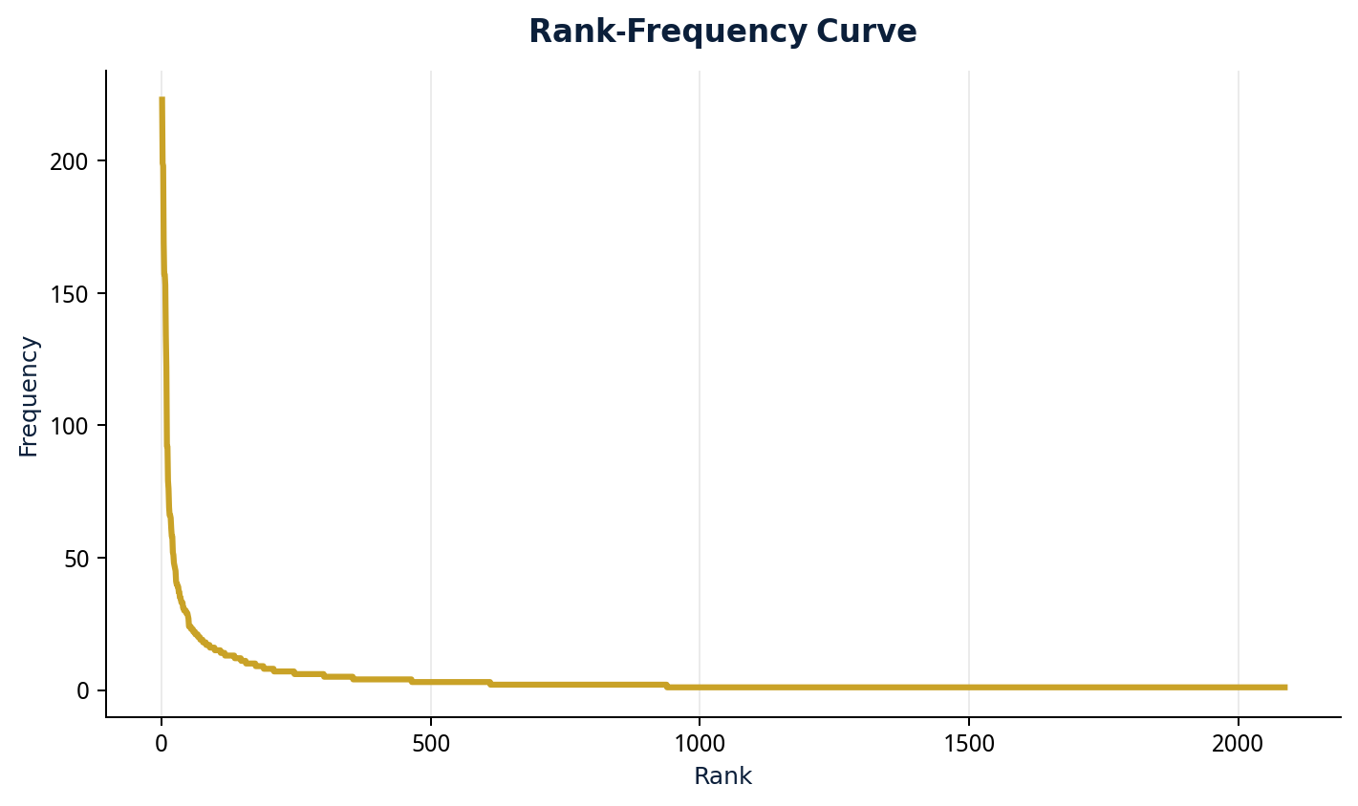
Figure 4. Rank-frequency curve.

Skip-gram Word Embedding Model
The skip-gram model learns word vectors by predicting context words around a center word. With negative sampling, the task becomes binary classification: true center-context pairs are labeled 1 and sampled negative pairs are labeled 0.
Setting | Value
Embedding dimension | 50
Context window | +/-4
Negative samples | 2
Approximate final skip-gram loss | 0.4951
Embedding matrix shape | (175, 50)

Word Embedding Analysis
Cosine similarity compares word vectors. Nearest words are interpreted as contextual neighbors, not always perfect synonyms, because the corpus is small and domain-specific.

PCA Visualization
PCA reduces 50-dimensional embeddings to 2D for visual inspection. It is useful for comparing skip-gram embeddings and scratch learned embeddings, but it loses information.
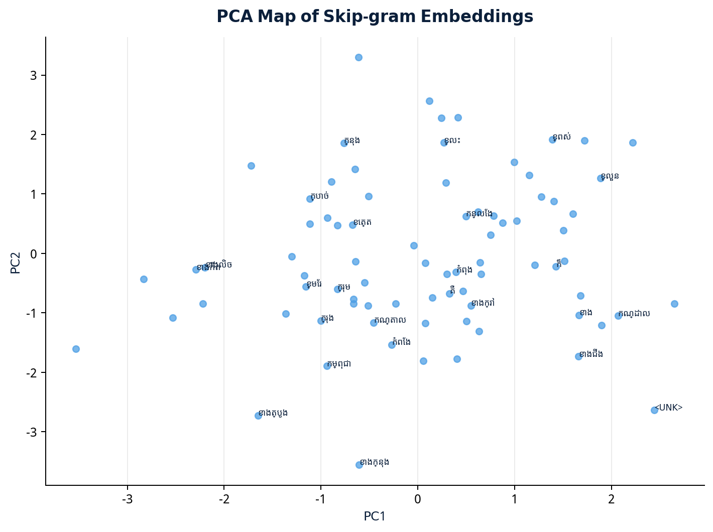
Figure 5. PCA visualization of skip-gram embeddings.
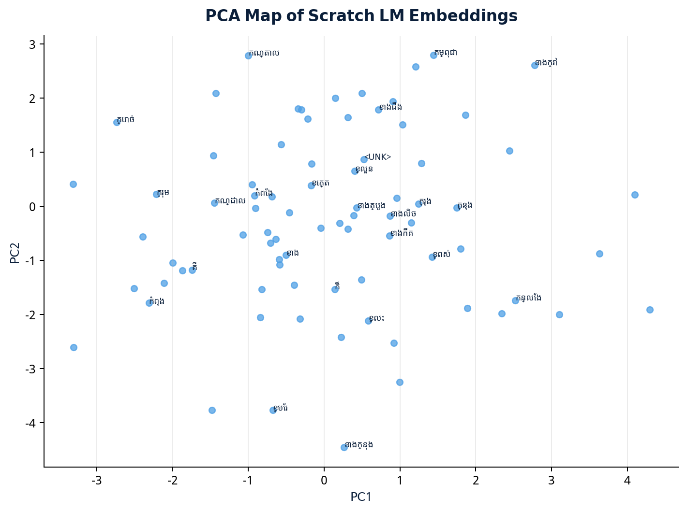
Figure 6. PCA visualization of scratch LM embeddings.

Advanced Embedding Exploration
As optional advanced analysis, K-means and hierarchical clustering were applied to the learned skip-gram embeddings. These methods help inspect whether Khmer words that appear in similar contexts form groups in the embedding space. They are exploratory and do not replace the required Mini Project 3 PCA visualization.
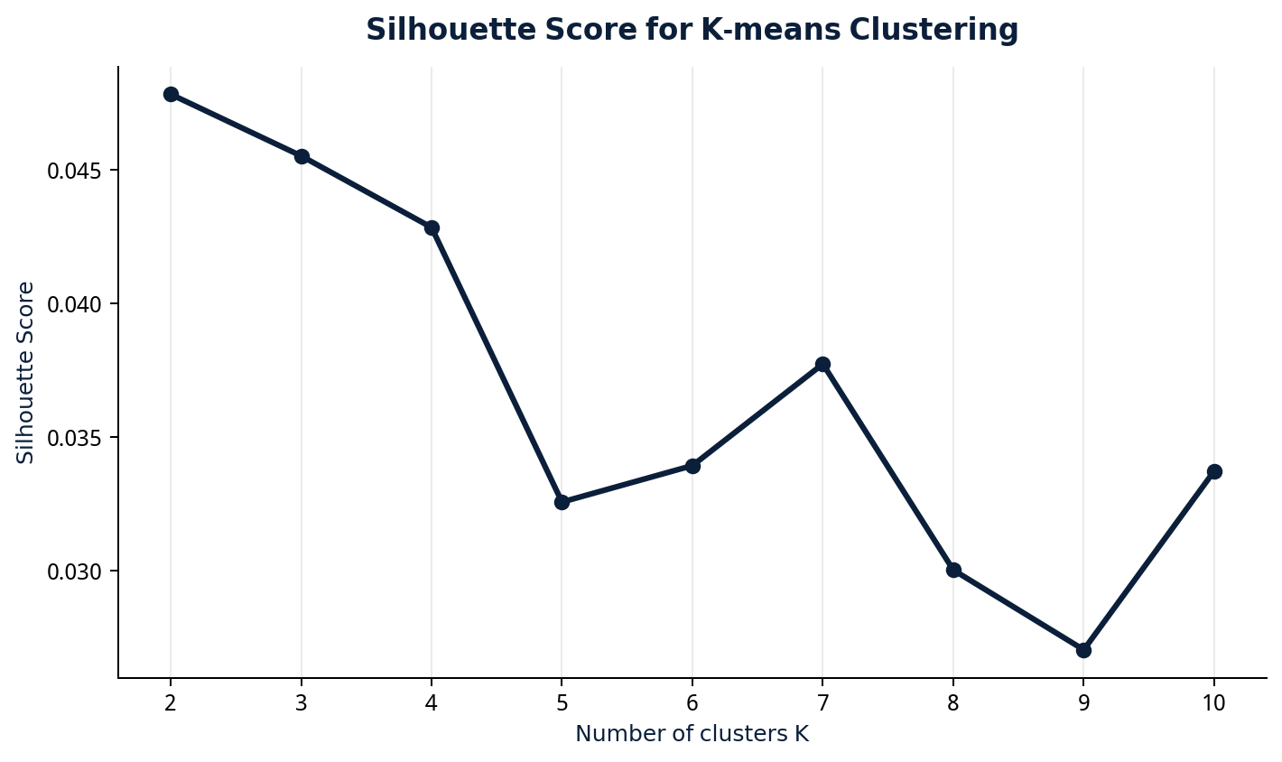
Figure 7. Silhouette score for choosing K in K-means clustering.
Cluster | Number of Words | Top Frequent Words | Interpretation
0 | 98 | ប្រាសាទ, មាន, បាន, នៃ, ត្រូវបាន, ដោយ, របស់, អង្គរវត្ត, ទៅ, ក្នុង | This cluster contains a broad group of contextual words from the temple corpus.
1 | 76 | និង, ដែល, នៅ, នេះ, ជា, ថា, មួយ, គឺ, ទី, តាម | This cluster contains a broad group of contextual words from the temple corpus.

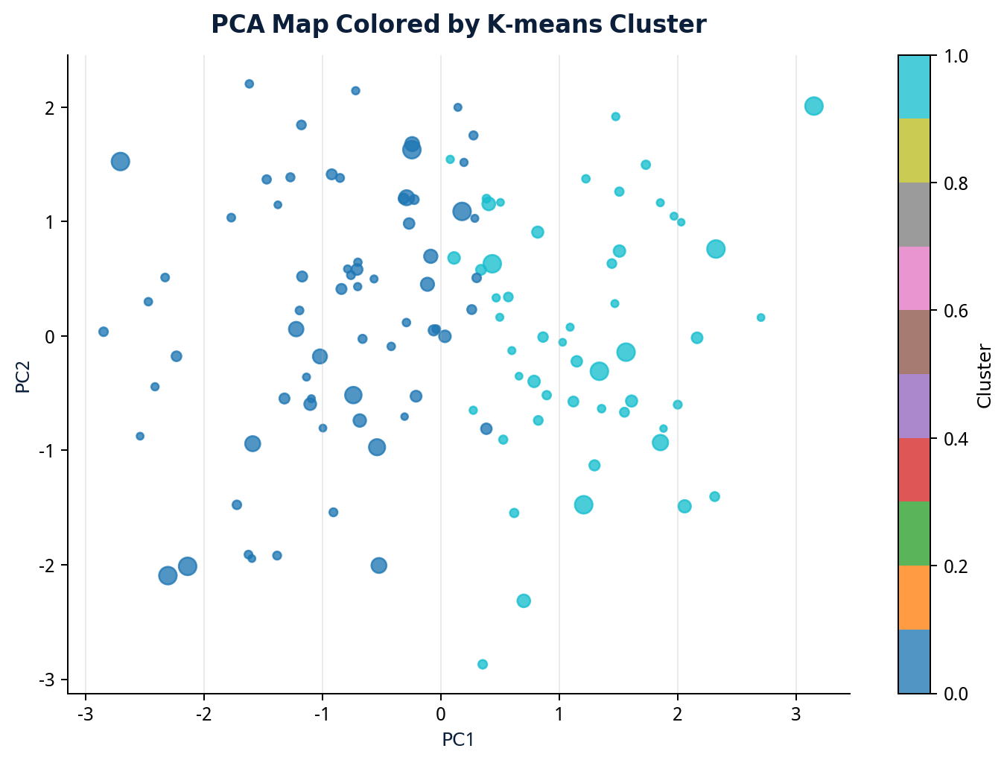
Figure 8. PCA visualization colored by K-means cluster.
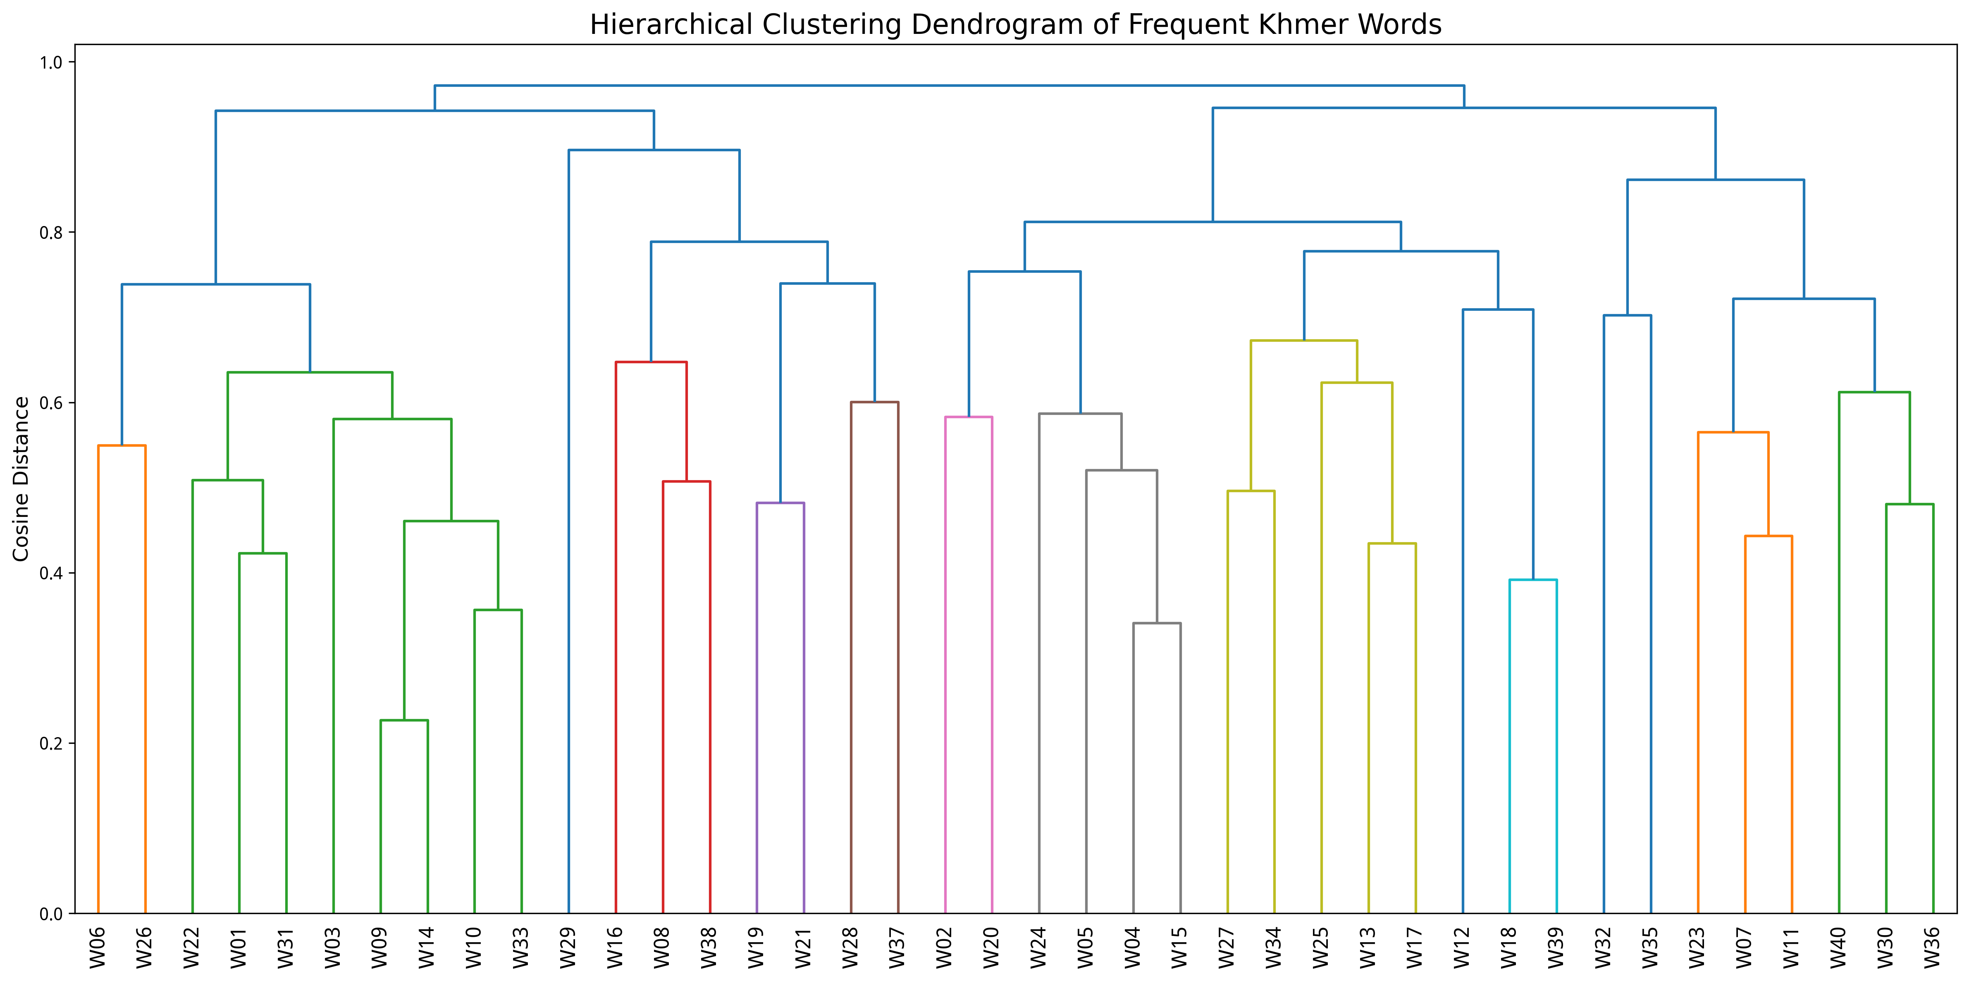
Figure 9. Hierarchical clustering dendrogram using numbered word labels.
ID | Khmer Word | Frequency
W01 | និង | 223.0
W02 | ប្រាសាទ | 199.0
W03 | ដែល | 198.0
W04 | មាន | 169.0
W05 | បាន | 157.0
W06 | នៅ | 157.0
W07 | នៃ | 153.0
W08 | នេះ | 134.0
W09 | ជា | 122.0
W10 | ថា | 92.0
W11 | ត្រូវបាន | 92.0
W12 | ដោយ | 79.0
W13 | របស់ | 76.0
W14 | មួយ | 69.0
W15 | ទៅ | 66.0
W16 | អង្គរវត្ត | 66.0
W17 | ក្នុង | 65.0
W18 | គេ | 61.0
W19 | ថ្ម | 58.0
W20 | អង្គរ | 58.0
W21 | ពី | 52.0
W22 | លើ | 51.0
W23 | គឺ | 48.0
W24 | ទី | 47.0
W25 | ខេត្ត | 46.0
W26 | តាម | 45.0
W27 | សៀមរាប | 41.0
W28 | ទៀត | 40.0
W29 | នោះ | 40.0
W30 | ច្រើន | 39.0
W31 | ឆ្នាំ | 39.0
W32 | នូវ | 37.0
W33 | ឈ្មោះ | 37.0
W34 | ពួក | 35.0
W35 | ថែវ | 35.0
W36 | ហើយ | 34.0
W37 | ធំ | 33.0
W38 | ដើម្បី | 33.0
W39 | តំបន់ | 33.0
W40 | ជាច្រើន | 31.0

Words in the same K-means cluster suggest similar contextual patterns. The dendrogram gives a tree-style view of selected frequent words. Because the corpus is small and temple-specific, these clusters should be interpreted cautiously as contextual groups, not perfect semantic classes.

Neural Language Modeling
The neural language model predicts the next word from the previous five words. It concatenates five 50-dimensional embeddings, applies a hidden layer of size 512, and predicts the next word using a softmax output with CrossEntropyLoss.
- N-gram baseline uses add-one smoothing.
- Fixed neural LM uses pretrained skip-gram embeddings.
- Scratch neural LM learns embeddings from random initialization.

Model Comparison and Results
Model | Embedding Source | Test Perplexity | Top-1 Accuracy | Top-5 Accuracy | Interpretation
N-gram baseline | No embeddings | 158.84 |  |  | Add-one smoothing; stable for small corpus
Neural LM fixed | Skip-gram embeddings fixed | 115.1 | 0.3588798820928519 | 0.5239498894620487 | Uses semantic vectors but does not update embeddings
Neural LM scratch | Learned from scratch | 229.07 | 0.3544583640383198 | 0.5232129697862933 | Learns task-specific embeddings

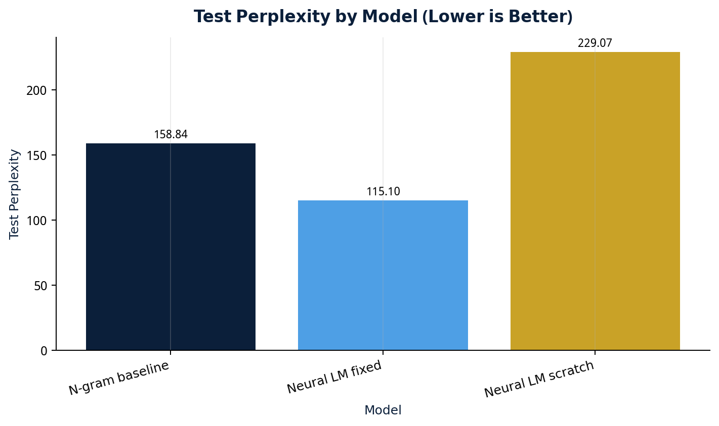
Figure 10. Test perplexity by model. Lower is better.
The fixed skip-gram neural LM achieved the best perplexity, indicating that pretrained contextual embeddings helped prediction.

Error Analysis
context_words | true_next_word | predicted_next_word | correct
ប្រាសាទ បុរាណ <UNK> ទៀត ជាច្រើន | <UNK> | <UNK> | True
បុរាណ <UNK> ទៀត ជាច្រើន <UNK> | នេះ | <UNK> | False
<UNK> ទៀត ជាច្រើន <UNK> នេះ | ក្រុង | បាន | False
ទៀត ជាច្រើន <UNK> នេះ ក្រុង | សៀមរាប | <UNK> | False
ជាច្រើន <UNK> នេះ ក្រុង សៀមរាប | កំពុង | នៃ | False
<UNK> នេះ ក្រុង សៀមរាប កំពុង | <UNK> | <UNK> | True
នេះ ក្រុង សៀមរាប កំពុង <UNK> | <UNK> | <UNK> | True
ក្រុង សៀមរាប កំពុង <UNK> <UNK> | ជា | <UNK> | False
សៀមរាប កំពុង <UNK> <UNK> ជា | ក្រុង | <UNK> | False
កំពុង <UNK> <UNK> ជា ក្រុង | <UNK> | <UNK> | True

Common errors are caused by rare words, <UNK>, Khmer compound words, named entities, and the small corpus size.

Discussion
The project successfully connects course topics from preprocessing and n-grams to word meaning and neural language modeling. Tokenization had the largest impact on quality. Pretrained skip-gram embeddings helped the neural LM because they already captured local contextual information.

Limitations
- The corpus is small and temple-specific.
- Khmer tokenization remains challenging.
- MIN_FREQ=10 removes rare but meaningful words.
- PCA reduces 50D vectors to 2D and loses information.
- Nearest words represent contextual association, not always synonyms.

Future Work
- Train on a larger Khmer corpus.
- Improve tokenizer and compound word handling.
- Compare Word2Vec, FastText, and transformer embeddings.
- Add optional retraining for uploaded text in Streamlit.
- Deploy the Streamlit app publicly.

Conclusion
The project satisfies the Mini Project 3 requirements. It implements Khmer skip-gram embeddings, PCA visualization, n-gram and neural language models, scratch embedding comparison, and honest evaluation. The fixed skip-gram neural LM performed best with test perplexity around 115.10.

