Mini Project 1: Text Generation with 4-gram Language Models
Natural Language Processing | Master of Data Science
Corpus: Combined Khmer Wikipedia articles related to Angkor Wat

1. Objective
This project builds and evaluates two 4-gram language models for Khmer text generation. LM1 uses an unsmoothed backoff method, while LM2 uses interpolation with add-k smoothing. The models are evaluated with perplexity and demonstrated using generated text examples.

2. Corpus and Preprocessing
To improve corpus size, five related Khmer Wikipedia articles were combined. The notebook removes noisy English-only lines, removes artificial article markers, separates Khmer punctuation, and uses khmernltk.word_tokenize for Khmer word segmentation. Vocabulary is limited and remaining tokens are replaced with <UNK>, matching the assignment requirement.
Item | Value
Articles in corpus | 5
Corpus characters | 96,199
Tokenizer | khmernltk.word_tokenize
Total tokens | 19,681
Training / Validation / Testing | 13,776 / 1,968 / 3,937
Vocabulary size | 500
Validation <UNK> / Test <UNK> | 660 / 1433

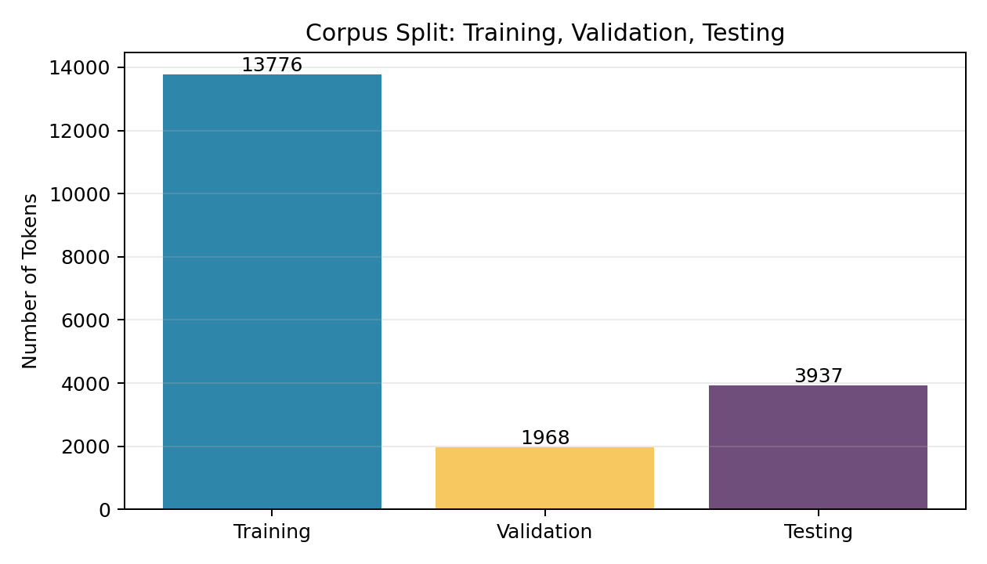

3. Model Design
LM1 Backoff first tries the 4-gram probability. If the 4-gram is unseen, it backs off to trigram, bigram, and unigram probabilities. LM2 Interpolation combines unigram, bigram, trigram, and 4-gram probabilities using lambda weights. Each LM2 term uses add-k smoothing.
Model | Method | Key idea
LM1 | Unsmoothed backoff 4-gram | Use longest available context; back off when unseen.
LM2 | Interpolation + add-k smoothing | Combine all n-gram levels and smooth unseen events.

4. Hyperparameter Tuning
Grid search was used for LM2. Several lambda combinations and k values were tested on the validation set. The best setting was selected by lowest validation perplexity, then final performance was measured on the test set.
Best LM2 parameter | Value
Best lambdas | (0.4, 0.3, 0.2, 0.1)
Best k | 0.001
Validation perplexity | 47.4493

5. Evaluation Results
Model | Method | Best parameters | Test perplexity
LM1 | Unsmoothed backoff 4-gram | No lambda/k | 27.2196
LM2 | Interpolation + add-k smoothing | lambdas=(0.4, 0.3, 0.2, 0.1), k=0.001 | 45.7879
Lower perplexity is better. LM1 Backoff performs better than LM2 Interpolation in this experiment. The best LM2 lambda values give more weight to lower-order n-grams, showing that exact 4-gram patterns are still sparse.
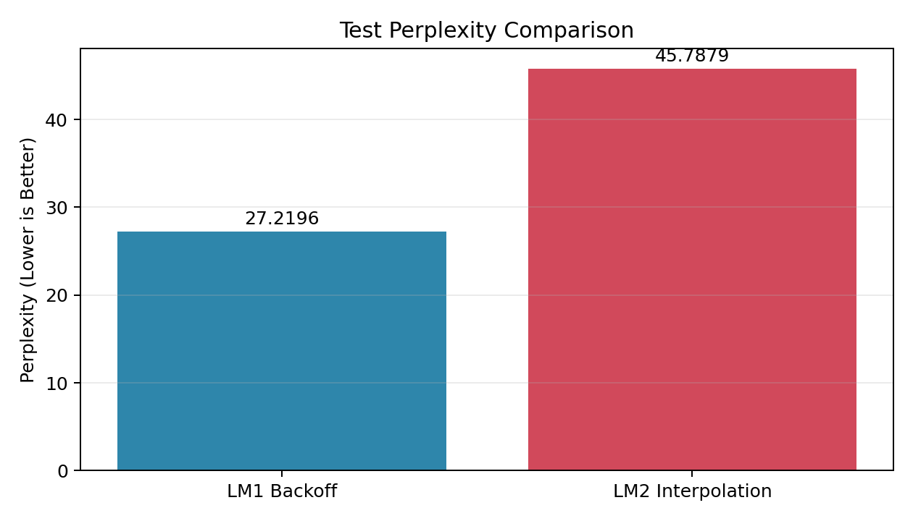

6. Vocabulary Size Experiment
Vocabulary size controls the trade-off between readability and perplexity. A small vocabulary creates many <UNK> tokens but can lower perplexity. A larger vocabulary keeps more real Khmer words but makes n-gram counts more sparse.
Vocab | Test <UNK> | LM1 PP | LM2 PP
100 | 2344 | 7.0151 | 9.2468
200 | 2021 | 11.3045 | 16.1981
300 | 1783 | 16.2645 | 24.74
500 | 1433 | 27.2196 | 45.7879
700 | 1233 | 38.2488 | 68.3284
1000 | 1119 | 49.2772 | 92.2916
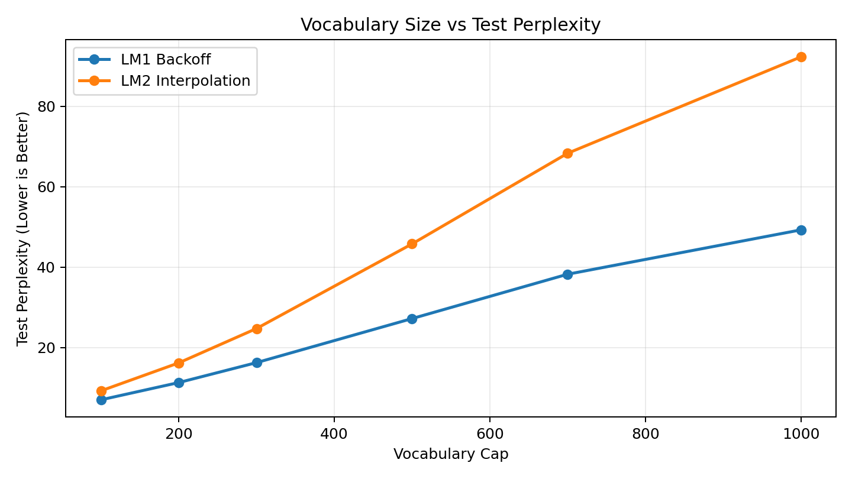

7. Text Generation Examples
Seed phrase: ប្រាសាទ
LM1 Backoff generated text:
ប្រាសាទ នេះ កសាង នៅ ចុង សតវត្សរ៍ ទី ១២ និង ១៣។
LM2 Interpolation generated text:
ប្រាសាទ នេះ បង្ហាញ ឲ្យដឹង ថា ត្រូវបាន ទៅជា <UNK> ទើប នៅក្នុង រូបរាង <UNK> <UNK> របស់ ព្រះអង្គ <UNK>។
For presentation, LM1 Backoff is recommended because it has lower perplexity and usually produces cleaner short generated text. A generation length of 20-30 tokens is easier to read.

8. Conclusion
The project satisfies the assignment requirements: corpus selection, 70/10/20 split, tokenization, vocabulary limiting with <UNK>, two 4-gram language models, LM2 hyperparameter tuning, perplexity evaluation, and text generation. LM1 Backoff achieved the best test perplexity. LM2 is smoother but performed worse on this corpus. The main limitations are n-gram sparsity, the vocabulary/readability trade-off, and imperfect naturalness of generated Khmer text.

References
https://km.wikipedia.org/wiki/ប្រាសាទ_អង្គរវត្ត
https://km.wikipedia.org/wiki/អង្គរធំ
https://km.wikipedia.org/wiki/ប្រាសាទបាយ័ន
https://km.wikipedia.org/wiki/ខេត្តសៀមរាប
https://km.wikipedia.org/wiki/ចក្រភពខ្មែរ

