CMPG223 Project

R Marx

Lecturer: Linda Redelinghuys

36581852

https://github.com/Tanaille/cmpg223-project

Table of Contents

1. Physical Data Model 3

2. Physical Process Models 4

3. Database Schema 9

4. SQL Statements 19

4.1. Table Creation 19

4.1.1 City 19

4.1.2 User Type 19

4.1.3 Animal Type 19

4.1.4 Users 19

4.1.5 Passwords 19

4.1.6 Adopter 20

4.1.7 Animal 20

4.1.8 Adoption 20

4.2. SELECT Queries 21

4.2.1 User authentication 21

4.2.2 Get NULL values 21

4.2.3 Check if record exists 21

4.2.4 Value retrieval 21

4.2.5 Populate and filter form controls 23

4.2.6 Reporting 24

4.3. Maintenance Queries (INSERT, UPDATE, DELETE) 25

4.3.1 Adopters 25

4.3.2 Adoptions 25

4.3.3 Animals 25

4.3.4 Animal Types 25

4.3.5 Cities 26

4.3.6 Passwords 26

4.3.7 Users 26

4.3.8 User Types 26

5. Child Entity Maintenance Example 27

6. Reports 28

7. User Manual 29

8. Detail Diary 32

# 1. Physical Data Model

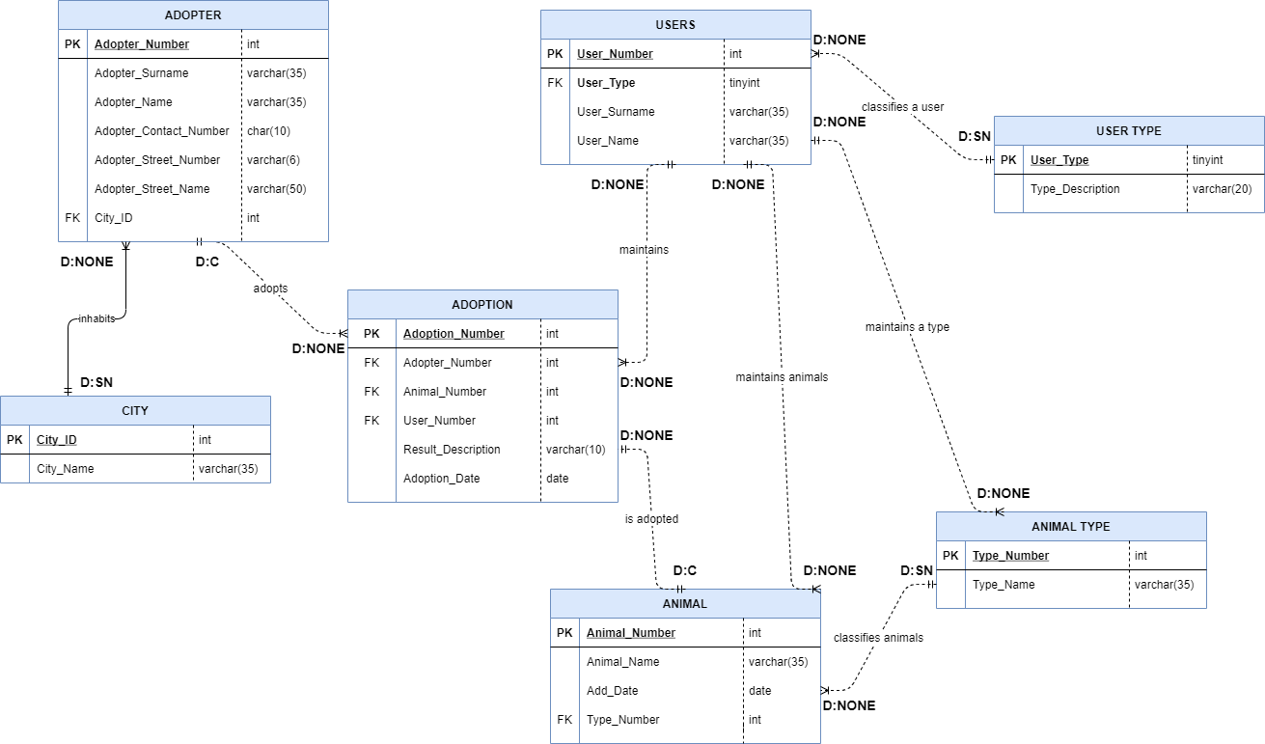

# 2. Physical Process Models

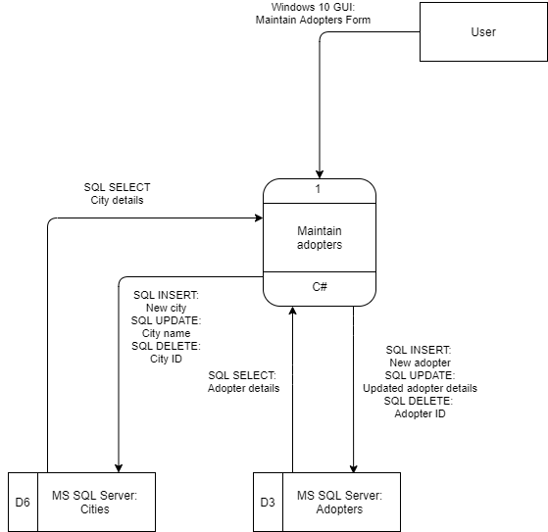

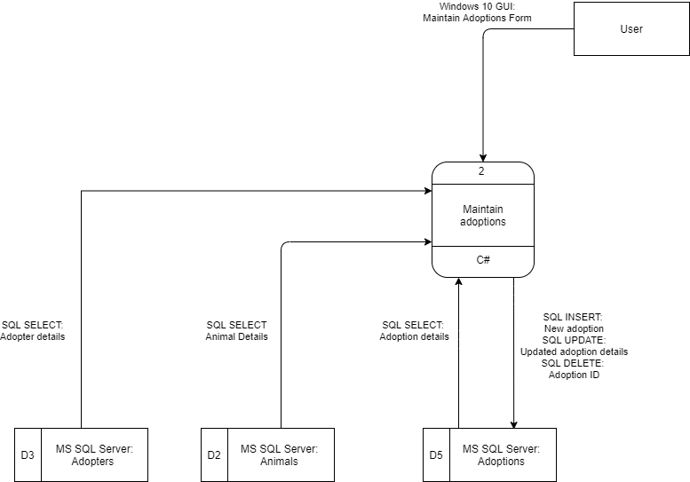

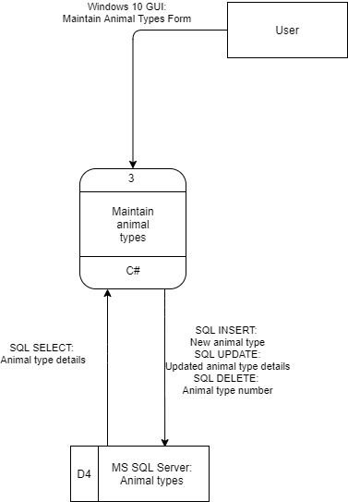

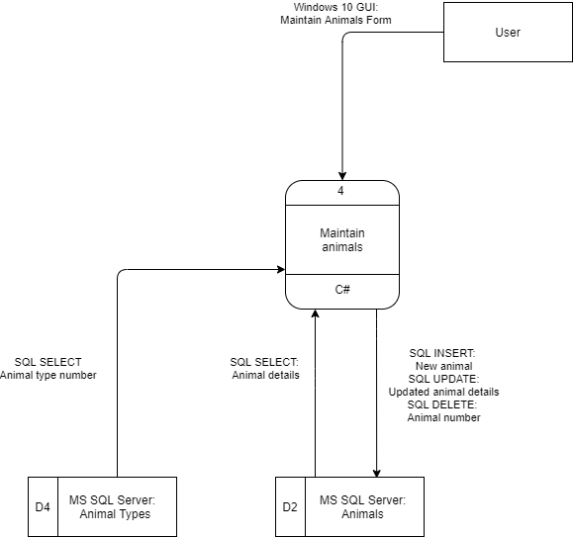

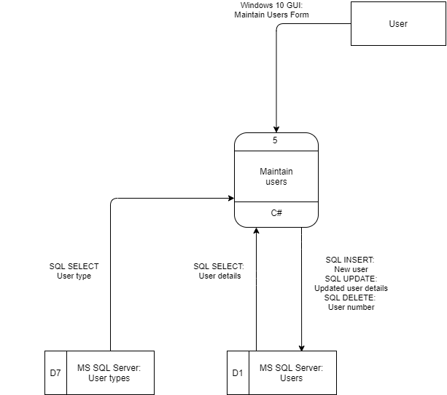

# 3. Database Schema

Full size images of the database schema can be found in the Screenshots\Schema Creation folder of the zipped project.

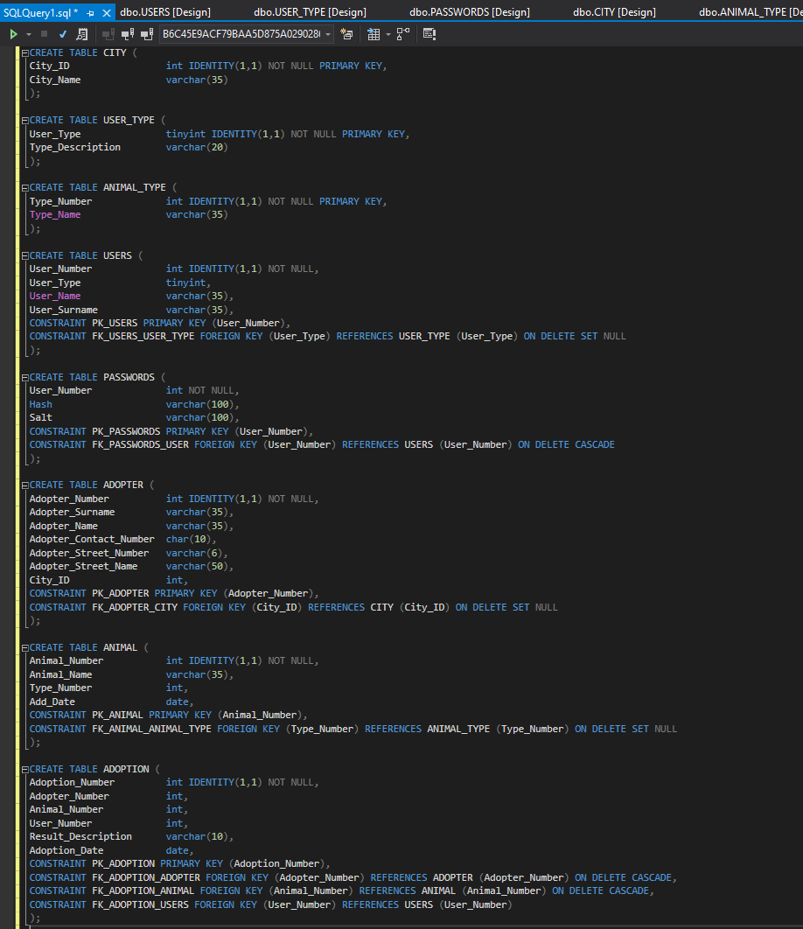

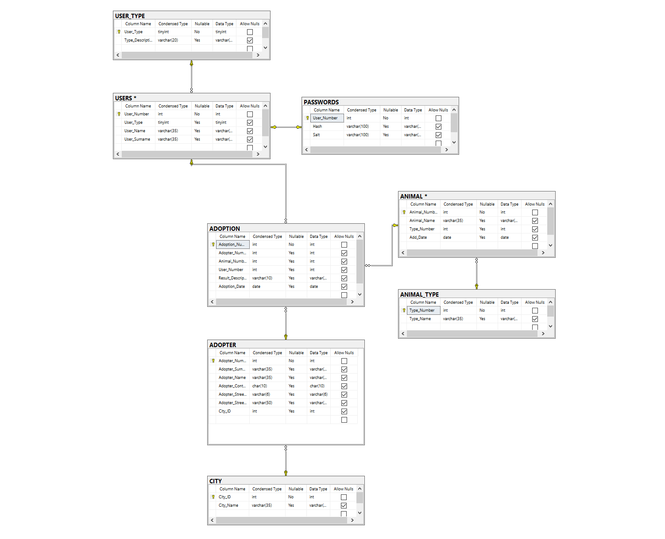

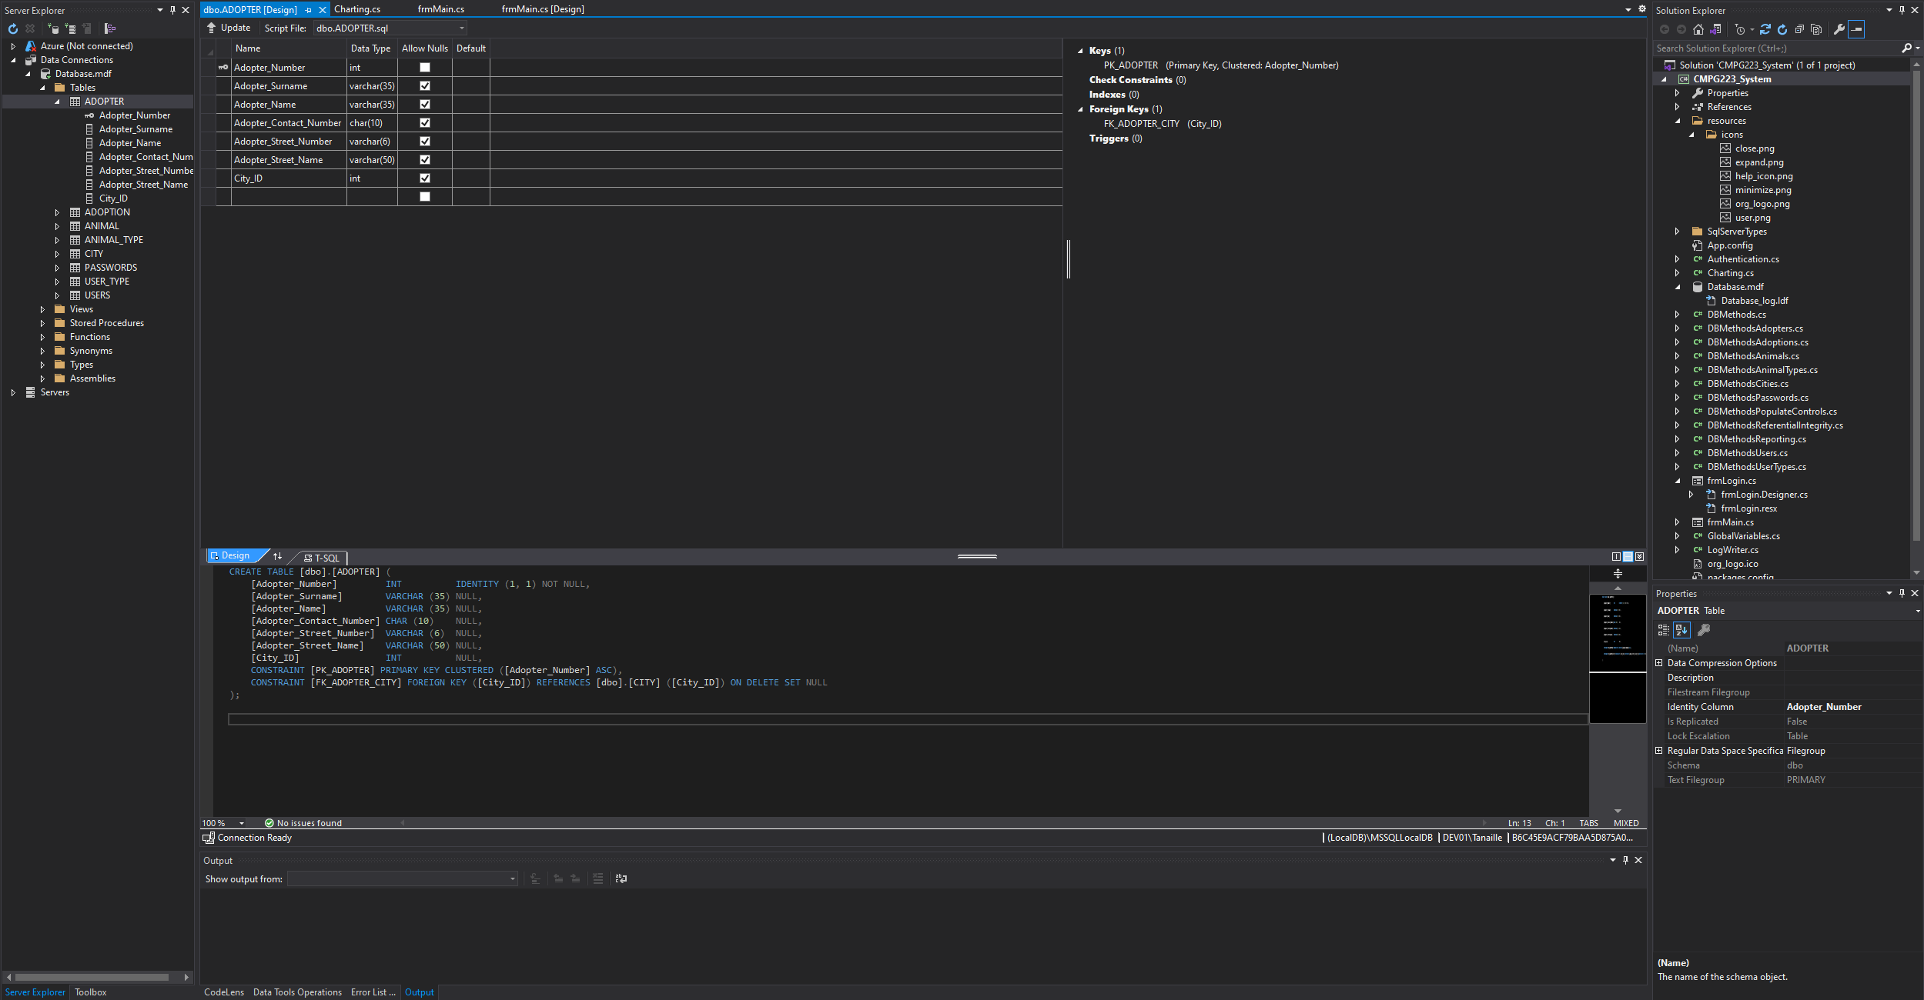

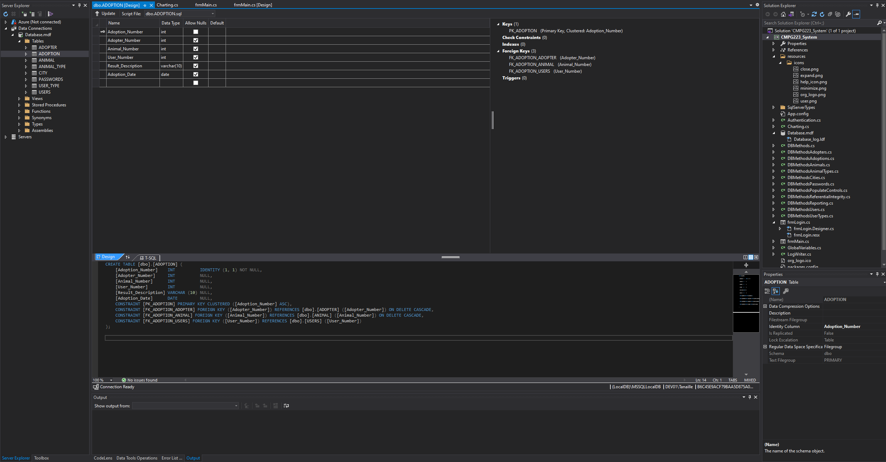

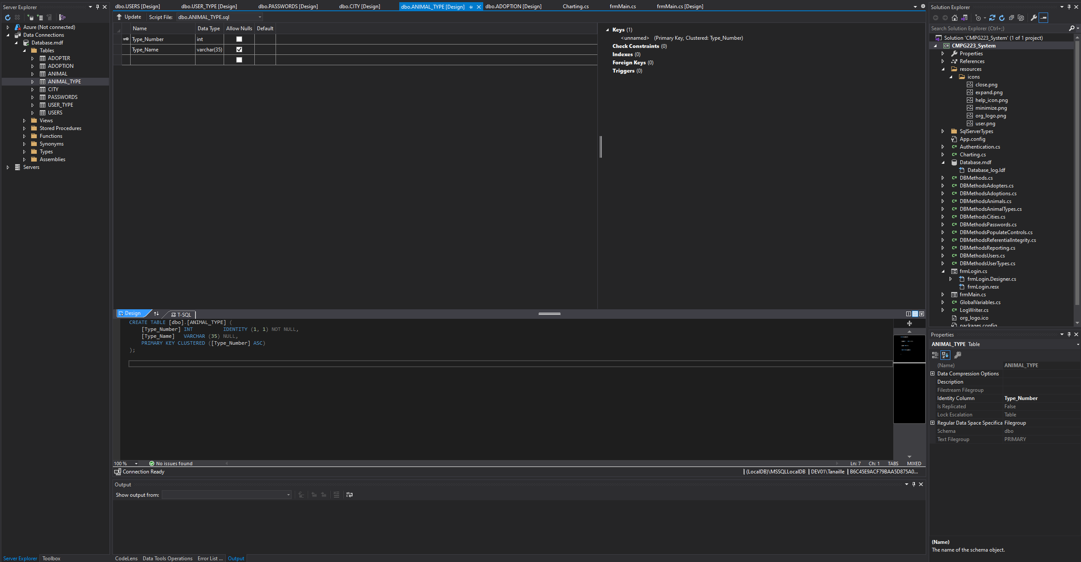

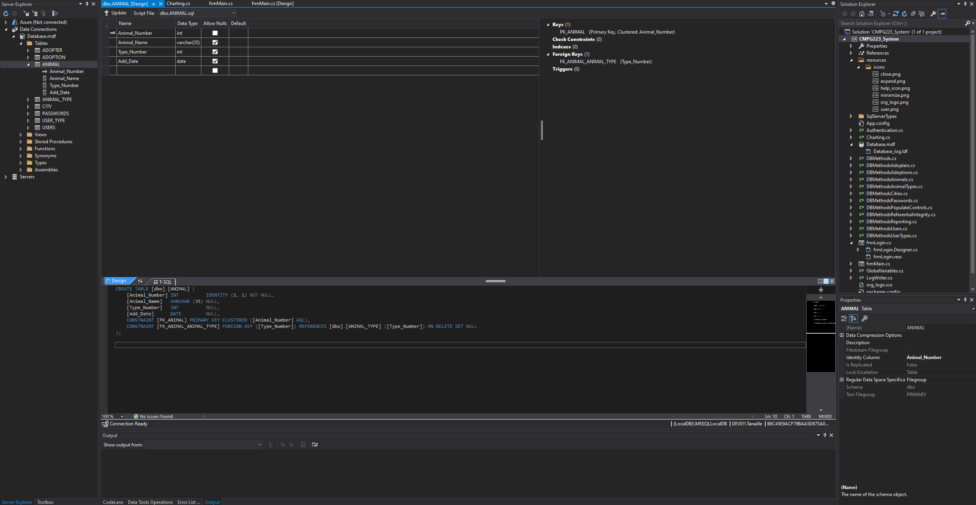

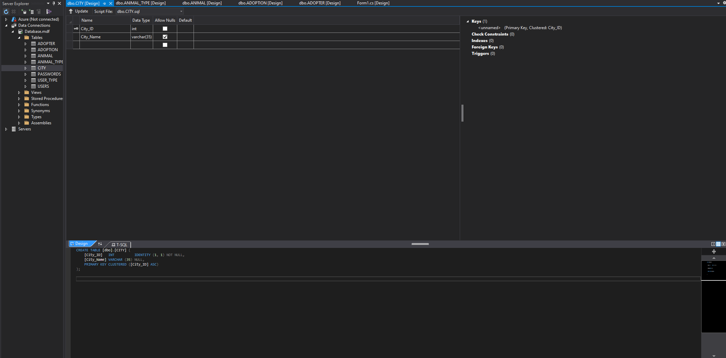

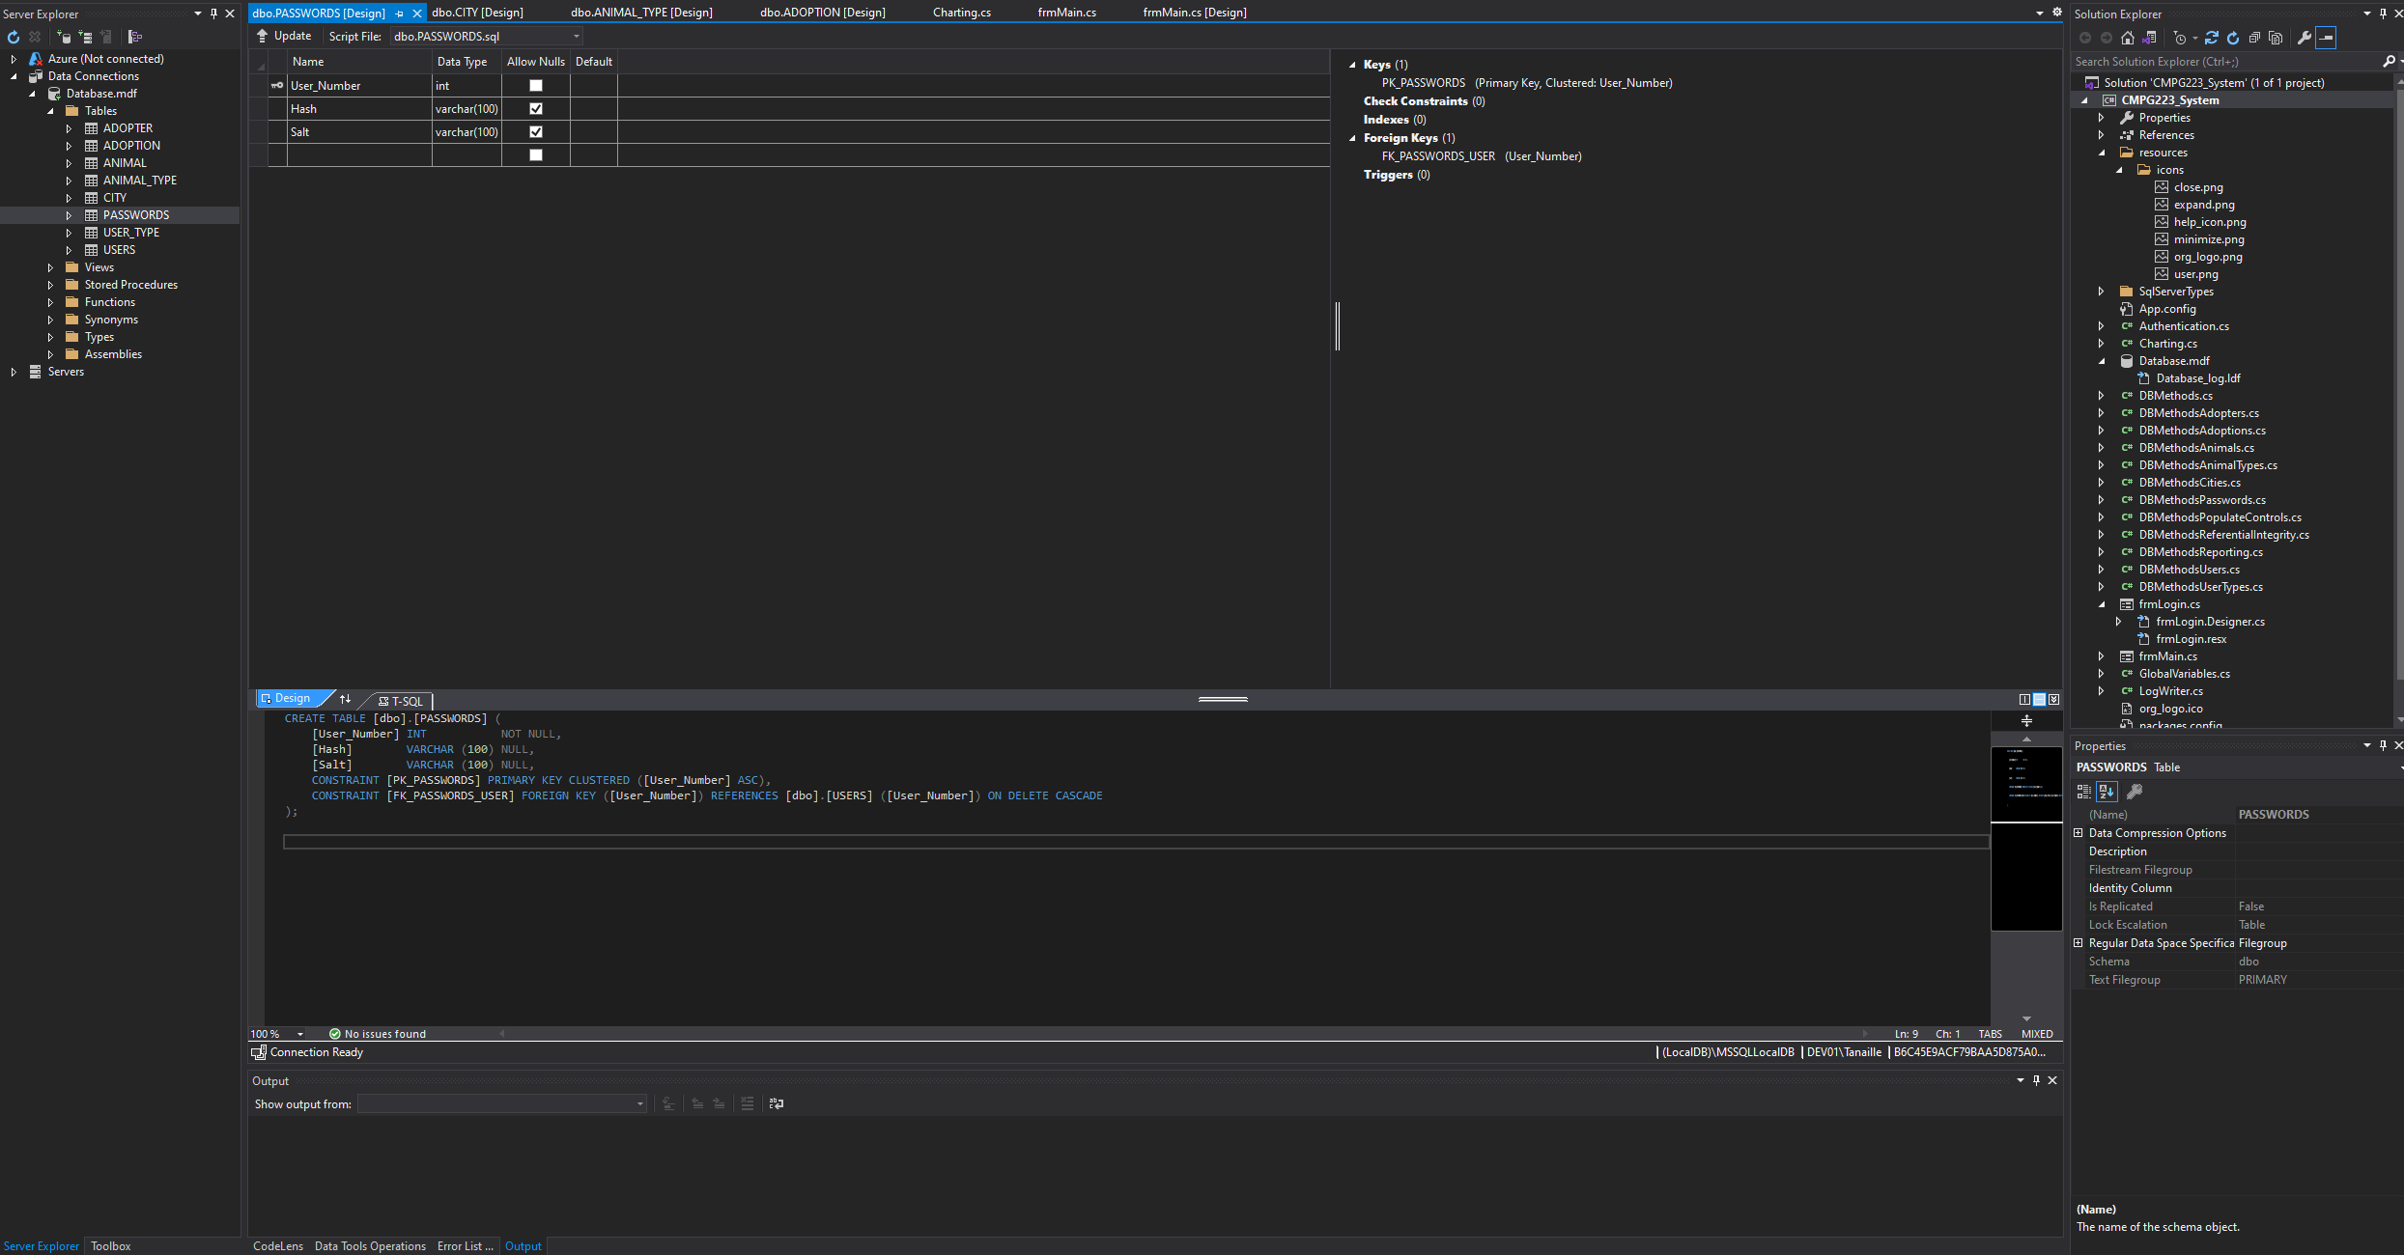

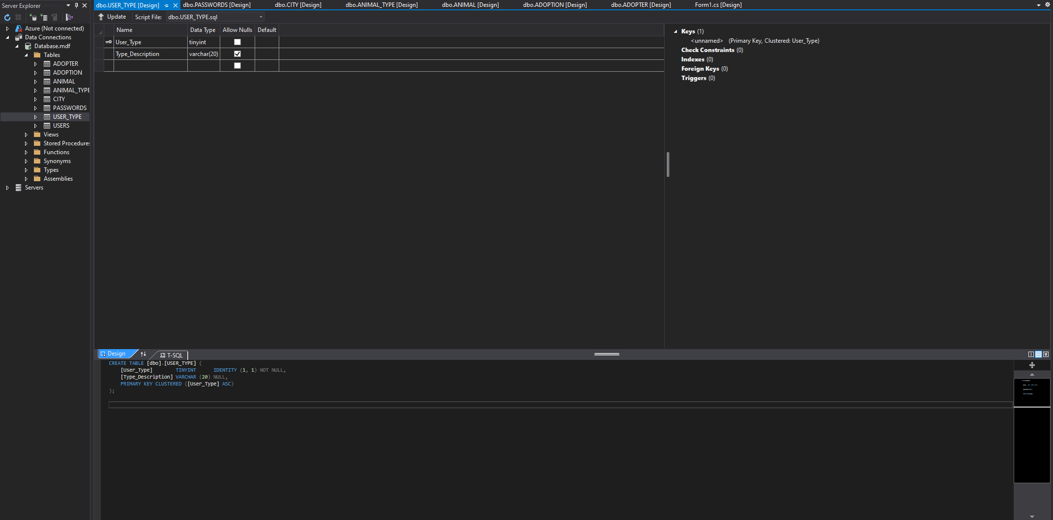

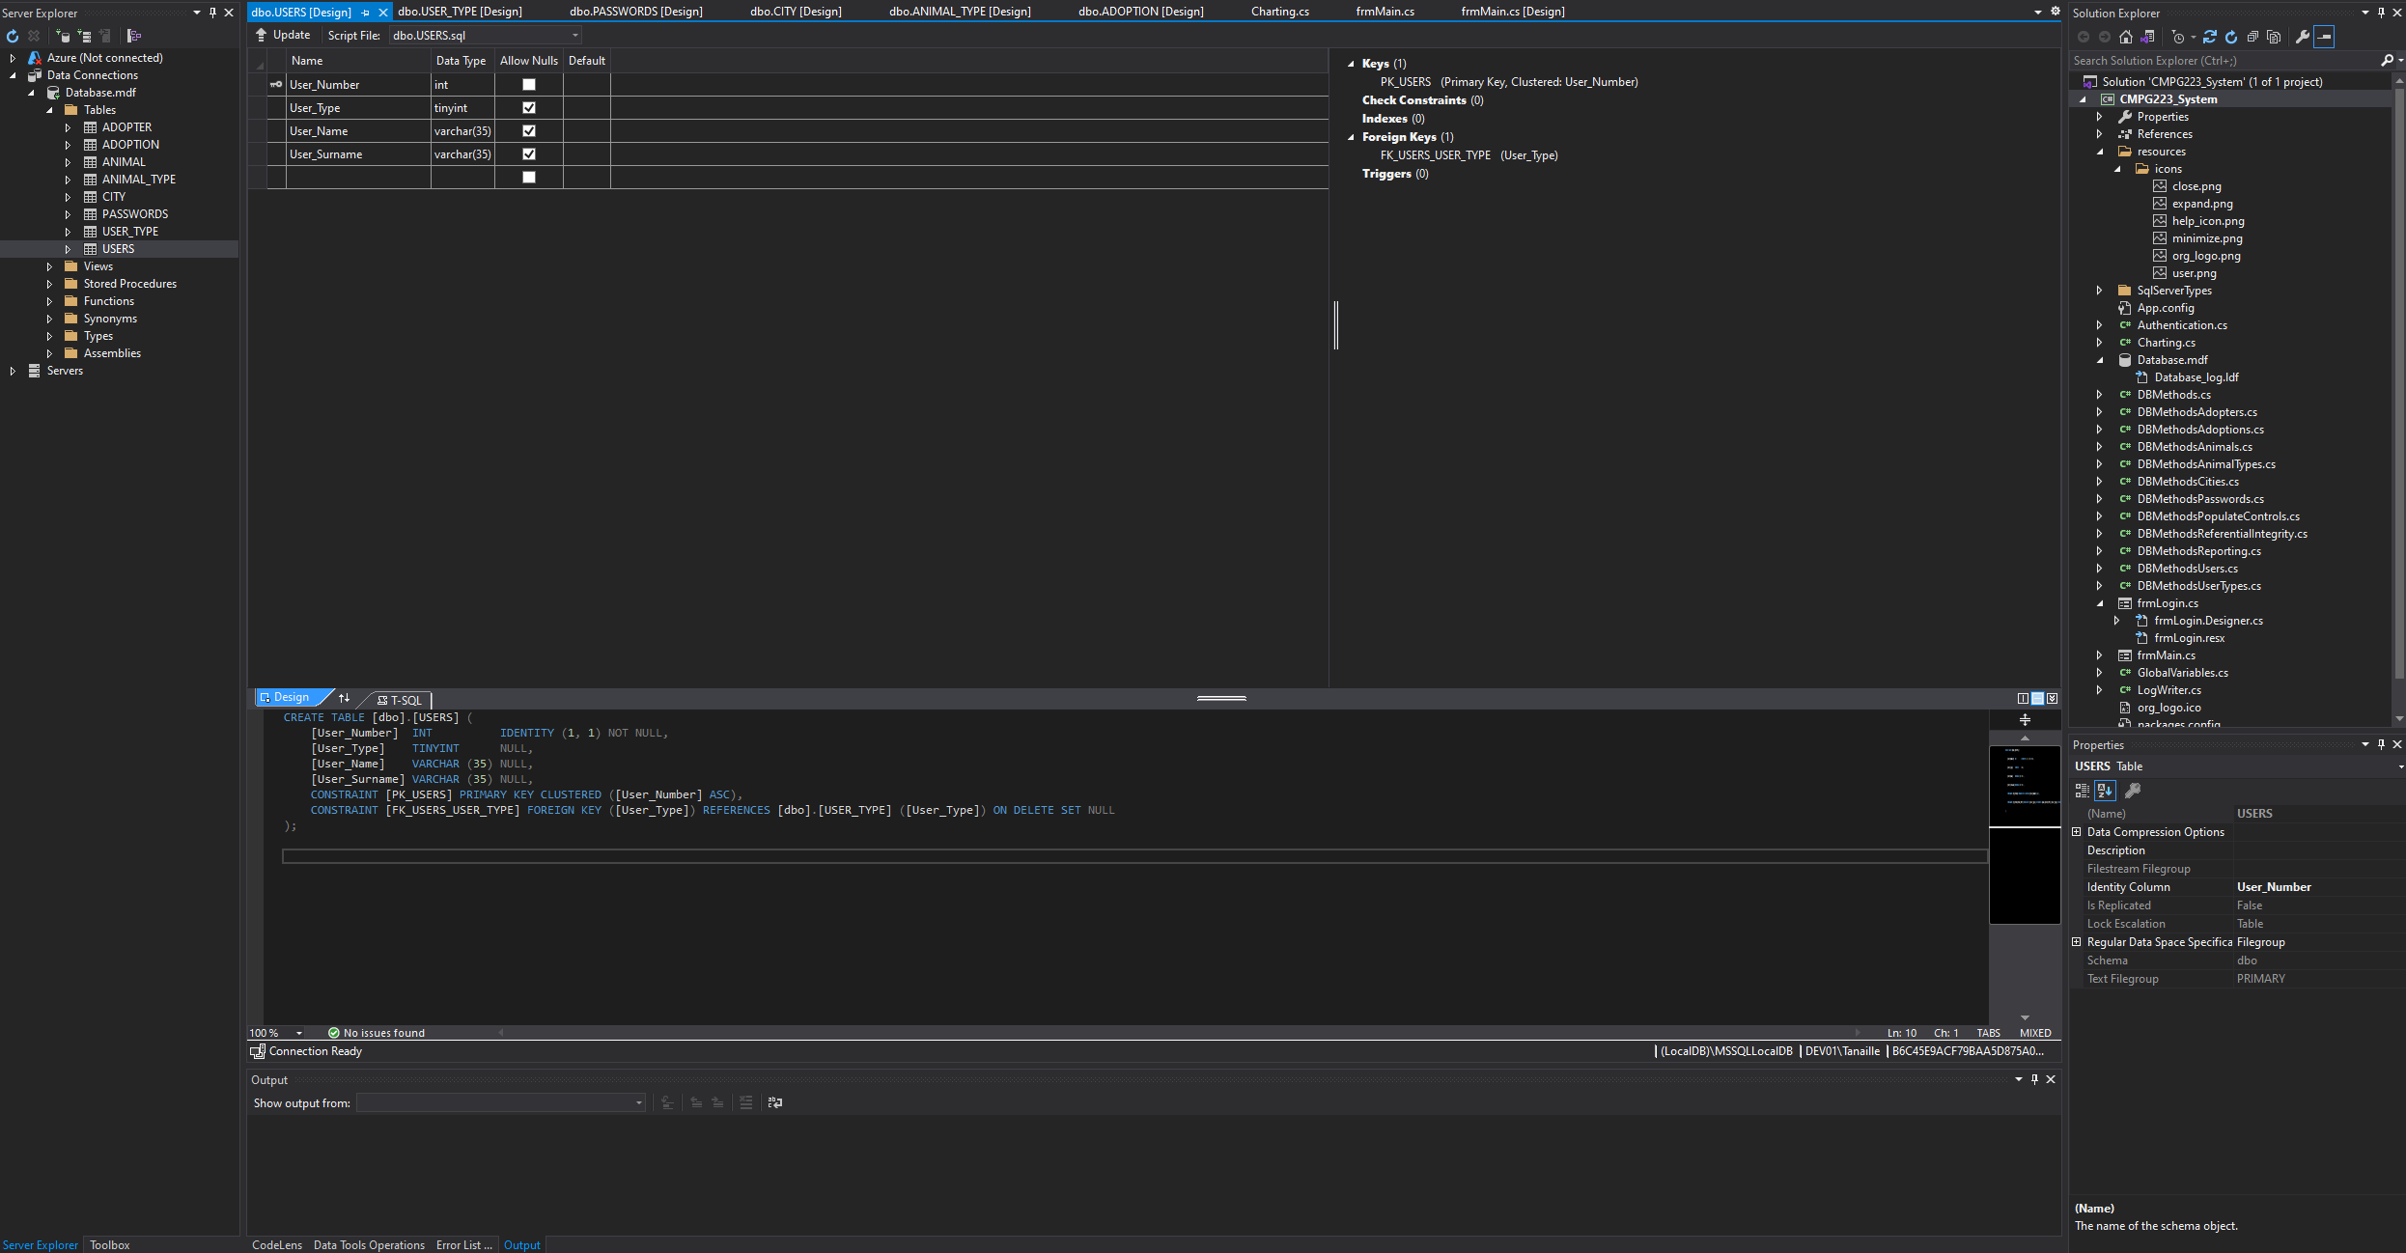

# 4. SQL Statements

# 4.1. Table Creation

## 4.1.1 City

CREATE TABLE CITY (

City_ID int IDENTITY(1,1) NOT NULL PRIMARY KEY,

City_Name varchar(35)

);

## 4.1.2 User Type

CREATE TABLE USER_TYPE (

User_Type tinyint IDENTITY(1,1) NOT NULL PRIMARY KEY,

Type_Description varchar(20)

);

## 4.1.3 Animal Type

CREATE TABLE ANIMAL_TYPE (

Type_Number int IDENTITY(1,1) NOT NULL PRIMARY KEY,

Type_Name varchar(35)

);

## 4.1.4 Users

CREATE TABLE USERS (

User_Number int IDENTITY(1,1) NOT NULL,

User_Type tinyint,

User_Name varchar(35),

User_Surname varchar(35),

CONSTRAINT PK_USERS PRIMARY KEY (User_Number),

CONSTRAINT FK_USERS_USER_TYPE FOREIGN KEY (User_Type) REFERENCES USER_TYPE (User_Type) ON DELETE SET NULL

);

## 4.1.5 Passwords

CREATE TABLE PASSWORDS (

User_Number int NOT NULL,

Hash varchar(100),

Salt varchar(100),

CONSTRAINT PK_PASSWORDS PRIMARY KEY (User_Number),

CONSTRAINT FK_PASSWORDS_USER FOREIGN KEY (User_Number) REFERENCES USERS (User_Number) ON DELETE CASCADE

);

## 4.1.6 Adopter

CREATE TABLE ADOPTER (

Adopter_Number int IDENTITY(1,1) NOT NULL,

Adopter_Surname varchar(35),

Adopter_Name varchar(35),

Adopter_Contact_Number char(10),

Adopter_Street_Number varchar(6),

Adopter_Street_Name varchar(50),

City_ID int,

CONSTRAINT PK_ADOPTER PRIMARY KEY (Adopter_Number),

CONSTRAINT FK_ADOPTER_CITY FOREIGN KEY (City_ID) REFERENCES CITY (City_ID) ON DELETE SET NULL

);

## 4.1.7 Animal

CREATE TABLE ANIMAL (

Animal_Number int IDENTITY(1,1) NOT NULL,

Animal_Name varchar(35),

Type_Number int,

Add_Date date,

CONSTRAINT PK_ANIMAL PRIMARY KEY (Animal_Number),

CONSTRAINT FK_ANIMAL_ANIMAL_TYPE FOREIGN KEY (Type_Number) REFERENCES ANIMAL_TYPE (Type_Number) ON DELETE SET NULL

);

## 4.1.8 Adoption

CREATE TABLE ADOPTION (

Adoption_Number int IDENTITY(1,1) NOT NULL,

Adopter_Number int,

Animal_Number int,

User_Number int,

Result_Description varchar(10),

Adoption_Date date,

CONSTRAINT PK_ADOPTION PRIMARY KEY (Adoption_Number),

CONSTRAINT FK_ADOPTION_ADOPTER FOREIGN KEY (Adopter_Number) REFERENCES ADOPTER (Adopter_Number) ON DELETE CASCADE,

CONSTRAINT FK_ADOPTION_ANIMAL FOREIGN KEY (Animal_Number) REFERENCES ANIMAL (Animal_Number) ON DELETE CASCADE,

CONSTRAINT FK_ADOPTION_USERS FOREIGN KEY (User_Number) REFERENCES USERS (User_Number)

);

# 4.2. SELECT Queries

## 4.2.1 User authentication

SELECT USERS.User_Name, PASSWORDS.Hash, PASSWORDS.Salt

FROM USERS

INNER JOIN PASSWORDS

ON USERS.User_Number = PASSWORDS.User_Number

WHERE USERS.User_Name = @userName;

## 4.2.2 Get NULL values

SELECT *

FROM table

WHERE + column IS NULL;

## 4.2.3 Check if record exists

SELECT TOP 1 column

FROM table

WHERE column = @value;

## 4.2.4 Value retrieval

**Animal type number from animal type name**

SELECT Type_Number

FROM ANIMAL_TYPE

WHERE Type_Name = @typeName;

**Animal type number from animal name**

SELECT Type_Number

FROM ANIMAL

WHERE Animal_Name = @name AND Type_Number IS NOT NULL;

**Animal number from animal name**

SELECT Animal_Number

FROM ANIMAL

WHERE Animal_Name = @animalName;

**Animal type name from animal type number**

SELECT Type_Name

FROM ANIMAL_TYPE

WHERE Type_Number = @typeNumber;

**User type number from user type name**

SELECT User_Type

FROM USER_TYPE

WHERE Type_Description = @typeName;

**User number from user name**

SELECT User_Number

FROM USERS

WHERE User_Name = @userName AND User_Surname = @userSurname;

**User surname from user name**

SELECT User_Surname

FROM USERS

WHERE User_Name = @userName;

**City ID from city name**

SELECT City_ID

FROM CITY

WHERE City_Name = @cityName;

**Adopter surname from adopter name**

SELECT Adopter_Surname

FROM ADOPTER

WHERE Adopter_Name = @adopterName;

**Adopter number from adopter name**

SELECT Adopter_Number

FROM ADOPTER

WHERE Adopter_Name = @adopterName AND Adopter_Surname = @adopterSurname;

**Adoption number from animal number**

SELECT Adoption_Number

FROM ADOPTION

WHERE Animal_Number = @animalNumber;

**Adoption number from adopter name**

SELECT Adoption_Number

FROM ADOPTION

WHERE Adopter_Number = @adopterNumber;

**User name and surname from user number**

SELECT User_Name, User_Surname

FROM USERS

WHERE User_Number = @userNumber;

**User type description from user name**

SELECT Type_Description

FROM USER_TYPE

WHERE USERS.User_Name = @userName;

**User type number from user name**

SELECT User_Type

FROM USERS

WHERE User_Name = @userName;

**User type description from type number**

SELECT Type_Description

FROM USER_TYPE

WHERE User_Type = @typeNumber;

**Authenticate a user**

SELECT USERS.User_Name, PASSWORDS.Hash, PASSWORDS.Salt

FROM USERS

INNER JOIN PASSWORDS

ON USERS.User_Number = PASSWORDS.User_Number

WHERE USERS.User_Name = @userName;

## 4.2.5 Populate and filter form controls

**Populate combobox**

SELECT column

FROM table

ORDER BY column ASC;

**Populate datagridview**

SELECT columns

FROM tables[0];

SELECT columns

FROM tables[0] a, tables[1] b WHERE a.key = b.key;

SELECT columns

FROM tables[0] a, tables[1] b, tables[2] c

WHERE a.key = b.key AND b.key = c.key;

SELECT columns

FROM ADOPTION a, ADOPTER b, USERS c, ANIMAL d

WHERE a.Adopter_Number = b.Adopter_Number AND a.User_Number = c.User_Number AND a.Animal_Number = d.Animal_Number;

**Populate listbox**

SELECT columns[0]

FROM table a

ORDER BY columns[0] ASC;

SELECT columns[0], columns[1]

FROM table[0] a, table[1] b

WHERE a.key = b.key

ORDER BY columns[0] ASC;

**Filter listbox**

SELECT column

FROM table

WHERE column

LIKE '%" + filter + "%'

ORDER BY column ASC;

## 4.2.6 Reporting

**Animals adopter per time period**

SELECT a.Animal_Name, a.Animal_Number, b.Adopter_Name, c.Adoption_Date, d.User_Name

FROM ANIMAL a, ADOPTER b, ADOPTION c, USERS d

WHERE a.Animal_Number = c.Animal_Number AND b.Adopter_Number = c.Adopter_Number AND d.User_Number = c.User_Number AND CAST(c.Adoption_Date AS date) BETWEEN CAST(@start AS date) AND CAST(@end AS DATE)

ORDER BY a.Animal_Name ASC;

**Total number of adoptions**

SELECT COUNT(1)

FROM ADOPTION

WHERE Adoption_Date BETWEEN CAST(@start AS date) AND CAST(@end AS date);

**Animals added per time period**

SELECT a.Animal_Number, a.Animal_Name, b.Type_Name, a.Add_Date

FROM ANIMAL a, ANIMAL_TYPE b

WHERE a.Type_Number = b.Type_Number AND a.Add_Date BETWEEN CAST(@start AS date) AND CAST(@end AS date)

ORDER BY a.Animal_Number ASC;

**Total number of animals**

SELECT COUNT(1)

FROM ANIMAL

WHERE Add_Date BETWEEN CAST(@start AS date) AND CAST(@end AS date);

**All animal type names**

SELECT Type_Name

FROM ANIMAL_TYPE;

**Number of animals per type**

SELECT Type_Name, COUNT(*)

FROM ANIMAL a, ANIMAL_TYPE b

WHERE a.Type_Number = b.Type_Number

GROUP BY Type_Name;

**Animals added per time period**

SELECT Add_Date, COUNT(*)

FROM ANIMAL GROUP BY Add_Date;

# 4.3. Maintenance Queries (INSERT, UPDATE, DELETE)

## 4.3.1 Adopters

INSERT INTO ADOPTER (Adopter_Name, Adopter_Surname, Adopter_Contact_Number, Adopter_Street_Number, Adopter_Street_Name, City_ID)

VALUES (@name, @surname, @contactNumber, @streetNumber, @streetName, @cityID);

UPDATE ADOPTER

SET Adopter_Name = @name, Adopter_Surname = @surname, Adopter_Contact_Number = @contactNumber, Adopter_Street_Number = @streetNumber, Adopter_Street_Name = @streetName, City_ID = @cityID

WHERE Adopter_Number = @adopterNumber;

DELETE FROM ADOPTER

WHERE Adopter_Number = @adopterNumber;

## 4.3.2 Adoptions

INSERT INTO ADOPTION (Adopter_Number, Animal_Number, User_Number, Result_Description, Adoption_Date)

VALUES (@adopterNumber, @animalNumber, @userNumber, @resultDescription, @adoptionDate);

UPDATE ADOPTION

SET Adopter_Number = @adopterNumber, Animal_Number = @animalNumber, Result_Description = @resultDescription

WHERE Adoption_Number = @adoptionNumber;

DELETE FROM ADOPTION

WHERE Adoption_Number = @adoptionNumber;

## 4.3.3 Animals

INSERT INTO ANIMAL (Animal_Name, Type_Number, Add_Date)

VALUES (@animalName, @animalTypeNumber, @addDate);

UPDATE ANIMAL

SET Animal_Name = @newName, Type_Number = @newNumber

WHERE Animal_Number = @oldNumber;

DELETE FROM ANIMAL

WHERE Animal_Name = @name;

## 4.3.4 Animal Types

INSERT INTO ANIMAL_TYPE (Type_Name)

VALUES (@typeName);

UPDATE ANIMAL_TYPE

SET Type_Name = @newTypeName

WHERE Type_Name = @oldTypeName;

DELETE FROM ANIMAL_TYPE

WHERE Type_Name = @typeName;

## 4.3.5 Cities

INSERT INTO CITY (City_Name)

VALUES (@cityName);

UPDATE CITY

SET City_Name = @cityName

WHERE City_ID = @cityID;

DELETE FROM CITY

WHERE City_Name = @cityName;

## 4.3.6 Passwords

INSERT INTO PASSWORDS (User_Number, Hash, Salt)

VALUES (@userNumber, @hash, @salt);

UPDATE PASSWORDS

SET Hash = @hash, Salt = @salt

WHERE User_Number = @userNumber;

DELETE FROM PASSWORDS

WHERE User_Number = @userNumber;

## 4.3.7 Users

INSERT INTO USERS (User_Type, User_Name, User_Surname)

VALUES (@typeNumber, @name, @surname);

UPDATE USERS

SET User_Name = @userName, User_Surname = @userSurname, User_Type = @typeNumber

WHERE User_Number = @userNumber;

DELETE FROM USERS

WHERE User_Number = @userNumber;

## 4.3.8 User Types

INSERT INTO USER_TYPE (Type_Description)

VALUES (@typeDescription);

DELETE FROM USER_TYPE

WHERE Type_Description = @typeDescription;

# 5. Child Entity Maintenance Example

Full size images of these screenshots can be found in the Screenshots\Child Entity Maintenance folder of the zipped project.

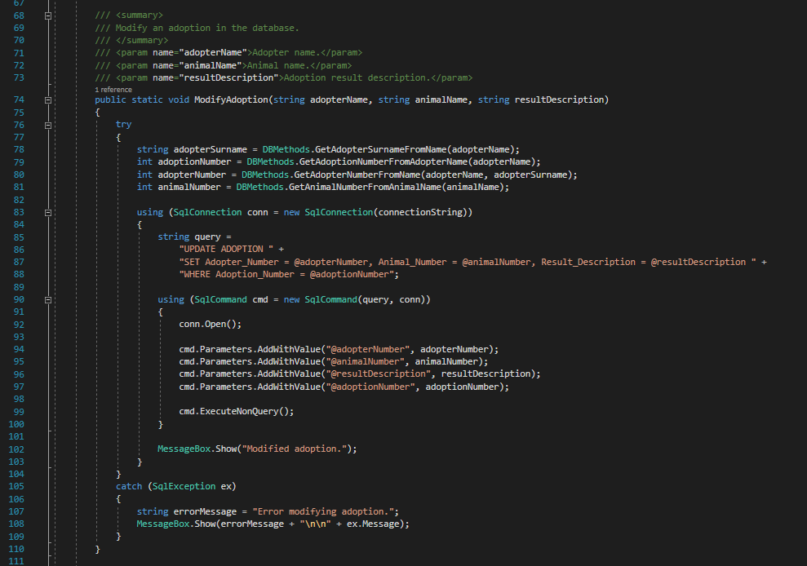

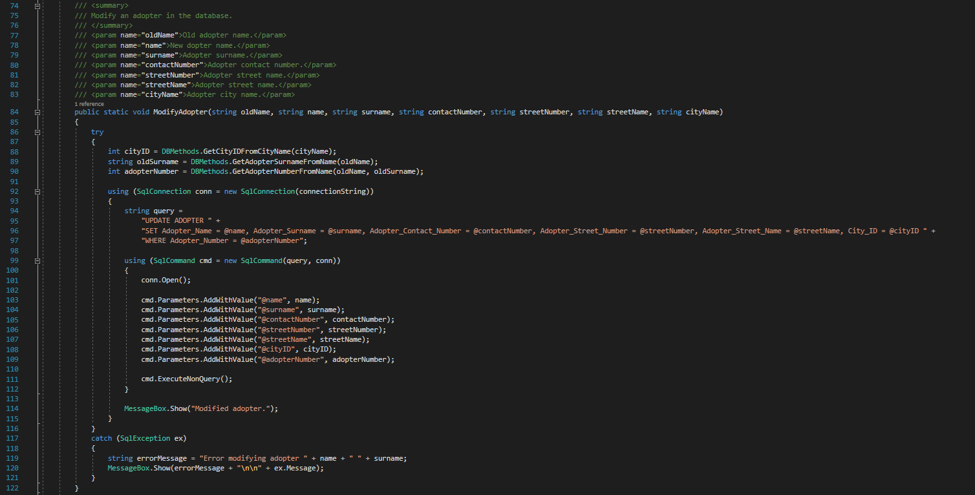

# 6. Reports

Full size images of these screenshots can be found in the Screenshots\Reports folder of the zipped project.

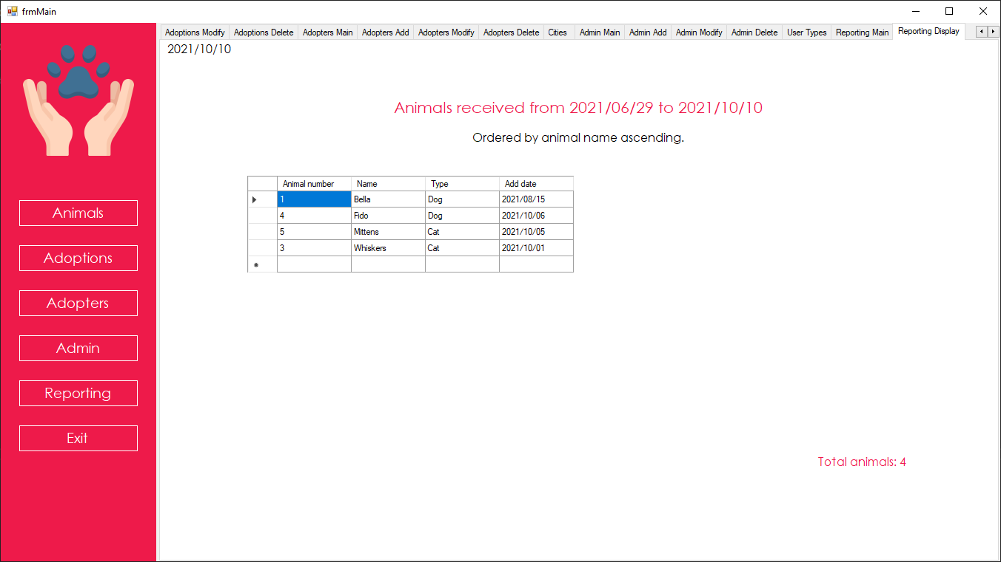

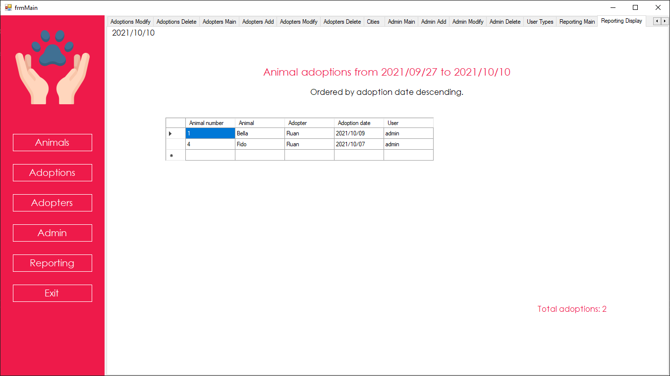

# 7. User Manual

A separate PDF user manual can be found in the Documentation\User Manual folder of the zipped project.

New Hope Foundation

Adoption Manager



User Manual

Getting Started

Installation

|  |  |
| --- | --- |
| 1. | Run the Setup.exe file. |
| 2. | Click the Install button. |
| 3. | The NHFAM application installation window will open. |
| 4. | Click the Next button. |
| 5. | Select the installation location and whether the application will be installed for all users. By default, the application installs into the current user’s local app data folder. Please note that if this location is changed, the user will need administrative rights to run the application, or an administrator needs to give all required users full permissions on the installation folder. |
| 6. | Click Next to begin the installation. |
| 7. | Click the Close button. |
| 8. | The SQL Server Express 2019 LocalDB installation window will open. |
| 9. | Click Next. |
| 10. | Accept the license agreement and click Next. |
| 11. | Click Install. |
| 12. | Click Finish. |

Note: .NET Framework 4.8 must be present on the system for the application to install. If it is not present, install it using the ndp48-x86-x64-allos-enu.exe setup file.

The default credentials are:

Username: admin

Password: admin

Please change these default credentials as soon as possible to secure the system.

The source files can be found on GitHub: https://github.com/Tanaille/cmpg223-project

Uninstall

|  |  |
| --- | --- |
| 1. | Close the application. |
| 2. | Open the control panel. |
| 3. | Select the New Hope Foundation Adoption Manager application from the list. |
| 4. | Click the uninstall button to remove the application. |

System Requirements

|  |  |
| --- | --- |
| Operating System | Microsoft Windows 7/8/8.1/10 |
| Dependencies | Microsoft .NET Framework 4.8 |
| Processor | Intel Celeron 2.8GHz or greater |
| RAM | 2GB RAM |
| HDD | Install size: 100MB  Database: 1GB minimum recommended |
| Network | N/A |

# 8. Detail Diary

As I was the sole person working on this project, the detail diary will only consist of my own contributions. Full size images of these screenshots can be found in the Screenshots\Detail Diary folder of the zipped project.

