**Project Deliverable 3 – User Manual**

**Faculty Name:** Information Technology

**Module Code:** ITECA3-B12

**Module Name:** Web Development and e-Commerce

**Content Writer:** Sandile Dlamini

**Copy Editor:** Mr Kyle Keens

**Submission Date:** Block 2 Week 5

|  |  |
| --- | --- |
| **Student Name** | Tanaka Augustine Zuze |
| **Student Number** | GLLX38ZS3 |
| **Project Title** | User manual |
| **Submission Date** | 2024/06/21 |

**Table of Contents**

3.1 Introduction 3

3.2 Basics: Accessing your website and Admin 4

3.3 Products: Adding, removing, and updating products 5

3.4 Shipping Options 5

3.5 Orders 5

3.6 Updating a page on your site 6

3.7 Collecting money from the store 6

3.8 Checking Web Traffic and Statistics 6

3.9 Appendix 6

3.10 References 7

# Introduction

**3.1.1 Background**

An online store called Deli.Aslan that specializes in art that has been carefully crafted by the gifted Lukhanyo Ngxeke. The website makes use of a strong technology stack, which includes JavaScript for interactive features, HTML for structure, CSS for styling, and PHP for server-side scripting. I was able to test the website locally using XAMPP. The administration dashboard makes it easy to manage orders, merchandise, clientele, and website content. The products are dynamically loaded; a load-more function allows for scalability after the initial display of 18 items. Weight-based shipping choices are computed dynamically throughout the checkout process. User experience is improved, and marketing tactics are informed by payment choices and traffic metrics, which are tracked by Google metrics.

**3.1.2 About this website**

The Deli.Aslan site is an ecommerce site that sells artwork that are designed by the artist. The type of art range depends on the artist because he is multitalented, and it was not feasible to put him in a box.The technology stack of the site includes:

* PHP
* HTML
* CSS
* JavaScript
* XAMPP

PHP

A powerful server-side scripting language that is designed specifically for web development. It can be embedded into HTML, making it highly suitable for creating dynamic web pages and applications

Html

HTML is the foundation that holds all the content and design elements together. It gives structure to the website

CSS

used to define styles for your web pages, including the design, layout and variations in display for different devices and screen sizes i.e. mobile devices, tablets and smart watches. In today’s world a website must be adaptable to many devices because there just is a wide range of them

JavaScript

JavaScript is a cross-platform, object-oriented programming language used by developers to make web pages interactive. This of course is not its only use it can also be used to generate dynamic content

XAMPP (X-Cross-platform,A-Apache HTTP Server-MariaDB-PHP,P-Perl)

Its widely used by developers to set up a local server on your laptop allowing developers to test web applications locally

# Basics: Accessing your website and Admin

**3.2.1 Accessing the website.**

The user can access the site through the link to the site. The admin can access the admin dashboard through the log in portal that will route the admin to the dashboard. The admin log in details is provided by me and I only share with the admin.I can create more login accounts as per the clients request  
The link to the site: https://deliaslan.000webhostapp.com/

**3.2.2 The Admin Area**

The admin area is the platform where the admin/client can add and update products, manage orders, customer management, manage website content, manage analytics and reports.

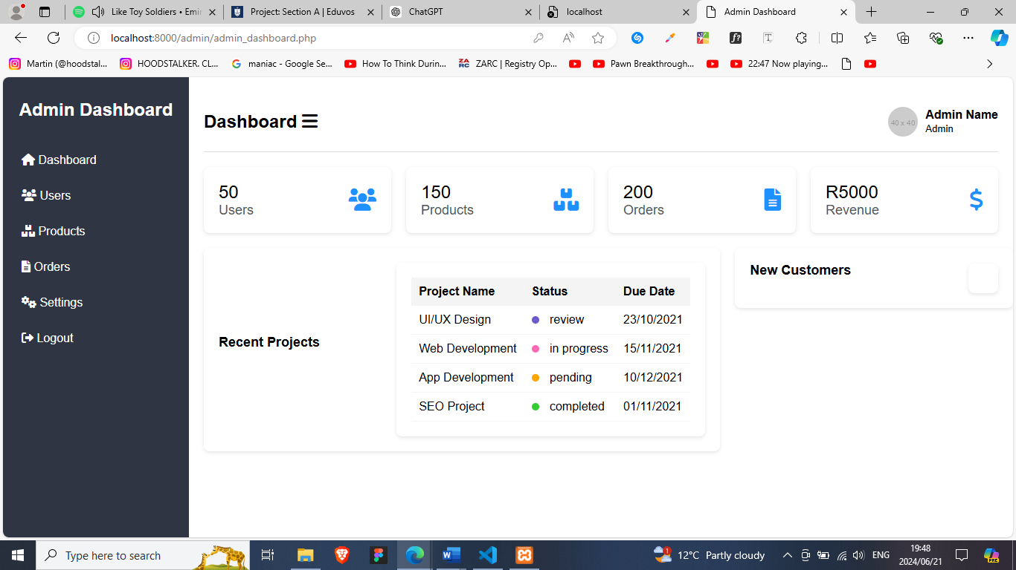

# Products: Adding, removing, and updating products

**3.3.1 Adding and Removing Products**

In the admin dashboard, there is a products page to manage products. To add a product, click the add product button. Fill in the product name, price and product description and click add. The product will then be added to the shopping page.

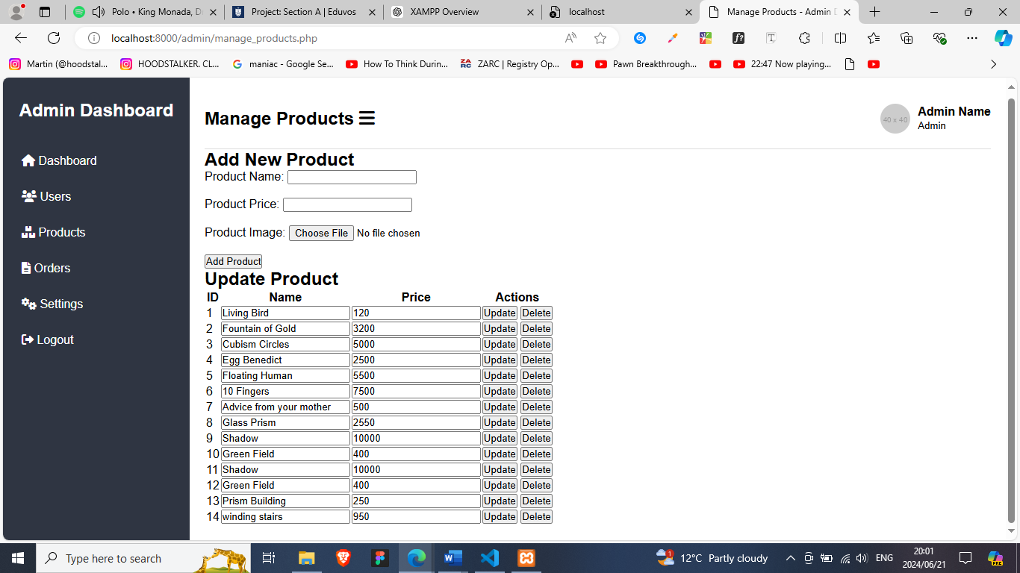

To remove a product the click the delete button, the product will be deleted from the shopping page.

**3.3.2 Updating Products**

To update a product click the update button where the inputs will displayed and update the product name or header, description, price and click update and the product will be updated in the shopping page.

# Shipping Options

Weight based shipping. The total weight of the order is calculated from the cart. I have predefined weight ranges that will determine the prices. The shipping total is dynamically calculated and added to the total order value.

# Orders

When an order is placed it is displayed on the orders page in the admin dashboard. The admin can fulfil the order and once the shipping has begun, they initiate the outgoing order functionality, when the order has been delivered the order is successfully transferred admin clicks a button on the admin dashboard is clicked updating and closing the order.

# Updating a page on your site

Pages are not added but, the products are dynamically coded so that the first 18 products are displayed then a load more button is generated that when clicked will dynamically fetch more products from the database and display them.

# Collecting money from the store

# Checking Web Traffic and Statistics

On this site I used Google Analytics. A web analytics service that provides statistics and basic analytical tools for search engine optimization and marketing purposes. The admin has access to features like:

* Visitor tracking-tracks the number of visitors to the site, geographical locations.
* Behavior analysis-insight into how visitors navigate the site i.e. which pages they visit mostly, how long they stay on a page.
* Traffic sources-show where visitors are coming from i.e. search engine, social media direct traffic, YouTube etc.
* Conversion tracking if the admin has specific goals e.g. how many users signed up this month.
* Performance monitoring-can monitor site performance like how long pages take to load, this information is vital for search engine optimization.

# Appendix

Upload the files to a file manager on a web hosting platform then connect the database, make sure to update the connection with the username and password from the created database connection.

# References

1. Business Analytics. (n.d.). What is Google Analytics and how does it work? | Definition from TechTarget. [online] Available at: https://www.techtarget.com/searchbusinessanalytics/definition/Google-Analytics#:~:text=The%20service%20is%20part%20of [Accessed 21 Jun. 2024].
2. edX. (2023). Learn XAMPP With Online Courses and Programs. [online] Available at: https://www.edx.org/learn/xampp#:~:text=XAMPP%2C%20which%20stands%20for%20Cross.
3. www.google.com. (n.d.). why html - Google Search. [online] Available at: https://www.google.com/search?q=why+html&oq=why+htm&gs_lcrp=EgZjaHJvbWUqBwgBEAAYgAQyBggAEEUYOTIHCAEQABiABDIHCAIQABiABDIHCAMQABiABDIHCAQQABiABDIHCAUQABiABDIHCAYQABiABDIHCAcQABiABDIHCAgQABiABNIBCDc2NjJqMGo0qAIAsAIB&sourceid=chrome&ie=UTF-8 [Accessed 21 Jun. 2024].
4. www.w3schools.com. (n.d.). CSS Introduction. [online] Available at: https://www.w3schools.com/css/css_intro.asp#:~:text=Why%20Use%20CSS%3F.
5. www.youtube.com. (n.d.). Beginners Guide to Google Scholar: Use Google Scholar for Academic Research. [online] Available at: <https://www.youtube.com/watch?v=EevV36TGIE8>