React JS

Tips
- You should create a bunch of small components instead of a handful of big components
  - For reuse ablility

Introduction
It is a library that helps us build user interfaces (UI) from components
Components are small pieces of frontend, that can reassemble to large application

Basics of JSX
- Components combine HTML and logic into a single reusable function
- We write a bunch of functions, and it knows exactly, how to render itself into HTML
  - We write something about logics in JS in that function then combine them with HTML to get a component
- In what we see that function is consist of HTML but it not!
- It’s ‘JSX’ stand for Javascript Syntax Extension
- It allows us to write content that look like HTML inside of JS files
  - But it’s not Exactly HTML or JS
- It (React) uses babel dependency (it’s external library, module or something like express, axios, numpy)
  - Babel will take JSX, turns into real JavaScript

Basic React ‘App’ Structure
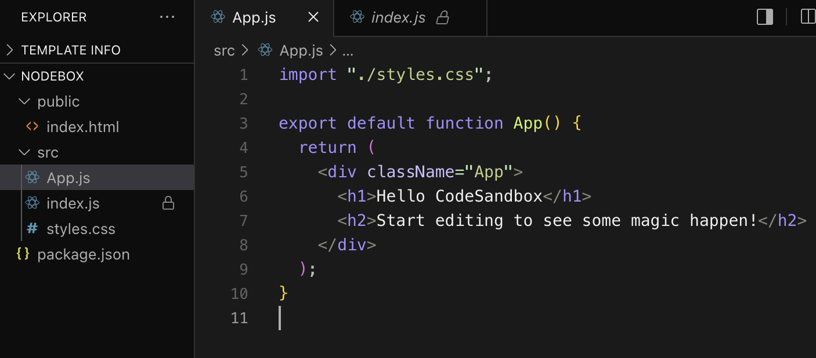
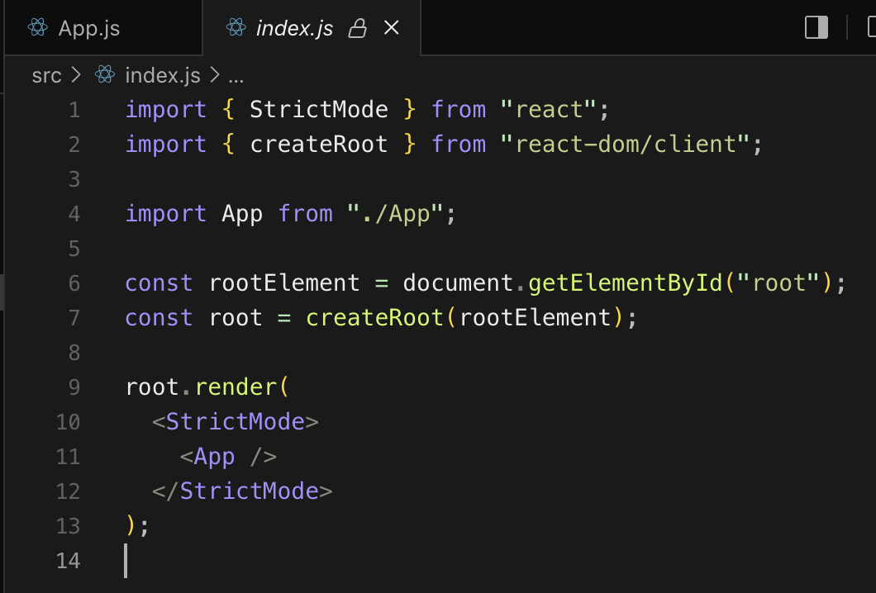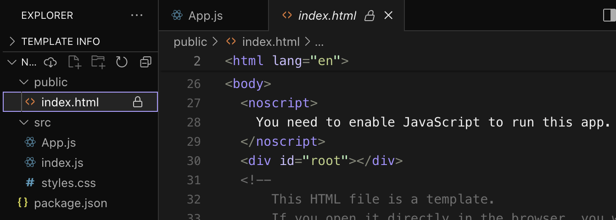
- From the first image, it’s ‘App’ file that’s a component
- And second image we import ‘App’ file, then get ‘root’ id from HTML file then render it into root in index.html in third image

JSX in Detail
Export vs Export default
- Regular export uses for multiple components in that file
  - If that file had multiple export, you must import it with curly bracket and exactly name of those funtions
- Export with default uses for 1 component in that file
  - No need bracket and exact function name, you can name it what ever name you want without curly bracket
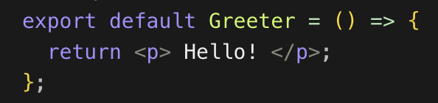
JSX Rules
- You must clearly put the closing element tags (</>)
- A Component can only return a single element <> </>
  - <div> BLAH BLAH </div> <- PASS
  - <div> BLAH BLAH </div> <div> BLAH BLAH </div><- Not pass, you must create a parent tag to cover these tags
  - And return it parenthesis ()
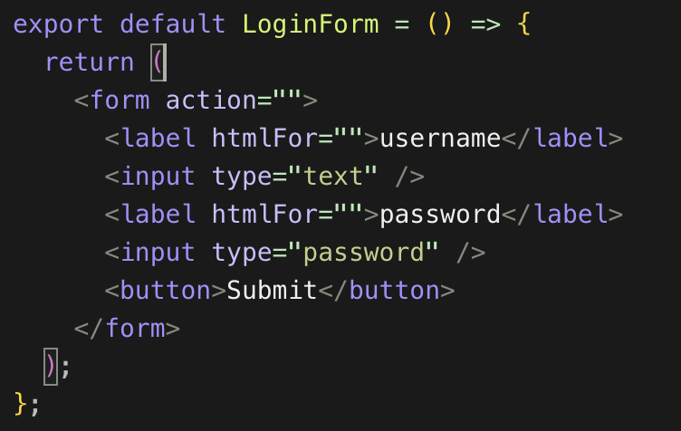
- <> </> <- You can use this to be a parent element
  - From this you will get any html tag, just for the rules and don’t want any tag to bothering you
- We can do it dynamic like this in curly brakets in html tag
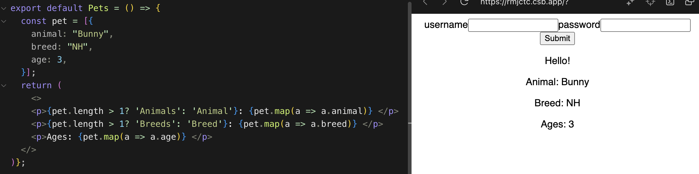
Styling Component
- If you style a component child, it’s not just that component will get style, its parent will get it too
- 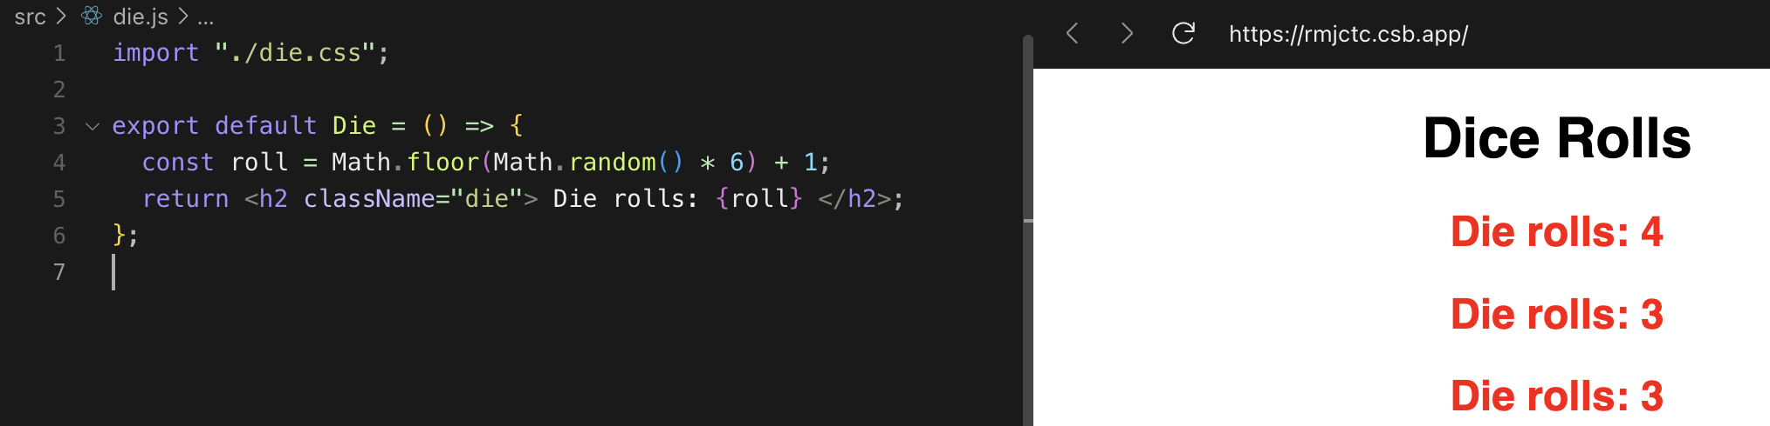
- I have changed this die component with class ‘die’ that consist of color=red
- 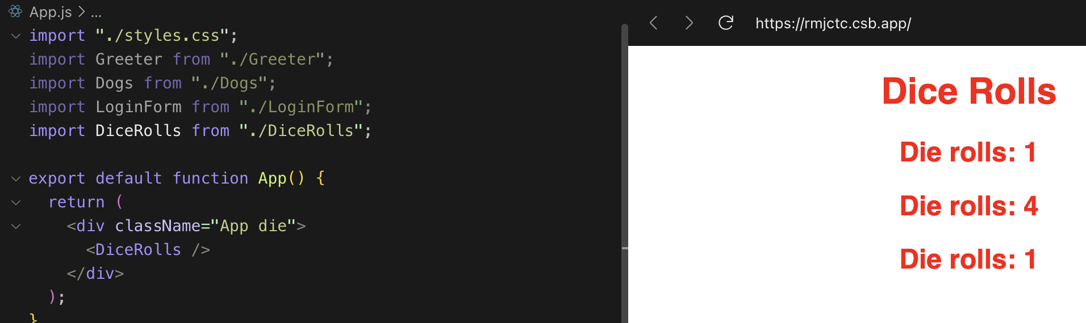
- Then I change the App.js that is this parent component with class ‘die’ to
  - So, it colors also change to ‘red’ without import anything in its file
- And the style, it’s better to split file .css for each file, not only in 1 file with all styles

Creating React App with Vite
installing
- Npm create vite@latest

Props
Introducing Props
- Props allow us to write configurable conponents
- Props are like arguments that pass to each component
- Props are immutable
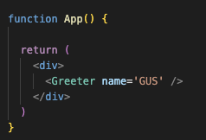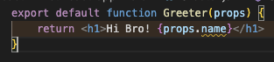
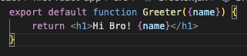
- We have pass a prop in to ‘Greeter’ component, in that component must declare a prop what ever name you want as argument , then you can use that prop
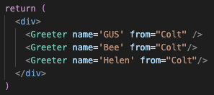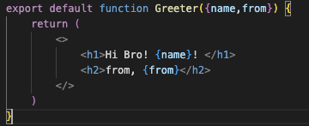
- We use space to pass another prop
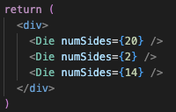
- To pass props as numbers, we must use curly brackets
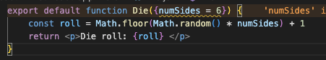
- We can set a default value for prop
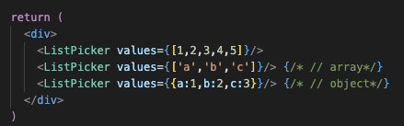
- To pass an object and array
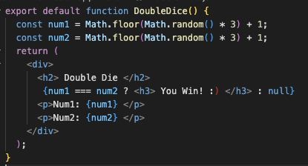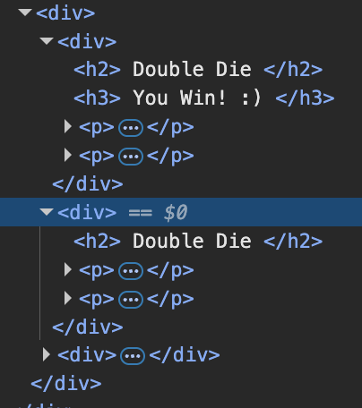
- This don’t relate to propbut it about React Condition
  - From the image it just a condition but from red square. It is to displaying tag when the condition is matched and not showing the tag when it isn’t
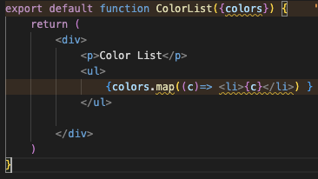
- To rendering an array
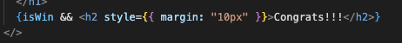
- Shortcut condition, to not ‘{iswin? Show:null}’ < like this

Key Props
- React need a unique Identifier for each element in a list (<li>), so that it can keep track iof that elements if it changes
  - If you don’t touch the list, don’t move, reorder, remove or something it will not error, just warning
  - It will mess up when you change something on the lists or you want it to be dynamic
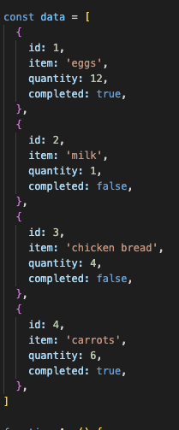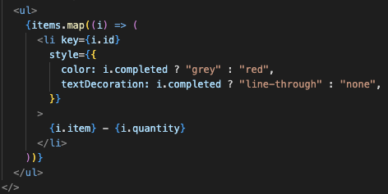
- Data should already its own identifier, we just tell the lists where does this ID lays on, and tell it with key=id
- If in your data doesn’t have any ID, you can use what ever in your data that unique or maybe just make it up
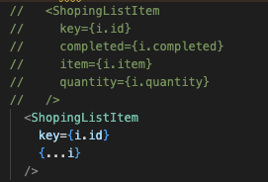
- For sending props you can use spread operator to shorten it up
  - Colt said, the longer version is more understandable when you come back and read this code, and I agree

Props validation
- It’s about es-lint configuration, it froms vite installs
- es-lint
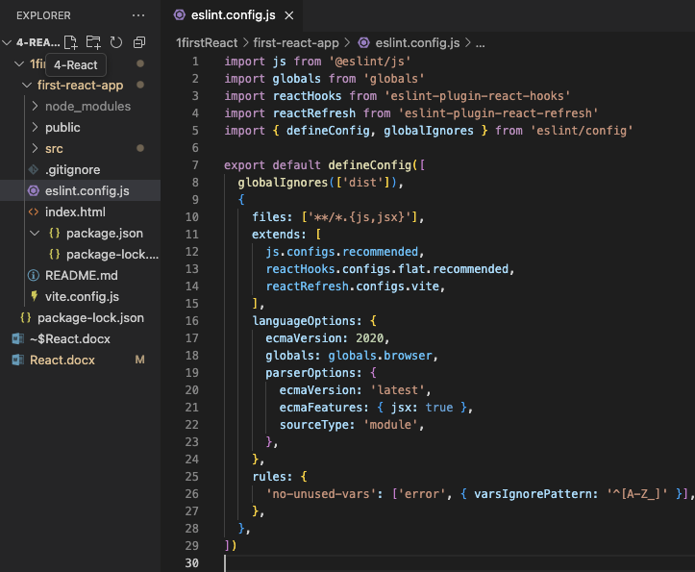
  - it’s a file that tell us about plugins
  - it’s configuring the rules of what eslint should care about, to avoid mistake like if we don’t have a key prop
- So, about props validation that yelling everything like “‘name’ is missing in props validation” will shut up
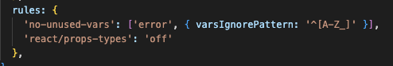
  - This is like typescript, but it’s not
  - Because we will not define the types on any props yet
  - We will do it with typescript
- Or you can use it like this
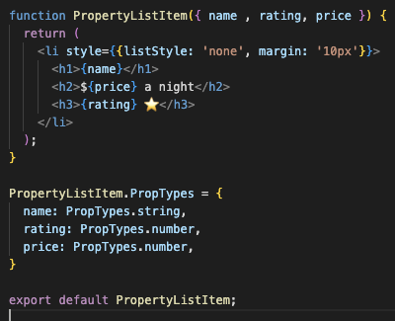
Events
Introducing Events
- For user interface interaction
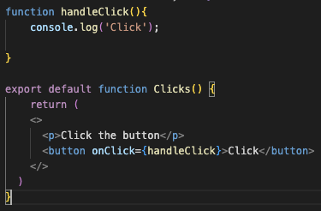
- This is how we do with event in the world of react
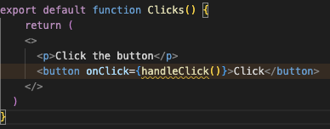
- And we don’t do this in function, if we do function with parentesis this will execute inmediately we want to click to trigger, not the reload page, so we just pass the name of the function, and that’s it
- We do camel case with on and we will use that event, like className
- Event Exercise
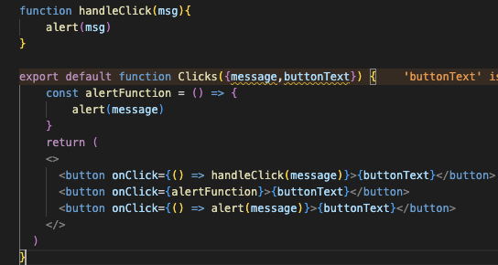
State
Introducing State
- Data that can change within a component, change instancely
- It’s not like props, because props cannot change, but state is
- It can do with everything that can change
  - API fetches
  - UI
  - Values
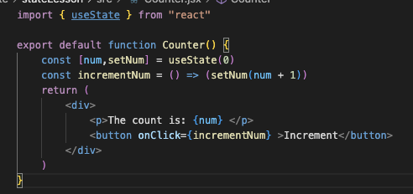
- To using State and the Rules
  - To create a state, we must call a hook of ‘useState’ and import it
  - In useState argument is a default value, we must must set this value
  - State returns us an array, contains 2 elements
    - Index[0] = state variable that keep the value
    - Index[1] = a function to change the state value in variable(index[0])
  - We can speard an array into 2 elements like the image or you can use it with an array and use index instead (this method unpopular)
  - You muse call useState inside a component, you can’t declare it at top level

UseState() & Rendering
- State when it’s changing value, react will rerender the whole component functions
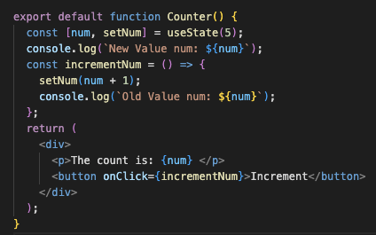
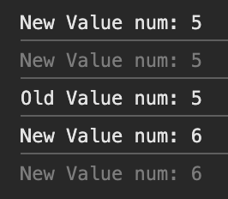
- From this about the state renderer (Important)!
  - The only way you get a new num value(state) is when the line useState executed
  - From the beginning log ‘New value num’ is set to 5, because of default value
  - Then when I clicked and then event goes to trigger the ‘incrementNum’ function, this function will go to call ‘setNum’ function
  - ‘setNum’ function is not execute instantly it will tell the React, this state is going to update next round
  - Then from the yellow line, everything in that round will be going to excute first and ‘num’ is still the same value as default (5) it’s not update yet, see in the yellow line
  - When all lines have executed in that round, React will call or rerender Counter() or this component again
  - And the line on ‘useState’ will execute, State will restore the latest value to ‘num’, then ‘num’ will be the new value on this round, see in the red line
  - This is all about the render cycle, that you must understand what’s going on here

Updater Function
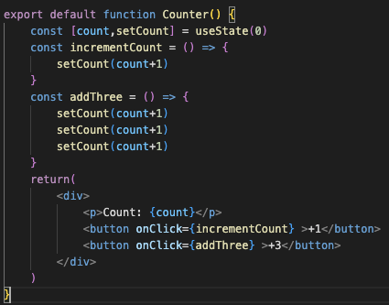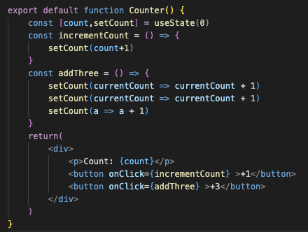
- From these Image, we want to sum up count to 3 by using funtion ‘addThree’ and it contains ‘setCount’ 3 times
- Left image
  - From the image, as the previous section. Count will change when it goes to next round
  - So, from this method we will get ‘count’ as result = 1
  - Count doesn’t change. it’s 1 to all lines.
  - Count will change when it goes to next round, this round count = 0
  - React has queue them like
    - Round 1: set count + 1 = 0 + 1 = 1
    - Round 2: set count + 1 = 0 + 1 = 1
    - Round 3: set count + 1 = 0 + 1 = 1
    - In the end of this round, state send this value to count = 1
- Right Image
  - We should do this, all the time we set state on any project
  - This is the updater function
  - The left side (green square) it’s ‘previous value’ or ‘current value’ call it what ever, it will keep the previous value at it
  - The right side (purple square) it’s the result and the next value
  - This will sent value to another updater function to all functions in this component
    - No matter the name is, it can still send to other
  - React has queue them like this
    - Round 1: set currentCount + 1 = 0 + 1 = 1
    - Round 2: set currentCount + 1 = 1 + 1 = 2
    - Round 3: set currentCount + 1 = 2 + 1 = 3
    - In the end of this event, and go to next round, from this ther state will set the count value to 3
    - But you must know this, the currentCount literally change but count hasn’t changed yet in this round
- React has queue to all states, sum all up and set it to next round
  - To decreasing rerender
  - In 1 event state, sum all of it and send it to next round just 1 time

State initializes
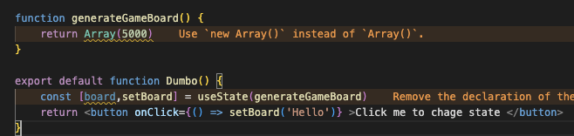
- From this initializes without parenthesis, useState will run 1 time in first time load
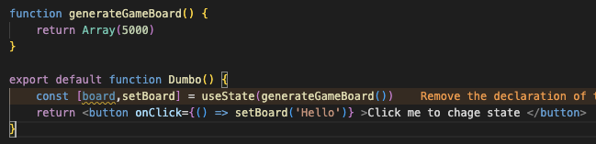
- From this initializes with parenthesis, useState will run every time when state changes

React re-render
- 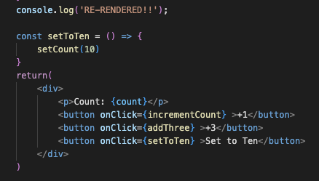
- From this ‘setToTen’ function
- As we know, when state is changed, component will rerender every time it changes right? But from this we have set the state to 10, 10 is number it’s constant
- React will rerender it when we click the button 3 times, and the last fourt time it will not rerender anymore. It will check, is this state changed? if it didn’t then React will not rerender it although we assign the value into state, but it’s the same value

Working with Object and Array in React
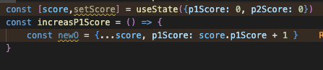
- Object
  - To working with object in state, we must do like this
  - Object in state can not assign values directly, we have to use this concept
  - This concept is speard operator that is take the object assign a new value to the same key, then copy it to new object and assign it back to state
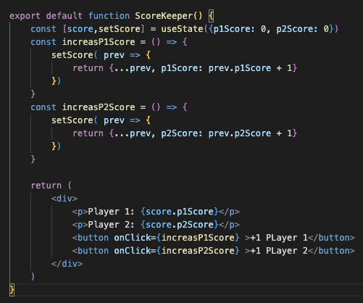
- Array
  - Also in Array, we use Spread operator
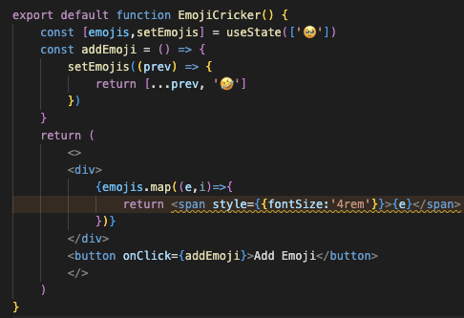
- Remember this concept to work with Array and Object we must copy it and assign it back, not assign it directly
- to remove warning key by not using index as its key
  - using UUID
  - npm I UUID
  - 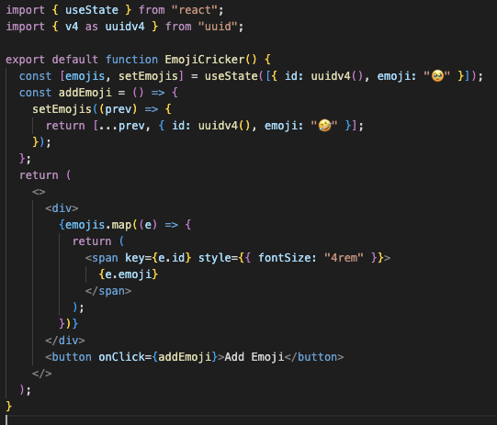
- Delete elements in array
  - To delete something from array, we just filter out that id, then get a new array and set a new array to state

Component Design
Goals
- to understand stategies for ‘component decomposition’
- Practise designing a React app
- Learn how to pass functions between components

Data flows (React commons pattern)

