YELPCAMP

Middleware
Concept of Middleware
- Middleware are just functions
- It stands between request (req) and response (res) in a web service
- It can check all requests incomming, before sending to other middleware or route
  - It is a guard at the pub’s entrance, that checks all guests (req)
  - The guard (middleware) gonna check their ID card
    - He can appove them to go the pub, let them go to their reserved table (route), or reject them
  - They will stamp your wrist
    - The stamp will be:
      - To tell other guard (middleware) that person’s authenticated
      - This req has been parsed
      - Or this person is VIP guest (President, admin)
  - They will send their guest (req) to other guard or their table (next middleware or route)
    - By next() function
    - Req,res,next()
Morgan Logger
- Npm I morgan
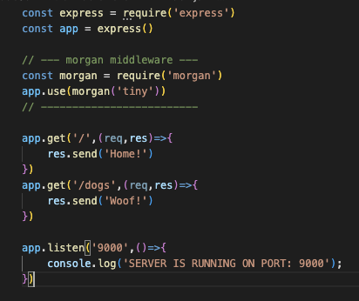
- It’s a logger middleware
  - logger middleware: a middleware that record what’s happening for each request
- Morgan middleware, it’s like CCTV that log every step from request, every route
  - HTTP method: GET POST …
  - Which URL
  - Status code
  - Response time
  - Date & time
  - User agent
- With app.use(), to check every request, so we put Morgan in there
- Comman morgan formats
  - ‘dev’: colorful
  - ‘tiny’: just basic info.
  - ‘combined’: log file, Apache-style logs
Defining our own middleware
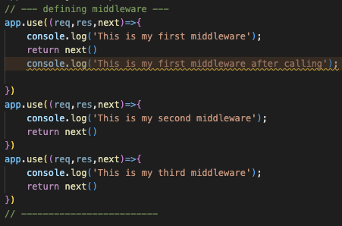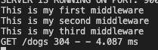
- I’ve done it in app.use(), from req, res just appends next to them
- After end of app.use we have to use next() to go next middleware or route
- And next() we don’t need to return next(), but in this example we add it to prevent the code after next() (This is not common and shouldn’t do it affter ‘next’ function)

Upload
- We need to install ‘NPM I Multer’ for receive multiple files
  - We can parse JSON, parse URL encoded from form
  - It adds file(object) or files(array) to req
- We need to store images somewhere like cloud or local
  - In demo we use cloud (cloudinary)
  - In real situation it’s up to where is your server, if there is a server you can store in it by using local storage(server)

