Summary:
- Fraction math review
  - Terms for parts of a fraction
  - How to multiply and divide fractions
- Canceling out factors and labels
  - When fractions are multiplied, if a factor (or a label) occurs in both the numerator and the denominator, they cancel out
- Scientific notation
  - Know how to convert between standard and scientific notation
  - Remember that a positive power is associated with a large number (greater than 10) and a negative power is associated with a small number (less than 1)
- Correct use of a calculator
  - Use the correct scientific notation button on your calculator to avoid errors
  - Know when to use parentheses
- Algebra review
  - Use opposite operations to isolate your variable of interest

Section 1: Fraction math review
Fractions play a key role in science because they allow us to use ratios in our calculations. In chemistry, they have many uses as we’ll see if upcoming chapters and exercises. The most common math that we do with fractions in chemistry is multiplying and dividing them. To carry out multiplication of fractions, we simply multiply together all of the values in the numerators (the top of the fraction), keeping the product in the numerator of the final answer, and then do a similar operation with the denominator (the bottom of the fraction).
Multiplication of fractions example 1:
$$\frac{2}{3}×\frac{7}{3}=\frac{2×7}{3×3}=\frac{14}{9}$$
Multiplication of fractions example 2:
$$\frac{a}{b}×\frac{c}{d}×\frac{e}{f}×\frac{g}{h}=\frac{a×c×e×g}{b×d×f×h}$$
Dividing fractions is similarly quite easy to do. In a division problem, the first number is the dividend (the number being divided) and the second is the divisor (the number that the dividend is being divided into). Division of fractions can be expressed in multiple ways
$$\frac{4}{3}÷\frac{7}{8}=\frac{\frac{4}{3}}{\frac{7}{8}}$$
Please note that the dividend is the numerator in the fraction expression and the divisor becomes the denominator. To complete this division problem, we simply need to flip the divisor and multiply that value by the dividend.
$$\frac{4}{3}÷\frac{7}{8}=\frac{4}{3}×\frac{8}{7}=\frac{4×8}{3×7}=\frac{32}{21}$$

Exercise 1: Fraction math review
- Fraction math. Do the following math problems without a calculator.
- $\frac{7}{3}×\frac{4}{3}=$
- $\frac{2}{3}×\frac{7}{2}×\frac{3}{5}=$
- $\frac{4}{3}÷\frac{3}{4}=$
- $\frac{a}{b}÷\frac{c}{d}×\frac{c}{a}=$
- $7×\frac{5}{3}÷9=$
Section 2: Canceling out factors and labels in calculations
Another VERY important lesson to remember about fractions is that if the numerator and denominator both contain the same factor, then they cancel out. This is true for both numbers in the fractions but also for labels like units. See the examples below:
Example 1: $\frac{4}{3}×\frac{3}{7}=\frac{4×3}{3×7}$ (the 3s cancel out) $=\frac{4}{7}$
Example 2: $4 miles\left(\frac{hr}{10 miles}\right)=\frac{4 miles×hr}{10 miles}$ (the “miles” labels cancel out)
$$=\frac{2}{5}hr$$
Exercise 2: Canceling out factors and labels in calculations
- Simplify the following expressions without using a calculator.
- $\frac{7}{5}×\frac{15}{14}$
- $\frac{7}{3}÷\frac{7}{9}$
- $\frac{x}{y}×\frac{z}{y}×\frac{y}{z}$
- $50km×\frac{hr}{10km}×\frac{60min}{hr}$
Section 3: Scientific notation
In chemistry, we frequently have to make use of very large numbers (e.g. when we’re discussing numbers of atoms) as well as very small numbers (e.g. the weight of an atom). We have a couple of strategies that make this much more palatable for us. One such strategy is to have different units of measurement for discussing large numbers vs. small numbers. The other common approach is to use scientific notation. Ultimately scientific notation is required, even if we use different units, because we still need to use very large (or small) numbers to express the relationship between these different units. For example, if we are talking about the distance across an atom, a common unit of measurement is an Angstrom. A hydrogen atom has a diameter of approximately 1.1 Angstroms. But how many inches is that? In order to convert between units of Angstroms and inches we’d have to know that 1 Angstrom = 0.00000000394 inches. Working with that number is obviously obnoxious, requiring us to count exactly how many zeroes there are. To get around this, we like to use scientific notation.
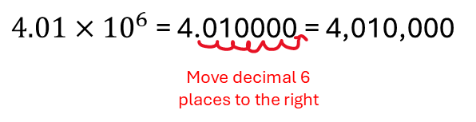
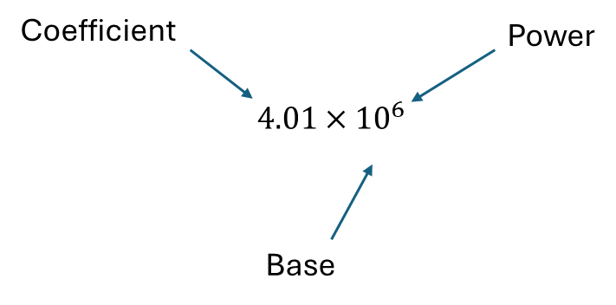
To write a number in scientific notation, we combine a coefficient with a base. The coefficient is always a number that is greater than or equal to 1 and less than 10, and is written as a decimal. The coefficient is then multiplied by the base which is 10 raised to some power. A positive power makes the coefficient larger by moving the decimal in the coefficient to the right by the number of digit places given by the number in the power.

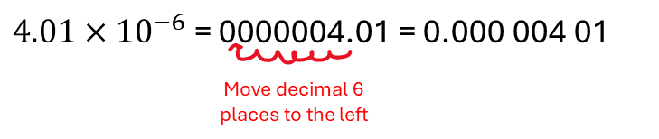
Conversely, a negative power makes the coefficient smaller by moving the decimal in the coefficient to the left by the number of digit places given by the number in the power.
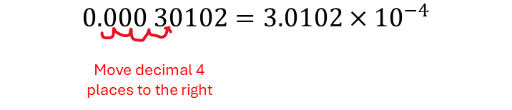

We also have to be able to take a number that is written in standard notation and rewrite it in scientific notation. To do this, we move the decimal point in the direction that will result in a coefficient that has a value between 1 and 10. We count the number of digit places that we moved the decimal and that becomes the value in the power. If we moved the decimal to the left, then the power remains positive. If the decimal had to be moved to the right, then the value in the power becomes negative.

One of the things that often confuses students about scientific notation is remembering when to move the decimal to the right or the left. These rules can be summed up by remembering the simple rule that big numbers have positive powers and small numbers have negative powers. Remembering this rule can help you determine for yourself whether you should move the decimal right or left.
Exercise 3: Scientific notation
- Do the following math problems without using a calculator.
- Write the following numbers in scientific notation.
    - 3,001.002
    - 5,000,005
    - 10,055,057,001
    - 0.000 057 8
    - 0.08
    - 0.000 000 007 044
- Write the following numbers in standard notation.
    - $4.4×{10}^{9}$
    - $4.993×{10}^{2}$
    - $4.993×{10}^{-2}$
    - $9.0×{10}^{3}$
    - $7.000 01×{10}^{-3}$
    - $4.4×{10}^{-7}$

- Do the following math problems using your calculator. You probably have a SCI and DEC button or mode on your calculator. If you need help figuring out how to do these on your calculator, please reach out to your instructor or find an online tutorial that is specific to your calculator model.
  - Write the following numbers in scientific notation.
    - 3,001.002
    - 5,000,005
    - 10,055,057,001
    - 0.000 0578
    - 0.08
    - 0.000 000 007 044
  - Write the following numbers in standard notation.
    - $4.4×{10}^{9}$
    - $4.993×{10}^{2}$
    - $4.993×{10}^{-2}$
    - $9.0×{10}^{3}$
    - $7.000 01×{10}^{-3}$
    - $4.4×{10}^{-7}$

Section 4: Scientific notation and calculators
Doing multi-step calculations often leads to errors. These errors often result from incorrect calculator usage. It is important to make sure that you are correctly inputting scientific notation into your calculator. Often the correct way to do this is using the EE button on your calculator. If, on the other hand, you input scientific notation using the times button and then your exponent button, you may inadvertently input the incorrect math problem. See the example below:
$\frac{4.1×{10}^{3}}{3.3×{10}^{10}}=?$
Correct input: 4.1 EE 3 “divided by” 3.3 EE 10 = $1.2×{10}^{-7}$
Incorrect input: 4.1 “times” 10 ^ 3 “divided by” 3.3 “times” 10 ^ 10
This incorrect input above is actually calculating the following: $\frac{4.1×{10}^{3}}{3.3}×{10}^{10}$
Another way that you can correctly input scientific notation is to put parentheses around each of your scientific notation inputs. This allows you to input the scientific notation using whichever method you’d prefer.
Alternative correct input: ( 4.1 “times” 10 ^ 3 ) “divided by” ( 3.3 “times” 10 ^ 10)
Another important calculator rule to remember is that when we write complex fractions, all of the operations in the numerator and denominator respectively are carried out before the division step. This is correctly input into a calculator by remembering to put parentheses around both the numerator and denominator. See the example below:
$$\frac{7+3}{5.5×{10}^{3}+100}=?$$
Correct input: ( 7 “plus” 3 ) “divided by” ( 5.5 EE 3 “plus” 100 ) = $1.8×{10}^{-3}$

Exercise 4: Scientific notation and calculators.
    - Complete the following problems using your calculator.
- $\frac{4.331×{10}^{-30}}{1.05×{10}^{10}}$

- $9.1×{10}^{3}+\frac{8×{10}^{3}}{2.2×{10}^{-1}}$

- $\frac{8×{10}^{3}}{2.2×{10}^{-1} × 4.4×{10}^{3}}$

- $\frac{8×{10}^{3}}{2.2×{10}^{-1}+ 4.4×{10}^{1}}$

Section 5: Algebra review
The final part of this math review is a brief review of algebra. We use algebra to rearrange mathematical expressions to solve for some unknown. There are two things to remember when doing algebraic rearrangements. First, our goal is to isolate the variable of interest, remembering that it must be in the numerator if we’re dealing with fractions. Second, the way in which we will isolate the variable is by carrying out opposite operations to both sides of the equation. See the examples below:

Example 1: $\frac{x}{4}=7+3 → \frac{x}{4}×4=\left(7+3\right)×4→x=40$
(to isolate x we multiply by 4 because multiplication is the opposite operation to dividing by 4)

Example 2: $\frac{7}{x+3}=10 → \frac{7}{x+3}×\left(x+3\right)=10×\left(x+3\right) → 7=10x+30 →$
$$7-30=10x+30-30 → -23=10x → -\frac{23}{10}=\frac{10x}{10} → -\frac{23}{10}=x$$
(First we want to isolate x, but x needs to be in the numerator. We can fix this by multiplying both sides by the denominator “x+3”). We then use the distributive property to simplify the expression. Now we have 10x+30. The +30 must be removed first by subtracting 30. At this point we have 10x and can remove the 10 by dividing by 10 on both sides.)

Exercise 5: Algebra review.
- For the following problems, solve for the value of c. In some cases your solution will be an expression rather than a number. Write out all of your steps
- $\frac{3}{5}×c=\frac{9}{10}$
- $\frac{9}{5}c+50=105$
- $\frac{P}{c}=\frac{T}{X}$
- $\frac{c+3}{4}=\frac{7}{4}+1$
- $c×\left(\frac{5km}{hr}\right)=100km$

Key:
Exercise 1:

- 28/9
- 42/30=7/5
- 16/9
- (adc)/(bca)=d/b
- 35/27
Exercise 2.

- 3/2
- 3
- x/y
- 300min
Exercise 3:

- $3.001002×{10}^{3}$
- $5.000005×{10}^{6}$
- $1.0055057001×{10}^{10}$
- $5.78×{10}^{-5}$
- $8×{10}^{-2}$
- $7.044×{10}^{-9}$

- $4,400,000,000$
- $499.3$
- $0.04993$
- $9000$
- $0.007 000 01$
- $0.000 000 44$
Exercise 3, problem 2: Same as problem 1
Exercise 4:

- $4.125×{10}^{-40}$
- $4.546×{10}^{4}$
- $8.264$
- $180$.9

Exercise 5:

- 3/2
- 275/9
- $\frac{PX}{T}$
- 8
- 20 hr

The numerator is the top of a fraction
The denominator is the bottom of a fraction
The coefficient is the leading part of scientific notation. It should always be a number between 1 and 10 and should be written as a decimal.
The base follows the coefficient in scientific notation. It is multiplied by the base. It is always 10 raised to some integer power.

