**Introduction:**

As defined by IBM, a “Virtual Machine” is a fully protected and isolated copy of the underlying physical machine’s hardware. A virtual machine can be used in place of having a dedicated physical machine to write and test programs without crashing physical machine.

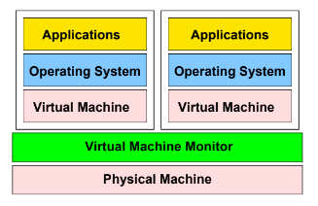

Figure 1: Represents traditional organisation of virtual machine.