**Overview**

**Input-Output Interface**

Peripherals connected to a computer need special communication links for interfacing with CPU. In computer system, there are special hardware components between the CPU and peripherals to control or manage the input-output transfers. These components are called **input-output interface units** because they provide communication links between processor bus and peripherals. They provide a method for transferring information between internal system and input-output devices.

## **Modes of I/O Data Transfer**

Data transfer between the central unit and I/O devices can be handled in generally three types of modes which are given below:

1. Programmed I/O
2. Interrupt Initiated I/O
3. Direct Memory Access

This part of I/O control deals with the communication of hardware. It generally contains some communication ways which are highlighted above: The subtopics covered are:

* **Buses**
* **Registers**
* **Polling**
* **Memory Mapped I/O**

-Introduction

-How data is accessed

-How it Works

-Communicating with Keyboard

* **Direct Memory Access (** DMA block diagram**)**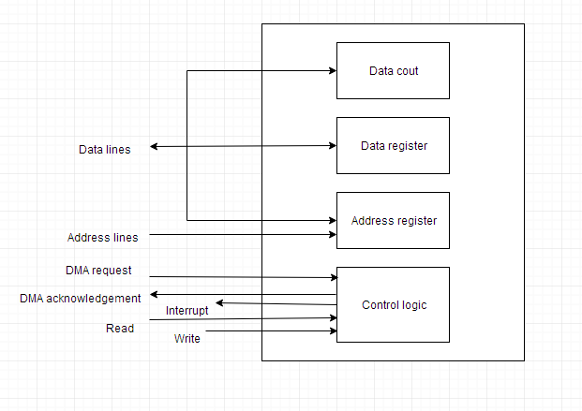

-Definition and Working

Made By : Om Katiyar (Enrollment No. : 18116057)