**LOVELY PROFESSIONAL UNIVERSITY**

**CSE-326**

***Project report on:-***

**"Online Flight Reservation System"**

**Section: -** K19HZ

**Submitted to: -** ManuBali

**Group Members: -**

1. Tanay Agarwal---(54)
2. Mohammad Musheer Anwar---(55)
3. Anand Kumar Jha---(56)

OUTLINE:

* INTRODUCTION
* CONCEPTS USED
* DIAGRAM
* SCREENSHOTS OF WEBSITE
* DESCRIPTION
* WORK DONE BY MEMBERS
* CONCLUSIONS
* BIBLIOGRAPHY

**Introduction:-**

In this project we are going to create an online Flight Reservation system site using HTML.

We are going to create the Website as per the Design given by the Teacher, which includes: -

* Home Page which will provide all the necessary view.
* Login and Signup link which will redirect the user to the new tab.
* About us will give the details of the site owner and contact

details.

* Different tabs for more functions like: -
* Booking flight ticket for one way and round trip.
* Dashboard which will give the account status.
* Check live status of flight.
* It also shows about all the facilities provided by our airlines.
* Booking section will allow the user to complete their ticket

booking process and make the transaction using various

payment methods like online banking, debit/credit card,

wallets etc.

**Concept:**

* We have use the concept of HTML programming like:-

Hyper link redirection.

* Use of different tags to make it more interactive like font , table, listing, hyperlink, styling etc.
* We use: -

1. Combo box
2. checkbox
3. radio button
4. reset and submit button
5. text field
6. labels

This project is basically an online ticket manager where one can book ticket of all the flight of all the airlines, also the user can check the current status of their booking and can also keep track of

real time location of their flight.

All designing and programming are done by us.

All the member has their role in creating this website in HTML language.

**Diagram**: -

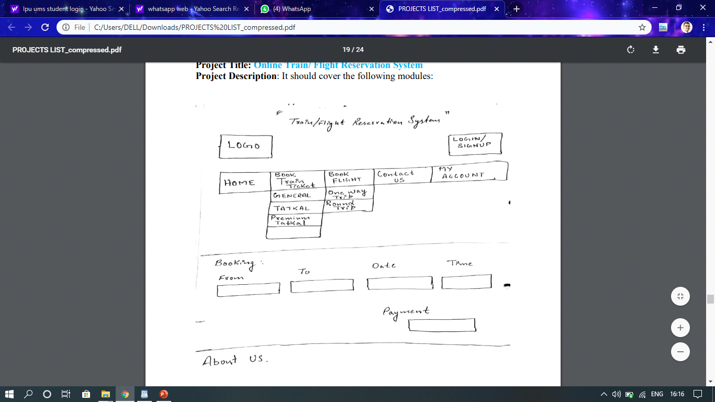

**Screen shots from website:-**

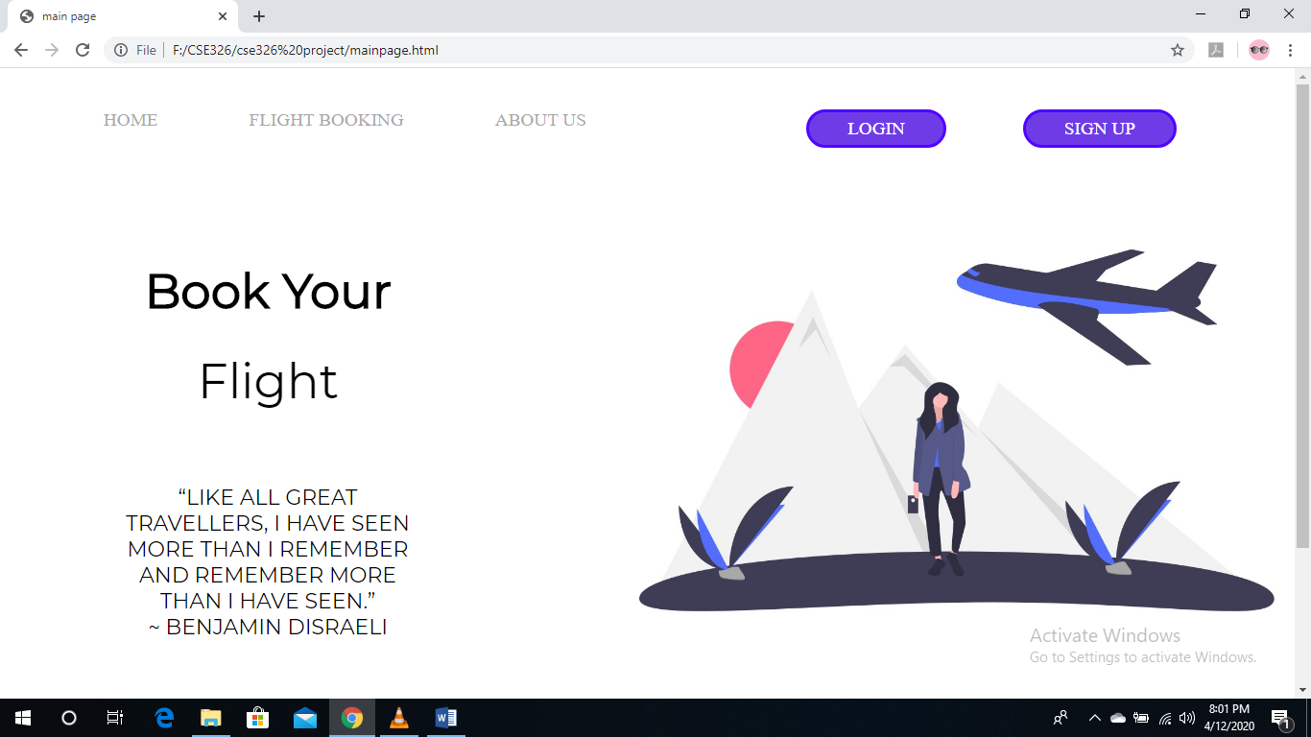

1. Main Page

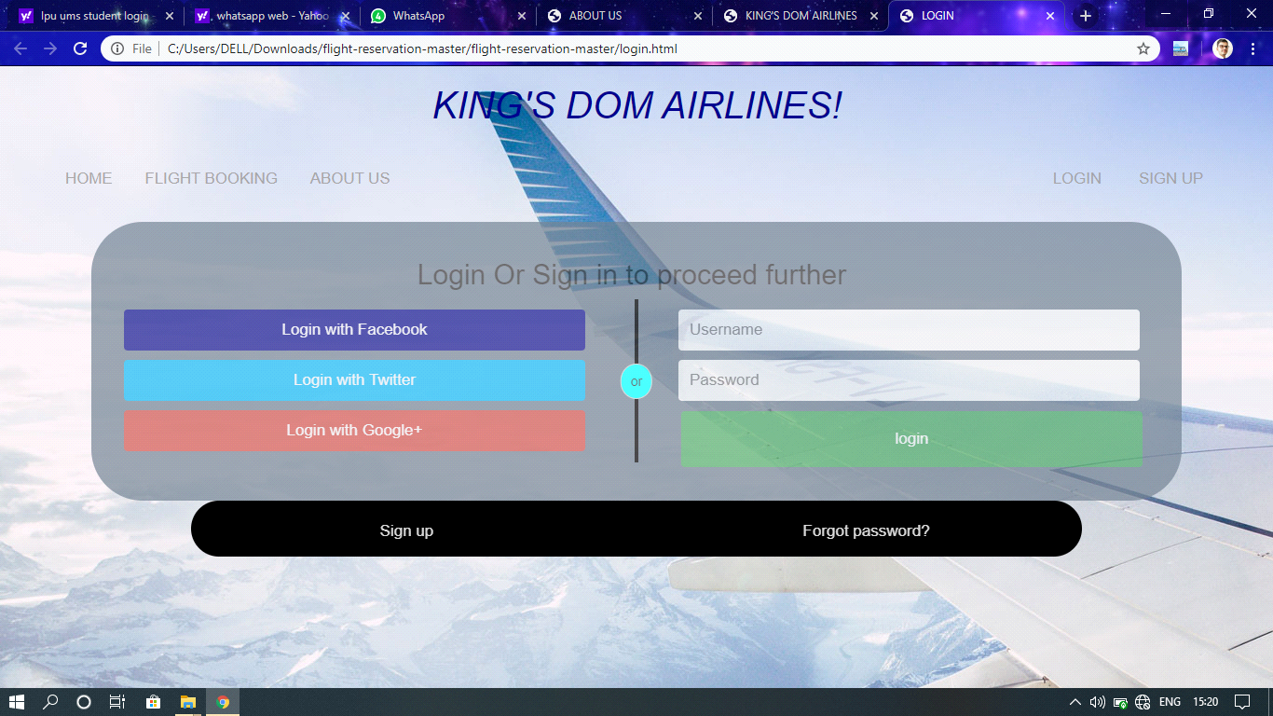

2. Login Page

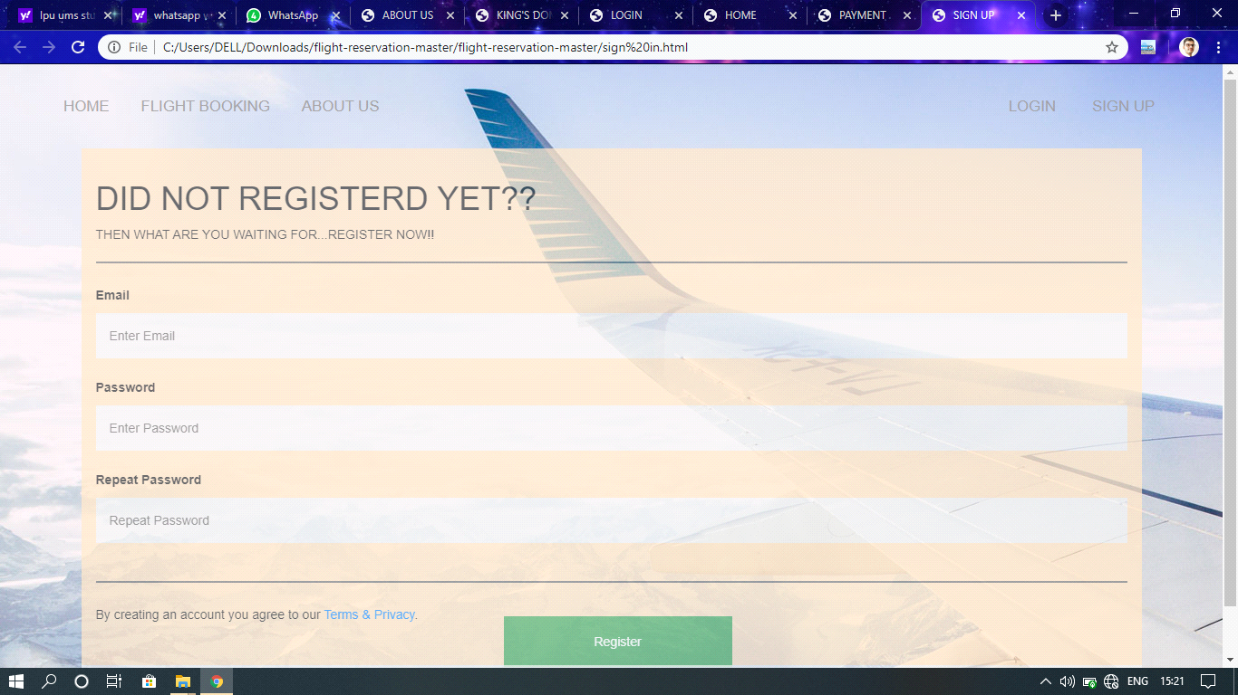

3. Sign-up Page

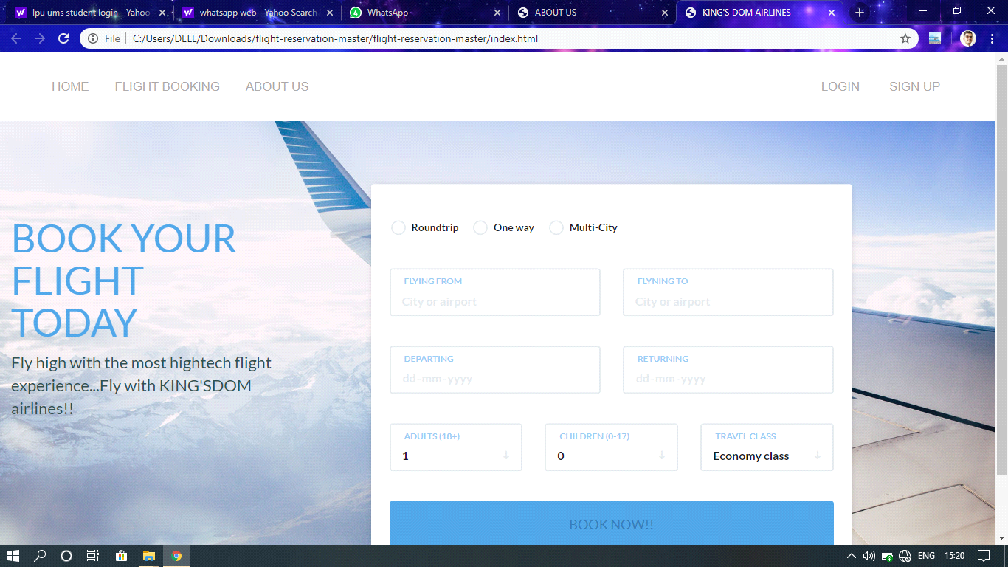

4. Booking Page

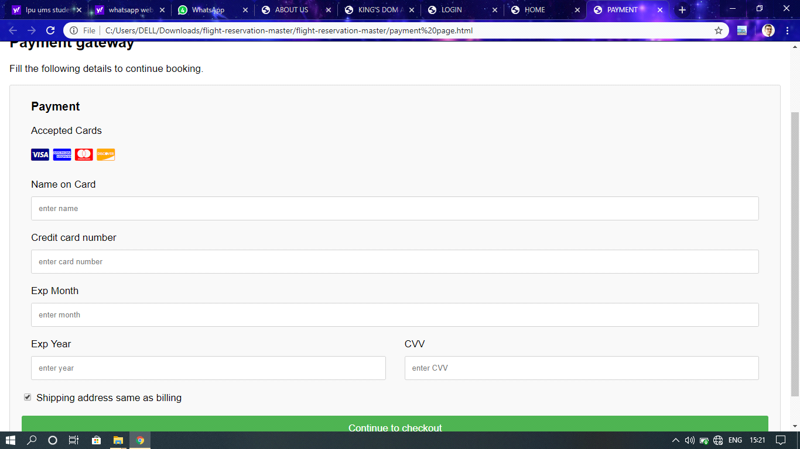

5.Payment Page

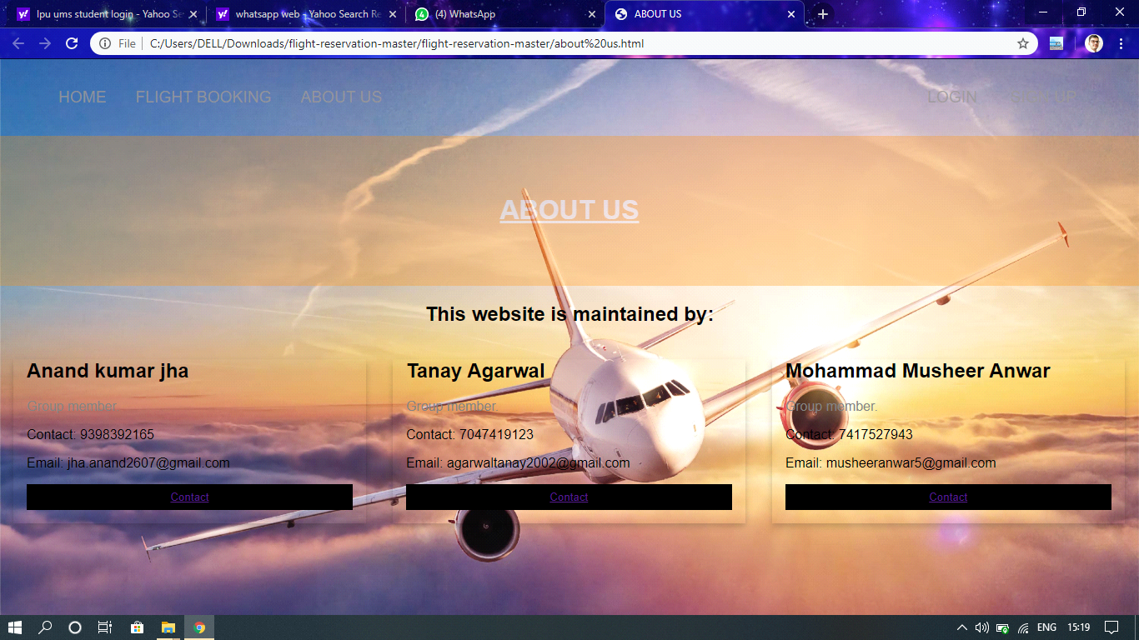

6.About Us

**Description**:-

* This site is a common work of all of us three members.
* Firstly we individually made different pages of

this site and then we combine/link them to make a complete website.

* In making this project we used HTML language, CSS, Java script.
* we also try to give our site an official look.
* We provide every option which anyone needed at the time of booking.
* If someone is booking first time, then he/she

must have to first make an account by signing up.

* After that he/she able to access the main page of the site.
* There they will find many options like home,

Booking ticket and, about us, sign in etc.

* After that they can fill up the details which are

ask to fill.

* Then finally they will procced to final step that is Payment.
* There we also provide option for payment like online banking, debit card and credit card.

**Work Done By members**: -

* **Tanay Agarwal** has made the Main page and Home page i.e: -





**I also learnt all the basic concepts like how to make forms with tables, some advanced tools and techniques of CSS and JavaScript to develop a website from various online sources. Then I helped in writing the codes and made**

**project report.**

* **Mohammad Musheer Anwar** has made the Login

and Payment page i.e:





**I learnt all the required concepts to develop a website. Learnt to work on frontend then I wrote all the codes to develop this site. Tried to make this site interactive by applying different tools and techniques from various sources.**

* **Anand Kumar jha** has made the index and about

us page i.e: -





**I learnt how to work on frontend. I also learnt all the concepts required in making a well responsive webpage. Then I helped my team members in writing codes and making project report. Suggested different ideas so that our page will look more attractive.**

**Lastly, we all gave the final finish to the webpage …linked all the individual pages and came up with this fabulous website**

**Which looks and works exactly same as any other official website would work. All the**

**pages are made simple yet**

**advance enough to make it what it looks now. We can assure that all the links present in**

**this website works well and with fast**

**response.**

**CONCLUSION:-**

The project was totally with done team work.

So we all three team members contributed equally in making this website.

Firstly we discussed about the look of our page and the contents that could be showcased in each page, so that it can attract users. Then we decided what all features we will add and the work of creating the pages was distributed. Then we started writing codes and started working on it. It took many days and efforts in implementing the project. All the basic concepts of HTML, CSS and JavaScript are being used. For extra help and attractive outlook, we used bootstraps also.

We have worked completely on front end.

All the basic tags of html and css are being used like for multimedia, for styles and semantics, for link etc.

After all the pages were made, they were linked and then made into a fully functional website.

**BIBLIOGRAPHY:-**

<https://developer.mozilla.org/en-US/docs/Web/HTML/Element/source>

<https://www.yourhtmlsource.com/>

<https://www.webnots.com/view-webpage-source-css-in-google-chrome/>

<https://www.w3schools.com/tags/tag_source.asp>

<https://www.w3.org/Style/Examples/011/firstcss.en.html>

<https://thenextscoop.com/web-design-techniques-2018/>

<https://pagely.com/blog/web-design-development-tools/>

<https://www.webfx.com/blog/web-design/6-advanced-javascript-techniques-you-should-know/>

<https://developer.mozilla.org/en-US/docs/Learn/Getting_started_with_the_web/JavaScript_basics>

<https://blog.hubspot.com/marketing/web-design-html-css-javascript>

<https://html.com/javascript/>

Thank you