Social Network Analysis

Social Network Analysis(SNA) is a sub-branch of network science, it deals with networks involving people as nodes and their relationship as edges. Social network can exist in very well defined scenario such as Facebook, LinkedIn, Twitter and Google+ or classroom ,workplace and family, which are not well defined. Relationship could be asymmetric, symmetric, weighted, non-weighted, random, preferential etc. These network comes to life in social situation and interaction. They play a significant role in deciding the outcome of social situation. This is what makes the analysis of such network very interesting.
These network also determine the flow of information through a network. This is of special interest to Advertiser who wants to pitch their idea to a person who is interested and well placed in his network to spread the information.

Degree Centrality
One of the first questions one asks when looking at a social network is who is more
important in this network?, or who has the power?

Every community has its own Paris Hiltons and Lady Gagas—people who are significantly more popular then others. There are usually very few of them, and they are orders
of magnitude more popular then everyone else. In order to quantify it we use degree centrality.

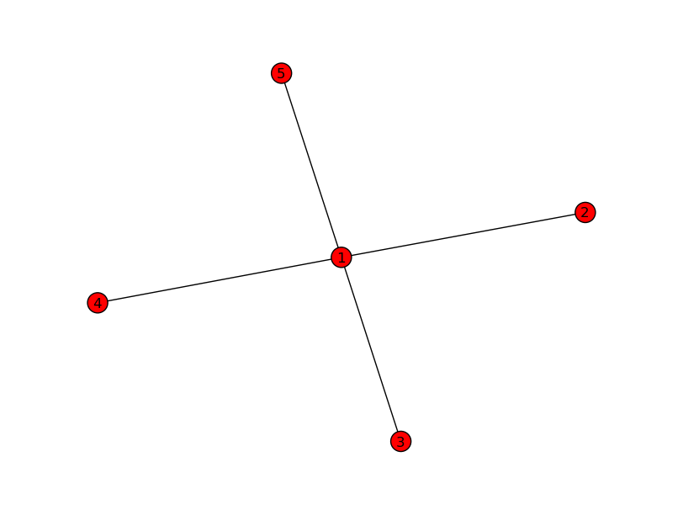

Fig1.1:Degree centrality of node “1” is 1 and node “2”, “3”, “4”, “5” is .25

It's the fraction of nodes connected to it.

Closeness Centrality
Ability to move information from one side of the network to another (i.e., gossip) is an important step towards establishing a shared perception of the world—whether it has to do with someone’s choice of outfits at a party or the formation of a political movement.

Thus, distance to others (or the inverse of it, closeness) can define a person’s role in
the network. This principle is at the root of the closeness centrality metric—the next
centrality concept we will explore.

The calculation of closeness centrality is computationally expensive:
1. Compute the shortest path between every pair of nodes using Dijkstra’s algorithm,
and store these distances in a table.
2. For every node:
a. Compute average distance to all other nodes
b. Divide by maximum distance
c. Closeness = 1 divided by average distance

Betweenness Centrality

Betweenness centrality is based on the assumption that an individual may gain power
if he presides over a communication bottleneck. In terms of computer network it could be thought of as the node, that if removed would result in two disjoint network.

The way we measure betweenness is as follows; this algorithm is fairly time-consuming
for large networks:
• Compute the shortest paths between every pair of nodes using Dijkstra's
Algorithm.
• For every node I in the network:
Count the number of shortest paths that I is on
• Normalize the numbers to bring your results to the 0-1 range.
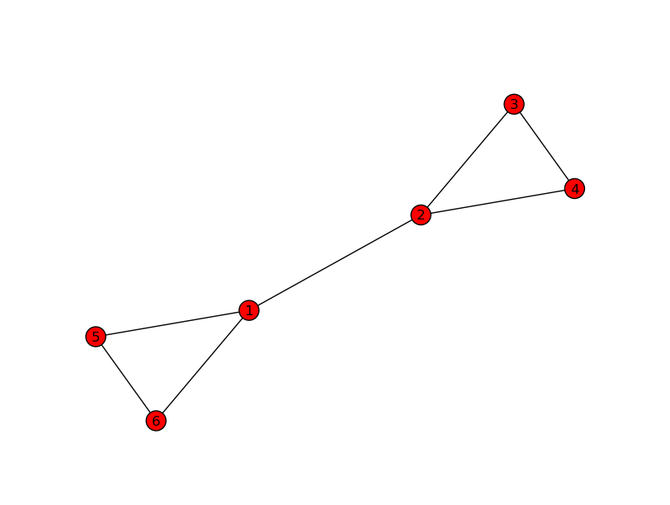

Fig 1.2: Betweenness Centrality of 1 and 2 is higher that 5,6,3 and 4 since more no of shortest path pass through 1 and 2.

Simplified PageRank algorithm

PageRank is scaled between 0 and 1 and represents the likelihood that a person following links (i.e., traversing the network, “surfing” the web, etc) will arrive at a particular page or encounter a particular person. A 0.5 probability is commonly interpreted as a “50% chance” of an event. Hence, a PageRank of 0.5 means there is a 50% chance that a person clicking on a random link will be directed to the document with the 0.5 PageRank.

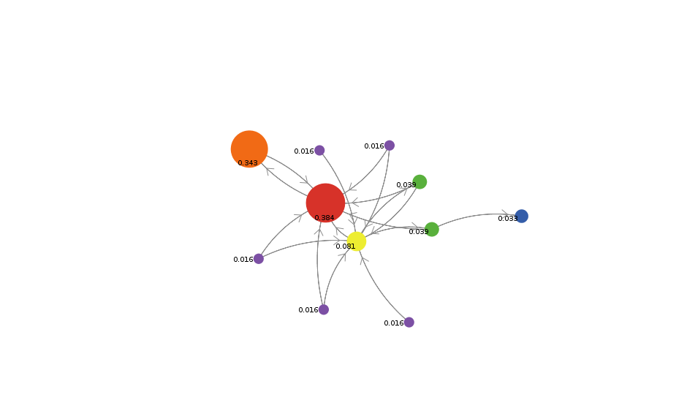
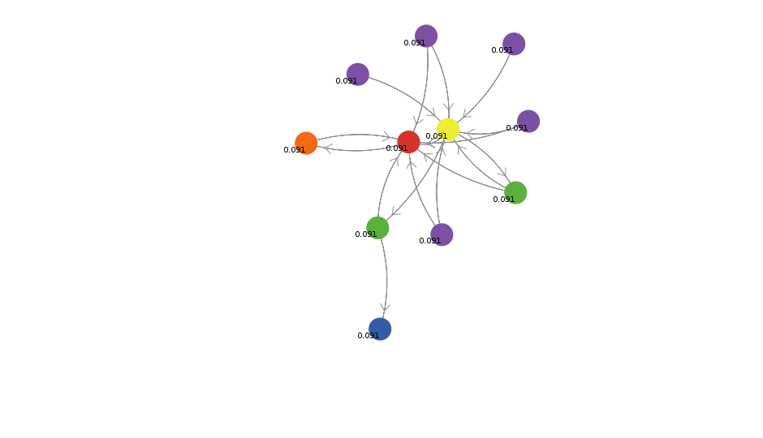

Fig 1.3:Here all nodes are assigned equal Fig 1.4: After simulation, probability of
probability initially. node changes according to page
rank algorithm.

Components and Subgraphs

• A subgraph is a subset of the nodes of a network, and all of the edges linking these nodes. Any group of nodes can form a subgraph—and further down we will describe several interesting ways to use this.

• Component subgraphs (or simply components) are portions of the network that are disconnected from each other. Before the meeting of Romeo and Juliet, the two families were quite separate (save for the conflict ties), and thus could be treated as components.
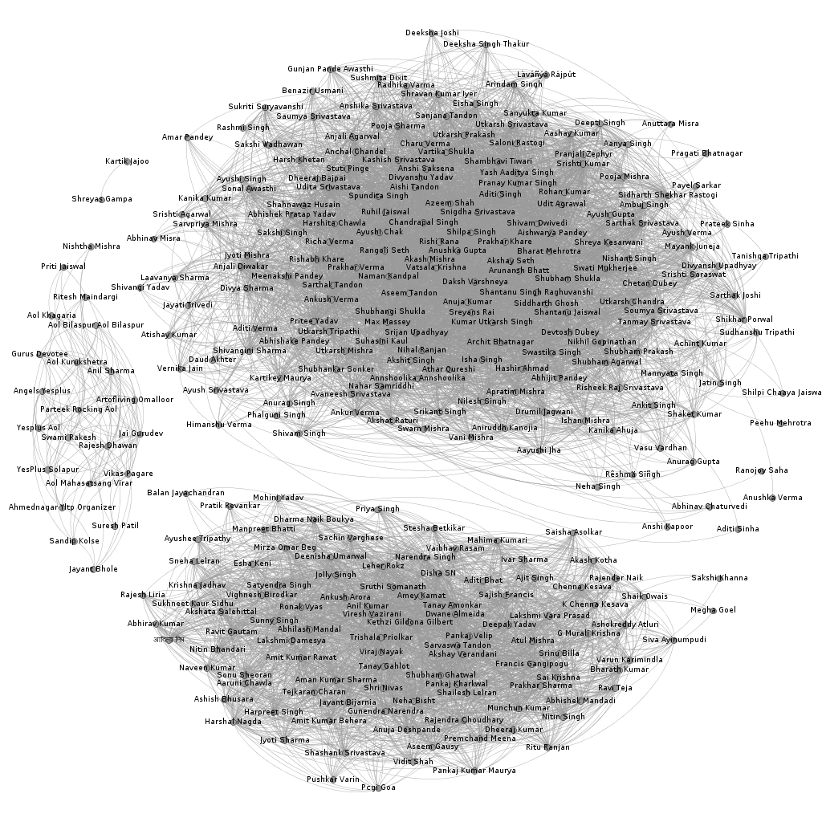
Fig 1.5: Facebook Network having 3 component

Subgraphs—Ego Networks

Ego networks are subnetworks that are centered on a certain node. On Facebook and
LinkedIn, these are simply described as “your network”—but you can only access your
own ego networks, and can’t do a broader survey. Having a larger dataset allows us to
survey and compare ego networks of various people.
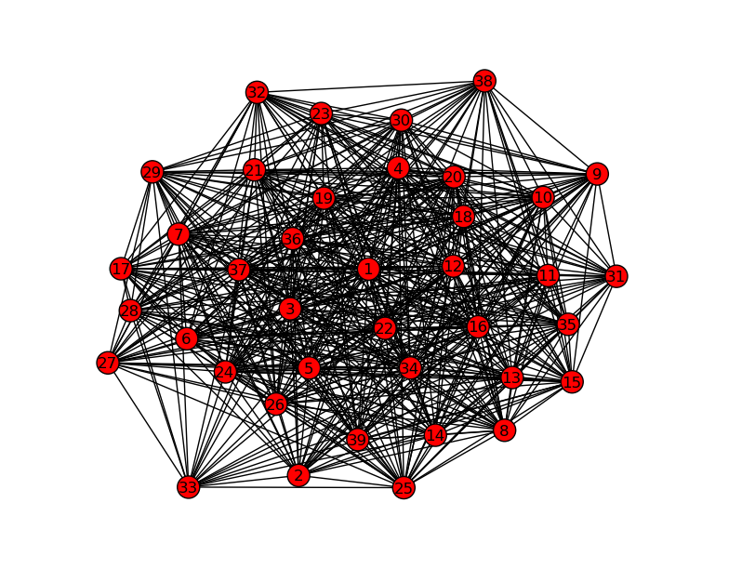
Fig 1.6: Ego Graph of node “1” of radius 1

Cliques

While we might have an intuitive understanding of a clique in a social network as a cohesive group of people that are tightly connected to each other (and not tightly connected to people outside the group), in the field of SNA there is a formal mathematical definition that is quite a bit more rigorous. A clique is defined as a maximal complete subgraph of a given graph—i.e., a group of people where everybody is connected directly to everyone else. The word “maximal” means that no other nodes can be added to the clique without making it less connected. Essentially, a clique consists of several overlapping closed triads, and inherits many of the culture-generating, and amplification properties of closed triads

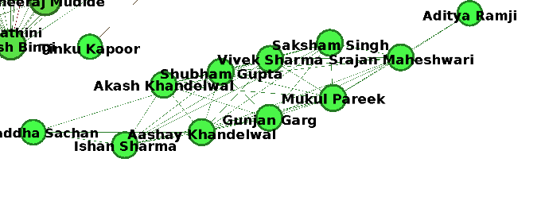
Fig 1.7: Clique of my friends from Hometown

Multi Mode Network

Much of network data currently available comes in a 2-mode (or bimodal, or bipartite)
format—that is, there are two different types of nodes, and links determine relation-
ships between one set of nodes and the other.
In the the graph given below “students” are connected to “college”,which is a of different type.
Such network are known as multi mode network since they contain two different type of entity connected together.
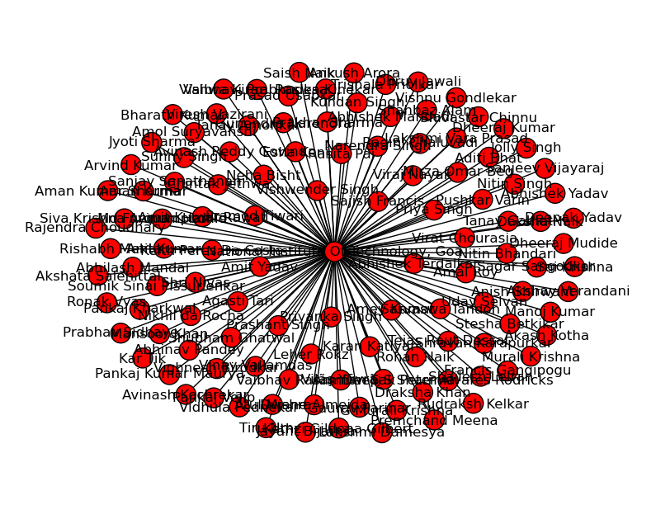
Fig 1.8: Multimode network of people connected to NIT, Goa in my Facebook network.
How are tools mentioned above used in Targeted Advertisement
Graph api is used to extract data from facebook about friends general information. Using this information a knowledge graph connecting interest subject with people is created. Then People who are interested in topic are identified using the multi mode graph so constructed using simple edge connection identification. Then interest subject is removed so that the graph comprises entirely of people. Then subcomponent of the graphs are identified. Among these subcomponent people who are most influential are identified using centrality measure like degree, closeness , betweenness, page rank and HITS.

Reference
- Social Network Analysis for Startup
- https://developer.facebook.com/docs/graph-api
- https://networkx.github.io
- https://matplotlib.org
- Crowd Network and Market by David Easley and Jon Kleinberg

