//oggpnosn
//hkhr

Text Analytics

Natural Language Processing is one of the most challenging tasks in analytics since it involves machine learning,Algorithm, and deep understanding of theory of computation. Text analytics is widely deployed in sentiment analysis of newspaper article in stock prediction, user feedback to advertisement on social media sites, calculating productivity in office using mail analytics, advertisement and many more places.

Lets start with a case study of youtube comment analyzer that I worked on over my summer internship at Innoplexus.
Why Do Opinion Matters?

Youtube video comments are very good indicator of the video. It helps us gauge peoples reaction to the video. Peoples opinion about the video matters to advertising department of companies. This helps them evaluate the effectiveness of their investment.
Tv Ads comes to youtube before going live(in most cases),therefore advertiser could gauge peoples reaction prior to launching ad in TV.

How Can We Guage Opinion?

To keep it simple we use + and – approach to opinion classification. By classifying a comment as either positive or negative, we can get a percentage score of positive comment for a video, which is a good estimate of how mass feels about the advertisement.

Whats your approach?

We use machine learning to classify comments. Using training set we train the classifier. As a filtering tool we use tf idf delta score instead of passing on the entire text.

This is how it works!

Video Feed
Comment Feed
Filter
Spell Check
Classifier
Train Set
Score
DataBase

How Do We get Data from youtube?

Using gdata-python-api we extract data from youtube. This can be installed using source file.

import gdata.youtube.service
yt_service = gdata.youtube.service.YouTubeService()
query = gdata.youtube.service.YouTubeVideoQuery()
query.vq = search_terms
query.orderby = 'relevance'
feed = yt_service.YouTubeQuery(query)

The feed we get is in xml format.

Alternatively we can get data is json format by using urllib.urlopen function.

url='http://gdata.youtube.com/feeds/api/videos?&alt=json&q='+SEARCH_TERM+'&start-index='+str(start_index)+'&max-results=50&v=2&orderby=relevance&uploader=partner&genre=11&paid_content=true&time=this_month&duration=short&license=youtube&region=IN'
feed=urlopen(url)
feed=json.loads(feed.read().replace('$','s'))

Feed that we get is in json format and could be easily inserted in data. There is a minor glitch in inserting the feed directly to mongo db ie '$' could not be at the start of the key. Therefore we replaced it with 's' in entire string.

try:
db.videos.insert(feed);print start_index
except bson.errors.InvalidDocument:
continue

This inserts feed to youtube database and videos collection

Classifier

Naive bayes classifier assigns a probability score to individual class. It assigns conditional probability to each class for a feature. This decides the liklihood of the class for a particular entry.

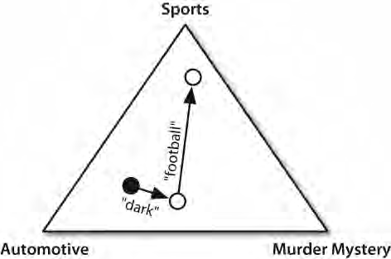

In this example sports, automotive and murder mystery are classes and dark and football are feature. This way feature help decide class. Feature determines the accuracy of a class. Therefore choice of feature is central to text mining process.

For the purpose of testing i wrote the following code to determine the accuracy of different feature.

Comments can be extracted using the same feed but different api ie

url='https://gdata.youtube.com/feeds/api/videos/'+video_id+'/comments?&alt=json&start-index='+str(start_index)+'&amp;max-results=25'

Video feed api returns 50 video entry in one request, whereas Comment Feed api returns 25 comments. A maximum of 1000 videos and comment could be retreived. Search could be modified by changing url, for specification you can have a look at gdata reference.

In most of the cases there arent 1000 comments for a video, therefore comment feed doesnt cointain entry key in it.

This can be evaluated by studying the feed in python interactive shell.

Based on this internal makeup the mosa feed collector were written.
Feature accuracy result of my analysis over train set was:

Feature | Accuracy
Polarity_score(using 5 point scale) | 65
Polarity_score(using 2 point scale) | 63
Term Presence | 64
Term Presence(len(word)>4) | 70
Term Presence(len(word)>5) | 67
Term Presence(len(word)>6) | 69
Term Presence(len(word)>7) | 67
Term Presence(len(word)>8) | 65
Term Presence(len(word)>9) | 65
Term Presence(len(word)>10) | 61
Term Frequency(len(word)>1) | 69
Term Frequency(len(word)>2) | -
Term Frequency(len(word)>4) | 71
Term Frequency(len(word)>5) | 67
Term Frequency(len(word)>6) | 68
Term Frequency(len(word)>7) | 66
Term Frequency(len(word)>8) | 66
Bigram | 67
Tf-Idf-Delta | 74

Frequency distribution for tf idf delta scores was:
