//oggpnosn
//hkhr

Real time information in disaster situation.

Quick Availability of information in disaster struck situation can speed up disaster rescue effort. Time after the disaster is the most critical time since majority of life can be saved. Therefore the strategy employed is very essential. Information about Survivor Position, Volunteer Position, Operational Clinics, fuel station and road etc is very valuable in such scenario.

I have designed a simulation of the request sent to a server after disaster scenario. Consider a disaster situation, survivor can give his/her real time position information to server. These request would look like this:

SURVIVOR me1 (386 169)
SURVIVOR me2 (163 128)
SURVIVOR me3 (158 48)
SURVIVOR me4 (158 90)
SURVIVOR me5 (84 309)
SURVIVOR me6 (260 17)
SURVIVOR me7 (387 393)
SURVIVOR me8 (319 332)

In my simulation i have used python language for scripting and mongodb for database. For graphical simulation Tkinter library is used.
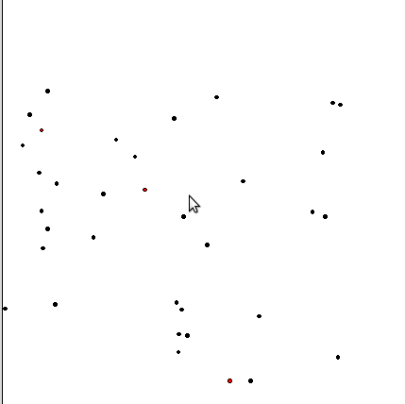

Fig:(a) drMah Simulator. Red point are volunteer and black
point are Survivor

In this simulation humans are represented by class Person. Survivor are represented as Survivor class which inherits properties of a person. Volunteer also inherits from Person. Person has two attribute “Name” and “Location”. Location is stored as a “Point” object and “Name” is a string.
The disaster struck area is abstracted as Cartesian field. In Field the survivor pops up with probability “ppop”. Volunteer pops with a probability one tenth of ppop. This makes the game interesting since the resources are constraint, therefore strategy of moving Volunteer must be optimal.

At each time step the field is updated and new survivor is added. These changes are made to database. Position of volunteer and presence of survivor is also tested to maintain consistency between database and program objects. Volunteer are redrawn at each time step to account for change in their position. Survivor are deleted based on the changes made to database and volunteer position.

Player uses another script to make changes to Volunteer position depending upon the amount of data available to him. There are two modes of game-play:
- No information about survivor position is available to player.
- Survivor position can be queried according to certain function.

This play simulates the actual work done by Palantir Organization after Sandy Hurricane in NewYork, USA. Analytical tools were developed at runtime to suit the need. Network was established to connect volunteer with survivor.

PALANTIR’S SOLUTION
Palantir sent several engineers to camp out at Team Rubicon’s command center in the Rockaways. There, they partnered with team leaders to develop an application that enabled volunteers to enter requests for assistance into Palantir Gotham through web-enabled mobile devices. Within days,
volunteers on the ground were using iPads and smart phones to file requests for water, medical supplies, and home repairs in Palantir Gotham, where they were aggregated and analyzed as part of Team Rubicon’s broader operation. Volunteers also used the mobile devices to capture photos of
flooded spaces, damaged buildings, and blocked roads, which were entered into Palantir Gotham as media objects and used to inform response planning.
Analysts at Team Rubicon’s command center used Palantir Gotham to maintain situational awareness across all response activities. Coordinators tracked volunteer progress and dispatched additional support as needed. Analysts at Team Rubicon’s command center also used Palantir to connect to data sources provided by other organizations, including information on fuel availability, power grids, and available medical clinics. Volunteers on the ground accessed this information using Palantir and relayed the information to affected individuals. Using Palantir Gotham’s Map application, dispatchers could see where volunteers were located in relation to damaged houses,

