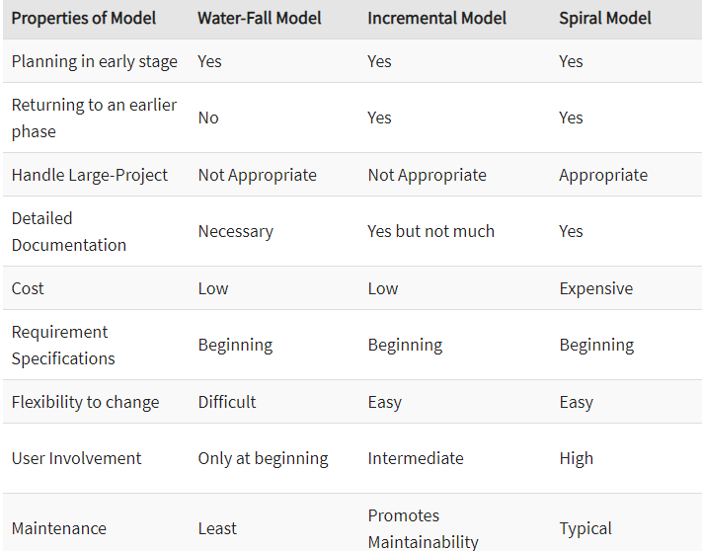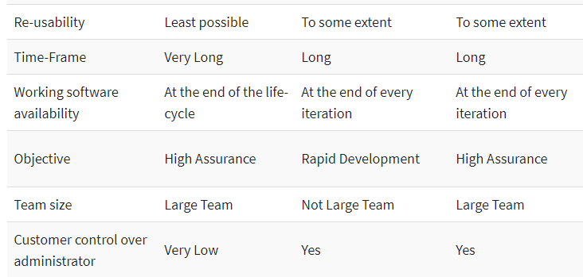

Q1. The problem statements are given below, choose a best possible software process model and give the reason for same. [CO2]

**P1: SCG Problem Statement**

SCG/Avatar supports a game-based software development process for computational problems CP defined by an input/output mapping. At least two competing and collaborating teams develop an avatar containing software for CP. The goal of the game is to have a focused, productive discourse about CP between the avatars, and indirectly, between the software teams, to find good software/algorithms for CP and to fairly evaluate all proposed solutions. The CP software is embedded in an avatar that proposes and opposes claims about how well CP can be solved.

There are many computational problems for which we want to develop high-quality software through SCG. Therefore we want to develop community support for running all those games for all those computational problems. Each computational problem uses different concepts and notations. It is a big advantage for the software developer when there is a consistent interface for all problems.

We want to use the SCG/Avatar game to (1) develop reliable software for computational problems, (2) evaluate potential employees, (3) develop new knowledge in the given domain, (4) evaluate algorithmic innovations fairly

**P2: Library Management System**

Library management software for the purpose of monitoring and controlling the transactions in a library. This case study on the library management system gives us the complete information about the library and the daily transactions done in a Library. We need to maintain the record of new s and retrieve the details of books available in the library which mainly focuses on basic operations in a library like adding new member, new books, and up new information, searching books and members and facility to borrow and return books. It features a familiar and well thought-out, an attractive user interface, combined with strong searching, insertion and reporting capabilities. The report generation facility of library system helps to get a good idea of which are ths borrowed by the members, makes users possible to generate hard copy. The following are the brief description on the functions achieved through this case study: End-Users:

•Librarian: To maintain and update the records and also to cater the needs of the users.

•Reader: Need books to read and also places various requests to the librarian.

•Vendor: To provide and meet the requirement of the prescribed books.

### P3: Online Auction System

New users can register to the system through an online process. By registering a user agrees to abide by different pre-defined terms and conditions as specified by the system. Any registered user can access the different features of the system authorized to him / her, after he authenticates himself through the login screen. An authenticated user can put items in the system for auction. Authenticated users users can place bid for an item. Once the auction is over, the item will be sold to the user placing the maximum bid. Payments are to be made by third party payment services, which, of course, is guaranteed to be secure. The user selling the item will be responsible for it's shipping. If the seller thinks he's getting a good price, he can, however, sell the item at any point of time to the maximum bidder available.