Drug Discovery Using Quantum-Inspired Qudit Genetic Algorithm (QudGA)

Poulami Das¹, Neerav Reddy¹, Tanay Shah¹, Vaclav Snasel² and Avishek Ray^{1*}
¹Mukesh Patel School of Technology Management and Engineering
NMIMS Deemed to be University, Mumbai, India
²VSB Technical University of Ostrava, Ostrava, Czech Republic
*avi_rkm@yahoo.co.in
Abstract. Drug discovery is basically an optimization problem defined over enormously large, high-dimensional, and nonlinear chemical spaces. Traditional computational approaches for drug discovery, like molecular docking, force field optimization, and molecular dynamics, are computationally expensive and prone to local minima. Metaheuristic optimization algorithms have been proposed as scalable alternatives. Among the many metaheuristic optimization algorithms, the classical Genetic Algorithm (GA) has proven its efficacy in solving a wide range of challenging optimization problems. Limitations such as premature convergence and loss of population diversity in classical GA have motivated the amalgamation of quantum principles with it. The resulting Quantum-Inspired Genetic Algorithms (QIGA) demonstrated their efficiency by enhancing exploration and convergence when solving optimization problems across numerous domains. This paper proposes a Quantum-Inspired qudit genetic algorithm (QudGA) for drug discovery, where molecular structures are encoded using multi-state qudits to enable richer representation and probabilistic exploration. A fitness function based on the Lennard-Jones potential and polarity compatibility is used to estimate ligand-protein interactions. Extensive experiments demonstrate that the proposed QudGA outperforms classical GA, QIGA (Qubit-based), and QuGA (Qutrit-based) in terms of convergence speed, solution stability, and binding energy optimization.
Keywords: Drug Discovery · Quantum-Inspired Genetic Algorithm · Qudit · Molecular Optimization · Lennard-Jones Potential.

1 Introduction
The discovery of new drug molecules is one of the most expensive and time-consuming processes in pharmaceutical research [1]. It is estimated that developing a single successful drug may require over a decade of research and substantial financial investment [2]. Computational drug discovery aims to reduce this cost by prioritizing promising candidate molecules before expensive laboratory experiments [3]. At its core, drug discovery is formulated as a multi-objective optimization problem in which the aim is to find molecular structures that exhibit strong binding affinity to target proteins while satisfying pharmacokinetic and toxicity constraints [4].
Traditional computational techniques like molecular docking, molecular dynamics simulations, and force-field-based optimization rely on deterministic or gradient-based methods [5]. While accurate, these approaches are computationally expensive and often fail to scale to large chemical libraries [6]. Moreover, the molecular interaction energy optimization is highly non-convex and prone to getting trapped in local maxima, which makes classical optimization methods less efficient [7].
Metaheuristic optimization algorithms [8][9] have proved their efficacy in solving a wide range of complex optimization problems. Their ability to explore large and complex search spaces makes them suitable for real-world optimization challenges. Among a vast range of metaheuristic optimization techniques, GA [9] is particularly attractive due to its population-based search and natural evolutionary operators such as selection, crossover, and mutation [9][10]. However, classical GA frequently suffers from premature convergence, especially in high-dimensional search spaces, leading to suboptimal solutions. To address these challenges in classical GA, Quantum-Inspired Genetic Algorithms (QIGA) [11][12] were introduced. QIGA incorporates quantum principles for diverse and parallel exploration of the search space [11] [12].
Unlike classical GA, QIGA represents each gene of candidate solutions using quantum probability amplitudes rather than fixed, deterministic states [11][12]. This quantum encoding enables a single gene to be in a superposition of two potential states ($\left.|0\right\rangle$and $\left.|1\right\rangle$) at the same time, improving the diversity of the search process [11]. In QIGA, each gene is therefore encoded as a qubit. Similarly, in QuGA [13][14] each gene is encoded as a qubit and successfully lies in a superposition of three states ($\left.|0\right\rangle ,$ $\left.|1\right\rangle$ and $\left.|2\right\rangle$) at the same time. QIGA and QuGA achieve higher efficiency than classical GA [11][12][13][14]. Still, the efficiencies of QIGA and QuGA are constrained in complex search spaces where each gene requires superposition of more than two or three states. To overcome this limitation, QudGA with qudit-based representations of candidate solutions has been introduced [15]. In QudGA each gene of each candidate solution stays in superposition of multiple states [15]. This significantly expands the diversity of the search space and enhances the algorithm's exploration capability. Consequently, QudGA improves solution quality without increasing the population size. This behavior of QudGA makes it much more effective for complex optimization problems like drug discovery.
The paper is organized as follows: Section 2 includes motivation and the contribution of the work. Section 3 reviews the related literature on classical evolutionary and swarm-based approaches to docking and ligand design, quantum computing applied to drug discovery, and quantum-inspired optimization for ligand–protein binding. Section 4 introduces the fundamentals of quantum computing relevant to this work, including qubit and qudit representation, superposition, and quantum measurement. Section 5 presents the fundamentals of drug design, including ligand structure representation, types of molecular interactions, and the Lennard–Jones–based energy model used for the fitness function. Section 6 describes the Qudit Genetic Algorithm (QudGA), covering quantum population generation, quantum crossover, quantum mutation, and the quantum disaster operation. Section 7 details the application of QudGA to the optimization of interaction energy, covering qudit-based molecular encoding, population initialization, selection, and genetic operators. Section 8 describes the implementation, including the algorithmic steps, the HRV-14 VP1 barrel target, the ligand functional group parameters, and the baseline algorithms used for comparison. Section 9 reports and analyzes the experimental results, including convergence behavior, binding energy, active nodes, and statistical validation through ANOVA and post hoc Tukey HSD tests. Finally, Section 10 concludes the paper and outlines directions for future work.

2 Motivation and Contribution

Ligand design for a given protein target is a combinatorial search over a rugged, non-convex energy landscape. The number of candidate ligands grows exponentially with the number of structural units and the number of functional-group choices per unit, which puts exhaustive search out of reach and makes deterministic or gradient-based methods prone to local minima. Classical GA handles such spaces better, but it tends to lose population diversity and converge prematurely as dimensionality grows. Quantum-inspired GAs relax this only partially: qubit- and qutrit-based genes carry just two or three basis states, so problems where each gene has many discrete choices must split a gene across several qubits or restrict the representation, thereby lengthening the chromosome and complicating the genetic operators. Existing quantum-inspired and evolutionary studies on ligand–protein binding optimization [16][17] remain at the binary-quantum or classical level. There is therefore a need for a richer, many-valued encoding that supports diverse exploration of large ligand search spaces without increasing the population size.
The key contributions of the manuscript are:
(a) An imaginary structure of Ligand with 17 nodes, which is basically a structured combination of chemical functional groups, is used to interact with the target protein of VP1 barrel of Human Rhinovirus strain 14 (HRV 14) in this paper. Each node comprises a functional group. The goal is to find an optimized combination of these nodes.
(b) QudGA is used for finding out an optimized ligand structure that can interact with the target protein in order to minimize the binding energy.
(c) QudGA starts with a generation of the initial population, where each candidate solution is a combination of 17 genes. Each gene is in a superposition state of 8 levels (7 chemical functional groups and 1 for NULL). Hence, QudGA significantly expands the higher-dimensional solution space and enhances search efficiency without increasing the population size.
(d) QudGA demonstrates superior convergence and stability compared to classical GA, QIGA, and QuGA, with much lesser binding energy.

3 Literature Survey

Classical drug design methods largely rely on evolutionary and swarm-based search methods to identify suitable ligand structures. An evolutionary approach that minimizes ligand-protein interaction energy using a genetic algorithm has been reported in [18], demonstrating that such searches can identify biologically active ligands in bio-structured drug design. However, classical evolutionary algorithms of this kind tend to lose population diversity over generations, causing the search to converge prematurely before the optimal binding configuration is found. A genetic algorithm was proposed in [19] to generate small organic molecules for de novo drug design. It solves the combinatorial optimization problem that comes with compound generation. But the method struggles when a more exhaustive search of the chemical space is needed. This is because classical genetic operators do not scale well with increasing molecular complexity.
Molecular docking has traditionally been performed using classical optimization algorithms to estimate binding affinity. An ant colony optimization method named PLANTS has been used to dock ligands onto a fixed protein target [20], though the receptor was kept almost entirely rigid except for the hydrogen bond, a fairly harsh approximation of real binding site flexibility. A genetic algorithm has similarly been applied to optimize protein ligand binding energy for a fixed target structure [21], but the method assumes constant bond angles and does not employ any energy minimization technique, so the resulting structures do not always match physical reality. Ligand selection based on protein ligand interactions has also been carried out using a genetic algorithm [22], useful when multiple ligands need to be compared, although the parameter approximations again tend to diverge from reality. An ant colony optimization method has also been used to determine the minimum binding energy between protein and ligand [23], though this approach is only practical when the search space is small. These studies show that classical docking algorithms, while computationally simple, tend to trade chemical realism against a limited search space.
Computer-aided drug design (CADD) has since evolved to make such calculations faster and more reliable. A linear optimization algorithm has been used to determine the molecular structures of tooth decay inhibitors [24], demonstrating that a straightforward optimization formulation can still support practical CADD tasks. Pharmacoprint, a method that combines a pharmacophore fingerprint with artificial intelligence, has also been proposed to cluster molecules with similar structures [25], thereby improving candidate screening compared with classical fingerprinting alone. Together, these works reflect how computer-aided drug design continues to combine classical optimization with learning-assisted molecular analysis.
As complexity grows, optimization becomes essential to drug design. Many parameters must be tuned simultaneously. These include ligand efficiency, molecular affinity, and Gibbs free energy. All of them matter for a therapy to succeed. Lead molecules must be optimized to interact strongly with a target protein. This has been shown to be necessary to minimize the ligand's interaction energy with the target [26]. Multi-objective optimization methods have also been reviewed more broadly [27]. They help bridge chemical and biological landscapes. They also support the automated de novo design of compounds. Together, these findings support the continued use of evolutionary and swarm-based optimization. These methods are preferred over exhaustive or purely deterministic search. They are useful throughout the drug design pipeline.
Quantum computing has recently been explored as a way to accelerate these optimizations of heavy drug design pipelines. The scaling properties of state-of-the-art quantum algorithms have been compared to estimate the quantum resources required to simulate a pharmaceutically relevant protein-drug complex [28], showing that recent advances in quantum phase estimation have considerably reduced this resource requirement. The opportunities and hardware challenges of performing drug design directly on quantum computers have also been surveyed [29], noting that although adoption in the pharmaceutical industry remains limited, quantum methods promise faster and more accurate electronic-structure calculations than their classical counterparts.
Closer to the present work, quantum-inspired optimization has started to be applied specifically in drug design. An energy-based deep learning model has been combined with quantum-computing-based optimization to guide navigation through chemical space using learned structure-property relationships [30]. Quantum-inspired digital annealing has also been used to solve a quadratic unconstrained binary optimization problem to modify the molecular structure of a DNA polymerase inhibitor for the dengue virus [31]. An alchemical quantum algorithm has been further proposed to simultaneously optimize the electronic structure and nuclear composition of a molecule, representing candidate structures as a superposition of possible atomic compositions to keep the search efficient within a polynomial number of resources [32]. Ghosh et al. applied a quantum binary PSO to minimize ligand–protein interaction energy, representing each candidate ligand as a variable-size tree whose nodes correspond to functional groups, with tree size adapted to the target active site [16]. The quantum PSO searches for optimal leaf-node assignments to minimize the binding energy between ligand and protein. Using the rhinovirus VP1 protein (PDB ID: 1RUC) and its antiviral binding barrel (25 Å deep, 12 Å wide, 3.1 Å resolution) as the target, the method sought ligands that could fit the barrel while aligning key functional groups with the essential binding-site residues. With a population of 40 and 100 iterations, Ghosh et al. showed that the variable-length quantum PSO achieved a lower interaction energy (8.5707) than the fixed-length version (12.4489), demonstrating the benefit of quantum-inspired, variable-length representations for ligand-protein docking optimization. A related classical approach is the Neighborhood-Based Genetic Algorithm (NBGA) [17]. It also encodes ligands as variable-length trees. It uses the same VP1 active site. It uses a ring-parent topology and trio selection instead of quantum operators. On the same target, variable-length NBGA achieved an interaction energy of 8.10467 kcal/mol. This is comparable to or slightly better than the variable-length quantum binary PSO result. It shows that neighborhood-based classical search remains a strong baseline. This holds even as quantum-inspired variants are explored. Darwish et al. proposed a Quantum-Inspired Genetic Programming (QIGP) model that uses genetic programming to derive a linear equation for estimating the degree of chemical toxicity [33], with quantum computing employed to improve the selection of the best-of-run individuals and to manage parsimony pressure to reduce solution complexity. Validated on a benchmark phenol toxicity dataset, the QIGP model achieved better goodness-of-fit statistics and significantly outperformed a neural network baseline, further illustrating how quantum-inspired operators can enhance evolutionary search for cheminformatics and toxicity-prediction tasks relevant to drug discovery. Despite these promising results, quantum-inspired optimization for drug design remains underexplored, with most existing studies restricted to qubit-level encodings, thereby motivating the need for a richer, higher-dimensional representation, such as the qudit-based genetic algorithm proposed in this paper.
4 Quantum Computing Fundamentals
In contrast to classical systems, which evaluate a single solution at a time, quantum computers leverage key quantum phenomena such as superposition and entanglement to process multiple possibilities simultaneously. This capability makes them particularly effective for addressing problems that are otherwise computationally infeasible using classical approaches. Furthermore, quantum computing shows strong potential in solving NP-hard optimization problems, which are typically challenging for conventional methods.
4.1 Quantum Representation and Superposition
A qubit is the key component of quantum computing [12][13]. Unlike classical computing, where bits can be either of the two states 0 and 1, qubits exist in the basis states of $\left.|0\right\rangle$ or $\left.|1\right\rangle$ or even can lie in a superposition of both the basis states. Likewise, qudits can occupy either of the states $\left.|0\right\rangle$, $\left.|1\right\rangle$, $\left.|2\right\rangle , …,\left.|n\right\rangle$ or can be in a superposition of these basis states as follows.
$|\left.φ\right\rangle =α_{0}\left.|0\right\rangle +α_{1}\left.|1\right\rangle$+$α_{2}\left.|2\right\rangle$+$…+α_{3}\left.|n\right\rangle$ (1) where, $α_{0}$, $α_{1}$, and $α_{2}$are arbitrary complex numbers satisfying the following unitarity condition.
$α_{0}^{2}+α_{1}^{2}+α_{2}^{2}+…+α_{n}^{2}=1$ (2)
In quantum-inspired optimization algorithms with qudit representations, a larger search space is explored with the same-sized candidate solutions, resulting in faster convergence and better solutions to the problem.
A pair of qubits can be in a superposition of these four states as [12][13]
$|\left.φ\right\rangle =α_{00}\left.|00\right\rangle +α_{01}\left.|01\right\rangle$+$α_{10}\left.|10\right\rangle +α_{11}\left.|11\right\rangle$ (3)
The normalization condition of these four states is represented as [12][13]
$α_{00}^{2}+α_{01}^{2}+α_{10}^{2}+α_{11}^{2}=1$ (4)
For an m-level qudit, the superposition state is represented as
$φ=\sum_{xϵ\{0,1,2,….,m\}}{α_{x}\left.|x\right\rangle }$ (5)
4.2 Quantum Measurement
Quantum measurement [13][14][15] is the process through which a quantum system, initially in a superposition of multiple possible states, yields a single, definite classical outcome. Algorithm 1 illustrates the quantum measurement of n-level qudits.
$$Result: Classical Values - 0, 1, 2, 3, …, n$$
$$Initialize Pick qudit c;$$
$$for i in 1, 2, …, num_sol$$
$for j in 1, 2, …, num_qudits$
$r = random number between [0,1]$
$cumulative_sum = 0$
$for k = 0, 2, …, n - 1$
$cumulative_sum = cumulative_sum + α_{k}^{2}$
$if r < cumulative_sum$
$C_{population}=k;$
break;
end
end
end
end

Algorithm 1. Quantum measurement of an n-level qudit

5 Fundamentals of Drug Design
Drug discovery fundamentally involves understanding the interaction between a ligand (drug molecule) and a target protein. These interactions depend on molecular structure, functional group composition, and physicochemical properties such as polarity and spatial arrangement of drug molecules [16][17].
5.1 Ligand Structure Representation
A ligand can be represented as a structured combination of functional groups connected through covalent bonds. Each functional group exhibits specific chemical properties, such as hydrophobicity, polarity, or reactivity, that influence binding affinity [16][17].
In drug design, ligands are modeled as chain-like or tree-like structures, where different branches represent different functional group attachments. This representation allows flexible exploration of molecular configurations while maintaining structural validity [16][17]. In Fig. 1 [16][17], chemical structures of 7 different functional groups are shown. These functional groups define the chemical behavior of the ligand molecule and determine its interaction with the protein binding site.

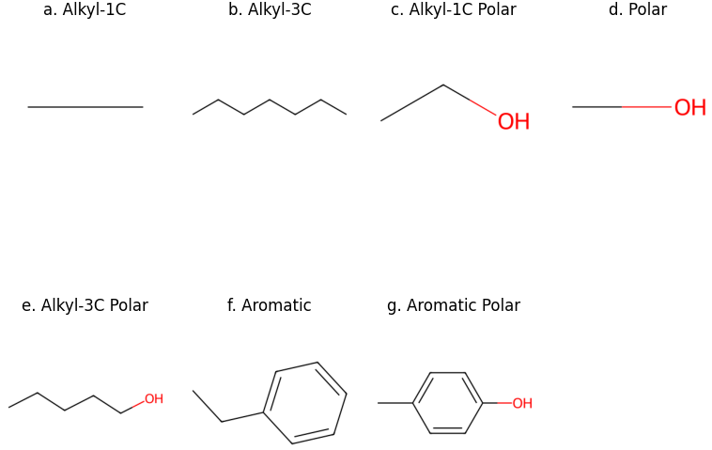
Fig. 1. Structure of functional groups used for Ligand construction
5.2 Types of Molecular Interactions
Ligand–protein binding is governed by non-covalent interactions, including van der Waals forces, electrostatic interactions, hydrogen bonding, and hydrophobic effects [16][17]. These interactions collectively determine the stability and specificity of binding.
5.3 Energy-Based Interaction Modeling
Each functional group of the ligand interacts with residues in the protein active site based on spatial proximity and polarity compatibility, ensuring chemically meaningful interactions. Fitness is derived from the interaction energy between each residue and its nearest functional group, accounting for the chemical nature of the pair. If a functional group and its closest residue differ in polarity, a penalty is applied. The interaction energy is computed as the sum of the van der Waals potential energies between the functional groups and the amino acid residues in the active site and the nearest functional group of the ligand.
The intermolecular interaction energy is modeled using a Van der Waals interaction formulation based on the Lennard–Jones potential, which accurately captures both short-range repulsive and long-range attractive forces [16][17]

$V\left(r\right)=4ε\left[\left(\frac{p_{n}}{r^{12}}\right)-\left(\frac{p_{m}}{r^{6}}\right)\right]$ (6)
where, $n$ and $m$ are integers and $p_{n}$ and $p_{m}$ are constants [16][17]. Polarity mismatches incur a penalty P
E = $\sum{V (r) + P}$ (7)
The final fitness $f$ is defined as
$f=\frac{k}{E}$ (8)

where, k is a scaling constant, and E is the total interaction energy.
Unlike the formulations in [16[17] that directly use $f=\frac{k}{E }$​, the inclusion of ε avoids numerical instability when the interaction energy approaches zero and reduces sensitivity to extremely small energy variations.
5.4 Relevance to Optimization Framework
Each node in the ligand structure is associated with a functional group that can be optimized through evolutionary search. In the present work, a QudGA is used for optimization, in which each component of each candidate solution is a superposition of multiple states. This encoding allows multiple combinations of functional groups to be explored in parallel, thereby improving population diversity and search efficiency within complex chemical spaces. The optimization process is guided by an energy-based fitness function, in which each candidate ligand structure is evaluated by its interaction energy with the target protein. In this way, the proposed technique systematically drives the search toward the ligand structures exhibiting lower interaction energy and improved binding stability.

6 Qudit Genetic Algorithm (QudGA)

QIGA was first introduced by Narayanan et al. in 1996 [34]. Unlike classical GA, it begins by generating a quantum population. In the proposed QudGA, a quantum population Q is generated in qudit representation and stored as Q′. A quantum measurement is then performed on Q to obtain the corresponding classical population. The fitness of each individual (candidate solution) in the classical population is evaluated, and the best-fitness individual is recorded. The classical individuals are then sorted in descending order of fitness, and the same ordering is applied to Q'. Crossover is then applied, followed by mutation, on Q'. The subsequent steps are repeated on Q. This continues until the stopping criterion is met. Finally, the algorithm returns the global best solution among the local best solutions obtained across multiple independent runs. Algorithm 2 illustrates the different steps of the algorithm.
6.1 Quantum Population Generation with Qudit Representation
Initially, a population of N chromosomes in qudit representation is generated randomly. Each gene is an n-level qudit represented as
$\left.|c\right\rangle =\sum_{i=0}^{n-1}{α_{i}}\left.|α\right\rangle$ (9)
where the amplitudes αᵢ are initialized randomly such that $\sum_{i}{{|α|}^{2}=1}$, as in [15]. Each $α_{i}^{2 }$gives the probability of observing basis state $\left.|i\right\rangle$ when the qudit is measured.
6.2 Quantum Crossover on Qudits

In qudit-based quantum systems, the crossover operation is applied to all probability amplitudes associated with the qudit's possible states. For example, in a 3-level system (qutrit), crossover is applied to the amplitudes $α_{0}$, $α_{1}$ and $α_{2}$. In an n-level qudit system, the operation extends further to include $α_{0}$, $α_{1}$, … $α_{n}$ as well [35]. As the dimensionality of the qudit increases, the crossover is correspondingly applied to all associated amplitudes representing the qudit's quantum state.
6.3 Quantum Mutation on Qudits
A random value is generated between [0, 1].
- If the random value is found to be less than $α_{0}^{2}$, then the values of $α_{0}$ and $α_{1}$ are interchanged.
- If the random value is less than $α_{0}^{2}$ + $α_{1}^{2}$, then the values of $α_{0}$ and $α_{2}$ are interchanged.
- If the random value is less than $α_{0}^{2}$ + $α_{1}^{2}+α_{2}^{2}$ , then the values of $α_{0}$ and $α_{3}$ are interchanged.
- This continues such that:
  - If the random value is less than
$\sum_{i=0}^{k}{α_{i}^{2}}$ (10)
Then the values of $α_{0}$ and $α_{k+1}$ are interchanged, where $k=1,2,3,…, n$

If none of the above cases are satisfied, then the values of $α_{n-2}$ and $α_{n-1}$ are interchanged. This mutation process is repeated until the entire population is traversed [12].
6.4 Quantum Disaster

A quantum disaster operation [12][33] is applied to preserve diversity within the quantum population. This operation is carried out by reinitializing a subset of chromosomes to their initial states using Eqn. 8. The quantum disaster is triggered only when the fitness of the current generation shows a decline compared to the previous one. The maximum fitness value, along with its corresponding threshold values, is then considered the optimal result.

$$Result: Global best solution and its fitness$$
$$Initialize population size N, Maximum generations G_max$$
$$Initialize quantum population Q(t) using Eqn. 9$$
$$t = 0; best_fitness = -∞;$$
$$Q'(t) = Q(t)$$
$$while t < G_{max}$$
$C(t) = Measure(Q(t))$
$for i = 1, 2, 3, …, N$
${fitness}_{i} = f(C_{i}(t))$
$end$
$if max(fitness) > best_fitness$
$best_fitness = max(fitness)$
$best_solution = best individual of C(t)$
$end$
$Sort C(t) in descending order of fitness$
$Rearrange Q(t) according to the order of C(t)$
$for each pair (Q_{i}^{'}, Q_{j}^{'}) in Q'(t)$
($Q_{i}^{'}_$new, $Q_{j}^{'}$_new) = Quantum_crossover($Q_{i}^{'}, Q_{j}^{'}$)
($C_{i}_$new, $C_{i}$_new) = Measure($Q_{i}^{'}_$new, $Q_{j}^{'}$_new)
$Apply fitness evaluation on \left({C_{i}}_{new}, {C_{i}}_{new}\right)$
$if (fitness(C_{i}_new) > fitness(C_{i}))$
$Replace(C_{i} by C_{i}_new)$
Replace($Q_{i}^{'}$ by $Q_{i}^{'}_$new)
$End$
$if (fitness(C_{j}_new) > fitness(C_{j}))$
$eplace(C_{j} by C_{j}_new)$
Replace($Q_{j}^{'}$ by $Q_{j}^{'}_$new)
$End$
End
$for i in 1, 2, …, N$
$r = random number between [0,1]$
$Q_{i}^{'}_new= Quantum_mutation(Q_{i}^{'}, r) using Eqn. 10$
$(C_{i}_new) = Measure(Q_{i}^{'}_new)$
$Apply fitness evaluation on C_{i}^{'}_new$
$if (fitness(C_{i}_new) > fitness(C_{i}))$
$Replace(C_{i} by C_{i}_new)$
End
End
$for i = 1, 2, 3, …, N$
$fitness_i = f(C_{i}(t))$
$End$
$if max(fitness) > best_fitness$
$best_fitness = max(fitness)$
$best_solution = best individual of C(t)$
$End$
$if max(fitness(t)) < max(fitness(t - 1))$
$Reinitialize a subset of Q'(t) using Eqn. 6$
$Preserve best_solution$
$End$
$Q(t+1) = Q'(t)$
$t = t + 1$
$$End$$
$$End$$
$$Return best_solution, best_fitness$$
Algorithm 2: Quantum-Inspired Qudit Genetic Algorithm (QudGA)
7 Interaction Energy Optimization Using QudGA
The QudGA operates on a population of quantum chromosomes, where each chromosome represents a candidate ligand molecule. Each gene is encoded as a qudit that probabilistically represents multiple functional group states.
7.1 Molecular Encoding Using Qudits
The ligand is modeled as a chain-like molecular configuration containing 17 [16][17] node positions.
In qudit representation, each node position is encoded using an 8-level qudit, where each basis state corresponds to one of the predefined functional group types, including a null state representing the absence of a functional group. Unlike classical encoding schemes that assign a single deterministic value to each gene, the qudit representation allows each position to be in a probabilistic superposition of all possible functional-group states.
Let g_{j} ∈ {0,1,2,...,7} denote the functional group code at position j. The corresponding quantum state is given by
$|\left.φ\right\rangle =α_{j}\left.|0\right\rangle +β_{j}\left.|1\right\rangle$+$γ_{j}\left.|2\right\rangle +δ_{3}\left.|3\right\rangle +φ_{j}\left.|4\right\rangle +θ_{j}\left.|5\right\rangle$+$ϑ_{j}\left.|6\right\rangle +η_{3}\left.|7\right\rangle$ (11) where, $α$, $β$, $γ, δ, φ,θ,ϑ,η$are arbitrary complex numbers satisfying the following unitarity condition.
$α_{j}^{2}+β_{j}^{2}+γ_{j}^{2}+δ_{j}^{2}+φ_{j}^{2}+θ_{j}^{2}+ϑ_{j}^{2}+η_{j}^{2}=1$ (12) ensuring probability normalization. A value of 0 denotes the absence of a group, allowing variable-length ligands to emerge naturally during evolution [35].

7.2 Quantum Population Initialization
The initial population is generated in superpositions of basis states to maximize the exploration, a standard practice in quantum-inspired evolutionary algorithms, as depicted in Eqn. 9.
7.3 Quantum Measurement
Quantum measurement of the population is performed as depicted in Algorithm 1, where each qudit is modeled as an 8-level quantum system.
7.4 Fitness Function: Drug Protein Interaction Model
The fitness function is formulated to evaluate ligand–protein binding affinity through an energy minimization framework as explained in Eqn. 8.

7.5 Selection Operator
Roulette-wheel selection is used to select individuals for the next generation, a widely adopted strategy in evolutionary computation [9]. The probability of selection is proportional to fitness
$P_{i}=\frac{f_{i}}{\sum_{j}{‍}f_{j}}$ (13)
This ensures that high-quality molecules are favored while preserving diversity.

7.6 Crossover and Mutation
Quantum crossover and mutation of the solutions are performed as stated in Algorithm 2.
8 Implementation Details
Input:
$$Protein target structure P$$
$$Number of functional group positions L=17$$
$$Number of Functional Groups (Qudit levels) K=8$$
$$Population size N$$
$$Maximum generations G_{Max}​$$
$$Mutation rate M_{rate}$$
$$Crossover rate C_{rate}$$
$$Fitness function f (binding affinity model)$$
Output:
$$Optimal ligand structure L^{*}$$

$for t=0, 1, 2,… ,$ $G_{max}$
$$Initialization of Quantum Population using Eqn. 9$$
$(each individual consists of 17 qudits, each of 8 levels)$
$Apply QudGA \left(Algorithm 2\right)iteratively to evolve the population$
$$Store the individual with the best fitness value as the local_best _solution after each iteration.$$
$t=t+1$
$$End$$
$$Identify the best individual among all stored local_best_solution$$

$$Assign it as the global_best_solution L^{*}$$

$$Use L^{*} as the final optimized molecular structure for drug protein interaction analysis$$

Algorithm 3. Ligand structure optimization using QudGA

The proposed QudGA is implemented in Python using the NumPy numerical library and executed on Google Colab. The experiment is performed on a VP1 barrel of Human Rhinovirus strain 14 (HRV-14), a hydrophobic antiviral binding pocket [16][17]. Following their structural mapping, the binding pocket was modeled as a two-dimensional projection of the real three-dimensional crystal structure, comprising twelve key residues that line the pocket wall: SER107, LEU106, LEU116, TYR128, PRO174, VAL176, PHE181, PHE186, PHE188, VAL191, TYR197, CYS199, ASN219, and MET224.
Each candidate ligand was represented as a chain of 17 functional groups. 8 discrete functional group types were defined, spanning a null placeholder (absence of substitution) through single- and triple-carbon alkyl chains, their polar-substituted variants, a pure polar group, and aromatic rings in both non-polar and polar-substituted forms. Each group was assigned a fixed bond length (ranging from 0.00 Å for the null group to 2.70 Å for the polar-substituted aromatic ring) and a binary polarity flag, reflecting the approximate steric extension and electrostatic character of the corresponding real organic moiety. These bond length and polarity values were encoded in a predefined lookup table and used to translate each gene's categorical group assignment into a physically interpretable geometric and chemical contribution during fitness evaluation.
To evaluate the effectiveness of the proposed approach, QudGA was compared against the following algorithms:
- Classical Genetic Algorithm (GA) [9]
- Qubit-based Quantum-Inspired GA (QIGA) [12][13]
- Qutrit-based Quantum GA (QuGA) [14]
All baseline algorithms were implemented using identical population sizes, fitness functions, and stopping criteria to ensure a fair comparison.
9 Results and Performance Evaluation
Fig. 2 illustrates the convergence behavior of GA, QIGA, QuGA, and QudGA over 800 generations. QudGA exhibits steady improvement in best fitness, with rapid gains in early generations followed by stable convergence. Similarly, Fig. 3 presents a comparative study of binding energy (kcal/mol), showing that QudGA is more effective than the other algorithms.

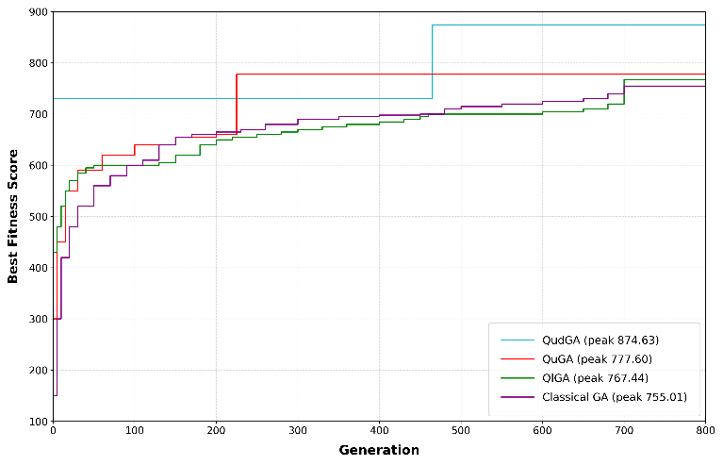
Fig. 2. Convergence of Best fitness
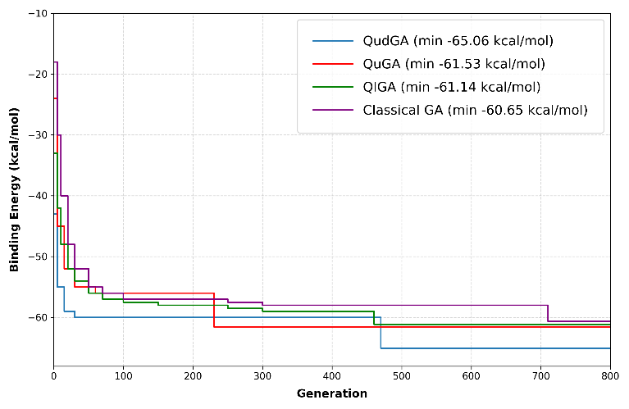
Fig. 3. Convergence of Binding Energy (kcal/mol)
The comparative study of best fitness, binding energy, and number of active nodes in the resultant ligand structure is shown in Table 1. From the table, the efficiency of the QudGA is determined not only by the best fitness and binding energy but also by the number of active nodes. These active nodes increase the potential for contact with the target protein. However, this potential does not always translate into improved binding energy, as node placement and chemical compatibility also play a determining role.
Table 1. Comparative study of best fitness, binding energy, and active nodes optimized using GA, QIGA, Qutrit GA, and QudGA
Algorithm | Best Fitness | Binding Energy (kcal/mol) | Active Nodes | Direct Interaction with Target Protein Pockets
QudGA | 874.6336 | - 65.06 | 15 | 3
Qutrit GA | 777.60 | -61.53 | 12 | 2
QIGA | 767.44 | -61.14 | 10 | 1
Classical GA | 755.01 | -60.65 | 12 | 0

Fig. 4(a) – (d) shows the optimized ligand structures corresponding to the best solutions generated using QudGA, QuGA, QIGA, and classical GA. The figures show the number of active nodes and their interactions with target protein pockets.
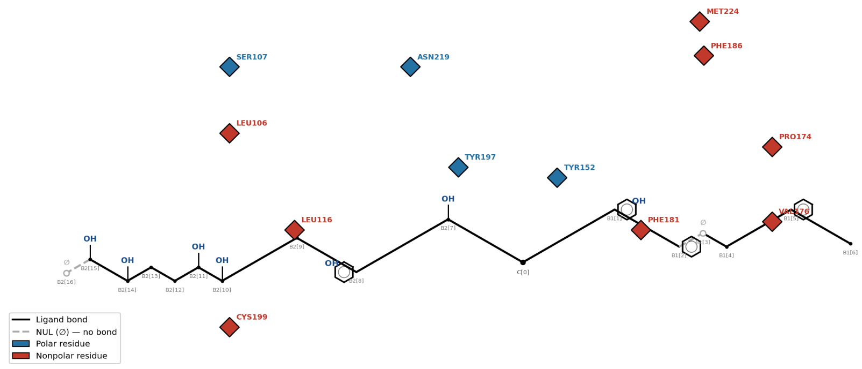
(a)
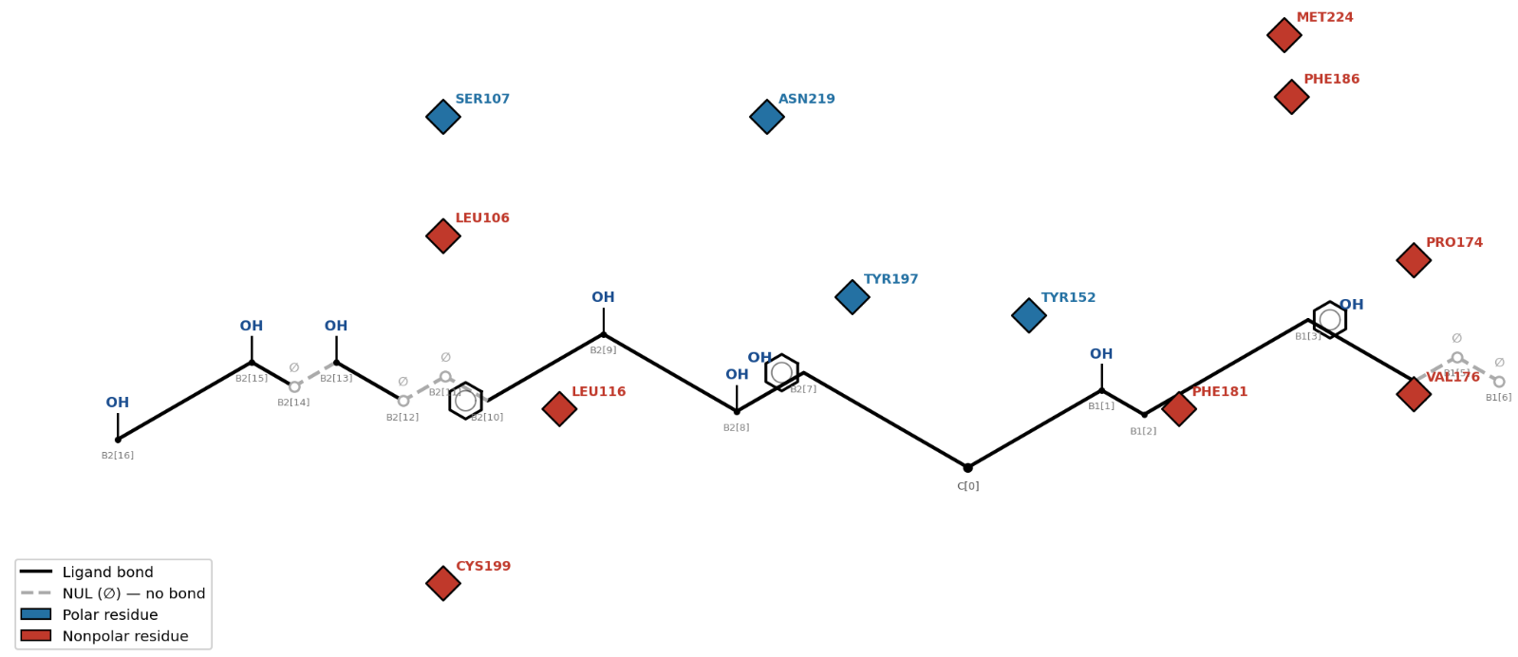
(b)

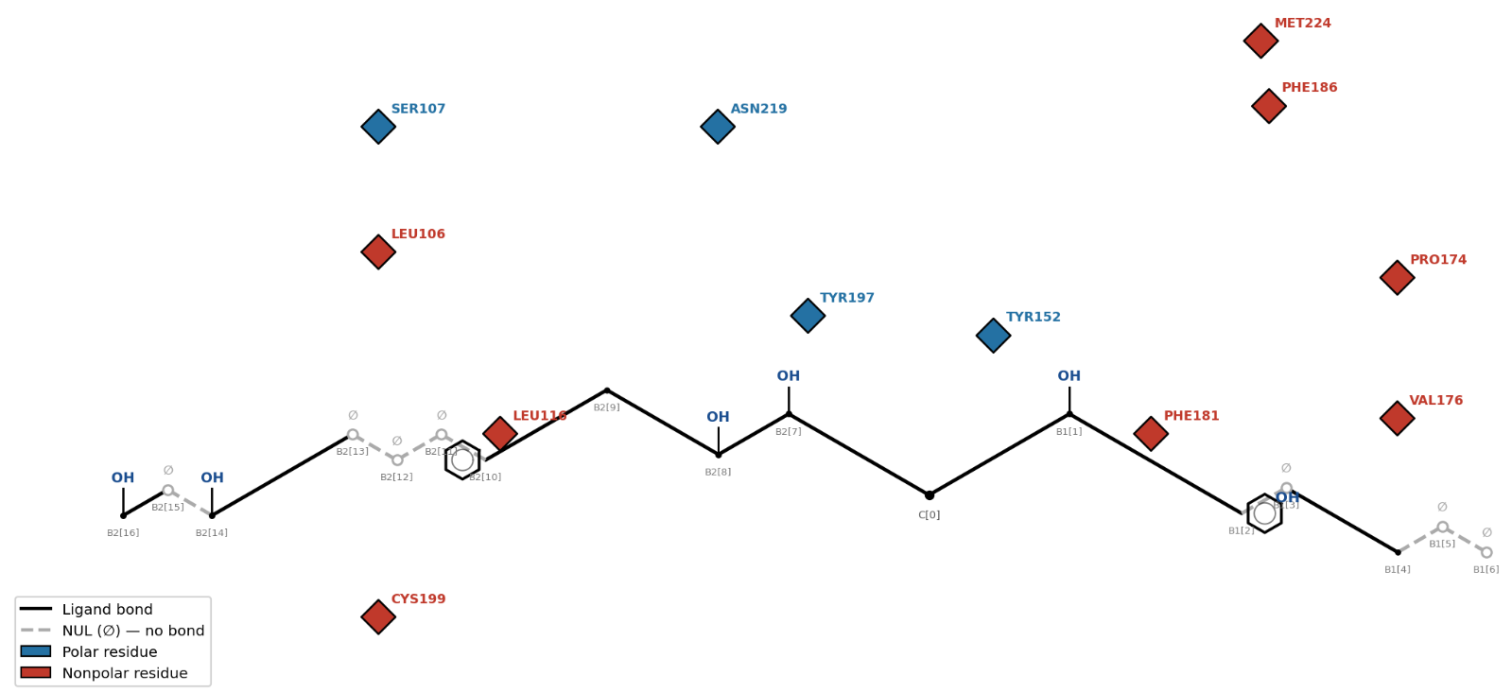
(c)
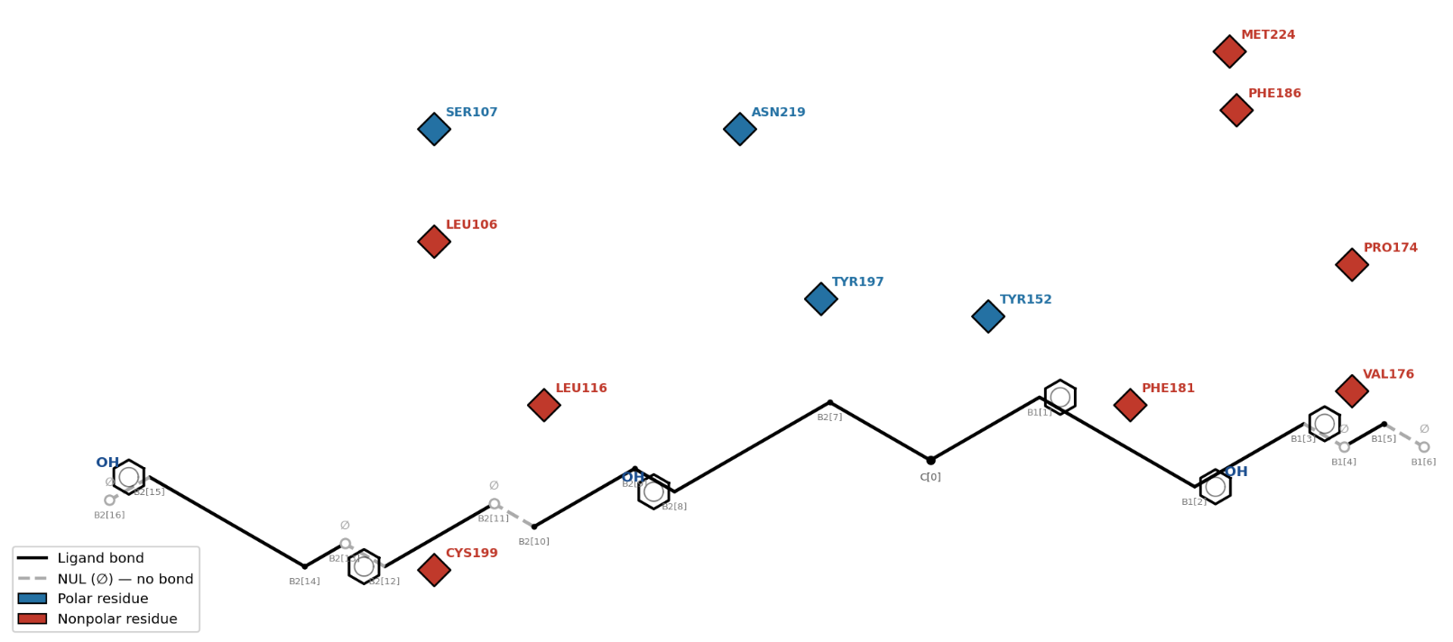
(d)

Fig. 4. Optimized ligand molecular structure generated using (a) QudGA, (b) QuGA, (c) QIGA, (d) Classical GA

Table 2 Comparative Analysis of Mean Computational Time of QudGA, QuGA, QIGA, and the classical GA (in minutes)
Algorithm | Mean Computational Time
Classical GA | 2.1052
QIGA | 2.2240
QuGA | 1.8282
QudGA | 1.2234

Table 3 ANOVA Test Results
Output Metric | F | F_{Crit} | p-Value | Significance
Best Fitness | 26042.3347 | 2.6094 | 1×10−300 | Significant
Binding Energy | 6125.2013 | 2.6094 | 1 × 10⁻300 | Significant

Table 4 Post hoc Tukey HSD for Best fitness
Group1 | Group2 | meandiff | Tukey-adjusted p-value | lower | Upper | Reject
Qudit GA | Qutrit GA | -95.6435 | 0.001 | -96.8604 | -94.4266 | True
Qudit GA | Qubit GA | -105.3972 | 0.001 | -106.6141 | -104.1804 | True
Qudit GA | Classical GA | -118.2135 | 0.001 | -119.4304 | -116.9966 | True
Qutrit GA | Qubit GA | -9.7538 | 0.001 | -10.9707 | -8.5369 | True
Qutrit GA | Classical GA | -22.5700 | 0.001 | -23.7869 | -21.3531 | True
Qubit GA | Classical GA | -12.8162 | 0.001 | -14.0331 | -11.5993 | True

Table 5 Post hoc Tukey HSD for Binding Energy
Group1 | Group2 | meandiff | Tukey-adjusted p-value | lower | Upper | Reject
Qudit GA | Qutrit GA | 3.4299 | 0.001 | 3.3383 | 3.5216 | True
Qudit GA | Qubit GA | 3.8501 | 0.001 | 3.7584 | 3.9417 | True
Qudit GA | Classical GA | 4.3435 | 0.001 | 4.2518 | 4.4352 | True
Qutrit GA | Qubit GA | 0.4201 | 0.001 | 0.3285 | 0.5118 | True
Qutrit GA | Classical GA | 0.9136 | 0.001 | 0.8219 | 1.0052 | True
Qubit GA | Classical GA | 0.4934 | 0.001 | 0.4018 | 0.5851 | True

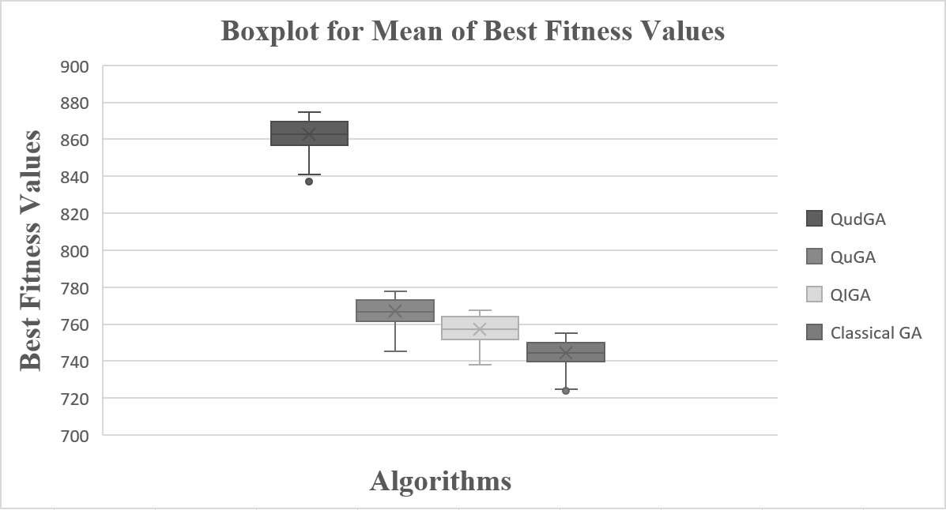
(a)
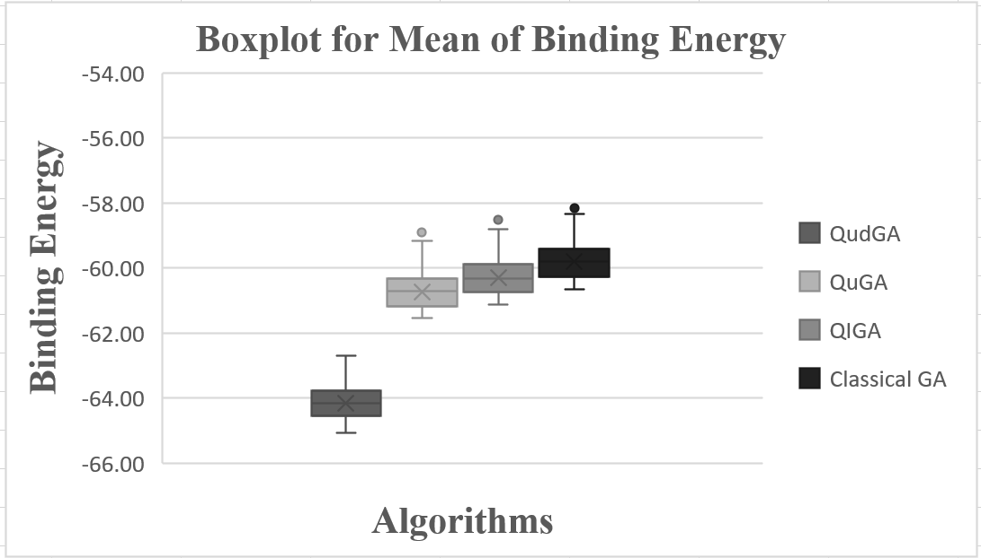
(b)
Fig. 5. Box Plot for the mean (a) best fitness and (b) binding energy values obtained by qudit GA, qutrit GA, qubit GA, and Classical GA
Table 2 shows the mean computation time of classical GA, AIGA, QuGA, and QudGA. A one-way ANOVA, as shown in Table 3, confirmed that algorithm choice has a statistically significant effect on both output metrics across 500 independent runs. For best fitness, F (3, 1996) = 26042.33 (p < 0.0001), and for binding energy, F (3, 1996) = 6125.20 (p < 0.0001), with both F-statistics far exceeding the critical value (F-crit = 2.61) at α = 0.05. These results confirm that the performance differences among Qudit GA, Qutrit GA, Qubit GA, and Classical GA are statistically robust rather than due to random variation. A post-hoc Tukey HSD test was then performed to identify which specific algorithm pairs differed significantly. Results are shown in Tables 4 and 5. All six pairwise comparisons were significant (p < 0.001) for both metrics, revealing a consistent performance hierarchy: Qudit GA > Qutrit GA > Qubit GA > Classical GA. Qudit GA significantly outperformed the other three algorithms in terms of best fitness and achieved significantly more favorable binding energies. The boxplots of the mean best-fit values and binding energies for all four algorithms are shown in Figs.ure 4 and 5. Together, these results provide strong statistical evidence for the superior and consistent docking performance of Qudit GA relative to all baseline methods.
10 Conclusion
This paper presented a comprehensive qudit-based genetic algorithm, QudGA, for drug discovery and molecular optimization. The ligand is modeled as a chain-like molecular configuration with 17 node positions. Each node is encoded as 8 state qudits, including 7 chemical functional groups and a null for the absence of any functional groups. The proposed QudGA effectively balances exploration and exploitation in high-dimensional chemical spaces. A Lennard–Jones potential is used as a fitness function. The experiments are performed on a VP1 barrel of Human Rhinovirus strain 14 (HRV-14).
Comparative analysis across QudGA, QuGA, QIGA, and classical GA reveals a consistent trend favoring QudGA. QudGA achieved the highest fitness score of 874.6336, the most favorable binding energy of -65.06 kcal/mol, the highest number of active nodes (15), and a direct interaction of 3 with the target protein among the algorithms tested.
In the future, experiments can be performed on different strains. Effects of different ligand structures can also be examined in future studies. Instead of using quantum-inspired evolutionary algorithms, other types of optimization algorithms can also be used for the same purpose, and an analysis on the effects of the algorithms can be performed.

References
[1] Pathak, A., Theagarajan, R., Rizqi, M. M., Nugraha, A. S., Boruah, T., Pratiksha, Kumar, H., Naik, B., Yadav, S., Jha, A. K., Trivedi, A., Gupta, A. K., & Kumar, P. (2025). AI-enabled drug and molecular discovery: computational methods, platforms, and translational horizons. Discover Molecules, 2(1), 32. https://doi.org/10.1007/s44345-025-00037-5
[2] Vidiyala, N., Sunkishala, P., Parupathi, P., & Nyavanandi, D. The role of artificial intelligence in drug discovery and pharmaceutical development: A paradigm shift in the history of pharmaceutical industries. AAPS PharmSciTech, 26(5), 133. https://doi.org/10.1208/s12249-025-03134-3, 2025.
[3] Dara, S., Dhamercherla, S., Jadav, S. S., Babu, C. M., & Ahsan, M. J. Machine learning in drug discovery: a review. Artificial Intelligence Review, 55(3), 1947-1999. https://doi.org/10.1007/s10462-021-10058-4, 2022.
[4] Huang, X., Ting, L., Dao, T.-K., Nguyen, T. X. H., & Nguyen, T. T. Optimizing the drug discovery pipeline: A multi-objective approach with genetic algorithms. In Genetic and Evolutionary Computing, Springer, 2026.
[5] Zheng, M. Development and optimization of molecular force fields. In: Li, H., Zheng, M., Zhu, F., & Bai, F. (Eds.), Artificial Intelligence for Drug Design. Springer, Singapore, 575-601, 2026.
[6] Cao, S., Wu, H., Wang, J. B., Yuan, Y., & Misir, M. MC-GNNAS-Dock: Multi-criteria GNN-based algorithm selection for molecular docking, Springer, 2026
[7] Turgut, O. E., Turgut, M. S., & Kırtepe, E. A systematic review of the emerging metaheuristic algorithms on solving complex optimization problems. Neural Computing and Applications, 35, 14275-14378, 2023.
[8] Cao, S., Wu, H., Wang, J. B., Yuan, Y., & Misir, M. MC-GNNAS-Dock: Multi-criteria GNN-based algorithm selection for molecular docking. Springer, 2026.
[9] Alhijawi, B., & Awajan, A. Genetic algorithms: theory, genetic operators, solutions, and applications. Evolutionary Intelligence, Springer, 2023.
[10] Dalkılıç, Ş. B., Özgür, A., & Erdem, H. Balancing exploration and exploitation in genetic algorithm optimization: a novel selection operator. Evolutionary Intelligence, 18, 40, 2025.
[11] Hakemi, S., Houshmand, M., KheirKhah, E., et al. A review of recent advances in quantum-inspired metaheuristics. Evolutionary Intelligence, 17, 627-642, 2024.
[12] Talbi, H., Draa, A., and Batouche, M., 2004, December. A new quantum-inspired genetic algorithm for solving the travelling salesman problem. In 2004 IEEE International Conference on Industrial Technology, 2004. IEEE ICIT'04. (Vol. 3, pp. 1192-1197). IEEE.
[13] Tkachuk, V., 2018. Quantum genetic algorithm based on qutrits and its application. Mathematical Problems in Engineering, 2018(1), p.8614073.
[14] Dutta, T., Dey, S., Bhattacharyya, S., Mukhopadhyay, S., and Chakrabarti, P., 2021. Hyperspectral multi-level image thresholding using qutrit genetic algorithm. Expert Systems with Applications, 181, p.115107.
[15] Das, P., Ray, A., Halder, S., Bhattacharya, S., Platos, J., Snasel, V., Multilevel Image Thresholding using Qudit Genetic Algorithm, In Proceedings of 7th International Conference on Artificial Intelligence and Advanced Manufacturing (AIAM 2025), Heidelberg, Germany, IET.
[16] Ghosh, A., Ghosh, A., Chowdhury, A., & Hazra, J. (2012). An evolutionary approach to drug-design using quantam binary particle swarm optimization algorithm. In Proceedings of 2012 IEEE Students' Conference on Electrical, Electronics and Computer Science (Vol. 2012, pp. 1–4). IEEE.
[17] Ghosh, A., Ghosh, A., Chowdhury, A., & Konar, A. (2012). An evolutionary approach to drug-design using a novel neighbourhood based genetic algorithm. arXiv preprint arXiv:1205.6412.
[18] Y. Kwon and J. Lee, MolFinder: an evolutionary algorithm for the global optimization of molecular properties and the extensive exploration of chemical space using SMILES, Journal of Cheminformatics, Springer/BMC, vol. 13, pp. 1–14, 2021.
[19] G. Chalmers, Introducing ligand GA, a genetic algorithm molecular tool for automated protein inhibitor design, Scientific Reports, Springer Nature, vol. 12, art. 20877, 2022.
[20] L. Guo, Z. Yan, X. Zheng, L. Hu, Y. Yang, and J. Wang, A comparison of various optimization algorithms of protein–ligand docking programs by fitness accuracy, Journal of Molecular Modeling, Springer, vol. 20, art. 2251, 2014.
[21] J. Thompson, Genetic Algorithms and Applications, in Handbook of Formal Optimization, A. J. Kulkarni and A. H. Gandomi, Eds., Springer, Singapore, 2024.
[22] S. Kamphausen, N. Höltge, F. Wirsching, C. Morys-Wortmann, D. Riester, R. Goetz, M. Thürk, and A. Schwienhorst, Genetic algorithm for the design of molecules with desired properties, Journal of Computer-Aided Molecular Design, Springer, vol. 16, pp. 551–567, 2002.
[23] J. Zhou, Z. Yang, Y. He, J. Ji, Q. Lin, and J. Li, A novel molecular docking program based on a multi-swarm competitive algorithm, Swarm and Evolutionary Computation, Elsevier, vol. 78, art. 101292, 2023.
[24] D. K. Chaurasia, R. Anjum, A. Shandilya, A. K. Patel, and B. Jayaram, Prioritizing Candidate Drugs Via Virtual Screening, Docking and Simulations, in Springer Handbook of Chem- and Bioinformatics, J. Leszczynski, Ed., Springer, Cham, 2025.
[25] X. Wang, W. Han, X. Yan, J. Zhang, M. Yang, and P. Jiang, Pharmacophore features for machine learning in pharmaceutical virtual screening, Molecular Diversity, Springer, vol. 24, pp. 407–412, 2020.
[26] R. P. Bhagat, S. A. Amin, L. Sessa, S. Concilio, S. Piotto, and S. Gayen, Cheminformatics in advancing dengue antiviral research: From conventional molecular modeling (MM) to current artificial intelligence (AI) approaches, European Journal of Medicinal Chemistry Reports, Elsevier, vol. 15, art. 100295, 2025.
[27] X. Huang, L. Ting, T.-K. Dao, T. X. H. Nguyen, and T. T. Nguyen, Optimizing the Drug Discovery Pipeline: A Multi-objective Approach with Genetic Algorithms, Springer, 2026.
[28] H. Mustafa, S. N. Morapakula, P. Jain, and S. Ganguly, Variational Quantum Algorithms for Chemical Simulation and Drug Discovery, in 2022 Int. Conf. on Trends in Quantum Computing and Emerging Business Technologies (TQCEBT), IEEE, 2022.
[29] I. Liliopoulos, G. D. Varsamis, T. Karamanidou, et al., Quantum algorithm for protein-ligand docking sites identification in the interaction space, Journal of Computer-Aided Molecular Design, Springer, vol. 39, art. 40, 2025.
[30] J. Li, M. Alam, C. M. Sha, J. Wang, N. V. Dokholyan, and S. Ghosh, Invited: Drug Discovery Approaches Using Quantum Machine Learning, in Proc. 59th ACM/IEEE Design Automation Conference (DAC), IEEE, 2022.
[31] Z. Liang, Z. He, Y. Sun, D. Herman, Q. Jiao, Y. Zhu, W. Jiang, X. Xu, D. Wu, M. Pistoia, and Y. Shi, Synergizing quantum techniques with machine learning for advancing drug discovery challenge, Scientific Reports, Springer Nature, vol. 14, art. 31216, 2024.
[32] I. Liliopoulos, G. D. Varsamis, T. Karamanidou, et al., Quantum algorithm for protein-ligand docking sites identification in the interaction space, Journal of Computer-Aided Molecular Design, Springer, 2025.
[33] Darwish, S. M., Shendi, T. A., & Younes, A. (2019). Chemometrics approach for the prediction of chemical compounds' toxicity degree based on quantum inspired optimization with applications in drug discovery. Chemometrics and Intelligent Laboratory Systems, 193, 103826. https://doi.org/10.1016/j.chemolab.2019.103826
[34] Narayanan, A. and Moore, M., 1996, May. Quantum-inspired genetic algorithms. In Proceedings of IEEE International Conference on Evolutionary Computation (pp. 61-66). IEEE.

