Data Analysis Report

# Summary Statistics

<class 'pandas.core.frame.DataFrame'>  
RangeIndex: 614 entries, 0 to 613  
Data columns (total 13 columns):  
 # Column Non-Null Count Dtype   
--- ------ -------------- -----   
 0 Loan_ID 614 non-null object   
 1 Gender 601 non-null object   
 2 Married 611 non-null object   
 3 Dependents 599 non-null object   
 4 Education 614 non-null object   
 5 Self_Employed 582 non-null object   
 6 ApplicantIncome 614 non-null int64   
 7 CoapplicantIncome 614 non-null float64  
 8 LoanAmount 592 non-null float64  
 9 Loan_Amount_Term 600 non-null float64  
 10 Credit_History 564 non-null float64  
 11 Property_Area 614 non-null object   
 12 Loan_Status 614 non-null object   
dtypes: float64(4), int64(1), object(8)  
memory usage: 62.5+ KB  
None

# Loan Status Plot

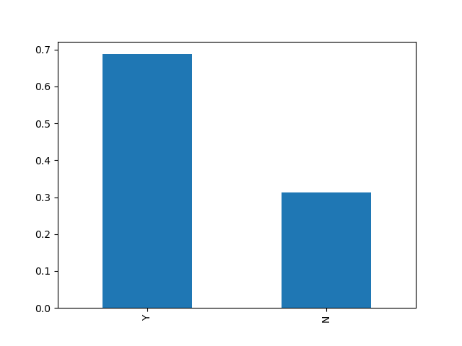

# Plot of Categorical Variables

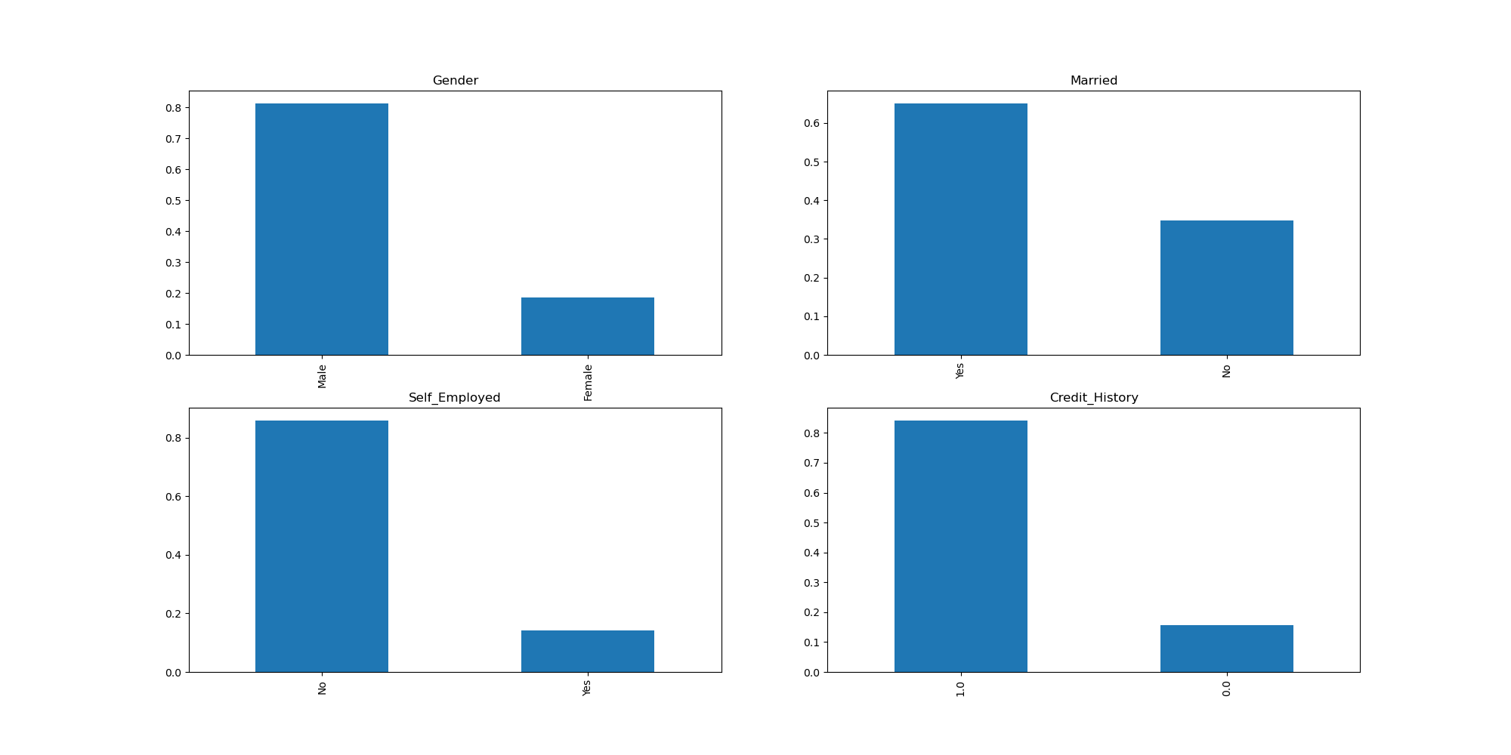

# Plot of Ordinal Variables

