LATTE TRADE (Ecosystem centred around the USER)

- In reality, there are no competitors for mocha trade in its own field, but still, it’s growing slowly. Why? – the main reason is TRUST, a lot of Indians want to trade US stocks and hence visit mocha trade and then get to know that they will not be a true share holder of that particular company, they just back out of mocha trade because the website not at all explains its backend working to gain trust by the users. Here, in Latte trade we have given all the steps and entire working of our company.

- A subscription system wherein a user can either choose small term investments plan (here per buy/sell costs ₹20) or long-term investments + perpetual futures plan (here ₹999 /month up to ₹50 Lakhs of investments).

- A dedicated and organised structural learning videos which helps a beginner to understand and think sequentially without any clumsy video gathering from various other sources. This makes a person from beginner to a level where he/she can take bold decisions.

- Simulated sessions wherein beginners will be given digital tokens, with that they can practice trading, investing and also with perpetual futures, before they step into the real market. This gives them a chance to learn even before having any real losses.

- We have introduced an entirely new concept of having a leaderboard for the top 20 traders who started off as beginners and currently are making significant profits. They’re trading strategies and opinions will be shared with the rest traders which will have a minimal charge, this will bring TRUST in themselves and also on the company.

- Trading, Investment, sustaining in the market and making Profits is mainly dependent on one’s psychology, we in Latte trade have taken a bigger leap on tracking the user’s psychology, his/her mental state by implementing the following 1. A user has to clearly state and explain about his opinion of buying and his goal in doing so, one must also set a stop loss as to what is his capacity of bearing a loss, before he buys any stock.
2. If the user did not reach his aimed goal (achievable and realistic goal) in 10 trades which is done, then a request to close all his trades and start with a new strategy which also includes the various reasons involved in the previous loss, will be sent.
3. Our AI will analyse various reasons which the user had given, his buying and selling points, the profits and losses which he/she makes, by collecting all these the state of mind of the user is known, if its on the wrong path, a request to correct and implement a new strategy will be sent.
- One more major implementation is that various stocks will be analysed by the past and present market values and shares to predict if it would uptrend or down trend in Perpetual Futures. With this we shall also keep all the analysed data in front of the user so that they themselves can also analyse it, which also erases misconceptions (if any) about the AI system being used.

- Revenue Projection: we shall be targeting 5% of the market initially.

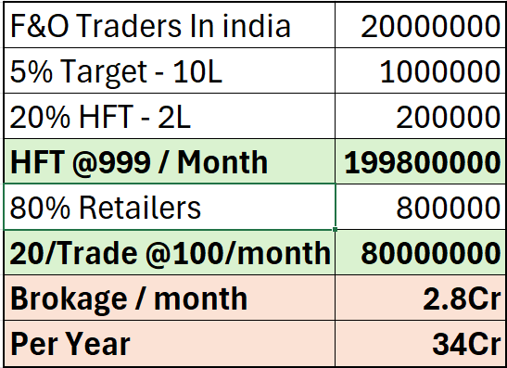

- Ecosystem centred around the USER: We here in Latte Trade, give every user a complete guide and track to achieve their respective goals through various features mentioned above , we also learn from their state of mind and recommend it to the newly joined young traders, to conclude we are 10 different divisions built into 1 single platform “LATTE TRADE”.

