Experiment No. 1

1) Title : Demonstrate inline, internal, and external JavaScript; use console methods; create a webpage showing user info and a welcome message.

2) Software/Tools Required :
- Visual Studio Code (VS Code) / Notepad++
- Web Browser (Google Chrome, Microsoft Edge, Firefox, etc.)
- JavaScript
- HTML

3) Theory :

JavaScript is a scripting language used to make web pages interactive and dynamic. It can be included in an HTML document in three ways:

A. Inline JavaScript
JavaScript code is written directly within an HTML element using event attributes.
Example:
<button onclick="alert('Welcome!')">Click Me</button>
B. Internal JavaScript
JavaScript code is written inside the <script> tag within the HTML file.
Example:
<script>
console.log("Internal JavaScript");
</script>

C. External JavaScript
JavaScript code is written in a separate .js file and linked to the HTML document.
Example:
<script src="script.js"></script>

Console Methods Used
- console.log() – Displays general information.
- console.info() – Displays informational messages.
- console.warn() – Displays warning messages.
- console.error() – Displays error messages.
- console.table() – Displays data in tabular format.

Program Description
The webpage displays:
- Student Name
- PRN Number
- Branch
- Welcome Message
It also demonstrates different console methods and all three JavaScript implementation techniques.

HTML File (index.html)
<!DOCTYPE html>
<html lang="en">
<head>
<meta charset="UTF-8">
<meta name="viewport" content="width=device-width, initial-scale=1.0">
<title>User Information Portal</title>
<style>
body {
font-family: Arial, sans-serif;
background: linear-gradient(135deg, #4facfe, #00f2fe);
margin: 0;
padding: 0;
}
.container {
width: 450px;
margin: 60px auto;
background: white;
padding: 30px;
border-radius: 15px;
box-shadow: 0 8px 20px rgba(0,0,0,0.2);
text-align: center;
}
h1 {
color: #0077cc;
}
.info {
text-align: left;
margin-top: 20px;
line-height: 1.8;
font-size: 18px;
}
.welcome {
margin-top: 20px;
color: green;
font-size: 20px;
font-weight: bold;
}
button {
background: #0077cc;
color: white;
border: none;
padding: 12px 25px;
border-radius: 8px;
font-size: 16px;
cursor: pointer;
margin-top: 20px;
}
button:hover {
background: #005fa3;
}
</style>
</head>
<body>
<div class="container">
<h1>User Information Portal</h1>
<div class="info">
<p><strong>Name:</strong> Tanay Soman</p>
<p><strong>PRN:</strong> YOUR_PRN</p>
<p><strong>Branch:</strong> AIML</p>
<p><strong>College:</strong> SIT Nagpur</p>
</div>
<div id="message" class="welcome"></div>
<!-- Inline JavaScript -->
<button onclick="alert('Welcome Tanay Soman! Have a great day.')">
Show Greeting
</button>
</div>
<!-- Internal JavaScript -->
<script>
document.getElementById("message").innerHTML =
"Welcome to the JavaScript Demonstration Page!";
console.log("Log: User Information Page Loaded");
console.info("Info: Welcome message displayed");
console.warn("Warning: This is a demo page");
console.error("Error: Sample error message");
</script>
<!-- External JavaScript -->
<script src="script.js"></script>
</body>
</html>

External JavaScript File (script.js)
const student = [
{
Name: "Tanay Soman",
PRN: "YOUR_PRN",
Branch: "AIML",
College: "SIT Nagpur"
}
];
console.table(student);
console.log("External JavaScript Loaded Successfully");
4) Output :

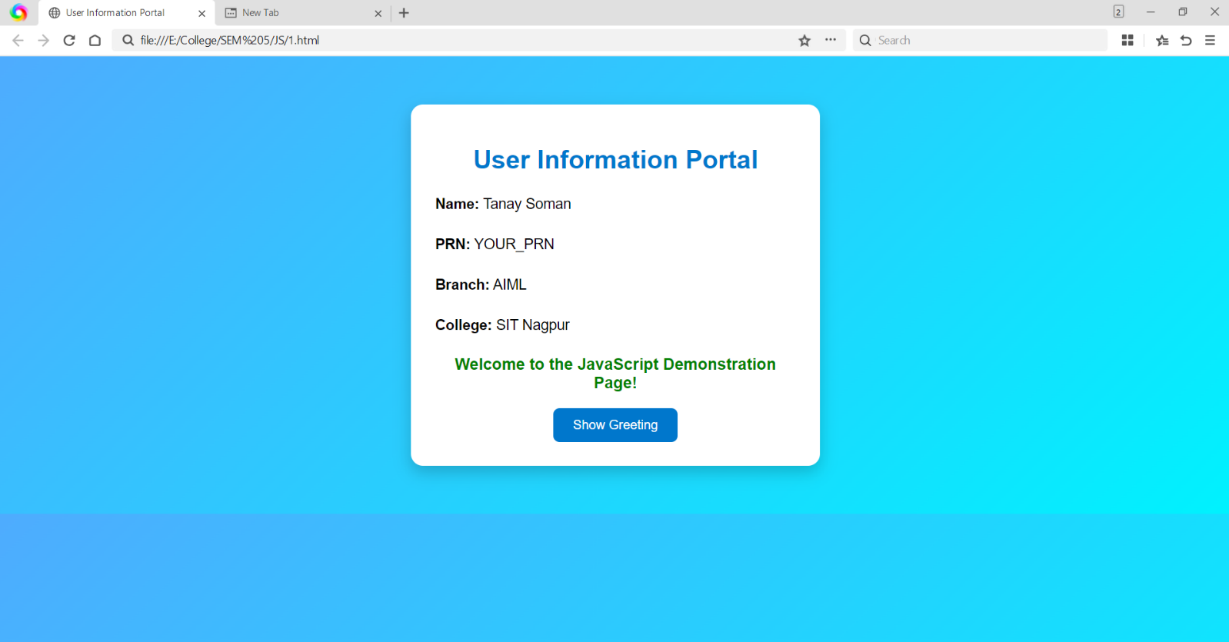

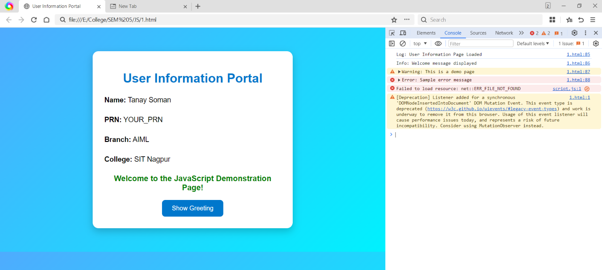

5) Result/Conclusion:
The experiment was successfully performed. Inline, Internal and External JavaScript were implemented in a webpage. Various console methods such as console.log(), console.info(), console.warn(), console.error() and console.table() were executed successfully. The webpage displayed user information and a welcome message, demonstrating the integration of JavaScript with HTML.

