Experiment No. 10

- Title : Load and Display JSON data using fetch() and jQuery$.getJSON(); render results dynamicallyin a table.

2) Software/Tools Required :
- Visual Studio Code – To write and edit the HTML, CSS, and JavaScript code.
- Web Browser – Google Chrome, Microsoft Edge, or Mozilla Firefox to run the webpage.
- jQuery 3.7.1 – Used for $.getJSON() and DOM manipulation.
- Internet Connection – Required to access the JSONPlaceholder public API.
- JSONPlaceholder API – Provides the sample user data in JSON format.

- Theory :

- The program demonstrates loading JSON data using fetch() and jQuery $.getJSON().
- The Fetch API uses Promises and async/await to retrieve and process data.
- $.getJSON() simplifies JSON retrieval by automatically parsing the response.
- The program uses error handling to manage failed or unsuccessful requests.
- The retrieved user data is dynamically displayed in an HTML table using jQuery.

index.html –
<!DOCTYPE html>
<html lang="en">
<head>
<meta charset="UTF-8">
<title>JSON → Table: fetch() vs $.getJSON()</title>
<script src="https://cdnjs.cloudflare.com/ajax/libs/jquery/3.7.1/jquery.min.js"></script>
<style>
:root {
--ink: #1c1c1e;
--paper: #fbfaf7;
--line: #d8d5cc;
--accent: #2f5d50;
--accent-soft: #e7efec;
--mono: "SFMono-Regular", Consolas, "Liberation Mono", Menlo, monospace;
--sans: -apple-system, "Segoe UI", Helvetica, Arial, sans-serif;
}
* { box-sizing: border-box; }
body {
margin: 0;
padding: 32px 20px 60px;
background: var(--paper);
color: var(--ink);
font-family: var(--sans);
line-height: 1.5;
}
.wrap { max-width: 860px; margin: 0 auto; }
h1 {
font-size: 1.4rem;
font-weight: 600;
margin: 0 0 4px;
}
p.lede {
color: #55554f;
margin: 0 0 28px;
max-width: 62ch;
}
.panels {
display: grid;
grid-template-columns: 1fr 1fr;
gap: 16px;
margin-bottom: 24px;
}
@media (max-width: 640px) {
.panels { grid-template-columns: 1fr; }
}
.panel {
border: 1px solid var(--line);
border-radius: 6px;
padding: 16px 18px;
background: #fff;
}
.panel h2 {
font-size: 0.95rem;
margin: 0 0 4px;
font-weight: 600;
}
.panel code {
font-family: var(--mono);
font-size: 0.8rem;
color: var(--accent);
}
.panel p {
font-size: 0.85rem;
color: #55554f;
margin: 8px 0 14px;
}
button {
font: inherit;
font-size: 0.85rem;
padding: 7px 14px;
border-radius: 5px;
border: 1px solid var(--accent);
background: var(--accent);
color: #fff;
cursor: pointer;
}
button:hover { background: #254a40; }
button:disabled {
opacity: 0.55;
cursor: default;
}
.status {
margin-top: 12px;
font-size: 0.8rem;
font-family: var(--mono);
min-height: 1.2em;
color: #55554f;
}
.status.err { color: #a6413a; }
.status.ok { color: var(--accent); }
table {
width: 100%;
border-collapse: collapse;
background: #fff;
border: 1px solid var(--line);
border-radius: 6px;
overflow: hidden;
font-size: 0.87rem;
}
thead th {
text-align: left;
background: var(--accent-soft);
padding: 10px 12px;
font-weight: 600;
border-bottom: 1px solid var(--line);
}
tbody td {
padding: 9px 12px;
border-bottom: 1px solid #eeece5;
vertical-align: top;
}
tbody tr:last-child td { border-bottom: none; }
tbody tr:hover { background: #faf9f5; }
.empty-row td {
text-align: center;
color: #918f86;
padding: 22px;
font-style: italic;
}
.source-tag {
display: inline-block;
font-family: var(--mono);
font-size: 0.7rem;
padding: 2px 6px;
border-radius: 4px;
background: var(--accent-soft);
color: var(--accent);
margin-left: 6px;
}
</style>
</head>
<body>
<div class="wrap">
<h1>Loading JSON two ways</h1>
<p class="lede">
Same public dataset, two loading methods. The left panel uses the native
<code>fetch()</code> API with <code>async/await</code>; the right panel uses jQuery's
<code>$.getJSON()</code> shorthand. Either button fills the same table below.
</p>
<div class="panels">
<div class="panel">
<h2>Native <code>fetch()</code></h2>
<p>Returns a Promise; you parse the body yourself with <code>.json()</code>.</p>
<button id="btn-fetch">Load with fetch()</button>
<div id="status-fetch" class="status"></div>
</div>
<div class="panel">
<h2>jQuery <code>$.getJSON()</code></h2>
<p>Wraps XHR and parses the response for you automatically.</p>
<button id="btn-jquery">Load with $.getJSON()</button>
<div id="status-jquery" class="status"></div>
</div>
</div>
<table>
<thead>
<tr>
<th>Name</th>
<th>Username</th>
<th>Email</th>
<th>City</th>
<th>Company</th>
</tr>
</thead>
<tbody id="results">
<tr class="empty-row"><td colspan="5">No data loaded yet — pick a method above.</td></tr>
</tbody>
</table>
</div>
<script>
const API_URL = "https://jsonplaceholder.typicode.com/users";
const $tbody = $("#results");
function renderRows(users, sourceLabel) {
$tbody.empty();
if (!users || !users.length) {
$tbody.append('<tr class="empty-row"><td colspan="5">No records returned.</td></tr>');
return;
}
users.forEach(function (u) {
const row = $("<tr></tr>");
row.append($("<td></td>").text(u.name));
row.append($("<td></td>").text("@" + u.username));
row.append($("<td></td>").text(u.email));
row.append($("<td></td>").text(u.address && u.address.city ? u.address.city : "—"));
row.append($("<td></td>").text(u.company && u.company.name ? u.company.name : "—"));
$tbody.append(row);
});
$("<span></span>").addClass("source-tag").text(sourceLabel);
}
function setStatus(el, text, cls) {
el.text(text).removeClass("ok err").addClass(cls || "");
}
// --- Approach 1: native fetch() ---
$("#btn-fetch").on("click", async function () {
const $btn = $(this);
const $status = $("#status-fetch");
$btn.prop("disabled", true);
setStatus($status, "Fetching…");
try {
const response = await fetch(API_URL);
if (!response.ok) {
throw new Error("HTTP " + response.status);
}
const users = await response.json();
renderRows(users, "via fetch()");
setStatus($status, "Loaded " + users.length + " records.", "ok");
} catch (err) {
setStatus($status, "Error: " + err.message, "err");
} finally {
$btn.prop("disabled", false);
}
});
// --- Approach 2: jQuery $.getJSON() ---
$("#btn-jquery").on("click", function () {
const $btn = $(this);
const $status = $("#status-jquery");
$btn.prop("disabled", true);
setStatus($status, "Fetching…");
$.getJSON(API\_URL)
.done(function (users) {
renderRows(users, "via $.getJSON()");
setStatus($status, "Loaded " + users.length + " records.", "ok");
})
.fail(function (jqXHR, textStatus) {
setStatus($status, "Error: " + textStatus, "err");
})
.always(function () {
$btn.prop("disabled", false);
});
});
</script>
</body>
</html>
software required
theory
conclusion fot this

- Output :

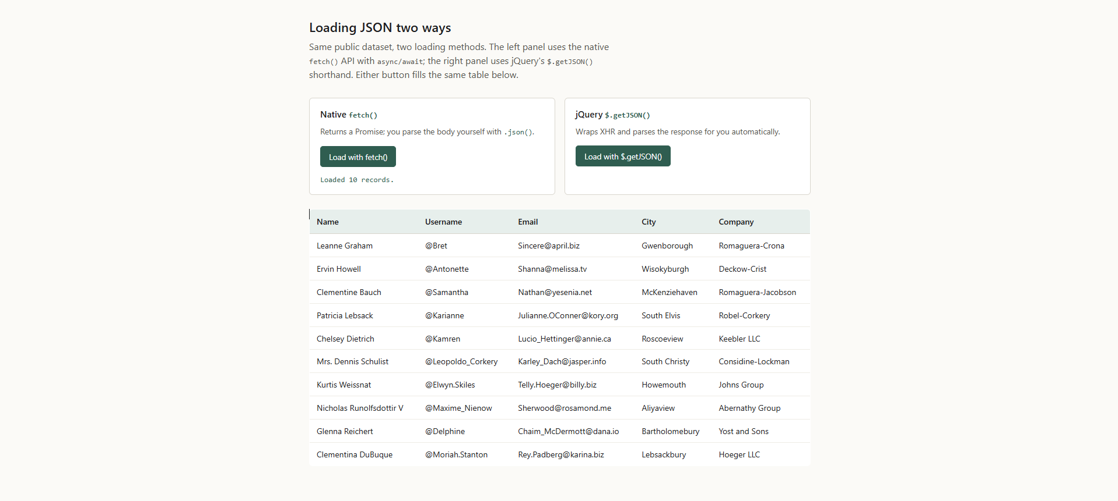

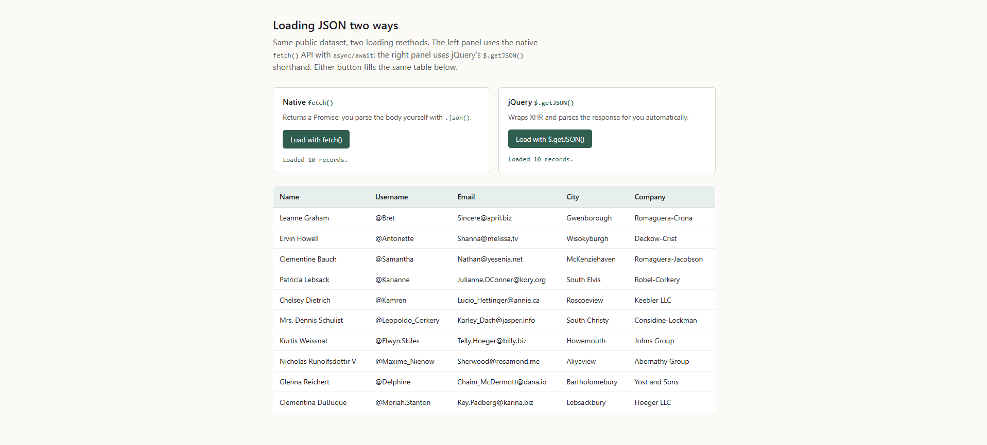

- Result/Conclusion:

The program successfully demonstrates how JSON data can be retrieved from a public API using both JavaScript fetch() and jQuery $.getJSON(). The fetched data is dynamically processed and displayed in an HTML table. It also demonstrates asynchronous programming, Promise handling, error handling, and DOM manipulation. fetch() provides a modern and flexible approach, while $.getJSON() offers a simpler jQuery-based method for retrieving JSON data.

