Experiment No. 2

- Title : Use var, let, const and demonstrate basic features like template literals and destructuring; build a billing calculator with user input.

2) Software/Tools Required :
- Visual Studio Code (VS Code) or any text editor (Notepad++, Sublime Text, etc.)
- Web Browser (Google Chrome, Mozilla Firefox, Microsoft Edge)
- HTML5
- JavaScript (ES6+)

3) Theory :

1. var
var is used to declare variables with function scope. It can be redeclared and updated.
var customerName = document.getElementById("customer").value;

2. let
let is used to declare block-scoped variables. It can be updated but cannot be redeclared in the same scope.
let quantity = Number(document.getElementById("quantity").value);

3. const
const is used to declare constants whose values cannot be reassigned after initialization.
const price = Number(document.getElementById("price").value);

4. Template Literals
Template literals allow embedding variables and expressions directly into strings using backticks ( ) and${}` syntax.
`Customer: ${name}`
Output Example:
Customer: Tanay Soman

5. Destructuring
Destructuring is used to extract values from objects or arrays and assign them to variables in a concise way.
const {name, qty, rate} = bill;
Here, name, qty and rate are extracted from the bill object.

index.html –
<!DOCTYPE html>
<html lang="en">
<head>
<meta charset="UTF-8">
<meta name="viewport" content="width=device-width, initial-scale=1.0">
<title>Billing Calculator</title>
<style>
body{
font-family: Arial, sans-serif;
background: #f4f4f4;
display:flex;
justify-content:center;
align-items:center;
height:100vh;
}
.container{
background:white;
padding:30px;
border-radius:10px;
box-shadow:0 0 10px rgba(0,0,0,0.2);
width:400px;
}
h2{
text-align:center;
color:#333;
}
input{
width:100%;
padding:10px;
margin:8px 0;
border:1px solid #ccc;
border-radius:5px;
}
button{
width:100%;
padding:10px;
background:#007bff;
color:white;
border:none;
border-radius:5px;
cursor:pointer;
}
button:hover{
background:#0056b3;
}
#result{
margin-top:20px;
padding:10px;
background:#eef;
border-radius:5px;
}
</style>
</head>
<body>
<div class="container">
<h2>Billing Calculator</h2>
<input type="text" id="customer" placeholder="Enter Customer Name">
<input type="number" id="quantity" placeholder="Enter Quantity">
<input type="number" id="price" placeholder="Enter Price per Item">
<button onclick="generateBill()">Generate Bill</button>
<div id="result"></div>
</div>
<script>
function generateBill()
// var demonstration
var customerName = document.getElementById("customer").value;
// let demonstration
let quantity = Number(document.getElementById("quantity").value);
// const demonstration
const price = Number(document.getElementById("price").value);
let total = quantity * price;
let gst = total * 0.18;
let finalAmount = total + gst;
// Object
const bill = {
name: customerName,
qty: quantity,
rate: price
};
// Destructuring
const {name, qty, rate} = bill;
// Template Literals
document.getElementById("result").innerHTML = `
<h3>Bill Details</h3>
<p><strong>Customer:</strong> ${name}</p>
<p><strong>Quantity:</strong> ${qty}</p>
<p><strong>Price:</strong> ₹${rate}</p>
<p><strong>Total:</strong> ₹${total}</p>
<p><strong>GST (18%):</strong> ₹${gst.toFixed(2)}</p>
<h3>Final Amount: ₹${finalAmount.toFixed(2)}</h3>
`;
console.log(`Customer: ${name}`);
console.log(`Final Amount: ₹${finalAmount.toFixed(2)}`);
}
</script>
</body>
</html>

4) Output :

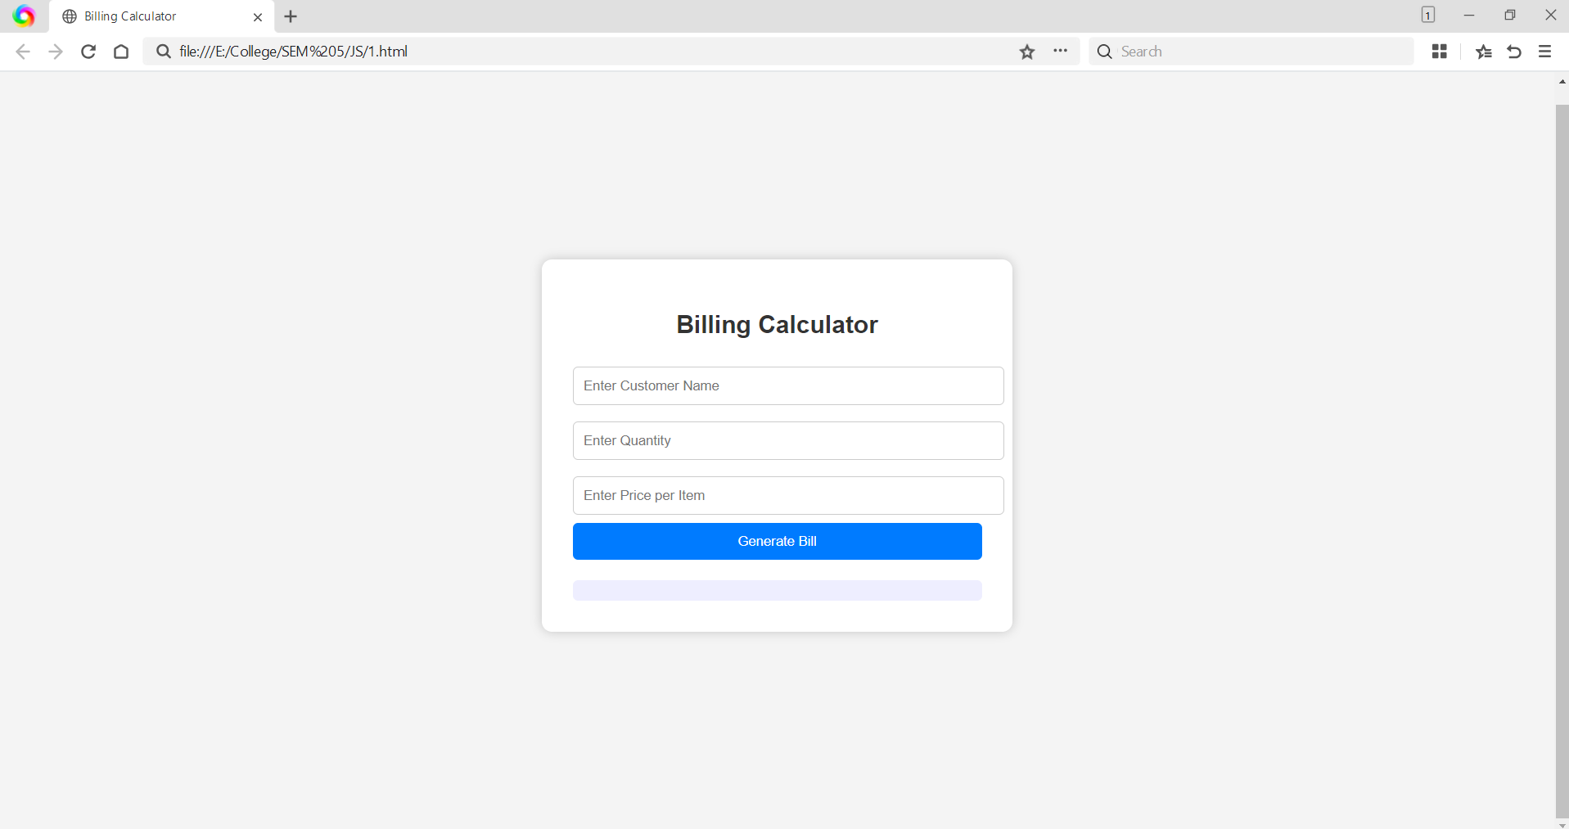
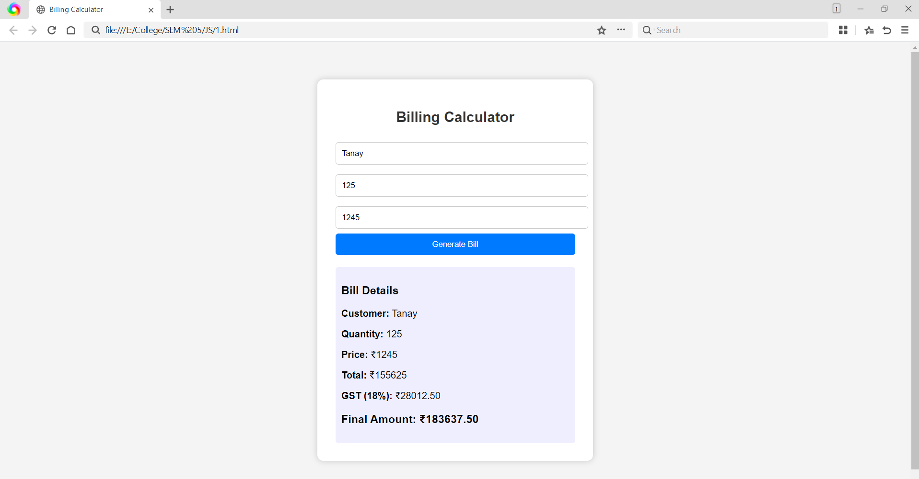

5) Result/Conclusion:
The Billing Calculator was successfully implemented using modern JavaScript features. The program demonstrated the use of var, let, const, template literals and object destructuring while accepting user input and generating a bill with GST calculation.

