Experiment No. 3

- Title : Implement control structures and form validation; create a grading system based on user-entered marks.

2) Software/Tools Required :
- Visual Studio Code (VS Code) / Notepad++
- Web Browser (Google Chrome, Firefox, Edge)
- HTML5
- JavaScript

- Theory :

1. Control Structures
Control structures are used to control the flow of program execution based on conditions.
Example:
if(marks >= 90){
grade = "A+";
}
else{
grade = "B";
}

2. Form Validation
Form validation ensures that the user enters valid data before processing.
Example:
if(marks === "" || marks < 0 || marks > 100){
alert("Please enter valid marks between 0 and 100");
return;
}

Program (index.html) –

<!DOCTYPE html>
<html>
<head>
<title>Student Grading System</title>
<style>
body{
font-family: Arial, sans-serif;
background:#f4f4f4;
display:flex;
justify-content:center;
align-items:center;
height:100vh;
}
.container{
background:white;
padding:30px;
width:400px;
border-radius:10px;
box-shadow:0 0 10px rgba(0,0,0,0.2);
text-align:center;
}
input{
width:90%;
padding:10px;
margin:10px 0;
}
button{
padding:10px 20px;
background:#007bff;
color:white;
border:none;
cursor:pointer;
border-radius:5px;
}
#result{
margin-top:20px;
font-size:20px;
font-weight:bold;
}
</style>
</head>
<body>
<div class="container">
<h2>Student Grading System</h2>
<input type="text" id="name" placeholder="Enter Student Name">
<input type="number" id="marks" placeholder="Enter Marks (0-100)">
<button onclick="calculateGrade()">Check Grade</button>
<div id="result"></div>
</div>
<script>
function calculateGrade(){
let name = document.getElementById("name").value;
let marks = document.getElementById("marks").value;
// Form Validation
if(name.trim() === ""){
alert("Please enter student name");
return;
}
if(marks === "" || marks < 0 || marks > 100){
alert("Please enter valid marks between 0 and 100");
return;
}
let grade;
// Control Structure (if-else)
if(marks >= 90){
grade = "A+";
}
else if(marks >= 80){
grade = "A";
}
else if(marks >= 70){
grade = "B";
}
else if(marks >= 60){
grade = "C";
}
else if(marks >= 50){
grade = "D";
}
else{
grade = "F";
}
document.getElementById("result").innerHTML =
`Student: ${name}<br>Marks: ${marks}<br>Grade: ${grade}`;
}
</script>
</body>
</html>

4) Output :

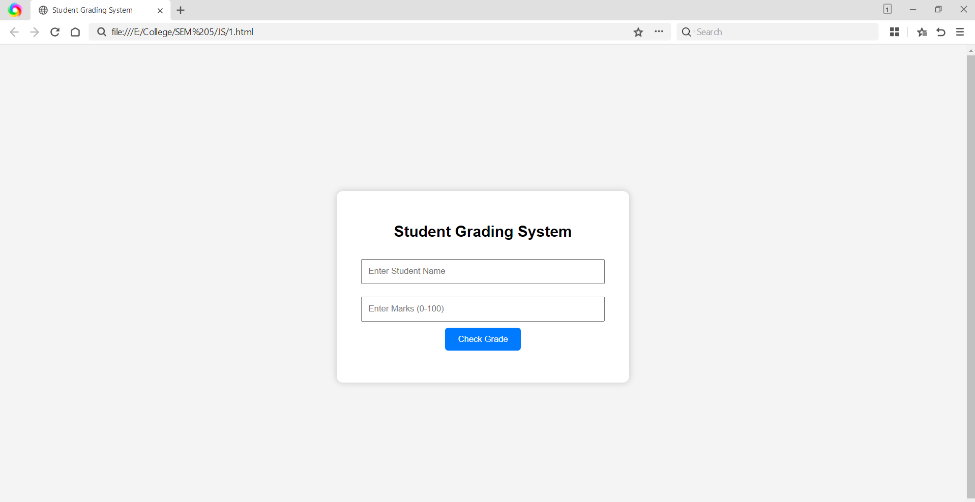
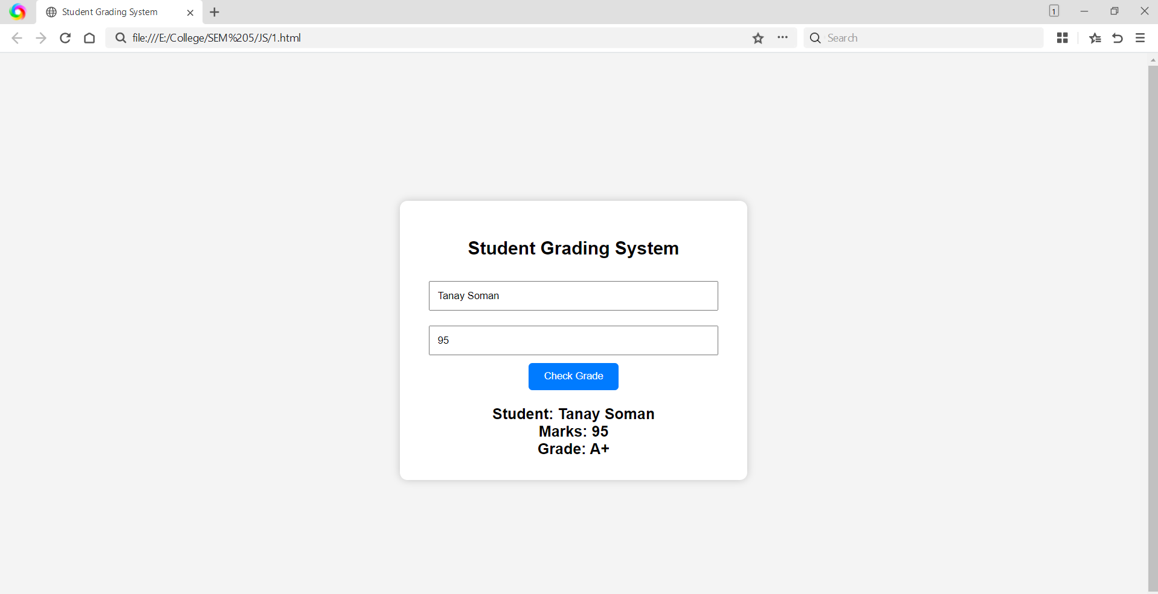

5) Result/Conclusion:
The program was successfully implemented using control structures (if-else) and form validation in JavaScript. The grading system correctly validated user input and assigned grades based on the entered marks.

