Experiment No. 4

- Title : Use function types, scope and closures; apply try-catch; build a palindrome checker.

2) Software/Tools Required :
- Visual Studio Code (VS Code) / Notepad++
- Web Browser (Google Chrome, Firefox, Edge)
- HTML5
- JavaScript

- Theory :

1. Function Declaration
A function declaration defines a reusable block of code.
function checkPalindrome(str) {
return str === str.split("").reverse().join("");
}

2. Arrow Function
Arrow functions provide a shorter syntax for writing functions.
const reverseString = str => str.split("").reverse().join("")

3. Scope
Scope determines where variables can be accessed.
let message = "Palindrome";
console.log(message);
Variables declared with let inside a function are accessible only within that function.

4. Closure
A closure allows a function to access variables from its outer function even after the outer function has executed.
function createCounter() {
let count = 0;

return function() {
count++;
return count;
};
}

5. Try-Catch
The try-catch statement handles runtime errors gracefully.
try {
console.log(value);
}
catch(error) {
console.log(error.message);
}

Program (index.html) –

<!DOCTYPE html>
<html>
<head>
<title>Palindrome Checker</title>
<style>
body{
font-family: Arial, sans-serif;
background:#f4f4f4;
display:flex;
justify-content:center;
align-items:center;
height:100vh;
}
.container{
width:400px;
background:white;
padding:30px;
border-radius:10px;
box-shadow:0 0 10px rgba(0,0,0,0.2);
text-align:center;
}
input{
width:90%;
padding:10px;
margin:10px 0;
}
button{
padding:10px 20px;
background:#007bff;
color:white;
border:none;
border-radius:5px;
cursor:pointer;
}
#result{
margin-top:20px;
font-size:20px;
font-weight:bold;
}
</style>
</head>
<body>
<div class="container">
<h2>Palindrome Checker</h2>
<input type="text" id="word" placeholder="Enter a word">
<button onclick="checkWord()">Check</button>
<div id="result"></div>
</div>
<script>
// Closure
function createCounter(){
let count = 0;
return function(){
count++;
return count;
};
}
const counter = createCounter();
// Function Declaration
function isPalindrome(str){
return str === str.split("").reverse().join("");
}
// Arrow Function
const cleanString = str =>
str.toLowerCase().replace(/\s/g,"");
function checkWord(){
try{
let word =
document.getElementById("word").value;
if(word.trim() === ""){
throw new Error(
"Please enter a word."
);
}
let cleanedWord =
cleanString(word);
let result =
isPalindrome(cleanedWord);
let attempts = counter();
document.getElementById("result")
.innerHTML =
result
? `"${word}" is a Palindrome<br>
Checked ${attempts} time(s)`
: `"${word}" is Not a Palindrome<br>
Checked ${attempts} time(s)`;
}
catch(error){
document.getElementById("result")
.innerHTML =
`<span style="color:red">
${error.message}
</span>`;
}
}
</script>
</body>
</html>

4) Output :

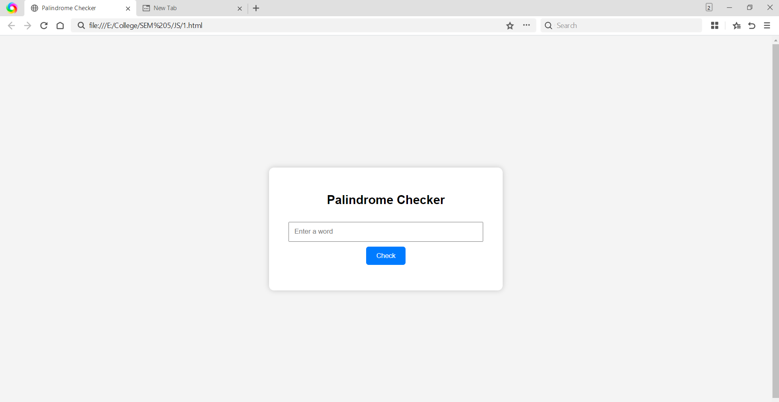
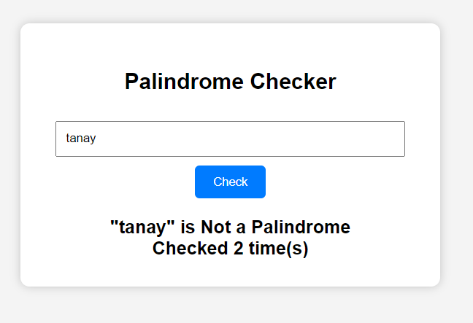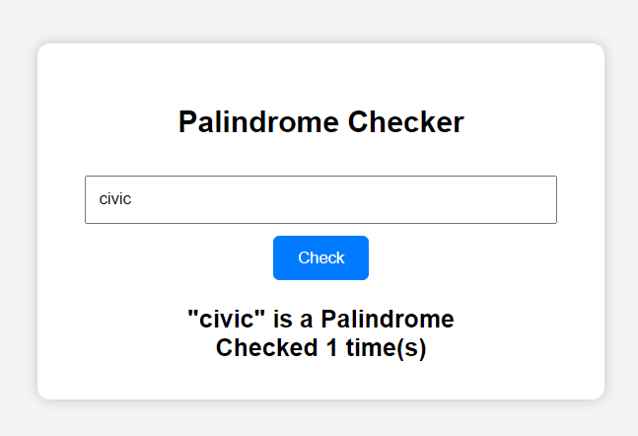

5) Result/Conclusion:
The Palindrome Checker was successfully implemented using JavaScript. The program demonstrated function declaration, arrow functions, variable scope, closures and try-catch exception handling while checking whether a user-entered string is a palindrome.

