Experiment No. 5

- Title : Apply array methods and object handling; create a cart total calculator with discount logic.

2) Software/Tools Required :
- Visual Studio Code (VS Code) – Code editor for writing HTML, CSS, and JavaScript.
- Web Browser – Google Chrome, Mozilla Firefox, Microsoft Edge, or any modern browser to run the application.
- Live Server Extension (Optional) – VS Code extension for real-time preview and automatic page refresh.
- Operating System – Windows, Linux, or macOS.
- Notepad/Notepad++ (Optional) – Alternative text editor for coding.

- Theory :

JavaScript arrays can store multiple objects representing products in a shopping cart. Array methods such as reduce() can be used to calculate totals efficiently. Objects help organize product details like name, price, and quantity. Discount logic can then be applied based on the cart's total value.

index.html –
<!DOCTYPE html>
<html>
<head>
<title>Cart Total Calculator</title>
</head>
<body>
<h2>Cart Total Calculator</h2>
<button onclick="calculateCart()">Calculate Total</button>
<div id="result"></div>
<script>
function calculateCart() {
const cart = [
{ name: "Laptop", price: 50000, quantity: 1 },
{ name: "Mouse", price: 1000, quantity: 2 },
{ name: "Keyboard", price: 2000, quantity: 1 }
];
let total = cart.reduce((sum, item) => {
return sum + (item.price * item.quantity);
}, 0);
let discount = 0;
if (total >= 50000) {
discount = total * 0.15;
} else if (total >= 20000) {
discount = total * 0.10;
} else if (total >= 5000) {
discount = total * 0.05;
}
let finalAmount = total - discount;
document.getElementById("result").innerHTML =
`<p>Total Amount: ₹${total}</p>
<p>Discount: ₹${discount}</p>
<p><strong>Final Amount: ₹${finalAmount}</strong></p>`;
}
</script>
</body>
</html>

- Output :

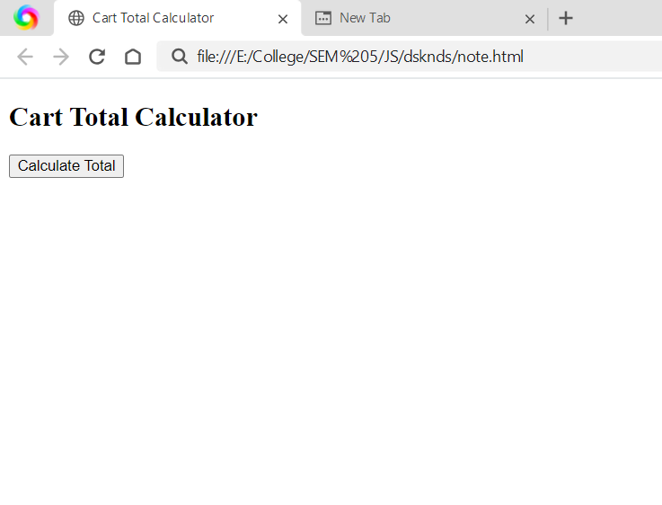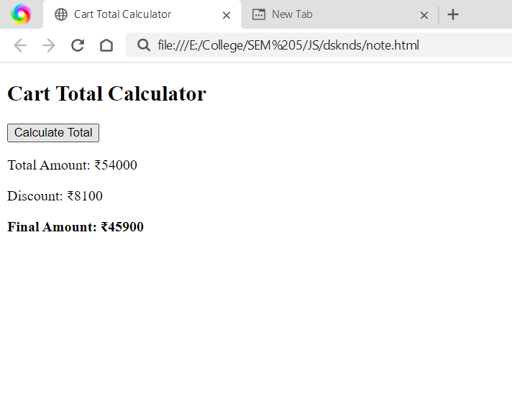
5) Result/Conclusion:
The Cart Total Calculator successfully demonstrates the use of objects, arrays, and the reduce() array method to calculate the total cart value. Discount logic is applied using conditional statements to determine the final payable amount.

