Experiment No. 6

- Title : Use string functions and regex for email validation, data extraction and text analysis.

2) Software/Tools Required :
- Visual Studio Code (VS Code) – Code editor for writing HTML, CSS, and JavaScript.
- Web Browser – Google Chrome, Mozilla Firefox, Microsoft Edge, or any modern browser to run the application.
- Live Server Extension (Optional) – VS Code extension for real-time preview and automatic page refresh.
- Operating System – Windows, Linux, or macOS.
- Notepad/Notepad++ (Optional) – Alternative text editor for coding.

- Theory :

- String Functions such as length, split(), match(), and toLowerCase() are used for text manipulation.
- Regular Expressions (Regex) are patterns used to search, validate, and extract text.
- Email validation ensures the entered email follows the correct format.
- Data extraction retrieves information such as phone numbers from text.
- Text analysis counts words and characters.

index.html –
<!DOCTYPE html>
<html>
<head>
<title>Email Validation and Text Analysis</title>
</head>
<body>
<h2>Email Validation, Data Extraction & Text Analysis</h2>
<label>Email:</label>
<input type="text" id="email" placeholder="Enter Email">
<button onclick="validateEmail()">Validate</button>
<br><br>
<label>Text:</label><br>
<textarea id="text" rows="5" cols="40"
placeholder="Enter text containing phone numbers"></textarea>
<br><br>
<button onclick="analyzeText()">Analyze Text</button>
<div id="result"></div>
<script>
function validateEmail() {
let email = document.getElementById("email").value;
let emailRegex =
/^[A-Za-z0-9._%+-]+@[A-Za-z0-9.-]+\.[A-Za-z]{2,}$/;
let result = emailRegex.test(email)
? "Valid Email Address"
: "Invalid Email Address";
document.getElementById("result").innerHTML =
"<p>" + result + "</p>";
}
function analyzeText() {
let text = document.getElementById("text").value;
let charCount = text.length;
let words = text.trim().split(/\s+/);
let wordCount = text.trim() ? words.length : 0;
let phoneNumbers =
text.match(/\b\d{10}\b/g) || [];
document.getElementById("result").innerHTML =
`<p>Characters: ${charCount}</p>
<p>Words: ${wordCount}</p>
<p>Phone Numbers Found:
${phoneNumbers.join(", ") || "None"}</p>`;
}
</script>
</body>
</html>

- Output :

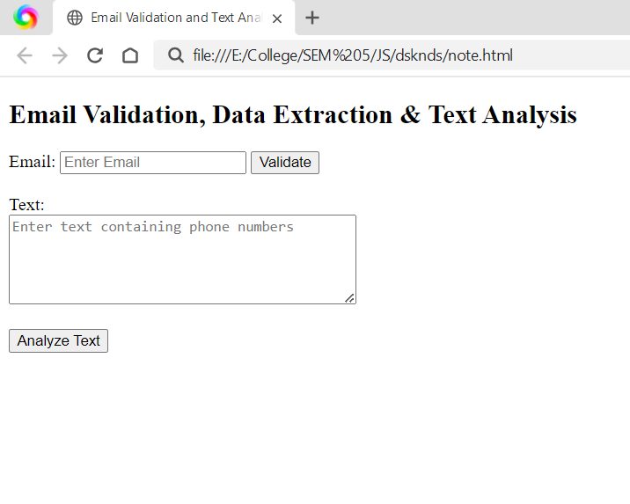

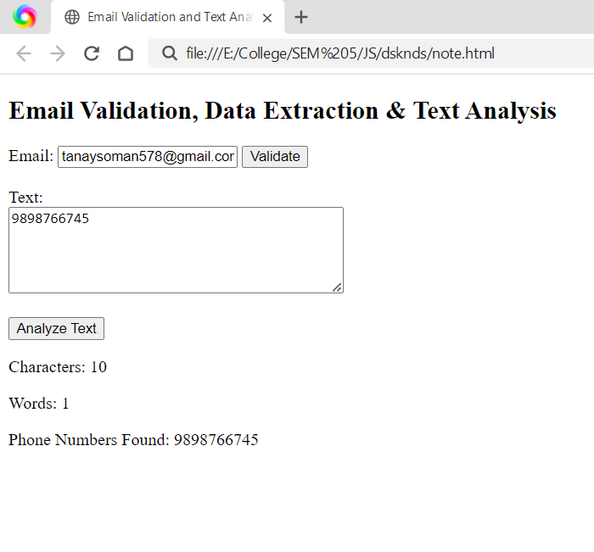

5) Result/Conclusion:
The program successfully demonstrates the use of string functions and regular expressions for email validation, extracting phone numbers from text, and performing text analysis by counting words and characters.

