Experiment No. 7

- Title : Perform DOM traversal and updates; develop a to-do list app with add, edit and delete features.

2) Software/Tools Required :
- Visual Studio Code (VS Code)
- Google Chrome / Mozilla Firefox / Microsoft Edge
- Live Server Extension (Optional)

- Theory :

- DOM (Document Object Model) allows JavaScript to access and modify HTML elements.
- DOM Traversal helps navigate between parent, child, and sibling elements.
- Methods like createElement(), appendChild(), remove(), and innerHTML are used to dynamically update web pages.
- Event handling enables user interaction with buttons and input fields.

index.html –
<!DOCTYPE html>
<html lang="en">
<head>
<meta charset="UTF-8">
<meta name="viewport" content="width=device-width, initial-scale=1.0">
<title>To-Do List App</title>
<style>
body {
font-family: Arial, sans-serif;
text-align: center;
margin-top: 50px;
}
input {
padding: 8px;
width: 250px;
}
button {
padding: 8px 12px;
margin: 5px;
cursor: pointer;
}
ul {
list-style-type: none;
padding: 0;
width: 400px;
margin: auto;
}
li {
padding: 10px;
margin: 5px;
border: 1px solid #ccc;
display: flex;
justify-content: space-between;
align-items: center;
}
</style>
</head>
<body
<h2>To-Do List Application</h2>
<input type="text" id="taskInput" placeholder="Enter a task">
<button onclick="addTask()">Add Task</button>
<ul id="taskList"></ul>
<script>
function addTask() {
let taskInput = document.getElementById("taskInput");
let taskText = taskInput.value.trim();
if (taskText === "")
alert("Please enter a task.");
return;
}
let li = document.createElement("li");
let span = document.createElement("span");
span.textContent = taskText;
let editBtn = document.createElement("button");
editBtn.textContent = "Edit";
editBtn.onclick = function () {
let updatedTask = prompt("Edit Task:", span.textContent);
if (updatedTask !== null && updatedTask.trim() !== "") {
span.textContent = updatedTask;
}
};
let deleteBtn = document.createElement("button");
deleteBtn.textContent = "Delete";
deleteBtn.onclick = function () {
li.remove();
};
let buttonGroup = document.createElement("div");
buttonGroup.appendChild(editBtn);
buttonGroup.appendChild(deleteBtn);
li.appendChild(span);
li.appendChild(buttonGroup);
document.getElementById("taskList").appendChild(li);
taskInput.value = "";
}
</script>
</body>
</html>

- Output :

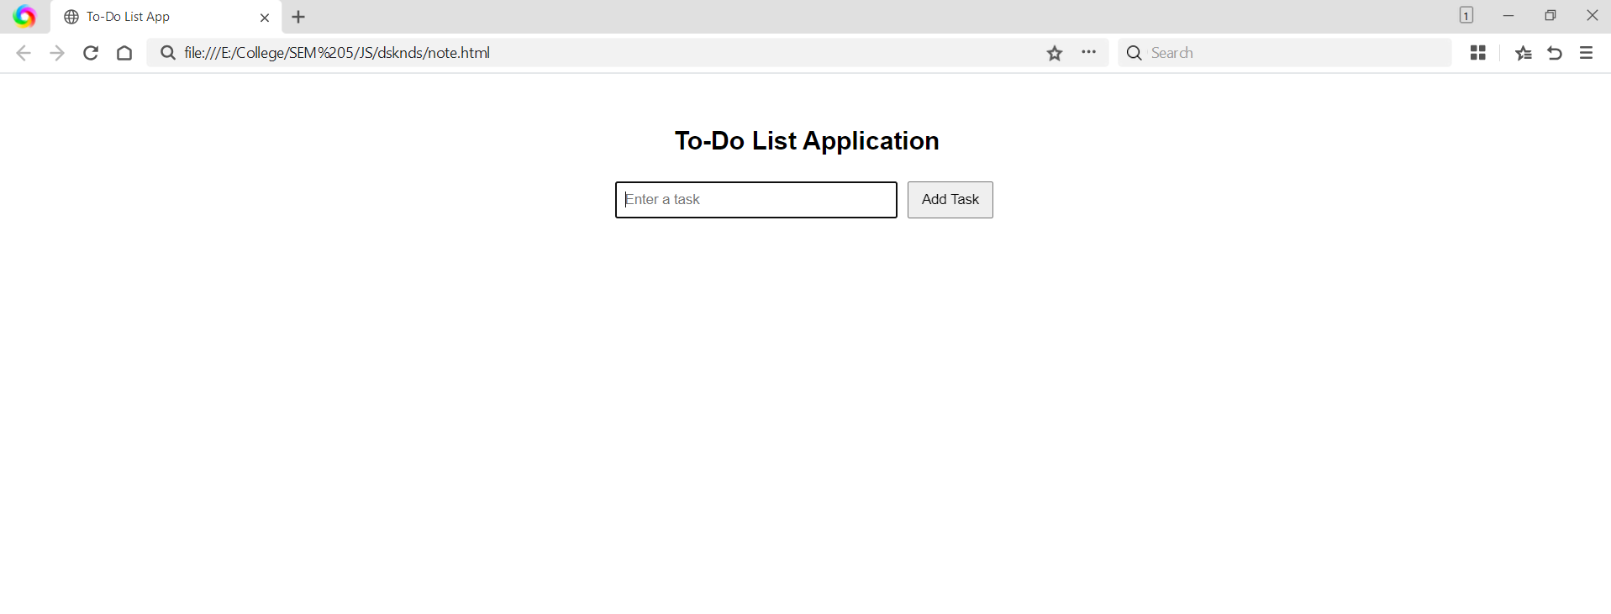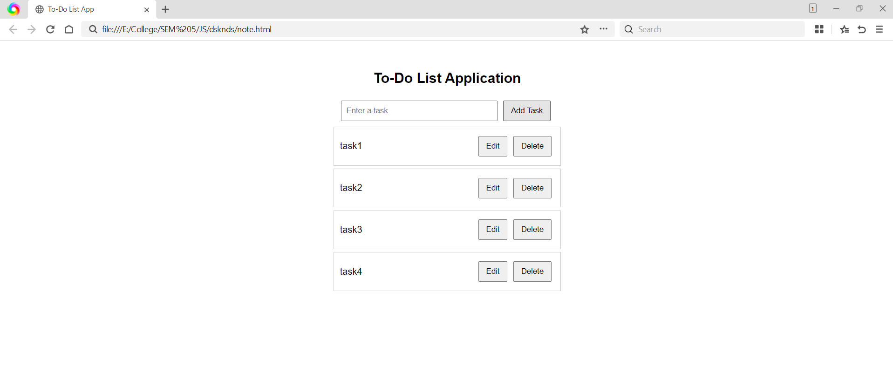

- Result/Conclusion:

The To-Do List Application successfully demonstrates DOM traversal and updates using JavaScript. Users can dynamically add, edit and delete tasks, showcasing real-time manipulation of HTML elements through the DOM.

