Experiment No. 8

- Title : Access and validate form fields using events; design a gym admission form with live input checks.

2) Software/Tools Required :
- Visual Studio Code (VS Code)
- Google Chrome / Mozilla Firefox / Microsoft Edge
- Live Server Extension (Optional)

- Theory :

- Form Validation ensures that users enter correct and complete information.
- JavaScript Events such as input, blur, and submit are used to validate data in real time.
- Validation improves user experience by providing instant feedback.
- Common checks include name length, email format, phone number length, and age restrictions.

index.html –
<!DOCTYPE html>
<html lang="en">
<head>
<meta charset="UTF-8">
<meta name="viewport" content="width=device-width, initial-scale=1.0">
<title>Gym Admission Form</title>
<style>
body {
font-family: Arial, sans-serif;
margin: 40px;
}
form {
max-width: 400px;
margin: auto;
}
input {
width: 100%;
padding: 8px;
margin: 5px 0;
}
.error {
color: red;
font-size: 14px;
}
.success {
color: green;
font-size: 14px;
}
button {
padding: 10px 15px;
margin-top: 10px;
}
</style>
</head>
<body>
<h2 align="center">Gym Admission Form</h2>
<form id="gymForm">
<label>Full Name:</label>
<input type="text" id="name">
<span id="nameMsg" class="error"></span>
<label>Email:</label>
<input type="email" id="email">
<span id="emailMsg" class="error"></span>
<label>Phone Number:</label>
<input type="text" id="phone">
<span id="phoneMsg" class="error"></span>
<label>Age:</label>
<input type="number" id="age">
<span id="ageMsg" class="error"></span>
<button type="submit">Submit</button>
</form>
<script>
document.getElementById("name").addEventListener("input", function() {
let name = this.value;
let msg = document.getElementById("nameMsg");
if (name.length < 3) {
msg.textContent = "Name must contain at least 3 characters";
} else {
msg.textContent = "Valid Name";
msg.className = "success";
}
});
document.getElementById("email").addEventListener("input", function() {
let email = this.value;
let msg = document.getElementById("emailMsg");
let pattern = /^[^\s@]+@[^\s@]+\.[^\s@]+$/;
if (!pattern.test(email)) {
msg.textContent = "Enter a valid email";
} else {
msg.textContent = "Valid Email";
msg.className = "success";
}
});
document.getElementById("phone").addEventListener("input", function() {
let phone = this.value;
let msg = document.getElementById("phoneMsg");
if (!/^\d{10}$/.test(phone)) {
msg.textContent = "Phone number must contain 10 digits";
} else {
msg.textContent = "Valid Phone Number";
msg.className = "success";
}
});
document.getElementById("age").addEventListener("input", function() {
let age = this.value;
let msg = document.getElementById("ageMsg");
if (age < 16) {
msg.textContent = "Minimum age for admission is 16";
} else {
msg.textContent = "Eligible for Admission";
msg.className = "success";
}
});
document.getElementById("gymForm").addEventListener("submit", function(event) {
let name = document.getElementById("name").value;
let email = document.getElementById("email").value;
let phone = document.getElementById("phone").value;
let age = document.getElementById("age").value;
if (name.length < 3 ||
!/^[^\s@]+@[^\s@]+\.[^\s@]+$/.test(email) ||
!/^\d{10}$/.test(phone) ||
age < 16) {
alert("Please enter valid details.");
event.preventDefault();
} else {
alert("Gym Admission Form Submitted Successfully!");
}
});
</script>
</body>
</html>

- Output :

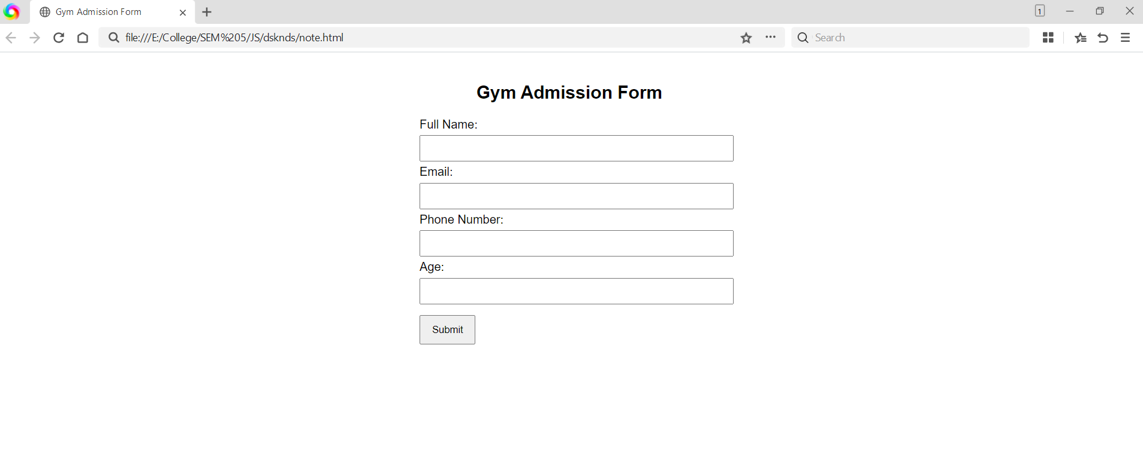

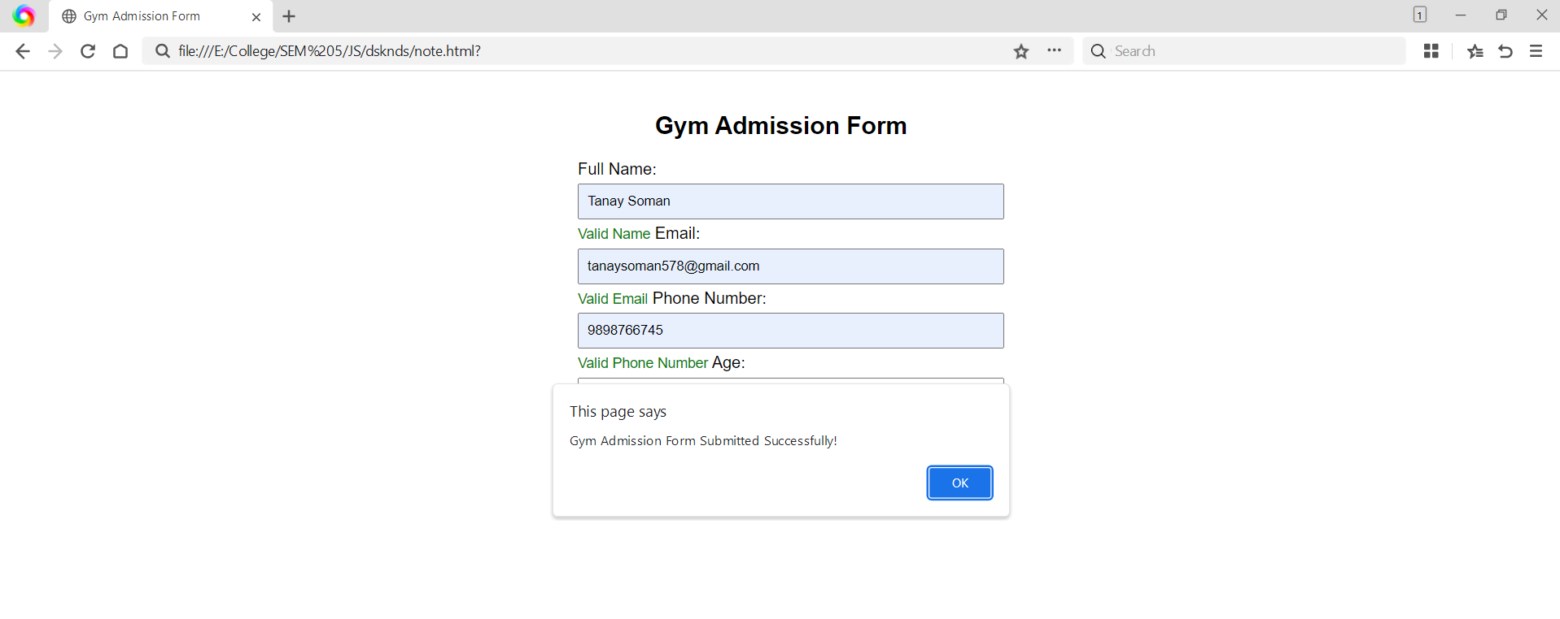

- Result/Conclusion:

The Gym Admission Form successfully demonstrates the use of JavaScript events and form validation. It performs live input checks for name, email, phone number, and age, providing immediate feedback and ensuring only valid data is submitted.

