Experiment No. 9

- Title : Implement localStorage and sessionStorage to save user preferences like theme settings.

2) Software/Tools Required :
- Visual Studio Code (VS Code)
- Google Chrome / Mozilla Firefox / Microsoft Edge
- Live Server Extension (Optional)

- Theory :

- localStorage stores data permanently in the browser until it is manually cleared.
- sessionStorage stores data only for the current browser session and is cleared when the browser tab is closed.
- Both storage mechanisms store data as key-value pairs.
- They help improve user experience by remembering preferences such as themes, language settings, and login information.

index.html –
<!DOCTYPE html>
<html lang="en">
<head>
<meta charset="UTF-8">
<meta name="viewport" content="width=device-width, initial-scale=1.0">
<title>User Preference Manager</title>
<style>
body {
font-family: Arial, sans-serif;
text-align: center;
margin-top: 100px;
transition: 0.3s;
}
.dark {
background-color: black;
color: white;
}
.light {
background-color: white;
color: black;
}
button {
padding: 10px 20px;
margin: 10px;
cursor: pointer;
}
</style>
</head>
<body>
<h2>User Preference Manager</h2>
<p>Select a Theme:</p>
<button onclick="setTheme('light')">Light Theme</button>
<button onclick="setTheme('dark')">Dark Theme</button>
<p id="sessionInfo"></p>
<script>
window.onload = function() {
let savedTheme = localStorage.getItem("theme");
if (savedTheme) {
document.body.className = savedTheme;
}
let visitCount = sessionStorage.getItem("visits");
if (!visitCount) {
visitCount = 1;
} else {
visitCount = parseInt(visitCount) + 1;
}
sessionStorage.setItem("visits", visitCount);
document.getElementById("sessionInfo").innerHTML =
"Page Visits in Current Session: " + visitCount;
};
function setTheme(theme) {
document.body.className = theme;
localStorage.setItem("theme", theme);
}
</script>
</body>
</html>

- Output :

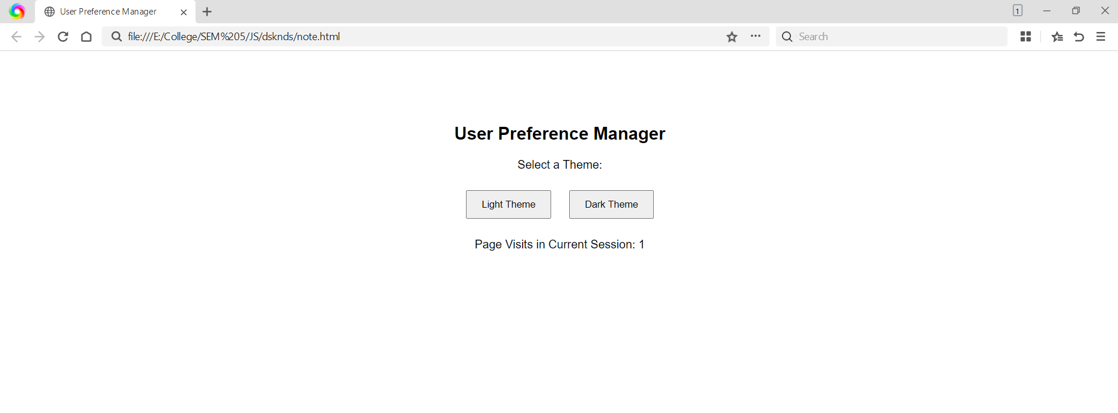

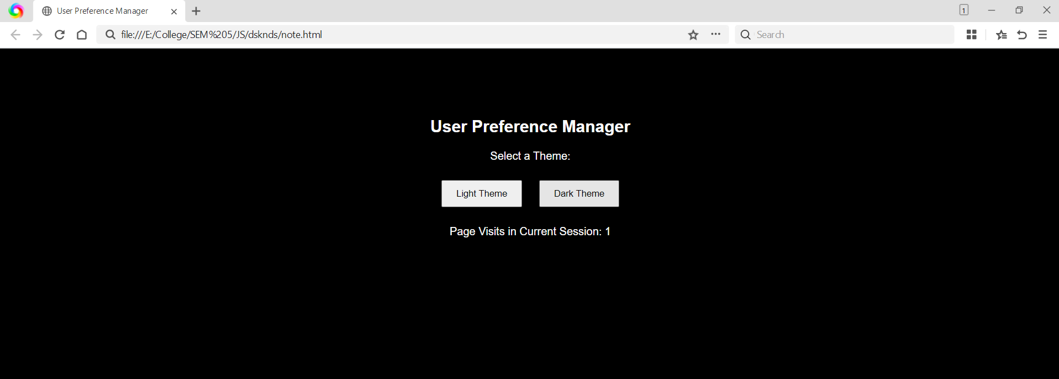

- Result/Conclusion:

The program successfully demonstrates the use of localStorage and sessionStorage. The selected theme is permanently stored using localStorage, while the session visit count is maintained only for the current browsing session using sessionStorage. This improves user experience by remembering preferences and managing temporary session data.

