The Protection of Women from Domestic Violence Act, 2005 (PWDVA) sections you listed cover access to the Magistrate, protection from abuse, residence in the shared household, financial support, child custody, compensation, interim relief and consequences for breaching a protection order.
For your legal search system, each section should have two kinds of triggers: legal terminology used in judgments and plain-language queries that ordinary people are likely to ask. The official statutory source is India Code — Protection of Women from Domestic Violence Act, 2005.

India Code

Section-by-section trigger map
The following are proposed search triggers, not additional statutory language. The legal subjects are grounded in the Act; the ordinary-language phrases are designed to help people who do not know the section numbers.
Section | Legal subject | Layperson query triggers
12 | Application to Magistrate | “How do I file a domestic violence case?”; “Where can I complain about abuse by my husband?”; “Can someone file a domestic violence application for me?”
17 | Right to reside in a shared household | “Can my husband throw me out of the house?”; “Can my in-laws evict me from their house?”; “Do I have a right to stay in my matrimonial home if it is not in my name?”
18 | Protection orders | “How can I stop my husband from threatening me?”; “Can the court stop him from contacting or harassing me?”; “How do I get protection from my abusive partner?”
19 | Residence orders | “Can I get another place to live?”; “Can the court stop my husband from selling the house?”; “Can I ask him to pay rent for another home?”
20 | Monetary relief | “Can I get money for my living expenses?”; “My husband stopped giving me money. What can I do?”; “Can I claim medical expenses and maintenance?”
21 | Custody orders | “Can I keep my child with me while the case is going on?”; “Can my husband take the children away?”; “Who will look after our child during the domestic violence case?”
22 | Compensation orders | “Can I get compensation for the mental torture I suffered?”; “Can I claim damages for emotional abuse?”; “Can the court order compensation for the violence?”
23 | Interim and ex parte orders | “Can I get urgent protection before the other side appears in court?”; “Can the court give an immediate temporary order?”; “Can I get an order without waiting for my husband to attend?”
31 | Penalty for breach of protection order | “He broke the court's protection order. What can I do?”; “My husband keeps threatening me even after the court ordered him to stop”; “Can he be arrested for violating a domestic violence order?”
The statutory subjects are verified against the official Act.

India Code
+1

Evidence from actual judgments
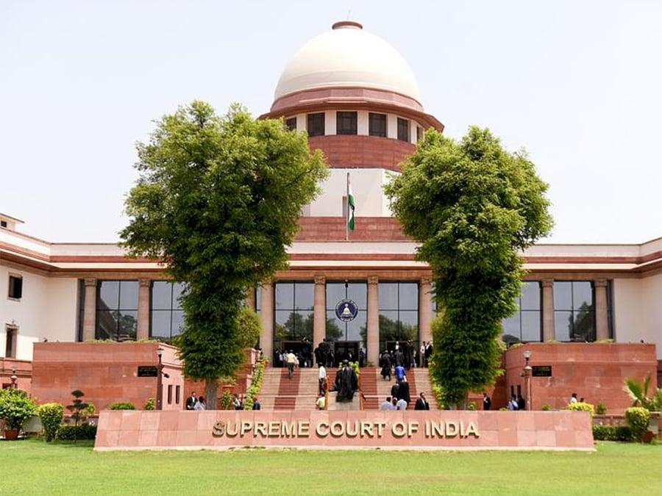
1. Satish Chander Ahuja v. Sneha Ahuja (2020)
Supreme Court of India · Sections 17 and 19
The Court rejected an overly narrow interpretation of “shared household.” A woman's claim to residence is not automatically defeated merely because the property is owned by her in-laws or she has no ownership interest. The specific facts and statutory requirements still matter.
Read the judgment on Indian Kanoon.

Indian Kanoon
+1
2. Rohan Shah v. Nishigandha Shah (2023)
Bombay High Court · Section 12 and relief under Sections 18–22
The judgment discusses the distinction between an application under Section 12 and the substantive reliefs that may be sought under Sections 18–22. It is useful for queries about where to file and what remedies to request.
Read the judgment on Indian Kanoon.
Indian Kanoon
3. Neha Chaturvedi v. State & Anr. (2023)
Delhi High Court · Section 31
The Court emphasized that Section 31 concerns breach of a protection order or interim protection order. A specific qualifying order and a breach of that order are important; a general allegation of misconduct does not, by itself, establish a Section 31 offence.
Read the judgment on Indian Kanoon.
Indian Kanoon

How to use these triggers in your search system
- High boost: Exact statutory references, such as PWDVA Section 23, “protection order under Section 18,” or “right to reside in shared household.”
- Medium boost: Clear everyday descriptions, such as “my in-laws are throwing me out” or “he stopped paying household expenses.”
- Low boost or contextual matching: Broad terms such as “family dispute,” “maintenance,” “house,” “abuse,” or “compensation.”
A single query may relate to several sections. For example, “My husband is threatening to throw me out and has stopped giving me money” may warrant retrieval of judgments concerning Sections 18, 19 and 20. The search system should return relevant candidates rather than force the query into just one section.
For Section 31, require evidence of an alleged breach of a qualifying protection order; do not activate the trigger merely because a user says that domestic abuse continued.
The sections you listed should be represented in a legal search system as separate statutory triggers, with both lawyer-facing phrases and plain-language expressions. The strongest design combines the exact section number, the legal issue, and the way an ordinary person would describe the same event.
The official statutory sources are the NDPS Act, 1985 and the Unlawful Activities (Prevention) Act, 1967.

India Code
+1

1. NDPS Act, 1985 — sections and search triggers
Official text: India Code — NDPS Act
Section | Legal subject | Lawyer-facing trigger examples | Layperson-facing trigger examples
20 | Cannabis-related offences | Cannabis, ganja, charas, cannabis plant | “Police caught me with ganja”; “I was arrested with charas”; “Is carrying marijuana illegal in India?”
21 | Manufactured drugs and preparations | Manufactured drugs, contravention relating to manufactured drugs | “Police found heroin on me”; “I was caught with smack”; “What happens if police find drugs in my bag?”
22 | Psychotropic substances | Psychotropic substances, controlled psychotropic drugs | “I was caught with illegal tablets”; “Police seized MDMA”; “I was arrested with LSD.”
27A | Financing illicit traffic and harbouring offenders | Financing illicit traffic, harbouring offenders | “They say I funded a drug gang”; “I gave shelter to someone accused of drug trafficking”; “Can I be arrested for paying a drug dealer’s expenses?”
29 | Abetment and criminal conspiracy | Abetment, criminal conspiracy, common plan | “I didn't carry the drugs, but they say I helped”; “My friend was caught and police accused me of being involved”; “Can I be charged for arranging a drug delivery?”
37 | Cognizable and non-bailable offences; special bail restrictions | Section 37 twin conditions, NDPS bail, reasonable grounds | “Why is bail so difficult in an NDPS case?”; “Can I get bail after being caught with commercial quantity?”
42 | Entry, search, seizure and arrest based on information in specified places | Secret information, recording information in writing, search of building or enclosed place | “Police searched my house after receiving a tip”; “Did the officer have to write down the secret information?”
43 | Seizure and arrest in public places | Public place, public conveyance, seizure and arrest | “Police caught me with drugs at a railway station”; “I was arrested with drugs on a public road.”
50 | Conditions for search of a person | Search before Gazetted Officer or Magistrate, informing suspect of right | “Police searched my body without giving me a choice”; “Could I ask for a Magistrate before they searched me?”
52A | Disposal of seized narcotic drugs; inventory, photographs and samples | Magistrate-certified inventory, certification of samples, disposal of seized contraband | “Police destroyed the seized drugs”; “Were the samples taken before a Magistrate?”; “The drug sample in court doesn't match the seizure record.”
57 | Report of arrest and seizure to superior officer | Forty-eight-hour report, arrest and seizure report | “Did the officer have to report my arrest to a senior officer?”; “Was the seizure report sent on time?”
67 | Power to call for information and examine persons during an inquiry | Section 67 statement, officer's power to call for information | “I signed a statement to the NCB”; “Can a drug officer use my confession against me?”; “Police forced me to admit I knew about the drugs.”
The section descriptions are grounded in the Act's text.

India Code
+1

Key NDPS judgments
- Section 42 — Karnail Singh v. State of Haryana (2009): Explains compliance with the requirements governing information received before a search, including when delayed compliance may be acceptable. Read judgment.
Indian Kanoon
- Section 50 — Vijaysinh Chandubha Jadeja v. State of Gujarat (2010): Holds that the suspect must be informed of the statutory right to be searched before a Gazetted Officer or Magistrate. Read judgment.
Indian Kanoon
- Section 67 — Tofan Singh v. State of Tamil Nadu (2020): Holds that officers invested with powers under Section 53 are police officers for the purpose of the confessional-statement rule, and confessional statements made to them under Section 67 cannot be used as confessions to convict an accused. Read judgment.
Indian Kanoon
- Section 52A — Union of India v. Mohanlal (2016): Addresses the statutory process for inventories, sampling, certification and disposal of seized narcotic substances. Read judgment.

Supreme Court

2. UAPA, 1967 — sections and search triggers
Official text: India Code — UAPA
Section | Legal subject | Lawyer-facing trigger examples | Layperson-facing trigger examples
10 | Penalty for membership of an unlawful association and related conduct | Unlawful association, membership, funds of unlawful association | “The government banned our organisation”; “Can I be punished for belonging to a banned group?”
13 | Punishment for unlawful activities | Unlawful activities, advocating or abetting unlawful activity | “I was arrested for supporting a separatist movement”; “Can a speech or social media post lead to a UAPA case?”
15 | Definition of terrorist act | Terrorist act, threat to unity or security, terrorist act causing death or damage | “Police accused me of a terror attack”; “What makes an act terrorism under Indian law?”
16 | Punishment for terrorist acts | Punishment for terrorist act, death or other punishment under Section 16 | “What punishment applies if someone is accused of carrying out a terror attack?”
17 | Raising funds for a terrorist act | Raising funds, proceeds intended for terrorist acts | “Can sending money to someone lead to a terrorism case?”; “Police say my bank transfer funded terrorism.”
18 | Conspiracy, attempt, abetment or facilitation of terrorist acts | Terrorist conspiracy, recruitment or facilitation, preparation for terrorist acts | “I am accused of planning an attack but no attack happened”; “Can helping someone plan an attack be a crime?”
20 | Membership of a terrorist gang or organisation | Terrorist gang, terrorist organisation membership | “Police say I belong to a terrorist organisation”; “Can I be charged because of my alleged links to a banned group?”
38 | Association with a terrorist organisation | Knowingly associating with a terrorist organisation; intention to further its activities | “I was accused of having links with a banned organisation”; “Is merely knowing someone in a banned group a crime?”
39 | Support given to a terrorist organisation | Support, invitation of support, assistance intended to further activities | “I am accused of helping a banned group”; “Can providing support or assistance lead to a UAPA charge?”
40 | Raising funds for a terrorist organisation | Raising funds, collecting or providing money for a terrorist organisation | “Police say money collected by me went to a banned organisation”; “Can collecting donations lead to a UAPA case?”
43D | Modified criminal-procedure rules, including investigation periods and bail restrictions | Section 43D(2), Section 43D(5), statutory bail, default bail | “Why is bail so difficult in a UAPA case?”; “Can police keep me in custody longer?”; “Can I get default bail if the chargesheet is delayed?”
43E | Presumption concerning offences under Section 15 | Presumption under Section 43E, arms or explosives linked to a terrorist act | “Police found weapons at the place of an alleged terror attack”; “When can the court presume an accused committed a terrorist act?”
The statutory descriptions are based on the official UAPA text.

India Code
+1

Key UAPA judgments
- Section 43D(5) — National Investigation Agency v. Zahoor Ahmad Shah Watali (2019): Explains the statutory approach to bail under UAPA and the assessment of whether accusations are prima facie true. Search/read judgment.
Indian Kanoon
- Sections 38, 39 and 43D(5) — Thwaha Fasal v. Union of India (2021): Examines association with and support for a terrorist organisation, including why possession of literature or association-related material alone may be insufficient without evidence of the required intention. Read judgment.
Indian Kanoon
+1

3. Implementation rules for your legal search system
- Keep exact section triggers. For example, NDPS Section 50, UAPA Section 43D(5) and their common formatting variants should be high-confidence matches.
- Add everyday descriptions as query triggers. Examples include “police searched my house,” “I signed a confession,” “why can't I get bail,” and “I was accused of helping a banned group.”
- Do not treat broad words as proof of a statutory issue. “Money,” “association,” “search,” “statement” and “bail” occur in many unrelated judgments.
- Allow multiple possible Acts. A question about money sent to a banned group might concern UAPA Sections 17, 38, 39 or 40 depending on the alleged conduct; the system should retrieve candidates rather than assume one section.
- Distinguish allegations from legal conclusions. A search result should not imply that a person committed terrorism or a drug offence merely because a trigger matched.
For your trigger workbook, the layperson phrases belong in the query-side vocabulary; exact section references, statutory expressions and case-specific legal terminology should remain in the passage-side markers.

