**FINAL PROJECT REPORT**

SEMESTER 2, ACADEMIC YEAR: 2024-2025

CT312H: MOBILE PROGRAMMING

* **Project/Application name:**
* **GitHub link:**
* **Student ID 1:**
* **Student Name 1:**
* **Student ID 2:**
* **Student Name 2:**
* **Class/Group Number (e.g, CT312HM01):**

1. **Introduction**

* Project/application description:A few words introducing an overview of the project/web application.
* A task assignment sheet for each member if working in groups.

1. **Details of implemented features**
2. **Feature / Application page 1:**

* **Description:** What is this feature/application page? What is it used for?
* **Screenshots:** some screenshots of this feature/application page.
* **Implementation details:** students should answer the following questions:
  + List the widgets used for this feature/page. Is there any special widget (not introduced in the lesson) used? If so, state them.
  + Does the feature use any libraries or plugins? If so, state them and state the role of those libraries/plugins.
  + Does this feature use a shared state management solution? If so state briefly how your solution works and describe the code architecture.
  + Does this feature read or store any data? Locally or remotely? If so, state the data table structure. If you are using a REST API, briefly describe that API (how to call, input, output).

1. **Feature / Application page 2**

Provide details like those on feature/application page 1.

1. **Feature / Application page 3: Cart Page**

* **Description:** This is the Cart Page of the user, where user could confirm to checkout, modify the selected product and see all the selected product
* **Screenshots:** 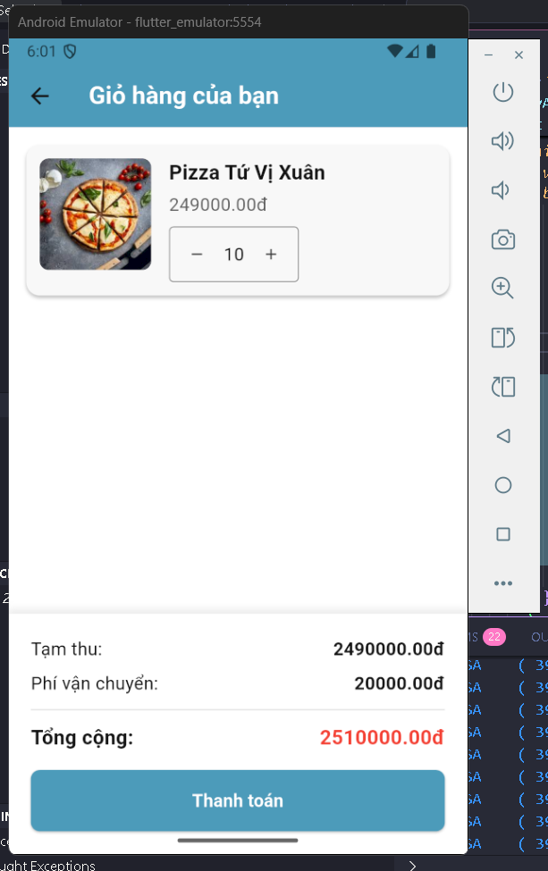

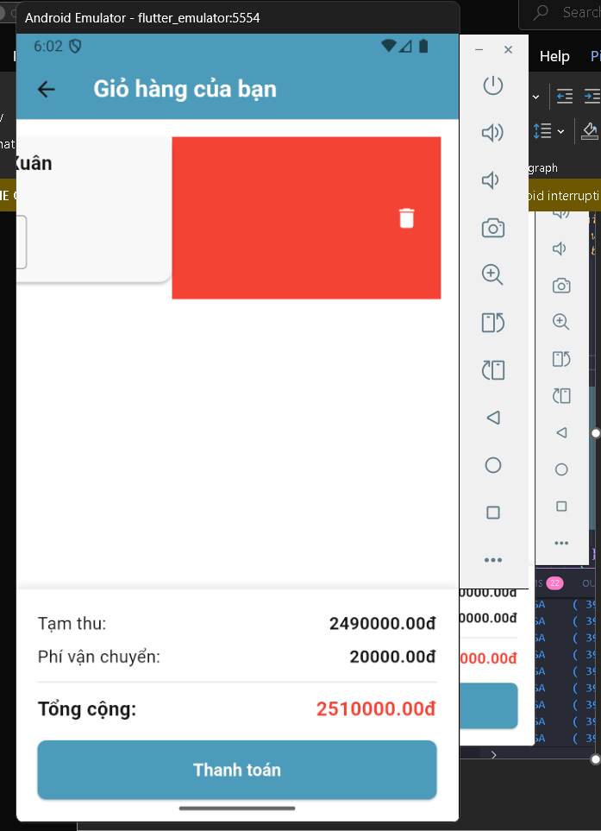 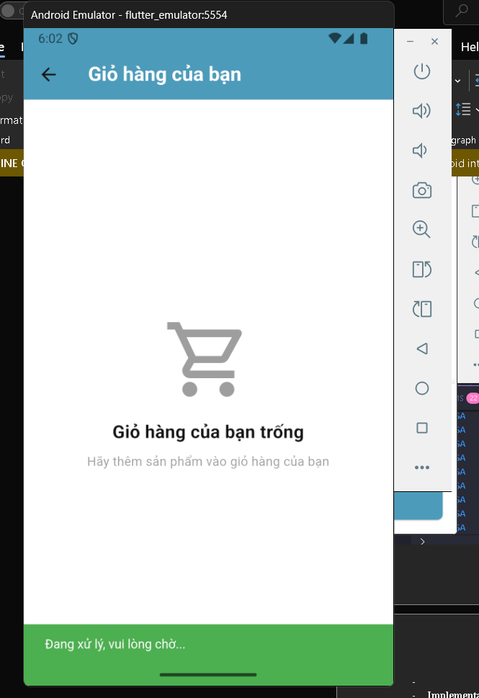

* **Implementation details:** students should answer the following questions:
  + **Widget:** Learned Widget, BoxShadow, ElevatedButton
  + **Libraries:** intl, provider
  + **State Manager and Code Structure:** 
    - **State Manager:**
      * Provider(use for quantity change)
    - **Code Structure:**
      * Models/cart.dart: store cart class
      * Page/cart.dart: Cart Page
      * Widget/cart_item_card.dart: Card of Item
      * Manager/cart_manager.dart: Store temporary data and data function
* **Database/Rest API:** Still not implemented

1. **Feature / Application page 4: Order Page**

* **Description:** This is the Order of the user, where user could see all the orders that had made, the user can reorder in here, cancel the order or see order detail.
* **Screenshots:**

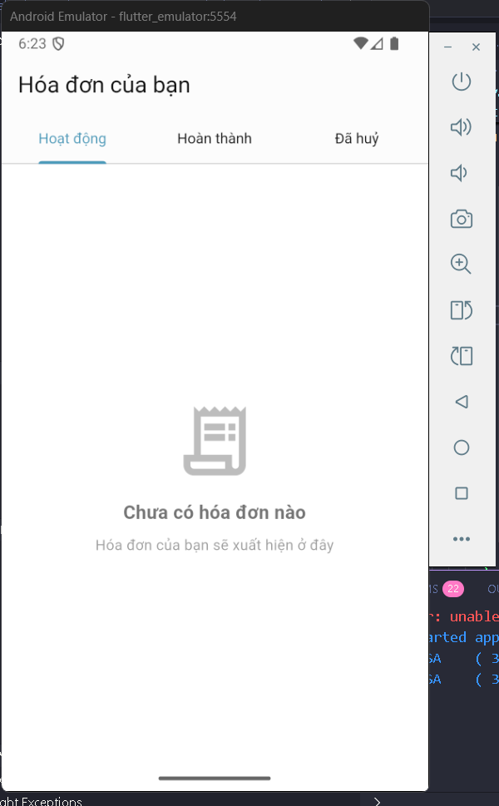

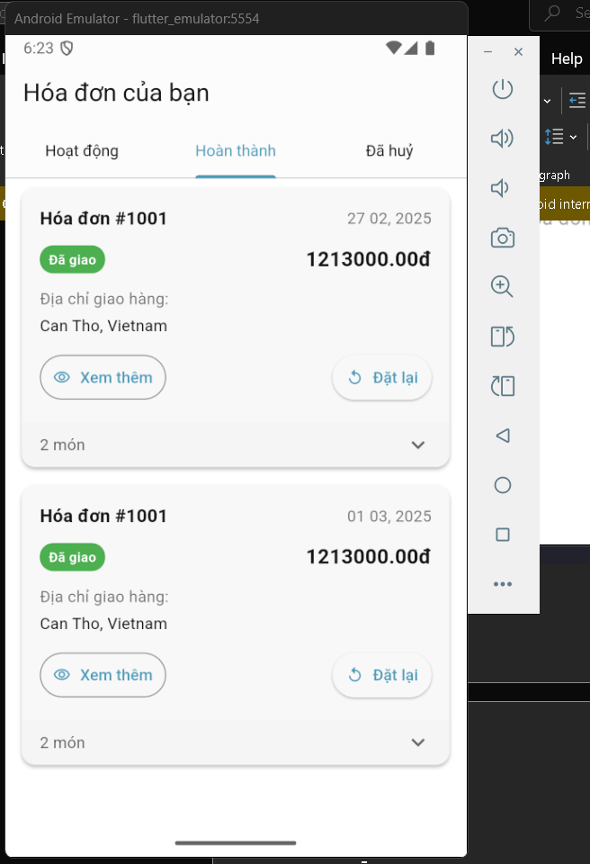

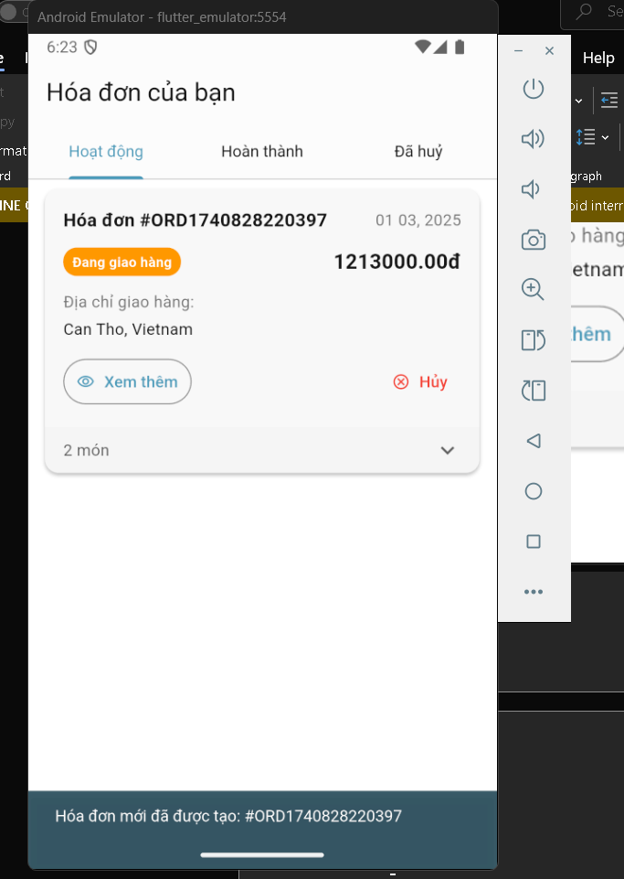

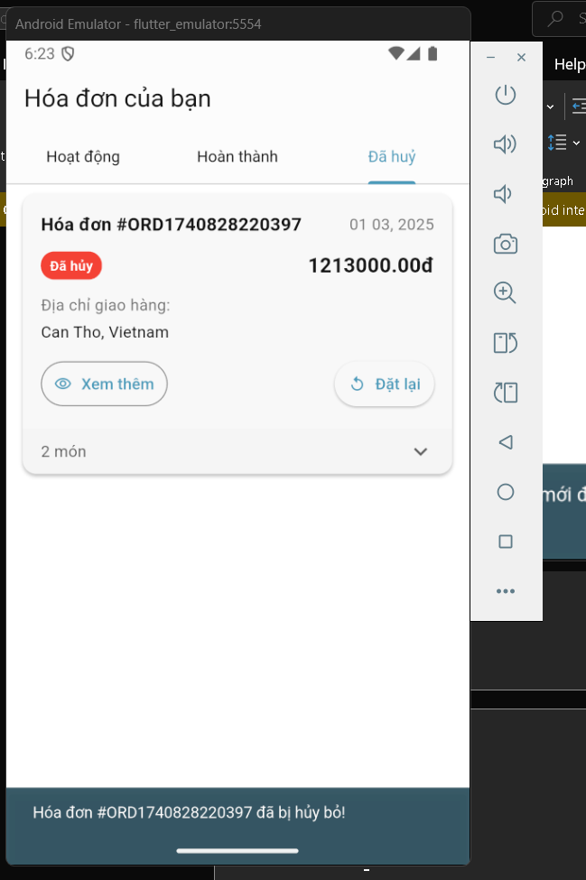

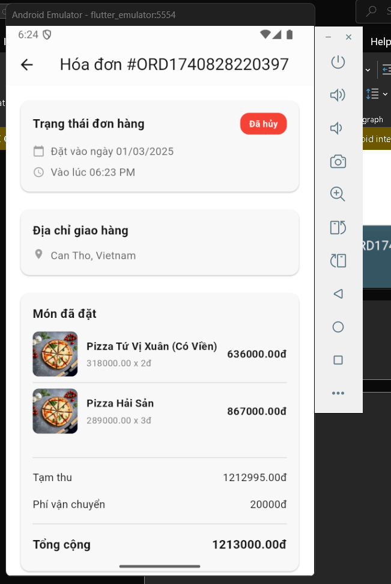

* **Implementation details:** students should answer the following questions:
  + **Widget:** Learned Widget, InkWell, ElevatedButton, OutlinedButton, TabBarView
  + **Libraries:** intl, provider
  + **State Manager and Code Structure:** 
    - **State Manager:**
      * Provider(use for reorder and cancel in Order Detail Page, and for change Order Page based on Status(‘Pending’, ‘Cancel’, ‘Delivered’)
    - **Code Structure:**
      * Models/order.dart: Store order class
      * Page/order_page.dart: Order Page
      * Page/order_detail_page.dart: Order Detail Page
      * Widget/order_item.dart: Order Item
      * Widget/order_list.dart: List of Order Item
      * Manager/order_manager.dart: Store temporary data and data function
* **Database/Rest API:** Still not implemented