Enhanced User Security with SUDO
1.Create a new user account called zomatoadmin on your Linux system, and configure it so that this user can run only the apt-get update and apt-get upgrade commands using sudo without entering a password.<br><br><em><strong>Hint:</strong> Edit the /etc/sudoers file using visudo and use the NOPASSWD directive for specific commands.</em>
Answer :
Create User zomatoadmin
useradd zomatoadmin
Enter Password:
passwd zomatoadmin
Check:
id zomatoadmin
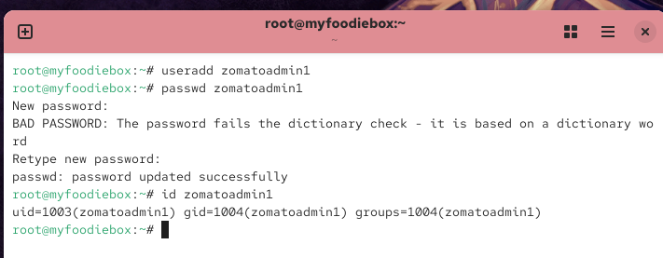
2.Modify the sudo privileges for your existing user so that they cannot run sudo rm -rf / but can run all other sudo commands.<br><br><em><strong>Constraint:</strong> Use command-specific restrictions in the sudoers file to block only the dangerous command.</em>
Root user inside:
su -
then type:
visudo
this line add In last:
zomatoadmin ALL=(ALL) NOPASSWD: /usr/bin/dnf update, /usr/bin/dnf upgrade
insert
Save:
Esc
:wq
Test:
su - zomatoadmin
then type:
sudo dnf update
And
sudo dnf upgrade
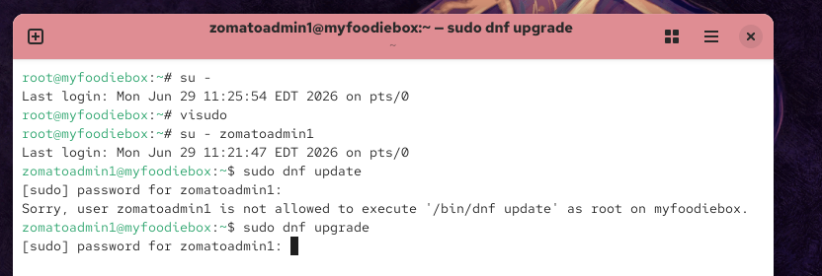
3.Simulate a scenario where a user tries to run a command with sudo that they are not allowed to. Take a screenshot of the error message and explain in 2-3 lines why the error occurs based on your sudoers configuration.
Answer:
Zomatoadmin1 with login:
sudo dnf install httpd
OR
sudo useradd testuser
Expected:
Sorry, user zomatoadmin is not allowed to execute...
Explanation:
The command failed because the sudoers configuration allows only dnf update and dnf upgrade. Other administrative commands are restricted to improve system security.
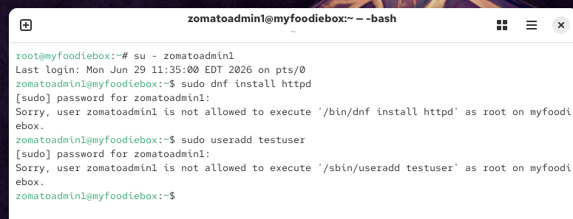
4.Set up a group called myntragroup and add two users to it. Grant sudo privileges to this group so that all members can restart the networking service (systemctl restart networking) but cannot edit any files in /etc.
Answer:
Login with Root user :
groupadd myntagroup
Add 2 users group :
usermod -aG myntagroup du
Then:
visudo
Add this line in last:
%myntagroup ALL=(ALL) NOPASSWD: /usr/bin/systemctl restart NetworkManager
Test:
su - du
sudo systemctl restart NetworkManager
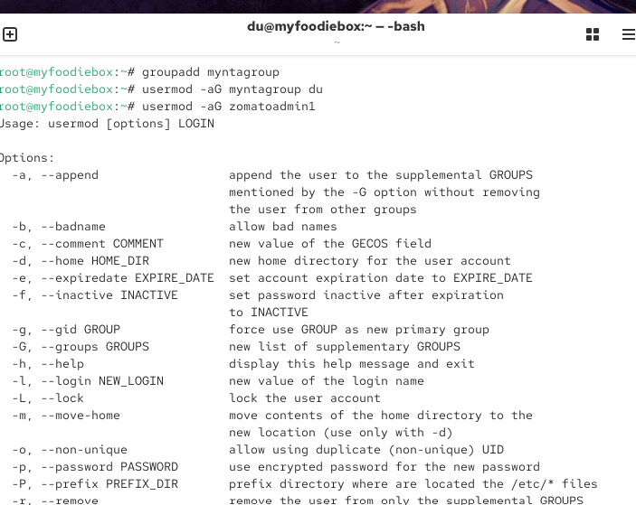
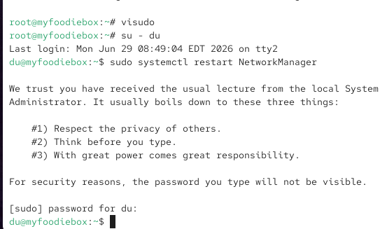
5.Use ChatGPT to generate a sample /etc/sudoers entry that allows a user called movieadmin to run all commands as root except for shutting down or rebooting the system. Copy the AI's suggestion, test it on your system, and write one line about whether it worked as expected.
Answer:
Add this line in visudo:
movieadmin ALL=(ALL) ALL, !/usr/sbin/shutdown, !/usr/sbin/reboot
One-line Result
The configuration worked as expected because the user could execute normal administrative commands but was not allowed to shut down or reboot the system.
