Sebelumnya maaf Pak, nama Saya Tandicha Marchelputra Siswoko, dengan Nim A11.2020.12445. Saya mengumpulkan penugasan kedua berupa file world dan pdf dikarenakan proses penyimpanan file coding yang saya buat tidak kunjung selesai

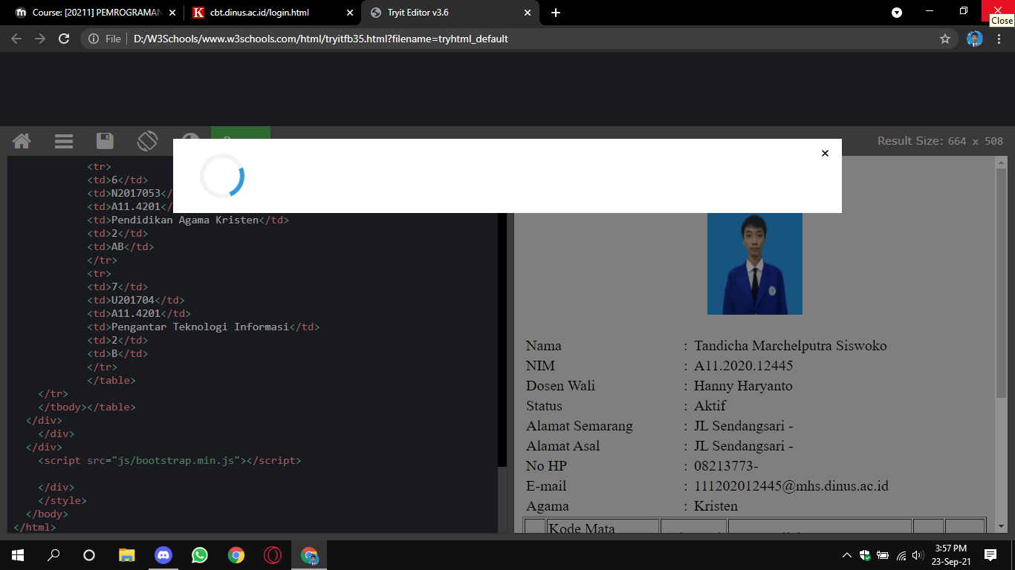

<!doctype html>

<html lang="en">

<head>

<meta charset="utf-8">

<title>Biodata Mahasiswa</title>

<style>

body {

background-color: lightgrey;

}

.foto {

padding: 10px;

}

tbody {

font-size: 20px;

font-weight: 300;

}

.biodata {

margin-top: 10px;

}

</style>

</head>

<body>

<center><a><h3>Biodata Mahasiswa</h3></a></center>

<div class="row">

<div class="foto">

<center><img src="../images/Tandicha.jpg" alt=" " style="width:128px;height:145px;"></center>

</div>

</div>

<div class="col-md-8 kertas-biodata">

<div class="biodata">

<table width="100%" border="0">

<tbody><tr>

<td valign="top">

<table border="0" width="100%" style="padding-left: 2px; padding-right: 13px;">

<tbody>

<tr>

<td class="textt">Nama</td>

<td width="2%">:</td>

<td>Tandicha Marchelputra Siswoko</td>

</tr>

<tr>

<td class="textt">NIM</td>

<td>:</td>

<td>A11.2020.12445</td>

</tr>

<tr>

<td class="textt">Dosen Wali</td>

<td>:</td>

<td>Hanny Haryanto</td>

</tr>

<tr>

<td class="textt">Status</td>

<td>:</td>

<td>Aktif</td>

</tr>

<tr>

<td class="textt">Alamat Semarang</td>

<td>:</td>

<td>JL Sendangsari -</td>

</tr>

<tr>

<td class="textt">Alamat Asal</td>

<td>:</td>

<td>JL Sendangsari -</td>

</tr>

<tr>

<td class="textt">No HP</td>

<td>:</td>

<td>08213773-</td>

</tr>

<tr>

<td class="textt">E-mail</td>

<td>:</td>

<td>111202012445@mhs.dinus.ac.id</td>

</tr>

<tr>

<td class="textt">Agama</td>

<td>:</td>

<td>Kristen</td>

</tr>

<table border="1">

<tr>

<td>No</td>

<td>Kode Mata Kuliah</td>

<td>Kelompok</td>

<td>Mata Kuliah</td>

<td>SKS</td>

<td>Status</td>

</tr>

<tr>

<td>1</td>

<td>AF201704</td>

<td>A11.4201</td>

<td>Dasar Komputasi</td>

<td>2</td>

<td>A</td>

</tr>

<tr>

<td>2</td>

<td>A11.54105</td>

<td>A11.4201</td>

<td>Dasar Pemprograman</td>

<td>4</td>

<td>BC</td>

</tr>

<tr>

<td>3</td>

<td>N201702</td>

<td>A11.4201</td>

<td>Bahasa Inggris</td>

<td>2</td>

<td>B</td>

</tr>

<tr>

<td>4</td>

<td>A11.54102</td>

<td>A11.4201</td>

<td>Fisika 1</td>

<td>4</td>

<td>A</td>

</tr>

<tr>

<td>5</td>

<td>A11.54101</td>

<td>A11.4201</td>

<td>Kalkulus 1</td>

<td>4</td>

<td>B</td>

</tr>

<tr>

<td>6</td>

<td>N2017053</td>

<td>A11.4201</td>

<td>Pendidikan Agama Kristen</td>

<td>2</td>

<td>AB</td>

</tr>

<tr>

<td>7</td>

<td>U201704</td>

<td>A11.4201</td>

<td>Pengantar Teknologi Informasi</td>

<td>2</td>

<td>B</td>

</tr>

</table>

</tr>

</tbody></table>

</div>

</div>

</div>

<script src="js/bootstrap.min.js"></script>

</div>

</style>

</body>

</html>

