
POWER BI PROJECT DOCUMENTATION
NETMIRROR
Content Analysis Dashboard
An end-to-end Power BI solution analysing the Netflix Movies & TV Shows catalogue
Power BI • DAX • Power Query • Media Analytics
SUBMITTED BY
TANDRIMA NANDY | RUDRANIL DAS | SUMONTA KOLLEY

Project Title | NetMirror Content Analysis Dashboard
Project Duration | 3 Days
Dataset | Netflix Movies & TV Shows catalogue
Tools Used | Power BI Desktop, Power Query (M), DAX
Trainer Name | Sayan Sau
AF Code | AF05323593, AF05306189, AF05318974
Submission Date
GitHub Username | Tandrimanandy
GitHub Repository Link | Tandrimanandy/Netmirorr_Content_Analysis
Table of Contents :

No. | Section | What it covers
1 | Project Objective & Overview | Purpose, problem statement, business questions
2 | Tools & Technologies Used | Power BI, Power Query, DAX and supporting tools
3 | Dataset Description | Source, columns, profile of the loaded data
4 | Data Cleaning & Preparation | Audit, Power Query steps, missing values, quality checks
5 | Data Model & Architecture | Flat single-table model and engineered fields
6 | DAX Measures | The four core measures and how they are used
7 | Dashboard Design & Key Features | Layout, colour palette, visuals, interactivity
8 | Dashboard Screenshots | Full page and section views
9 | Key Insights | Findings drawn from the data
10 | Business Strategy | How the insights translate into decisions
11 | Challenges & Solutions | Each problem mapped to its fix
12 | Observations & Improvement Notes | Known limitations and how to address them
13 | Future Scope | Near, mid and long-term roadmap
14 | Learning Outcomes | Skills gained from the project
15 | Conclusion | Summary of the project outcome
16 | Team Contributions | Role of each team member
17 | Submission Checklist & GitHub Details | Deliverables, repository and trainer verification

1. Project Objective & Overview :

1.1 Project Objective
NetMirror Content Analysis is an end-to-end Power BI project that turns the raw Netflix Movies & TV Shows catalogue into a single, interactive executive dashboard. The project covers the complete analytics workflow – data audit, cleaning in Power Query, data modelling, DAX measures and report design – so that a non-technical viewer can understand the catalogue mix, geographic reach, audience ratings and release trends at a glance.

1.2 Problem Statement
A large streaming catalogue is hard to understand when the data is messy and scattered across raw columns. The initial audit of the catalogue revealed four major data-quality challenges:
- High missingness – roughly 30% of titles had no director, and about 9% had no cast or country.
- Column misalignment – duration values (for example “74 min”) were stored inside the rating column for some records.
- Text and datetime inconsistencies – dates held as unstructured text with irregular whitespace; durations held as non-numeric strings.
- Multi-valued attributes – comma-separated entries in genres, production countries and cast lists.
Key question
How can a non-technical viewer quickly see the catalogue mix, geographic reach, audience ratings and release trends without wrestling with raw, inconsistent data?

1.3 Business Questions Answered
Business question | Dashboard component that answers it
How is the catalogue split between formats? | Total Titles by type (donut chart), Total Movies and Total TV Shows KPIs, type slicer
Which countries produce the most content? | Top 10 Countries (bar chart) and Total Countries KPI
Which age ratings dominate the catalogue? | Total Titles by rating (column chart) and Total Countries by rating (funnel)
How has production changed over time? | Total Titles by release_year and type (area chart) with the release-year slicer
How concentrated is production among directors? | Total Movies by director and type (pie chart)

1.4 Project Snapshot
Data source | Netflix Movies & TV Shows catalogue (CSV file, 12 source columns)
Records in the model | 1,000 titles (655 Movies, 345 TV Shows)
Data model | 1 flat, denormalised table (Netmirror) – no relationships required
DAX measures | 4 (Total Titles, Total Movies, Total TV Shows, Total Countries)
Report | 1 page, 1920 × 1080 px – 10 data visuals and 2 slicers

2. Tools & Technologies Used :
The project uses the Microsoft Power BI toolchain end to end. The table below lists each tool, the functions used from it, and its role in the project.
Tool / technology | Features and functions used | Role in the project
Power BI Desktop | Report canvas, visuals, slicers, gauges, cards, Top N and range filters, Fluent 2 theme, tooltips, cross-filtering | Building and publishing the interactive dashboard (.pbix)
Power Query (M language) | Csv.Document, Table.PromoteHeaders, Table.TransformColumnTypes, Table.ReplaceValue, Table.SplitColumn, Table.TransformColumns (Text.Trim), Table.AddColumn (Date.Year), Table.RenameColumns | Data import, cleaning, type conversion and feature engineering
DAX | COUNTROWS, CALCULATE, DISTINCTCOUNT | Creating the four core KPI measures
CSV data source | netflix_titles.csv – UTF-8, comma-delimited, 12 columns | Raw catalogue data
Microsoft PowerPoint | NetMirror dashboard presentation | Presenting the project, strategy and roadmap
Microsoft Word | Methodology and project documentation | Recording the cleaning methodology and this report

3. Dataset Description :

3.1 Source
The dataset is the public Netflix Movies & TV Shows catalogue, imported from a CSV file with twelve columns. Each row represents one title (a movie or a TV show) and describes its type, credits, country, the date it was added to the platform, release year, age rating, duration, genres and synopsis.

3.2 Source Columns
Column | Type | Description
show_id | Text | Unique identifier of each title (for example, s4)
type | Text | Content format: Movie or TV Show
title | Text | Name of the title
director | Text | Director name(s); frequently missing in the raw file
cast | Text | Comma-separated list of actors
country | Text | Production country or countries (can be multi-valued)
date_added | Date | Date the title was added to the platform
release_year | Whole number | Calendar year in which the title was originally released
rating | Text | Age / content certification (TV-MA, TV-14, R, PG-13, etc.)
duration | Text | Raw duration string (“90 min” or “2 Seasons”) – later split into value and unit
listed_in | Text | Genre categories (comma-separated)
description | Text | Short synopsis of the title

3.3 Profile of the Data Loaded in the Model
Attribute | Value
Total records | 1,000 titles (show_id is unique across all rows)
Content type split | 655 Movies (65.5%) and 345 TV Shows (34.5%)
Release-year range | 1959 to 2021 – 915 titles (91.5%) released in 2000 or later
Date-added range | 22 April 2021 to 25 September 2021
Distinct rating values | 10 (TV-MA, TV-14, R, PG-13, TV-PG, TV-Y7, PG, TV-Y, TV-G, G)
Distinct country values | 136 (includes multi-country entries and “Unknown Country”)
Columns in the final model | 14 (11 source columns + Duration_value, Duration _Unit and Year_Added; the raw duration column is replaced by the split fields)

4. Data Cleaning & Preparation :
Raw data was audited and then cleaned in Power Query before any modelling. The guiding principle was to preserve records: discarding every incomplete row (listwise deletion) would have removed over 30% of the catalogue and distorted global representation and historical trends, so missing values were handled column by column instead.

4.1 Data Audit Findings
Issue | Finding | Impact if untreated
High missingness | Director ~30%, cast ~9% and country ~9% missing | Blank categories in charts; large loss of rows if deleted
Column shift | Duration values (e.g. “74 min”, “84 min”) placed in the rating column | Wrong rating categories; missing duration for those titles
Text / date inconsistency | date_added stored as text with irregular whitespace | Dates cannot be sorted or aggregated by time
Mixed duration units | Minutes (movies) and seasons (TV shows) in one text column | No numeric averages or distributions possible
Multi-valued attributes | Compound entries in country, cast and listed_in | Combinations counted as separate categories

4.2 Power Query Transformation Steps
The steps below are the applied steps recorded in the Netmirror query of the Power BI file, in order of execution.
# | Step | What it does | Result
1 | Import CSV (Csv.Document) | Loads the catalogue as UTF-8, comma-delimited, 12 columns | Raw table
2 | Promote headers | Uses the first row as column names | Named columns
3 | Change column types | Text for descriptive columns, Date for date_added, Whole number for release_year | Typed columns
4 | Replace blank country | Blank → “Unknown Country” | No empty country values
5 | Replace blank director and cast | Blank → “Not Specified” in both columns | No empty director or cast values
6 | Replace blank rating | Blank → “Not Rated” | No empty rating values
7 | Split duration by delimiter | Splits “90 min” at the space into two columns | duration.1, duration.2
8 | Change type and rename | duration.1 → whole number; renamed to Duration_value and Duration _Unit | Numeric runtime / season count + unit
9 | Trim and convert date_added | Removes leading and trailing whitespace (en-IN locale parse), then changes the column back to the Date type | Valid calendar dates
10 | Insert and rename year | Date.Year([date_added]) → Year_Added | Whole-number year column

4.3 Missing-Value Strategy
Column | Treatment | Count in loaded data | Reasoning
director | Label “Not Specified” | 315 titles (31.5%) | Keeps independent titles and TV series where episode directors are not listed in the catalogue header
cast | Label “Not Specified” | 97 titles (9.7%) | Retains documentaries, news specials and animated titles without conventional cast credits
country | Label “Unknown Country” | 306 titles (30.6%) | Retains the title for genre, rating, release-year and format analysis; the gap stays visible in the charts
rating | Label “Not Rated” | 0 titles | Safeguard step – no blank ratings exist in the loaded data
date_added | Converted to Date | 0 nulls | Provides a clean timeline and the Year_Added field

4.4 Duration Decomposition
The raw duration column mixed two different measurements: movie length in minutes and TV-show volume in seasons. Splitting it into two fields separates the quantity from its unit and makes numeric analysis possible.
Field | Example values | Meaning
Duration_value | 90, 2 | Numeric scalar: minutes for movies, number of seasons for TV shows
Duration _Unit | min, Season, Seasons | Measurement unit (655 min, 191 Season, 154 Seasons)

4.5 Post-Cleaning Quality Verification
- Zero nulls – all 14 columns in the Netmirror table are 100% populated.
- Unique identifier – show_id is unique across all 1,000 rows.
- No duplicate releases – no repeats on the composite key (title, type, release_year).
- Numeric duration – every row carries a numeric Duration_value and one of three units, confirming the column-shift issue is resolved.
- Typed fields – date_added is a Date, release_year, Duration_value and Year_Added are whole numbers, ready for aggregation and charting.

5. Data Model & Architecture :
The model is intentionally simple: one flat, denormalised table named Netmirror, prepared entirely in Power Query. All measures and visuals read from this single table.

5.1 Why a Single Table?
- Reduces model overhead and avoids unnecessary relationships.
- Keeps cross-filtering fast and predictable for every visual on the page.
- Makes the report simple for non-technical viewers to explore.

5.2 Columns in the Netmirror Table :
Column | Origin | Purpose in the dashboard
show_id, title, description, listed_in | Source | Identification and descriptive attributes (available for future genre analysis)
type | Source | Movie / TV Show – slicer, donut legend, area-chart legend and measure filters
director | Source (cleaned) | Legend of the director pie chart
cast | Source (cleaned) | Retained for future cast analysis
country | Source (cleaned) | Axis of the Top 10 Countries chart; Total Countries measure
date_added | Source (typed) | Basis for Year_Added
release_year | Source | Slicer and area-chart axis
rating | Source (cleaned) | Column-chart axis and funnel categories
Duration_value | Engineered | Numeric runtime or season count
Duration _Unit | Engineered | min / Season / Seasons
Year_Added | Engineered | Year the title joined the catalogue

Power BI’s auto date/time feature also generated hidden helper date tables for the date_added column. No user-defined relationships exist or are needed.

6. DAX Measures :
Four measures were created in the Netmirror table. They are the numeric backbone of every visual: because they are measures rather than static columns, they recalculate automatically whenever a slicer or a cross-filter changes the filter context.

6.1 Measure Definitions
Total Titles – counts every title in the current filter context.
Total Titles = COUNTROWS('Netmirror')
Total Movies – counts only rows whose type is Movie.
Total Movies = CALCULATE(COUNTROWS('Netmirror'), 'Netmirror'[type] = "Movie")
Total TV Shows – counts only rows whose type is TV Show.
Total TV Shows = CALCULATE(COUNTROWS('Netmirror'), 'Netmirror'[type] = "TV Show")
Total Countries – counts the distinct values in the country column.
Total Countries = DISTINCTCOUNT('Netmirror'[country])

6.2 Where Each Measure Is Used
Measure | Functions | Used in
Total Titles | COUNTROWS | KPI gauge; donut chart; Top 10 Countries bar; area chart; rating column chart; Top N ranking filter
Total Movies | CALCULATE, COUNTROWS | KPI card; director pie chart
Total TV Shows | CALCULATE, COUNTROWS | KPI gauge
Total Countries | DISTINCTCOUNT | KPI gauge; rating funnel chart

7. Dashboard Design & Key Features :

7.1 Canvas and Layout
The report is a single page of 1920 × 1080 pixels set to Fit-to-Page for full-screen viewing. The layout follows a top-to-bottom reading flow: headline numbers first, then the catalogue mix and geography, then trends and distributions.
Zone | Content
Header band | Dark-navy title bar: “NETMIRROR / Content Analysis Dashboard”, with the tagline “Movies & TV Shows Catalog Insights” aligned right
Row 1 – KPIs and filters | Total Titles, Total Movies, Total TV Shows and Total Countries tiles; release_year range slicer; type slicer
Row 2 – Mix and geography | Total Titles by type (donut); Top 10 Countries (bar); Total Countries by rating (funnel)
Row 3 – Trends and distribution | Total Titles by release_year and type (area); Total Movies by director and type (pie); Total Titles by rating (column)
Accent strips | Royal-blue bars above each section and a footer band give consistent visual separation

7.2 Colour Palette
The dashboard uses a royal-blue and dark-navy palette on a light-blue canvas, applied consistently through the header, accent strips, charts and slicers.
Swatch | Hex code | Used for
 | #0A0F1E | Header band, KPI tile titles, dark text
 | #1F4FE0 | Accent strips, gauge arcs, slicer track, separator in the title
 | #8FBBFF | Subtitle text, tagline and light accents
 | #D5E2FA | Panel and strip backgrounds
 | #FFFFFF | Visual backgrounds and title text

Typography: Segoe UI Black (brand name), Segoe UI Light (sub-title) and Segoe UI Semibold (visual titles and labels).

7.3 Visual Inventory
# | Visual | Type | Fields | Purpose
1 | Total Titles | Gauge | Value: Total Titles | Catalogue size
2 | Total Movies | Card | Value: Total Movies | Movie count
3 | Total TV Shows | Gauge | Value: Total TV Shows | TV-series count
4 | Total Countries | Gauge | Value: Total Countries | Geographic reach
5 | release_year | Slicer (range) | release_year | Filter by release-year range
6 | type | Slicer | type | Switch between Movie and TV Show
7 | Total Titles by type | Donut chart | Legend: type; Value: Total Titles | Share of Movies vs TV Shows
8 | Top 10 Countries | Clustered bar | Axis: country; Value: Total Titles; Top N = 10 | Leading production countries
9 | Total Countries by rating | Funnel | Category: rating; Value: Total Countries | Geographic spread per rating
10 | Total Titles by release_year and type | Area chart | Axis: release_year; Legend: type; Value: Total Titles; filter release_year ≥ 2000 | Release trend over time
11 | Total Movies by director and type | Pie chart | Legend: director; Details: type; Value: Total Movies | Production concentration by director
12 | Total Titles by rating | Clustered column | Axis: rating; Value: Total Titles | Audience-rating distribution

7.4 Key Features and Interactivity
- Cross-filtering – selecting a segment in any visual (for example “Movie”) updates every other visual instantly.
- Two slicers – a release-year range slicer and a content-type slicer (the saved view opens with Movie selected and the range set to 1959–2020).
- Top N filter – the country chart is limited to the ten countries with the most titles, ranked by the Total Titles measure.
- Release-year filter – the area chart is restricted to releases from the year 2000 onwards, keeping the trend readable.
- KPI gauges and card – headline numbers that respond to the active filters.
- Tooltips – hovering over a chart element shows the exact value and its share of the total.
- Transparent data gaps – imputed labels such as “Unknown Country” remain visible instead of being hidden.

8. Dashboard Screenshots :
The screenshots below show the saved view of the dashboard, with the type slicer set to Movie and the release-year range set to 1959–2020 (469 movies).
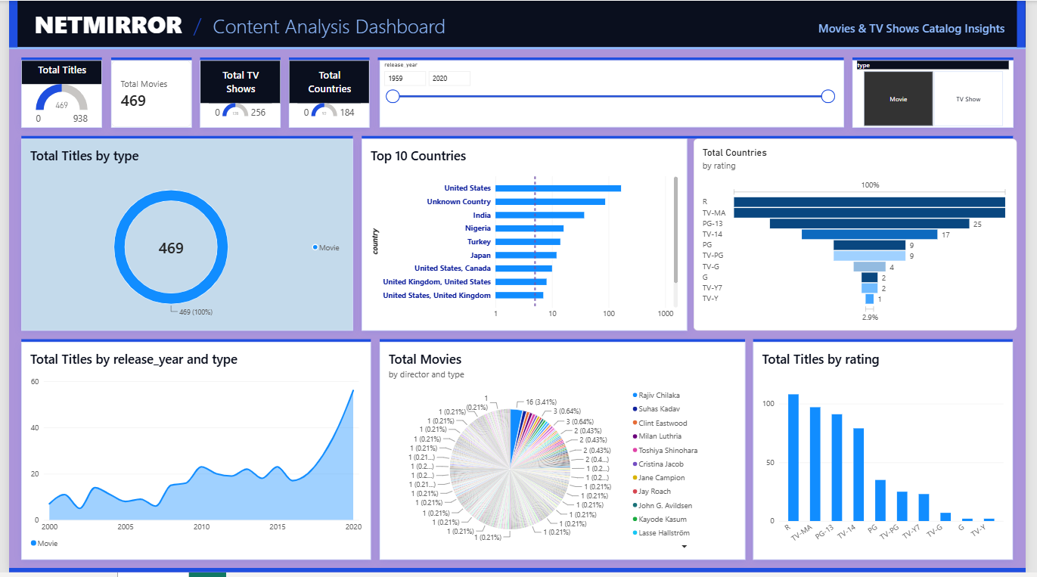
Figure 1: Complete NetMirror Content Analysis dashboard (Movie segment selected)
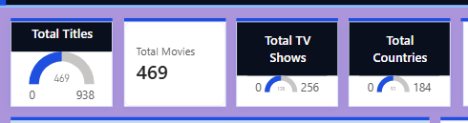
Figure 2: KPI trackers – Total Titles, Total Movies, Total TV Shows and Total Countries
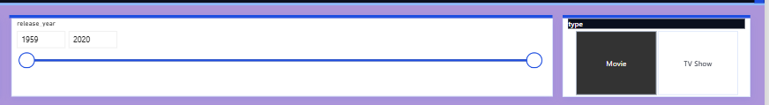
Figure 3: Slicers – release-year range and content type
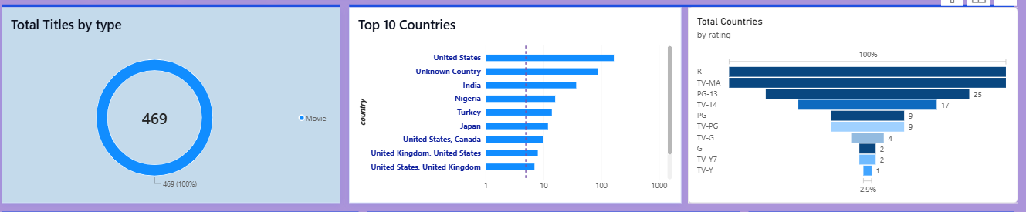
Figure 4: Catalogue mix, Top 10 Countries and rating funnel
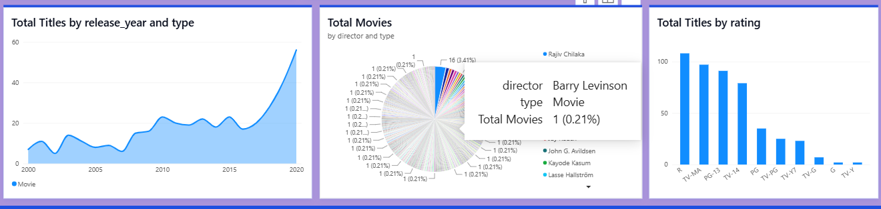
Figure 5: Release-year trend, director concentration and rating distribution

9. Key Insights :
The findings below are calculated from the 1,000-title dataset loaded in the Power BI model. They describe this snapshot of the catalogue.

9.1 Catalogue Mix
Metric | Finding
Format split | 655 Movies (65.5%) versus 345 TV Shows (34.5%) – roughly two movies for every TV show
Movie length | Average movie runtime is about 102 minutes
TV-show depth | Average of about 2 seasons; 191 of 345 TV shows (55.4%) have a single season

9.2 Geographic Footprint
Country value | Titles | Comment
Unknown Country | 306 (30.6%) | Largest single bucket – an explicit data gap, kept visible
United States | 271 | Leading identified country (titles credited to the US alone)
India | 58 | Second-largest identified country
Japan | 30 | Strong presence of anime and Japanese content
United Kingdom | 24 | Followed by Nigeria (18), Turkey (17) and South Korea (11)

The United States, India and the United Kingdom lead the catalogue, pointing to a global footprint with clear room to grow under-represented regions.

9.3 Audience Ratings
Rating | Titles | Share and meaning
TV-MA | 339 | 33.9% – the largest rating (mature audiences)
TV-14 | 211 | 21.1% – together with TV-MA, 55.0% of the catalogue
R | 120 | 12.0% – mature movie content
PG-13 | 101 | 10.1% – teen movie content
TV-PG / PG / TV-Y7 / TV-Y / TV-G / G | 64 / 44 / 59 / 35 / 25 / 2 | Family-friendly and children’s ratings make up the remaining ~23%

TV-MA, TV-14, R and PG-13 together account for 77.1% of titles, showing a catalogue that skews towards teen and mature audiences.

9.4 Release Trend and Production Concentration
- Recent skew: 915 of 1,000 titles (91.5%) were released in 2000 or later; 91 were released in 2020 and 403 in 2021.
- Growth after 2010: the area chart (movies, 2000–2020) rises from single digits in the early 2000s to 56 titles in 2020, with the sharpest acceleration after 2010.
- Director concentration: 315 titles (31.5%) have no director listed. Among named directors the picture is a long tail of one-title directors, with Rajiv Chilaka the most frequent at 16 titles.
- Default dashboard view: the Movie segment (release years up to 2020) holds 469 titles across 92 distinct country values, led by R (108), TV-MA (97), PG-13 (91) and TV-14 (79).

10. Business Strategy :
The dashboard converts catalogue data into repeatable content decisions. The recommendations below are drawn directly from what the visuals show.
Strategy | Evidence from the dashboard | Recommendation
1. Expand globally | US, India and UK lead the Top 10 Countries chart | Grow under-represented regions and pursue local licensing
2. Balance audiences | TV-MA, TV-14 and R dominate the rating charts | Compare mature with family-friendly ratings to fill audience gaps
3. Invest in growth | Release-year area chart accelerates after 2010 | Plan content acquisitions around this production trend
4. Decide with data | One interactive view with slicers and cross-filtering | Replace guesswork with a dashboard leadership can explore

Goal
Turn catalogue data into clear, repeatable content decisions.

11. Challenges & Solutions :
Each problem identified during the audit was mapped to a specific fix in Power Query, the data model or the report design.
Problem | Solution applied | Outcome
Duration values shifted into the rating column | Detected “min” in rating and moved the value to duration | Correct ratings and complete durations
High missing director, cast and country | Replaced blanks with explicit labels instead of deleting rows | More than 30% of rows preserved
Text dates and mixed duration units | Trimmed and typed dates; split duration into value and unit | Clean dates and numeric duration fields
Raw catalogue hard to read | Built a single-page interactive dashboard | Insights visible at a glance
Slow, unclear filtering | Used slicers and cross-filtering on a flat model | Fast, predictable interactions

12. Observations & Improvement Notes :
Being transparent about the limits of the analysis makes the results more useful. The notes below record what to keep in mind when reading the dashboard, and how each point could be improved.
Observation | Explanation | Suggested improvement
Snapshot of the catalogue | The model holds 1,000 titles, all added between April and September 2021, so Year_Added contains a single value | Load the full catalogue to unlock yearly and monthly additions analysis
Total Countries counts text values | DISTINCTCOUNT on country treats “United States, Canada” and “Unknown Country” as separate values, so the figure is higher than the number of real countries | Split multi-country entries into separate rows and exclude Unknown Country
Imputed labels appear in charts | “Unknown Country” is the second item in the Top 10 chart, and “Not Specified” appears among directors | Add a toggle or filter to hide unknown values when required
Crowded director pie chart | Hundreds of single-title directors make the pie hard to read | Replace with a Top N bar chart of directors
Genre and cast not yet analysed | listed_in and cast are multi-valued and were not visualised | Split into rows and add genre and cast leaderboards

13. Future Scope :
Horizon | Theme | Planned enhancements
Near term | Quick wins | Genre analysis from listed_in; country split for multi-country titles; top cast and director leaderboards
Mid term | Deeper analytics | Multi-page report with drill-through; publish to the Power BI Service with scheduled refresh; forecast release and addition trends
Long term | Intelligent insights | Add viewership and engagement data; NLP on descriptions for themes and sentiment; content recommendation and gap analysis

14. Learning Outcomes :
Through this project the team gained practical, end-to-end experience of the Power BI workflow:
- Auditing a real-world dataset and identifying missing values, misaligned columns and inconsistent data types.
- Cleaning and transforming data in Power Query using replace, split, trim, type-conversion and column-creation steps.
- Choosing a data model that suits the analysis – here, a single flat table for fast cross-filtering.
- Writing DAX measures with COUNTROWS, CALCULATE and DISTINCTCOUNT, and understanding filter context.
- Selecting suitable visuals (donut, bar, funnel, area, pie, column, gauge, card) and configuring slicers, Top N and range filters.
- Designing a consistent, professional dashboard with a custom colour palette, typography and layout.
- Turning analytical findings into clear business recommendations and presenting them.
- Working as a team with defined roles across preparation, modelling and design.

15. Conclusion :
The NetMirror Content Analysis project shows how a messy streaming catalogue can be turned into a clear, decision-ready story. Systematic cleaning kept over 30% of records that simple deletion would have lost, and a flat single-table model with four DAX measures powers a fast, interactive single-page dashboard.
The dashboard reveals a global catalogue led by the United States, India and the United Kingdom, a rating mix that skews towards TV-MA and TV-14 content, and production that accelerates sharply after 2010. Slicers and cross-filtering let non-technical users explore these patterns instantly, and the documented observations and roadmap provide a clear path for taking the project further.

16. Team Contributions :
Team member | Role | Responsibilities
TANDRIMA NANDY | Data Cleaning & Preparation | Data audit, handling of missing values, column-shift correction, type conversion and splitting of the duration field
RUDRANIL DAS | Dashboard Design | Page layout, visual selection and formatting, colour palette, slicers and interactivity
SUMONTA KOLLEY | Data Modelling & DAX | Flat data model, DAX measures (Total Titles, Movies, TV Shows, Countries) and measure validation

17. Submission Checklist & GitHub Details :

17.1 Submission Checklist
- Dataset file (netflix_titles .csv)
- Power BI file (.pbix) – Power_Bi_project_RoyalBlue_final.pbix
- Project report (this document)
- Presentation slides – NetMirror_Dashboard_Presentation_Final_v2.pptx
- Dashboard screenshots
- Data cleaning methodology document
- GitHub repository link

17.2 GitHub Repository Details
Item | Details
GitHub Repository Link | Tandrimanandy/Netmirorr_Content_Analysis
GitHub Username | Tandrimanandy
Repository Name | Netmirror_ Content_Analysis

Suggested repository contents: the dataset, the .pbix file, dashboard screenshots, this documentation, the presentation and a README.md describing the project. The repository should be public for evaluation.

17.3 Trainer Verification
Trainer Remarks | Signature

