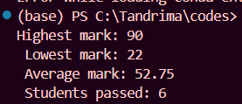
1st OUTPUT :

2nd OUTPUT :
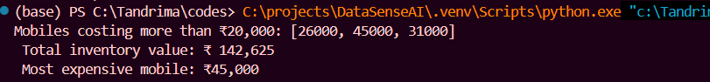

3rd OUTPUT :
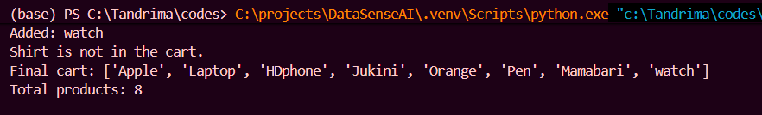

4th OUTPUT :
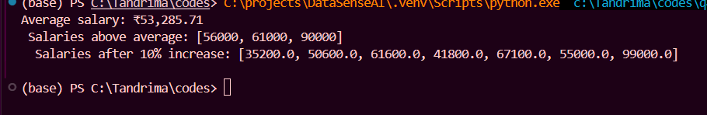

5th OUTPUT :
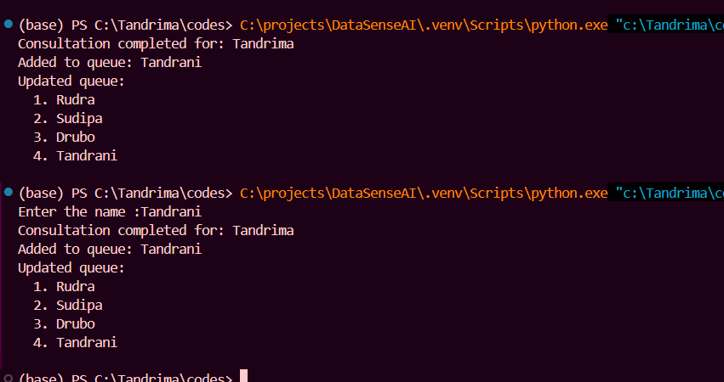

6th OUTPUT :
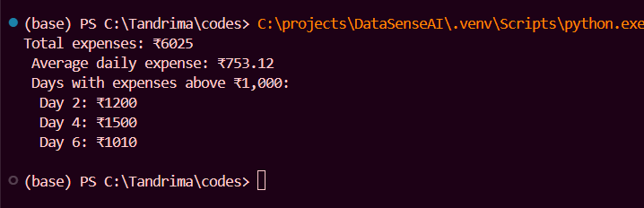
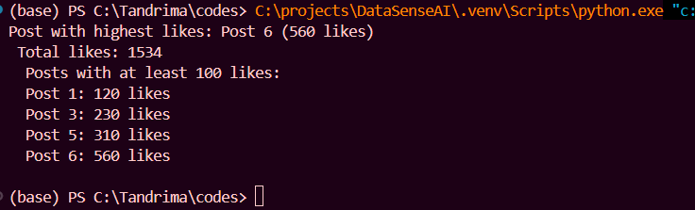

7th OUTPUT :

