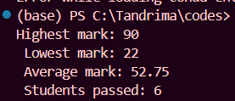
1st OUTPUT:

2nd OUTPUT:
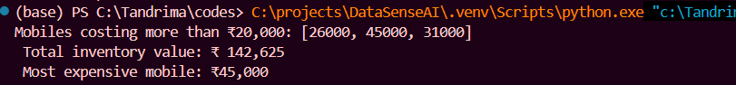

3rd OUTPUT:
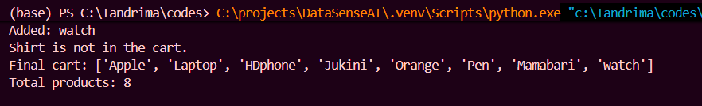

4th OUTPUT:
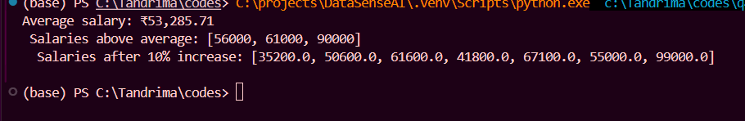

5th OUTPUT:
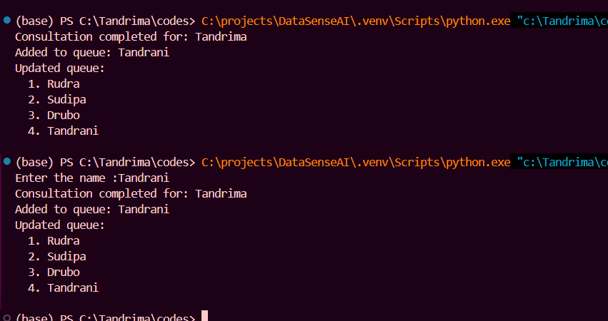

6th OUTPUT:
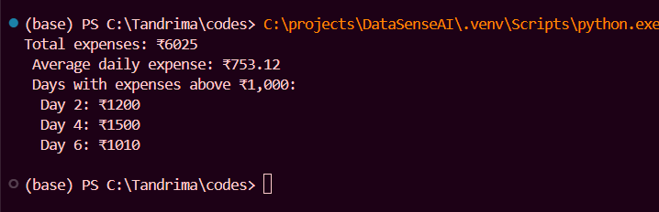
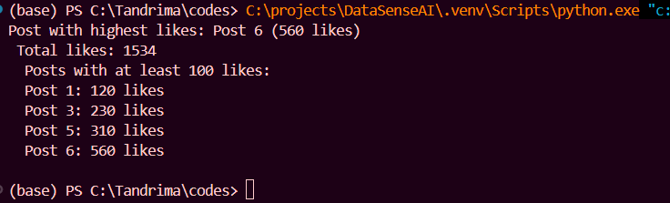

7th OUTPUT:

8th OUTPUT:
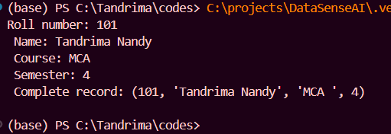

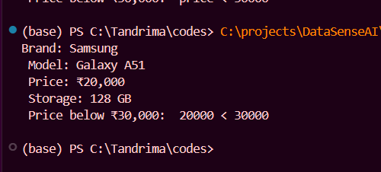
9th OUTPUT:

10th OUTPUT:
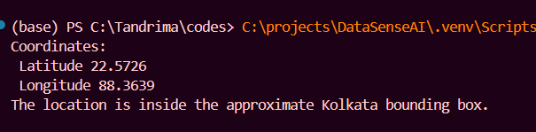

11th OUTPUT:
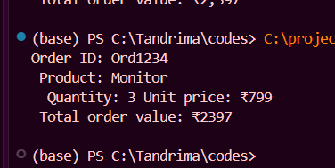

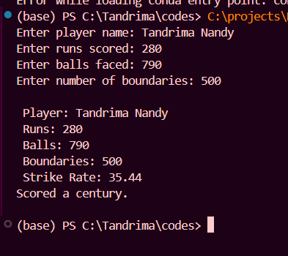
12th OUTPUT:

13th OUTPUT:
