Welcome Page:

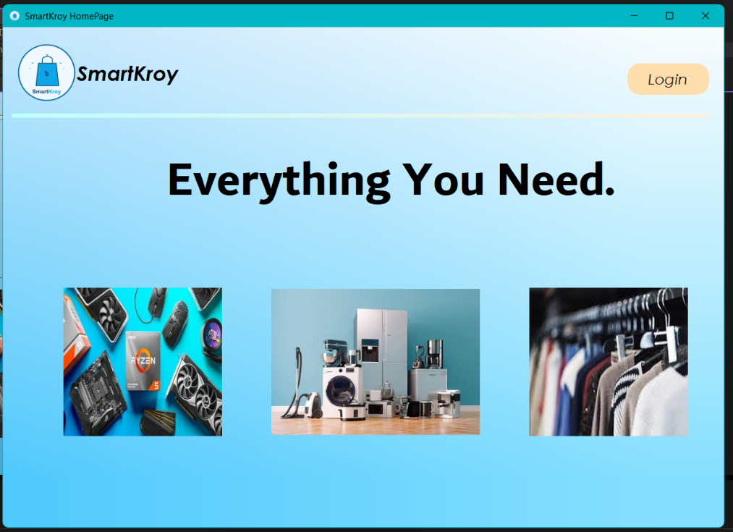

Figure 1. Welcome page of Smart Kroy

Customer part:

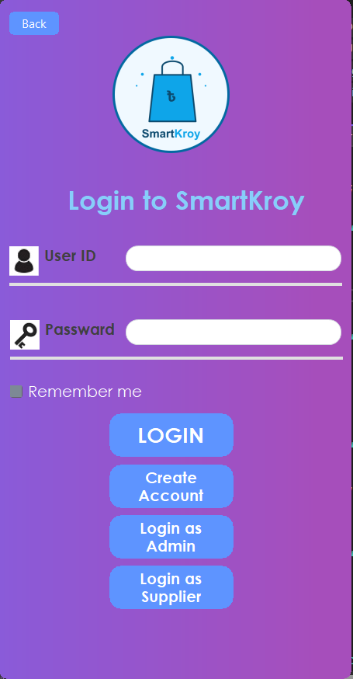

Figure 2. Login page for customer

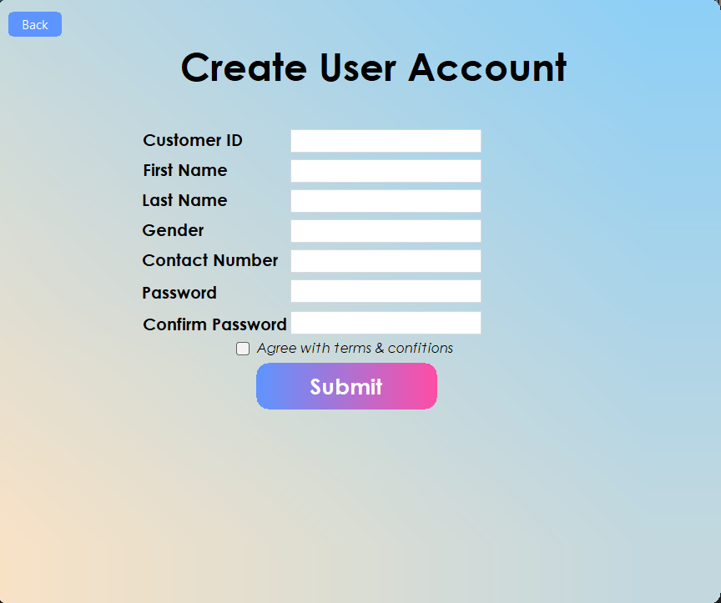

Figure 3. Account registration page for customers

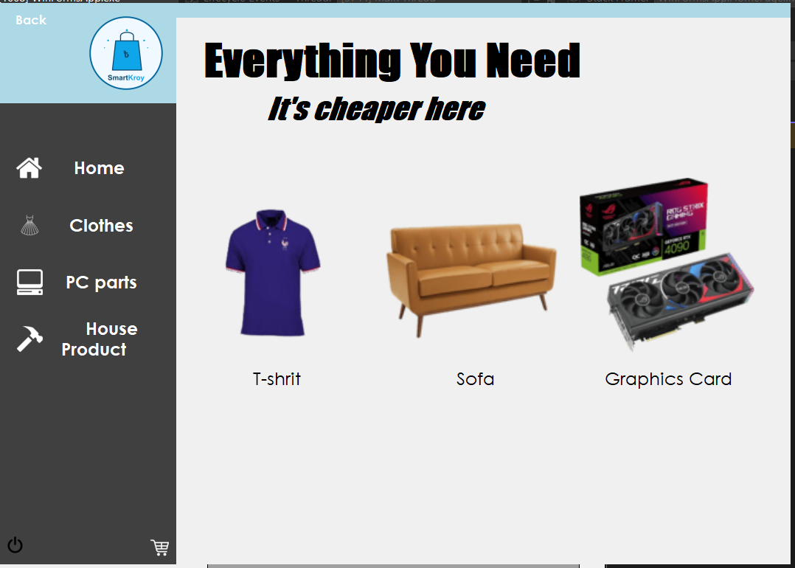

Figure 4. Home page for Customer after login

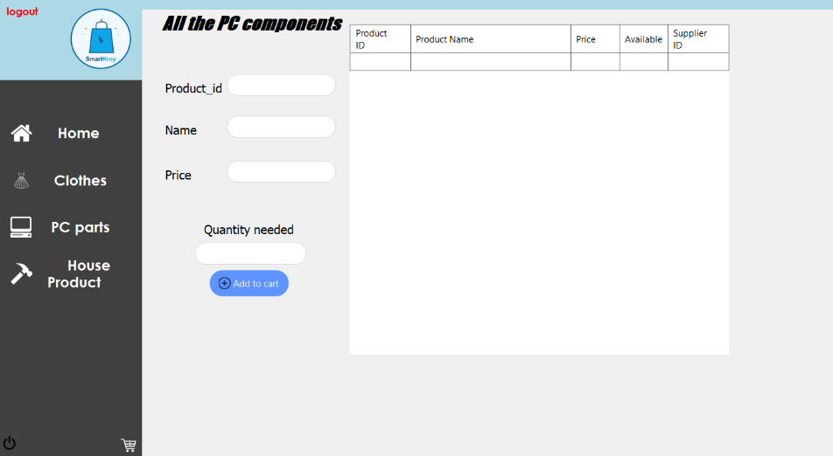

Figure 5. All electronic Component buying page

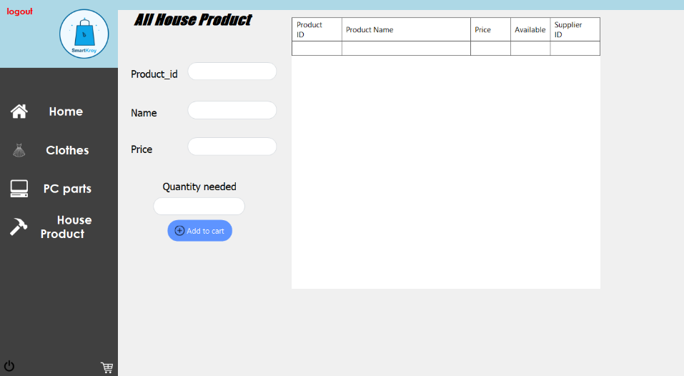

Figure 6. All Household product buying page

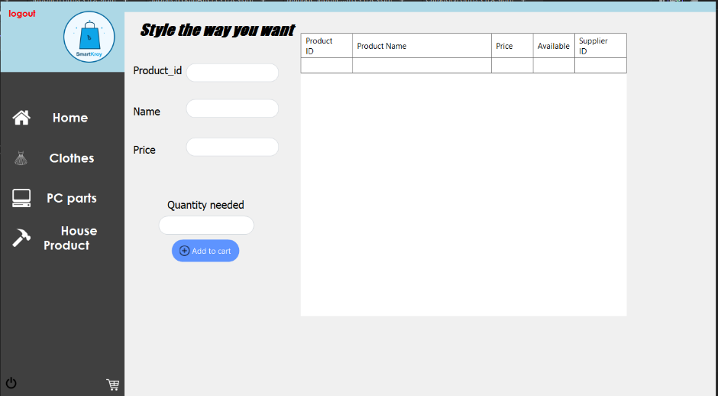

Figure 7. All Clothing item buying page

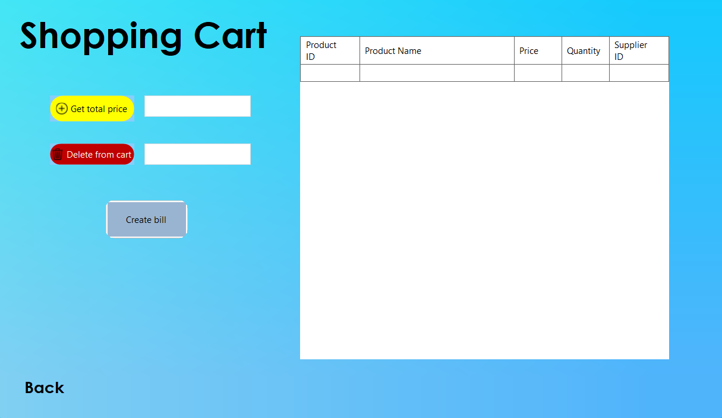

Figure 8. Shopping cart (the products that customer intended to buy)

Admin part:

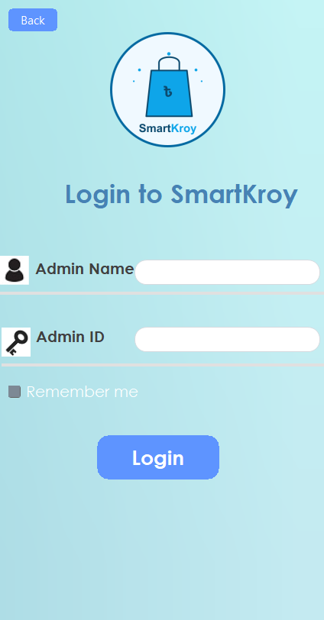

Figure 9. Admin login page

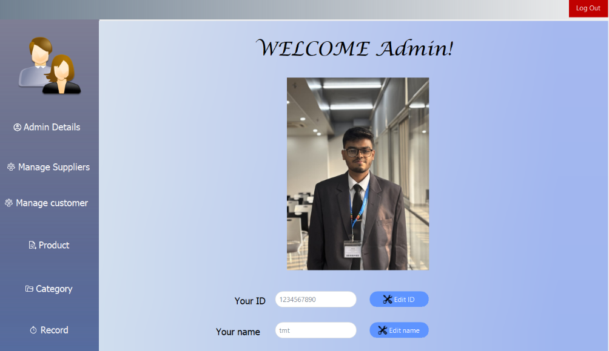

Figure 10. Admin Dashboard after login

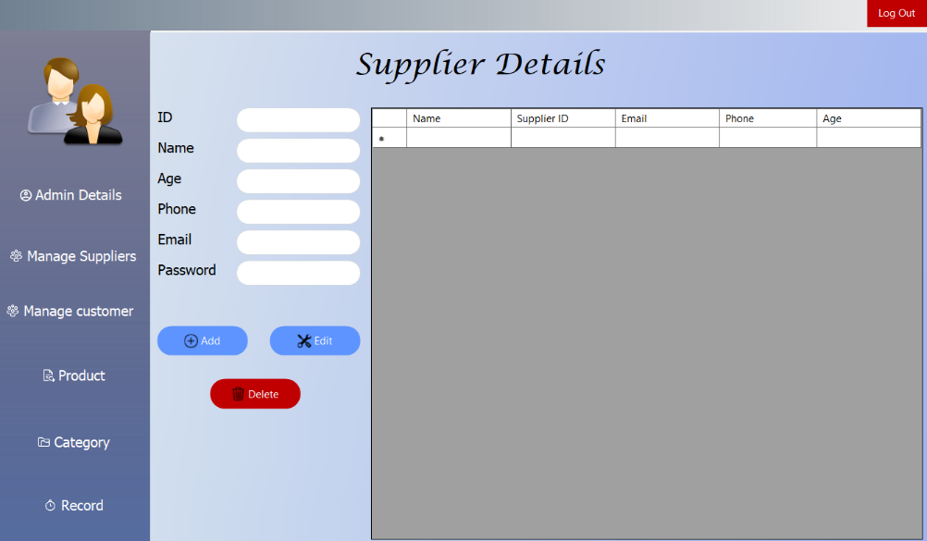

Figure 11. Supplier management page

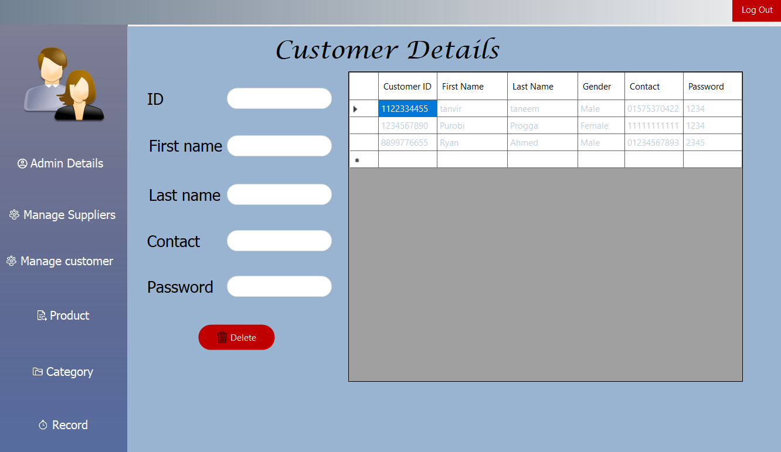

Figure 12. Customer management page

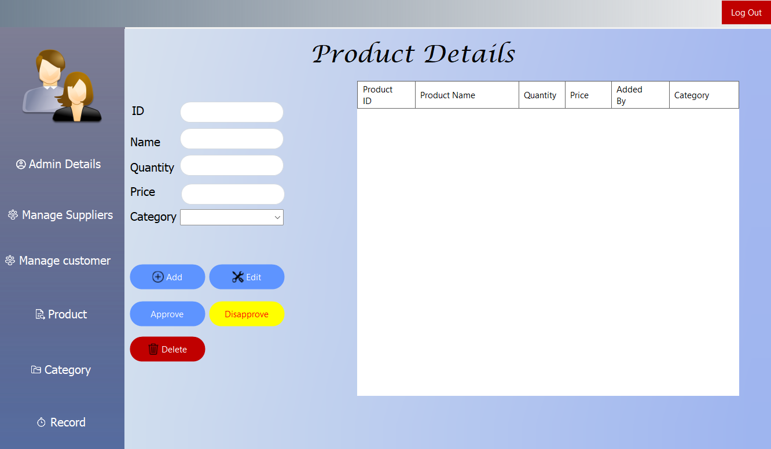

Figure 13. Product management page

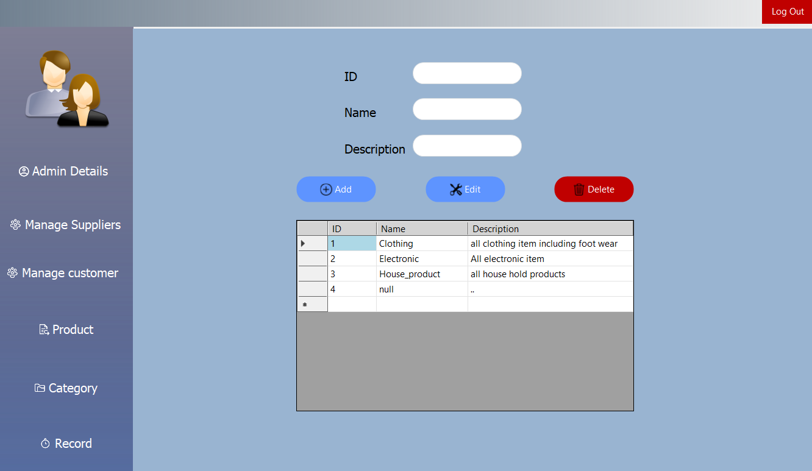

Figure 14.Product category management page

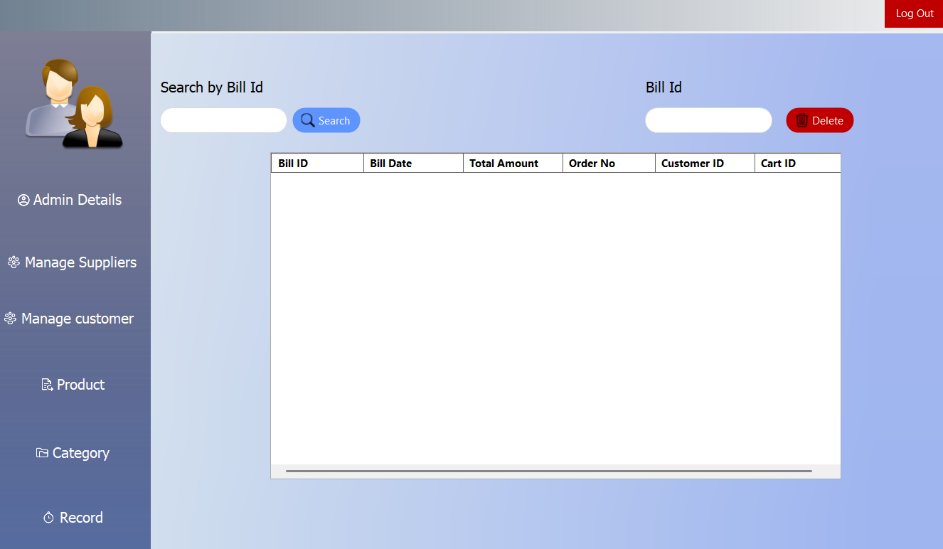

Figure 15. Bill information management page

Supplier part:

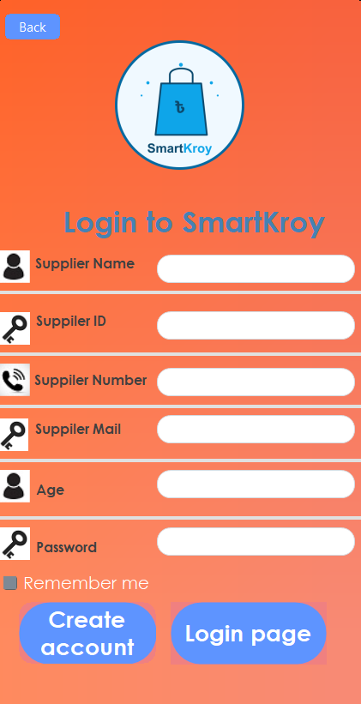

Figure 16. Supplier account registration page

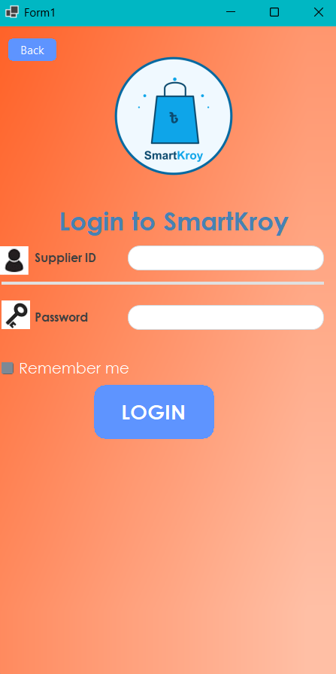

Figure 17. Supplier login page

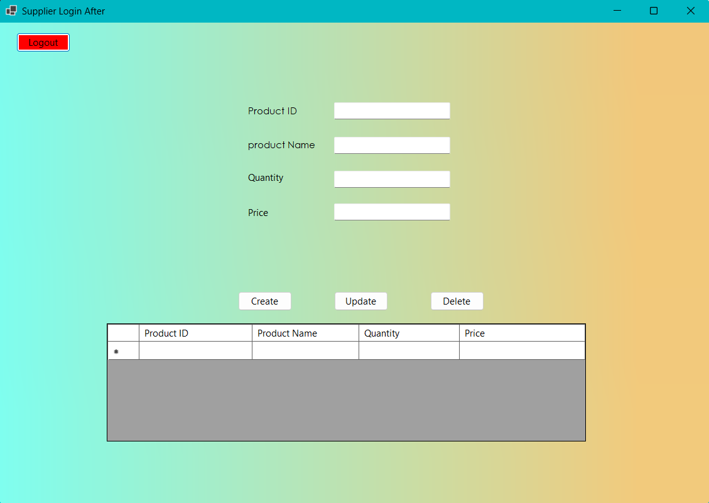

Figure 18. Supplier product adding page