Name:Taneeshq Cholekar Date:18/04/2025

Assignment-1

DevOps

**Problem Statement 1:**

1)Explain the following terms.

**a) DevOps Goals and Culture**

**DevOps** is a combination of **Development (Dev)** and **Operations (Ops).** It is a **software development methodology** that aims to bridge the gap between software development and IT operations teams

**Goals of DevOps**

1. Faster Delivery
   * Speed up the software development lifecycle.
   * Deliver features, bug fixes, and updates quickly and frequently.
2. Improved Collaboration
   * Break down silos between development and operations teams.
   * Foster a culture of shared responsibility.
3. Continuous Integration and Deployment (CI/CD)
   * Automate the process of integrating code and deploying it.
   * Ensure that code changes are tested and delivered to production quickly and reliably.
4. High Software Quality
   * Use automated testing and monitoring to reduce bugs.
   * Ensure stability, performance, and security of applications.
5. Scalability and Flexibility
   * Easily scale applications and infrastructure based on demand.
   * Adapt quickly to changes in market or business needs.

**DevOps Culture**

1. **Collaboration**: Developers and operations teams work together throughout the software lifecycle.
2. **Communication**: Open and transparent communication across teams to solve problems faster.
3. **Responsibility**: Shared responsibility for product performance, reliability, and uptime.
4. **Agility** : Encourages small, frequent updates rather than big, risky releases.
5. **Continuous Improvement**: Teams regularly review and refine processes to improve quality and speed.
6. **Feedback Loops**: Rapid feedback from testing, monitoring, and users to improve the product.

**b) DevOps Concepts & Practise**

**Devops Concepts**

1) Collaboration: Development and Operations work together throughout the software lifecycle

2)Automation: Automate repetitive and manual tasks like testing, integration, deployment, and infrastructure provisioning.

3)Continuous integration: Developers frequently integrate code into a shared repository, and each integration is automatically tested.

4) Continuous deployment : It is a DevOps practice where **every code change that passes automated testing is automatically deployed to production, without any manual approval.**

5) Continuous delivery: Code is automatically prepared for a production release with every change.

5)Infrastructure as Code: Managing and provisioning infrastructure using code (e.g., Terraform, Ansible).

6) Configuration management: is the practice of **automating and maintaining the consistency of an application’s functional and operational settings** across all environments (development, testing, production).

7) Monitoring and logging: Collect and analyze data to identify issues, track performance, and improve systems.

**DevOps Practices**

1) **CI/CD Pipelines:** Set up pipelines using tools like Jenkins, GitHub Actions, or GitLab CI for building, testing, and deploying applications

2) Automated testing: Write unit, integration, and end-to-end tests to ensure code quality before deployment.

3)Configuration management: Manage system configuration using tools like Ansible, Puppet, or Chef.

4)Containerization: Package applications and their dependencies using Docker to run consistently in any environment.

5)Orchestration: Manage containers at scale using Kubernetes or Docker Swarm.

**c) DevOps tools**

**DevOps tools** are software applications that help **automate, integrate, and manage** various stages of the **DevOps lifecycle**, such as development, testing, deployment, configuration, and monitoring.

* **Build Automation:**
* Maven: A project management and build automation tool based on XML (POM). Used to compile, test, and package Java applications.
* Gradle: A more flexible and faster build tool than Maven. Uses a Groovy/Kotlin-based DSL for builds.
* NPM: Node.js package manager used to install and run JavaScript tools and manage dependencies.
* Gulp: A JavaScript task runner used for automating frontend workflows like minifying CSS, JS, and image optimization.
* **Continuous Integration**
* Jenkins: A popular open-source automation server for building CI/CD pipelines. Highly customizable with plugin
* Travis CI: A cloud-based CI tool that integrates directly with GitHub for automated testing and builds.
* **Configuration Management**
* Ansible: Agentless tool using **YAML (playbooks)** to automate configuration, deployment, and orchestration. Simple and powerful.
* Puppet: Uses a declarative language to manage configurations. Ideal for large-scale deployments.
* Chef: Uses Ruby-based DSL for configuration scripts (recipes and cookbooks). Focuses on infrastructure automation.
* Salt: Fast and scalable configuration management and orchestration tool using remote execution and event-driven automation.
* **Containerization**
* Docker: A platform for **containerization** that allows applications to run in isolated environments with their own dependencies. Lightweight and portable.
* **Infrastructure Monitoring**
* Sensu: Monitors servers, services, and applications using a plugin-based architecture.
* New Relic: Cloud-based tool for monitoring infrastructure, servers, and containers.
* **Application Performance Monitoring**
* AppDynamics: Provides real-time performance insights for applications and services. Detects bottlenecks and issues.
* **Orchestration**
* Docker Swarm: Docker's native container orchestration tool. Simple setup, tightly integrated with Docker
* Kubernetes: Open-source orchestration system for automating deployment, scaling, and management of containerized applications. Industry standard
* Apache Zookeeper: Centralized service for maintaining configuration information and coordination in distributed systems.
* Terraform: Tool for **Infrastructure as Code (IaC)** to define and provision infrastructure using declarative configuration files. Supports multiple cloud providers.

**d) Relationship between DevOps and the cloud**

* DevOps and Cloud Computing go hand in hand in modern software development.
* DevOps focuses on automating and streamlining the development, testing, and deployment processes, while the cloud provides a scalable and flexible infrastructure to support those processes.
* The cloud plays a critical role in enabling DevOps by offering on-demand access to computing resources, storage, and networking.
* It eliminates the need for manual hardware setup and allows teams to spin up development, testing, and production environments within minutes. This aligns perfectly with the DevOps goal of continuous integration and continuous deployment (CI/CD), where speed and automation are crucial.
* One of the key benefits of combining DevOps and the cloud is scalability. Cloud platforms can automatically scale infrastructure up or down based on the workload, and DevOps tools can ensure the application remains functional and optimized as it scales.
* Cloud platforms offer built-in services like version control, CI/CD pipelines, monitoring, and logging, which reduce the complexity of managing DevOps pipelines.
* Security and consistency are also enhanced through the use of Infrastructure as Code (IaC), a DevOps practice that allows teams to define cloud infrastructure using configuration files.

**Problem Statement 2:**

**Explain the following terms with a diagram:**

**1. Microservices**

**Microservices** is an architectural style that structures an application as a collection of small, independent, and loosely coupled services. Each service:

* Has a specific responsibility or business function.
* Communicates with other services via APIs (usually HTTP/REST or messaging queues).
* Can be developed, deployed, and scaled independently.

### Key Characteristics of Microservices:

* **Independent Deployment**: Services can be updated without redeploying the whole system.
* **Technology Flexibility**: Each service can use different languages or databases.
* **Scalability**: Only the needed services can be scaled based on demand.
* **Fault Isolation**: Failures in one service do not affect the entire application.

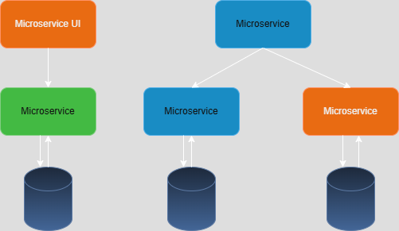

Figure .Microservices

**2) Monolithic Architecture**

**Monolithic architecture** is a traditional software development approach where an application is built as a single, unified unit. All components—UI, business logic, and data access—are tightly coupled and run as one service.

### Key Characteristics of Monolithic Architecture:

1. **Single Codebase**: The entire application resides in one codebase.
2. **Tightly Coupled Components**: All modules are dependent on each other.
3. **Single Deployment Unit**: The whole app is compiled and deployed together.
4. **Shared Database**: All components use a common database.
5. **Scalability**: Difficult to scale individual parts; scaling means cloning the whole app.
6. **Tech Stack Uniformity**: Often built using a single language/framework.

### Monolithic Flow Example:

1. User sends a request to the application.
2. The application handles UI, logic, and data access within the same process.
3. Response is returned after processing all in one go.

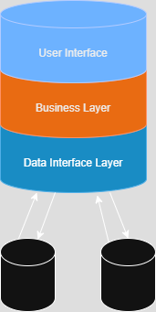

Figure .Monolithic Architecture

**3) Microservice Architecture**

**Microservices architecture** is a modern approach to software design where an application is structured as a collection of **loosely coupled**, **independently deployable** services. Each microservice focuses on a single business capability and can be developed, deployed, and scaled independently.

### Key Characteristics of Microservices Architecture:

1. **Decoupled Services**  
   Each service operates independently and communicates with others via APIs (usually REST or messaging queues).
2. **Independent Deployment**  
   Services can be updated or redeployed without affecting the whole system.
3. **Scalability**  
   Each microservice can be scaled individually based on its load.
4. **Polyglot Tech Stack**  
   Each team can use the tech stack best suited for their service (e.g., Node.js for one, Python for another).
5. **Fault Isolation**  
   If one service fails, others can continue to work normally.
6. **DevOps & CI/CD Friendly**  
   Supports continuous delivery, containerization (like Docker), and orchestration (like Kubernetes).

### Microservices Flow Example:

1. User interacts with a frontend or API Gateway.
2. The Gateway routes requests to appropriate microservices.
3. Each microservice processes its part and may talk to others if needed.
4. Each one has its own database or data storage.

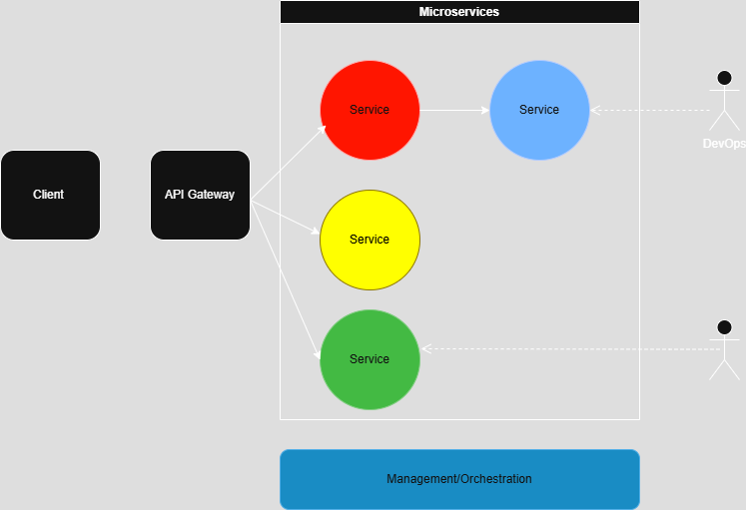

Figure .Microservice Architecture

**4) Loosely couple architecture**

**Loosely coupled architecture** refers to a software design principle where components or services are **independent** and **minimally dependent** on each other. Each part of the system has limited knowledge about the inner workings of others, allowing them to change or scale independently without breaking the whole system.

### Key Characteristics:

1. **Independent Services/Modules**  
   Components interact through well-defined interfaces (e.g., APIs) instead of direct code dependencies.
2. **High Modularity**  
   Each module performs a specific function and can be developed, tested, deployed, and updated independently.
3. **Minimal Dependencies**  
   Reduces tight interconnections between services, improving flexibility and maintainability.
4. **Better Scalability**  
   Each component can be scaled based on demand without impacting others.
5. **Easier Maintenance & Upgrades**  
   Changes in one service don’t require changes in others, enabling faster deployments and fixes.

**Example in Practice:**

In a microservices setup:

* A **Payment Service** doesn't need to know how the **Order Service** works.
* It only needs to know what kind of request to send (like POST /create-order) and what response to expect.
* Communication happens through HTTP, message queues, or events—not direct function calls.

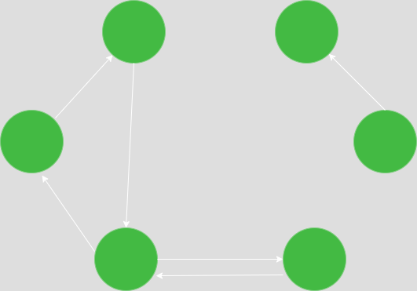

Figure .Loosely coupled Architecture

**5) Reasons to use Microservices**

Microservices have become a preferred architectural style for building large, scalable, and agile applications. Here are the key reasons why organizations choose **microservices** over traditional monolithic architecture:

### 1. ****Scalability****

* Microservices allow **independent scaling** of services based on demand.
* For example, if the product catalog is heavily used, only that service can be scaled without touching others.

### 2. ****Flexibility in Technology Stack****

* Teams can use **different programming languages, frameworks, or databases** for different services.
* This enables choosing the best tools for the job instead of being locked into one stack.

### 3. ****Faster Development and Deployment****

* Each team can develop, test, and deploy services independently.
* This speeds up the development lifecycle and supports **continuous delivery** and **DevOps** practices.

### 4. ****Resilience and Fault Isolation****

* A failure in one microservice doesn't crash the whole application.
* This **fault isolation** improves system reliability and uptime.

### 5. ****Better Organization Around Business Capabilities****

* Microservices align well with business domains (e.g., user service, order service, payment service).
* Teams can work in parallel on different modules, **enhancing team autonomy and ownership.**

### 6. ****Improved Maintainability****

* Services are smaller and easier to understand, maintain, and refactor.
* New team members can ramp up faster by focusing on a single service instead of a huge codebase.

### 7. ****Easier Testing****

* Since services are decoupled, **unit testing and integration testing** can be more focused and efficient.

### 8. ****Supports Continuous Integration/Continuous Deployment (CI/CD)****

* Microservices fit perfectly with CI/CD pipelines because each service can be deployed separately.
* This leads to **faster innovation** and **safer updates.**

### 9. ****Better Use of Resources****

* In a cloud environment, microservices can be deployed as **containers**, using only the resources they need.
* This leads to **cost-effective infrastructure** usage.

### 10. ****Legacy System Integration and Modernization****

* Microservices allow you to **gradually replace parts of a legacy system**, reducing risk and avoiding full rewrites.