Name:Taneeshq Cholekar Date:9/6/2025

Assignment-1

Kubernetes and Docker:Container Masterclass

(View image at: <https://hub.docker.com/u/tanc2002>)

**Problem Statement:**

Create a file called Docker File and edit it using vim.

Please note that the name of the file has to be "Docker file" with "D" as capital.

Build your Docker File using the following instructions.

#This is a sample Image.

FROM ubuntu

MAINTAINER [demousr@ibm.com](mailto:demousr@ibm.com)

RUN apt-get update

RUN apt-get install -y nginx

CMD ["echo", "Image created"]

Save the file

**Methodology:**

**Step 1:** Change directory to assignment-1 and create a Dockerfile.



**Step 2:** Open the file using vim editor.



**Step 3:** Write the given code by going into insert mode and save the file.

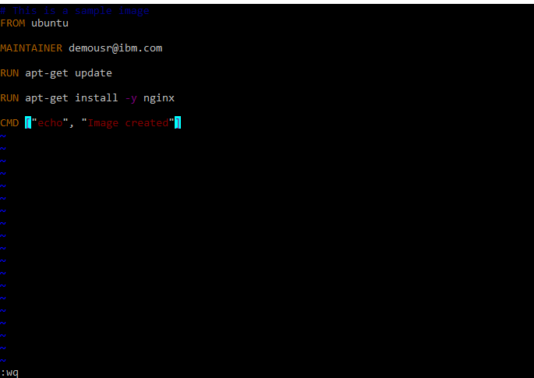

**Step 4:** Create an image of the file using docker build.

