Name:Taneeshq Cholekar Date:9/6/2025

Assignment-2

Docker and Kubernetes:Container Masterclass

**(**[**https://hub.docker.com/repository/docker/tanc2002/demorep**](https://hub.docker.com/repository/docker/tanc2002/demorep)**)**

**(docker pull tanc2002/demorep:latest)**

**Problem Statement:**

Build a Docker File and push it to Docker hub repository: docker build allows to build your own Docker images.

docker build -t ImageName:TagName dir

Log into Docker Hub and create your repository. This is the repository where your image will be stored.

Go to https://hub.docker.com/ and log in with your credentials.

Click the button "Create Repository" on the above screen and create a repository with the name demorep.

Make sure that the visibility of the repository is public.

Once the repository is created, make a note of the pull command which is attached to the repository.

The pull command which will be used in our repository is as follows docker pull demousr/demorep

Now go back to the Docker Host. Here we need to tag my image to the new repository created in Docker Hub.

Issue the Docker login command to login into the Docker Hub repository from the command prompt.

The Docker login command will prompt you for the username and password to the Docker Hub repository.

Once the image has been tagged, it's now time to push the image to the Docker Hub repository. We can do this via the Docker push command.

**Methodology:**

**Step 1:** Create a directory assignment-2 and create a Dockerfile in it. I used the nano editor to write to the file.

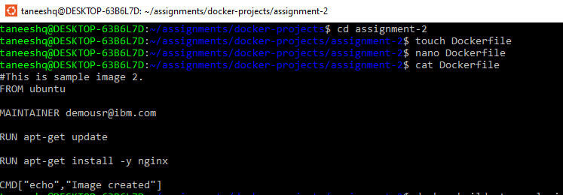

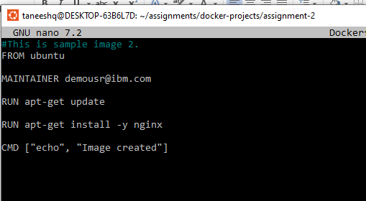

**Step 2:** Build the image using docker build command. Also I listed the images for verification.

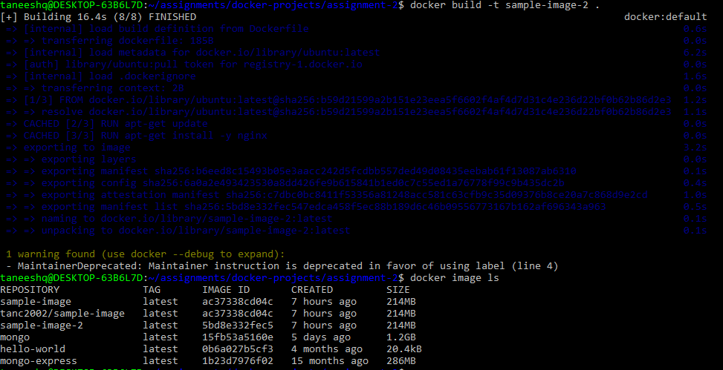

**Step 3:** Create a repository on Dockerhub

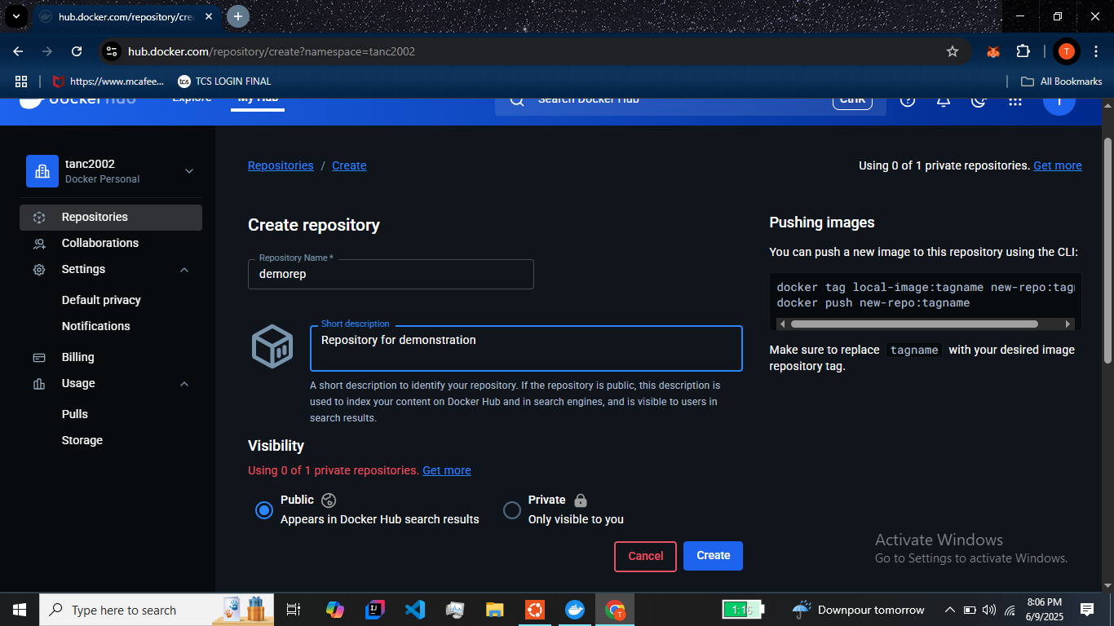

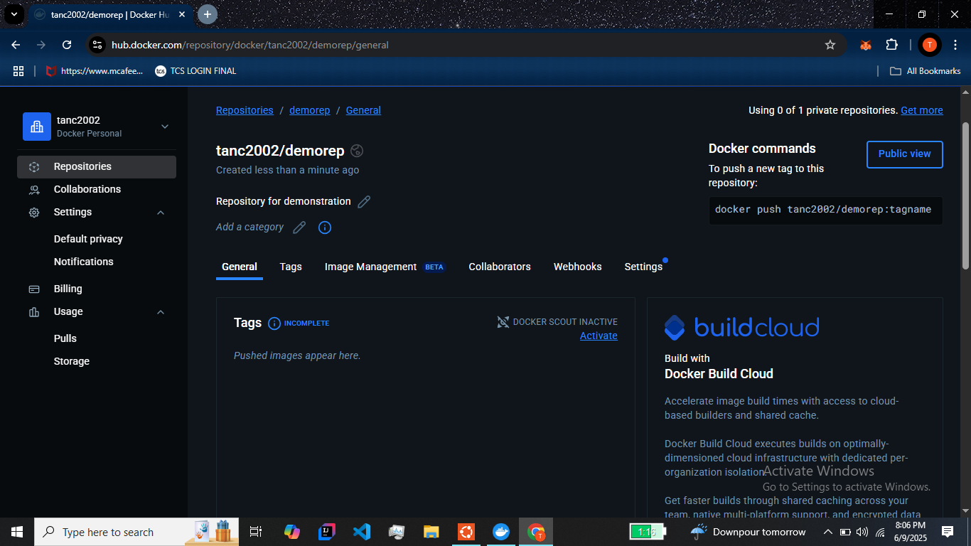

**Step 4:** Login to docker through the terminal and add a tag to the image.

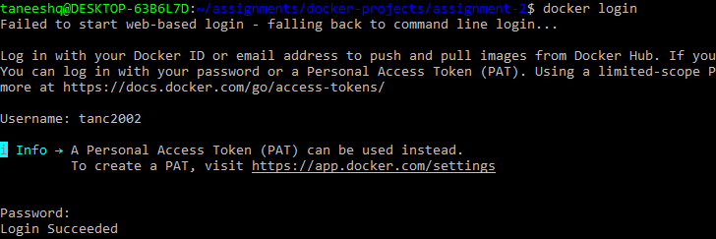

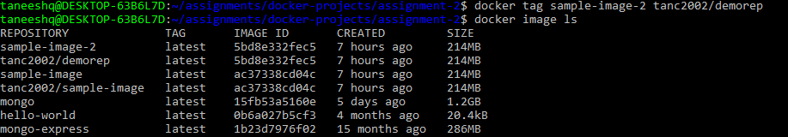

**Step 5:** Push the image to the repository.

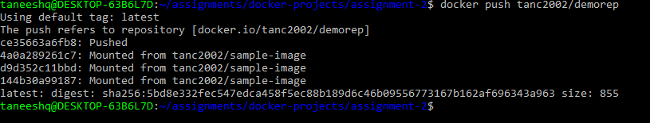

**Step 6:** Go back to dockerhub and verify the image.