Name: Taneeshq Cholekar Date:14/05/2025

**Assignment-3**

**Docker and Kubernetes: The Container Masterclass**

**Problem Statement:**

Setup Single Node Kubernetes Cluster with Minikube on Ubuntu, Minikube runs as a single node kubernetes cluster inside a VM on the laptop for the users who want to stry kubernetes and test codes locally on the kubernetes environment.

**Methodology:**

**Step 1:** Install kubectl and check version

curl –LO "https://dl.k8s.io/release/$(curl -s https://dl.k8s.io/release/stable.txt)/bin/linux/amd64/kubectl"

chmod +x kubectl

sudo mv kubectl /usr/local/bin/



**Step 2:** Install minikube and check version

curl -LO https://storage.googleapis.com/minikube/releases/latest/minikube-linux-amd64

sudo install minikube-linux-amd64 /usr/local/bin/minikube



**Step 3:** Start the minikube node

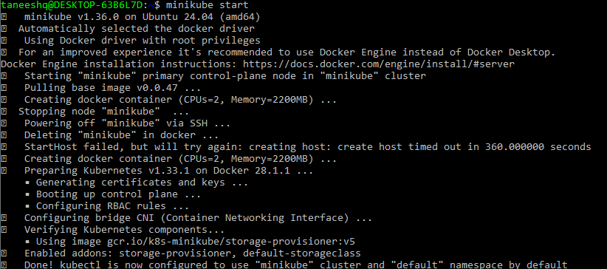

**Step 4:** Verify the cluster is started by listing the nodes



**Step 5:** Test the setup by deploying a sample image “hello-node”

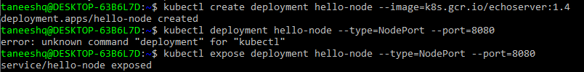

**Step 6:** Run the service to get the output. Also note the url given by minikube and verify it in browser.

